Midlothian Science Festival ‘Punching Anatomy’ – 8.10.2019

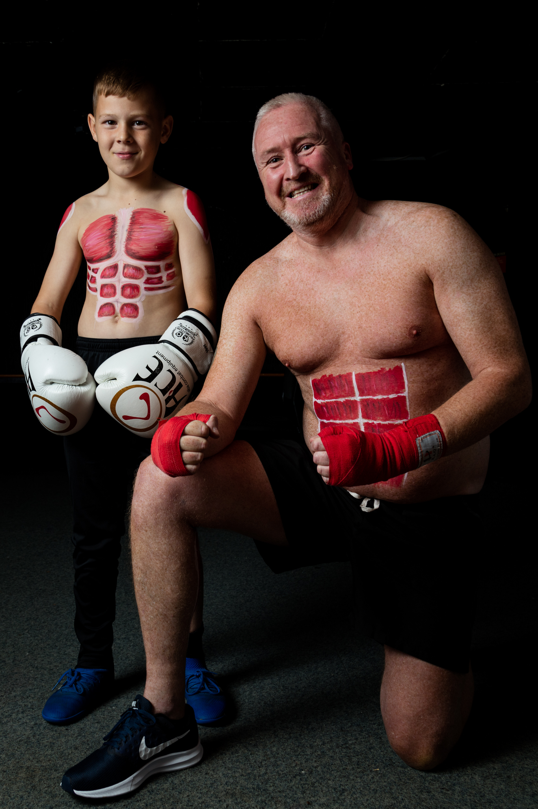
Two members of the Easthouses boxing club happily posing with painted on core muscles for our photographer Philip Gillespie during the interactive anatomical body painting workshop at the Midlothian Science Festival.
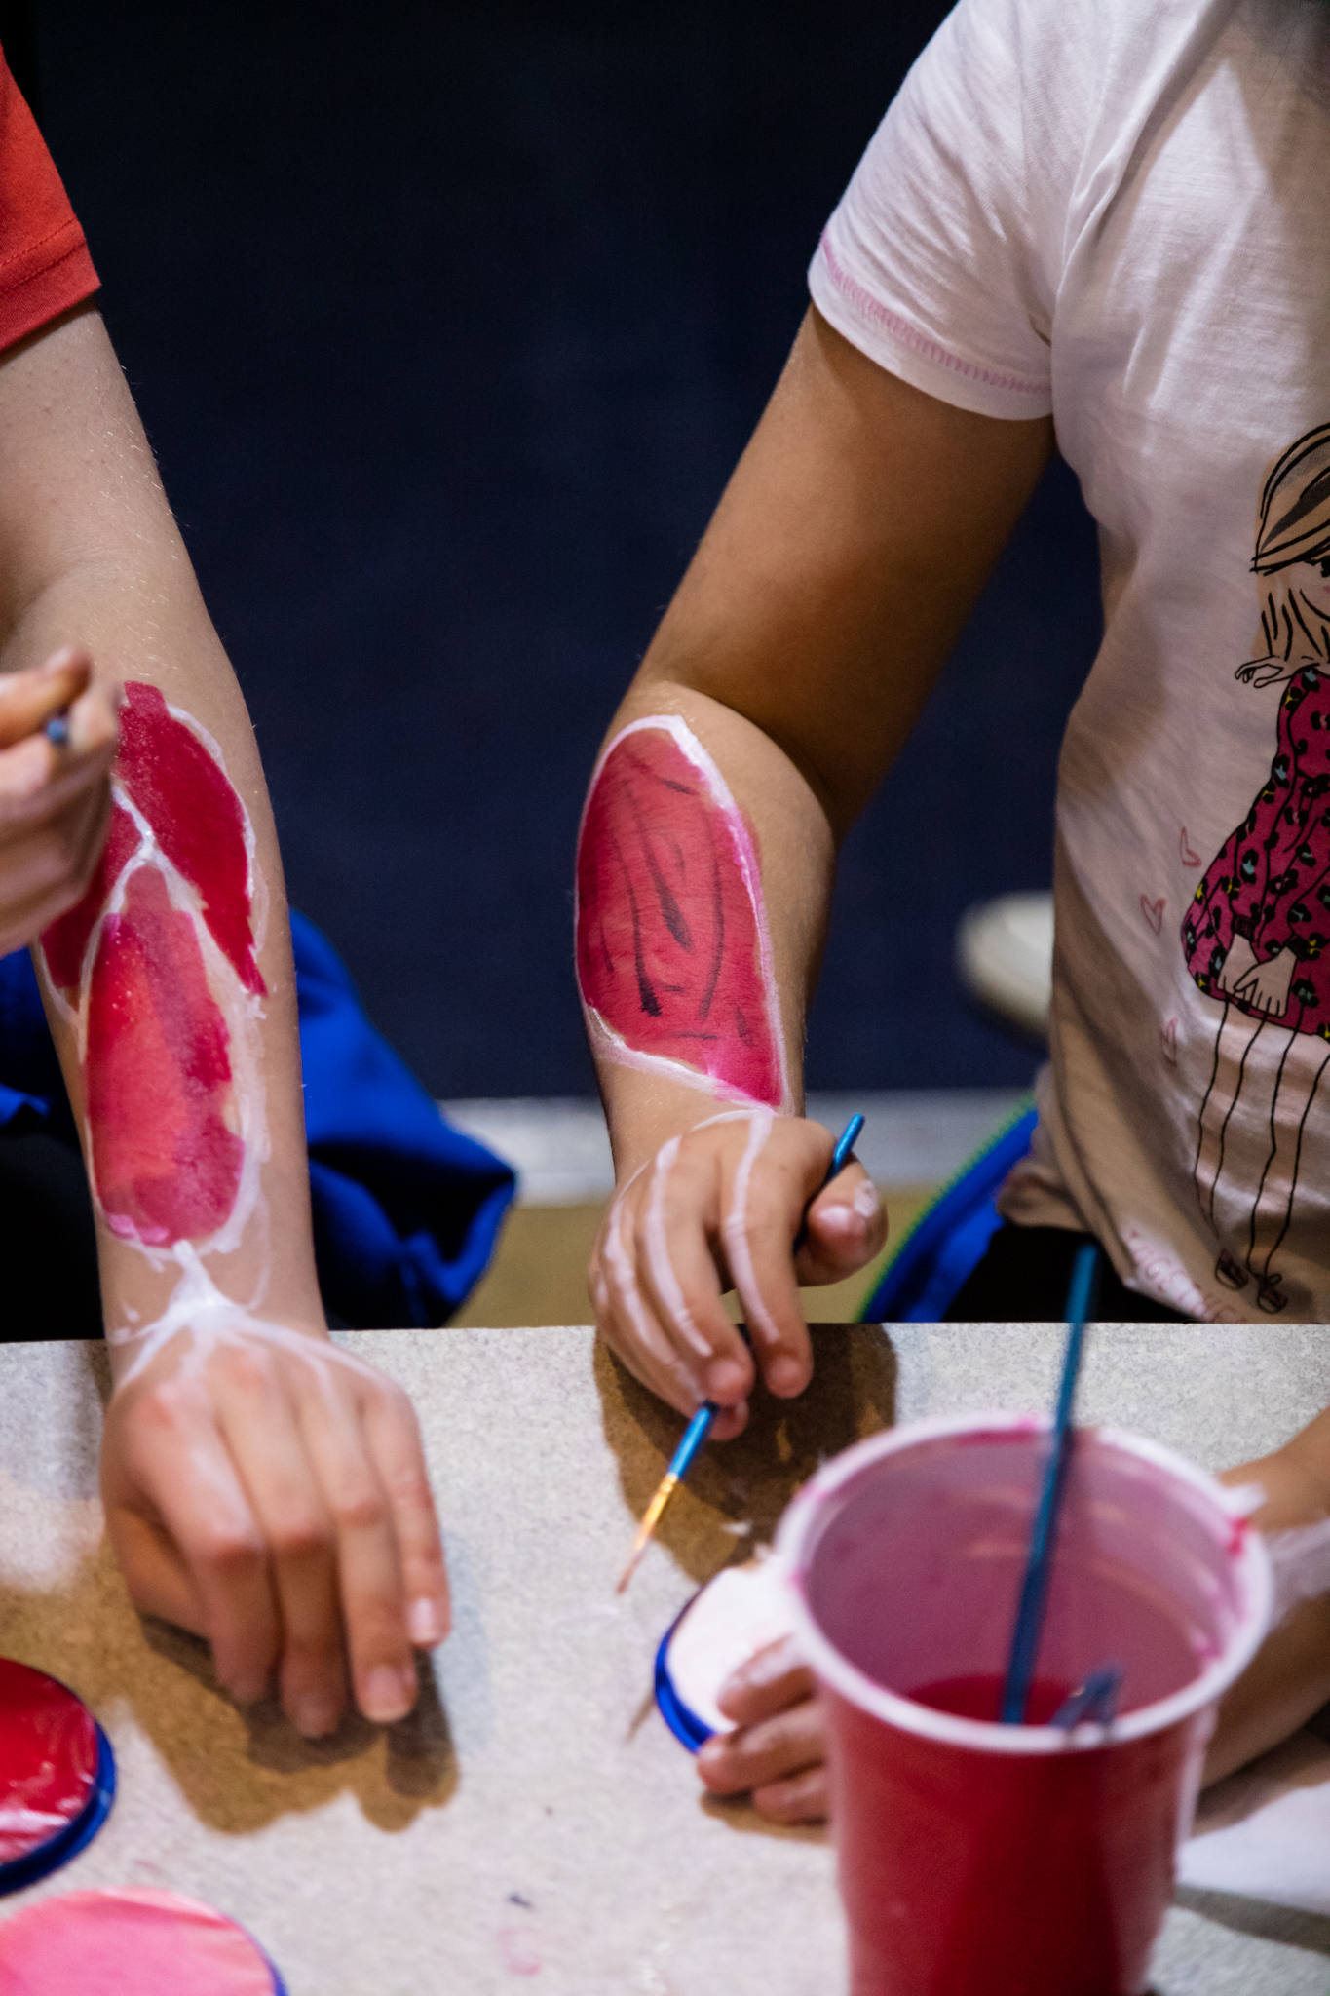
Girl Guides painting muscles of the lower forearm onto themselves at the event ‘Punching Anatomy’ during the Midlothian Science Festival.

