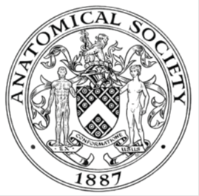
_______________________________________________________________________________________
AWARDEE REPORT FORM
_______________________________________________________________________________________

NAME |  | Alaa Alshwayyat
TWITTER HANDLE* optional |  | Alaa Alshwayyat
UNIVERSITY |  | University of Aberdeen
NAME OF AWARD |  | Symington Bequest Funding 2025/26 Round 1
PURPOSE OF AWARD conference/event attended/organised (full name) with city and dates.
The purpose of attending the 5th International Scientific Congress on Spinal Muscular Atrophy (Budapest, Hungary, March 11–14, 2026) was to present my PhD research through an oral presentation and to engage with leading experts, clinicians, and researchers in the field.

REPORT: What were your anticipated benefits?
Minimum number of words between 200-400. Please write in coherent paragraphs.
Attending the 5th International Scientific Congress on Spinal Muscular Atrophy was expected to provide several academic and professional benefits. First and foremost, presenting my PhD research offered a valuable opportunity to communicate my work to an international audience of specialists.

Another key benefit was the opportunity to stay up to date with the latest developments in SMA research. The congress covered a wide range of topics, including biomarkers, sensorimotor function, metabolism, regeneration, and emerging therapeutic approaches. Engaging with these sessions was expected to broaden my understanding of the field and help position my research within current scientific trends.

Networking was also a major anticipated benefit. The congress brought together researchers, clinicians, industry representatives, and patient advocates from around the world. I expected that interacting with this diverse group would open doors for future collaborations, provide insight into different research approaches, and allow me to learn from both academic and clinical perspectives.

Finally, engaging with individuals living with SMA and patient advocates was expected to provide valuable insight into the real-world impact of research. This perspective is essential for developing meaningful, patient-focused scientific work. Overall, I anticipated that attending the congress would contribute significantly to both my academic development and my broader understanding of the field.

COMMENTS: Describe your experience at the conference / lab visit / course / seminar/ event.
Minimum number of words between 200-400. Please write in coherent paragraphs.
Attending the 5th International Scientific Congress on Spinal Muscular Atrophy in Budapest was an incredibly rewarding experience. The congress brought together a unique mix of researchers, clinicians, pharmaceutical representatives, patient advocates, and individuals living with SMA, all united by a shared goal of improving patient outcomes. Being part of such a diverse and committed conference created a truly inspiring atmosphere. One of the highlights of the conference was presenting my research. Delivering my presentation allowed me to share my work with experts in the field and receive valuable feedback. The discussions that followed were insightful and helped me view my research from different perspectives, particularly in terms of its clinical relevance and future applications.

The scientific programme was rich and diverse, covering key areas such as biomarkers, sensorimotor function, fatigability, metabolism, regeneration, and optimisation of treatments. Each session provided new insights into how the field is evolving and highlighted the collaborative nature of SMA research. It was especially interesting to learn how ongoing research is being translated into clinical practice and improvements in patient care. Another particularly meaningful aspect of the conference was the opportunity to connect with people living with SMA. Hearing their experiences added an important human dimension to the scientific discussions and reinforced the importance of patient-centred research. Overall, the event was not only academically enriching but also personally motivating. It reinforced the importance of collaboration and provided new ideas to inform my future research.
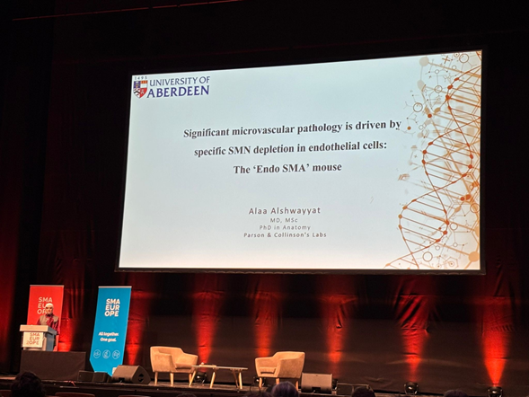

REPORT: In relation to skills, what were the most important things you gained? (does not apply to equipment grant. For public engagement/outreach awards what did your audience gain and how did you evaluate success?
Minimum number of words between 200-400. Please write in coherent paragraphs.
One of the most important skills I developed during the conference was the ability to communicate my research effectively to a diverse audience. Presenting my work in an oral format required me to clearly explain complex scientific concepts in a way that was accessible to both specialists and non-specialists. This experience significantly improved my confidence in public speaking and helped me refine how I structure and deliver scientific presentations. I also strengthened my ability to engage in scientific discussions. The questions and feedback I received following my presentation encouraged me to think critically about my work and consider alternative interpretations and approaches. Networking was another key area of development. Interacting with international researchers and clinicians helped me build professional connections and improve my confidence in initiating and maintaining academic relationships. I also gained insight into how collaborations are formed and sustained across different sectors. In addition, attending the various sessions improved my ability to critically evaluate research. Listening to presentations on a wide range of topics allowed me to compare methodologies, identify emerging trends, and better understand how different areas of research are interconnected.

Finally, I evaluated the success of my participation through the positive feedback I received from attendees, including researchers I had not previously met. Their comments and engagement with my work indicated that my research was well received and clearly communicated.

REPORT: How do you think you will put this learning experience into practice in the future? For public engagement/outreach awards how with the materials/knowledge generated by this activity be used in the future?
Minimum number of words between 200-400. Please write in coherent paragraphs.
The experience gained from attending this congress will have a good impact on my future research and professional development. One of the most immediate applications will be improving how I communicate my work. The feedback I received on my presentation will help me refine my research narrative, making it clearer and more impactful for future conferences and publications.

The knowledge gained from the scientific sessions will also inform the direction of my PhD research. Exposure to the latest developments in areas such as biomarkers, treatment optimisation, and disease mechanisms has provided new ideas that I can integrate into my work. This will help ensure that my research remains relevant and aligned with current advancements in the field, and will help to improve the understanding of the disease. The feedback and discussions with other researchers will also support the development of my current work. The insights I gained have provided new perspectives and ideas that I can build upon in my research.

The connections I made during the conference will be valuable for future collaborations. I plan to maintain contact with researchers and clinicians I met, as these relationships could lead to collaborative projects, shared data, or new research opportunities. Building on these networks will be important for my long-term academic career.

Data Protection/GDPR: I consent to the data included in this submission being collected, processed and stored by the Anatomical Society. Answer YES or NO in the Box below
Yes
Graphical Images: If you include graphical images you must obtain consent from people appearing in any photos and confirm that you have consent. A consent statement from you must accompany each report if relevant. A short narrative should accompany the image. Answer N/A not applicable, YES or NO in the box below
N/A

Copyright: If you submit images you must either own the copyright to the image or have gained the explicit permission of the copyright holder for the image to be submitted as part of the report for upload to the Society’s website, Newsletter, social media and so forth. A copyright statement must accompany each report if relevant. Answer N/A not applicable, YES or NO in the box below
yes

SIGNATURE | Alaa Alshwayyat |  | DATE | 31/3/2026
If submitted electronically, a type-written name is acceptable in place of a hand-written signature
File: AS-Award-Report-Form-171023 – International Conference

