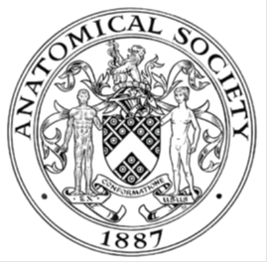
_______________________________________________________________________________________
AWARDEE REPORT FORM
_______________________________________________________________________________________

NAME |  | Ms Emily Baxter
TWITTER HANDLE* optional |  | @AnatomistEmily
UNIVERSITY |  | University of Liverpool (PhD Institution) & University of Nottingham (Employer)
NAME OF AWARD |  | Barclay-Smith Travelling Award
PURPOSE OF AWARD conference/event attended/organised (full name) with city and dates.
The Barclay-Smith Travelling Award was sought to attend the Anatomical Society Summer Meeting at the University of Bristol. This event took place between 15-17th July 2026 and provided a platform for me to disseminate pertinent research findings obtained from my PhD studies, via oral presentation.
REPORT: What were your anticipated benefits?
Minimum number of words between 200-400. Please write in coherent paragraphs.
The anticipated benefits of the conference included professional development as a PhD researcher. The conference would provide an opportunity to deliver the first oral presentation of my PhD, describing the shape variation and covariation of the calvarial sutures with the viscerocranium in both normocephalic and craniosynostotic skulls. This research applies Geometric Morphometric (GMM) techniques to investigate the ontogenetic and allometric drivers of shape variation, the emergence of sexual dimorphism, and the degree of integration between craniofacial units using a partial least squares (PLS) approach. The aim of this research is to improve our understanding of craniofacial morphology throughout growth from birth to adolescence, in order to better characterise the dysmorphology associated with premature suture fusion (craniosynostosis).
The theme of this conference, Musculoskeletal Anatomy, provided an ideal platform to discuss my research findings to an audience of anatomists and craniofacial researchers who could offer valuable feedback and engage in scientific discussion. Such interactions were expected to strengthen the direction of my PhD by refining my interpretation of the findings and generating new research questions, thereby increasing the impact of my work.

Given that this would be my first oral presentation, I also anticipated that I would gain valuable experience in responding to questioning, defending my research and developing my confidence in scientific communication. This would be a perfect opportunity to reflect on my own conclusions and consider areas for greater exploration as my PhD proceeds.

Finally, networking with fellow anatomists and craniofacial researchers would provide an opportunity to establish professional connections, identify potential collaborators working in related fields, and support my long-term development as an independent researcher.
COMMENTS: Describe your experience at the conference / lab visit / course / seminar/ event.
Minimum number of words between 200-400. Please write in coherent paragraphs.
The conference was held over three days at the University of Bristol's School of Anatomy. As I had never beforehand visited Bristol, I was unaware of the breadth of outstanding work undertaken there, particularly in the field of comparative anatomy! It was a privilege to attend both the oral presentations and keynote lectures. The talks were engaging, insightful, and demonstrated how knowledge of human anatomy can be applied across a wide range of research contexts. I was particularly interested in presentations describing applications of Geometric Morphometric (GMM) analysis. As this technique forms a central part of my own research, these sessions were especially valuable, reinforcing the strength of our collective research community.

One of the highlights of the conference was delivering my own oral presentation on the second day. Guided by their timekeeping unicorn—a brilliant idea—it was an enjoyable experience to present my research to the audience. I began by explaining how craniosynostosis develops through the premature fusion of the cranial sutures before discussing the findings from my GMM analyses of both the control and clinical cohorts. The audience then asked some great questions regarding my conclusions. Reflecting on this experience, the 15-minute presentation passed by quickly! Afterwards, I had further conversations with fellow attendees regarding future analyses which could further strengthen the work. I would strongly recommend this experience to any early career researcher considering an oral presentation at a future meeting.

In addition, I greatly enjoyed networking with fellow PhD students and early career researchers during the poster sessions. The breadth of research presented was impressive, ranging from machine learning and AI-generated anatomical images for pedagogical enhancement, to novel surgical approaches to the cervical spine. I found each presenter to be enthusiastic and happy to discuss their work. These informal conversations, accompanied by tea and a selection of pastries, provided an excellent platform to build professional connections.

Finally, the Gala Dinner at the Riverstation was another highlight. The sunny walk along Bristol’s riverside was a wonderful way to conclude the proceedings, and along the route we spotted several Gromit sculptures, as on my travels I also learned that Bristol is home to Aardman Animation Studios. The evening was an excellent opportunity to liaise with existing and newly established connections in a beautiful environment.

Overall, I had a highly enjoyable and memorable time at AnatSoc Summer 2026 and cannot thank the society enough for supporting this endeavour.
REPORT: In relation to skills, what were the most important things you gained? (does not apply to equipment grant. For public engagement/outreach awards what did your audience gain and how did you evaluate success?
Minimum number of words between 200-400. Please write in coherent paragraphs.
Attending AnatSoc Summer 2026 was an excellent opportunity to develop the skills required to be an independent researcher. This included strengthening my scientific communication and presentation skills to an audience of leading anatomical experts. This required practice and careful preparation to ensure that the content was delivered at an appropriate level, and to ensure those without a strong familiarity of GMM could follow the narrative I was intending to convey. The aims were intended to be concise, and the outputs delivered in a clear and logical manner to summarise the key research findings pertinent to craniosynostosis shape analysis.

Responding to questions following the presentation was another valuable skill I was able to practice. These discussions highlighted areas I had considered previously alongside areas requiring further analysis and exploration. In the coming months and years, I believe that this experience will prove to be extremely valuable as I prepare to defend my work within my thesis and viva.

In addition, the conference provided a perfect platform to network and interact with individuals from diverse research backgrounds. I was able to liaise with colleagues old and new and gain a greater appreciation for the methodologies underpinning craniofacial research. Networking and collaboration are fundamental skills required in establishing a supportive research community, and open avenues for future collaborations throughout my PhD and beyond.
REPORT: How do you think you will put this learning experience into practice in the future? For public engagement/outreach awards how with the materials/knowledge generated by this activity be used in the future?
Minimum number of words between 200-400. Please write in coherent paragraphs.
Overall, the conference emphasized the importance of building and maintaining a group of professional connections within the anatomical sciences, and the AnatSoc meetings are a perfect platform to do this. Listening to the oral and poster presentations enabled me to determine where the overlaps are between my own research and that of others – particularly when considering shared methodologies and how we can support each other in producing impactful research outputs.

The feedback I obtained and discussions I engaged with highlighted several themes for further exploration within my PhD work, particularly when interpreting the outputs of Geometric Morphometrics (GMM) analysis. These interacts have reinforced the value of seeking constructive feedback and will provide invaluable when I progress towards publishing my research findings.

Finally, attending AnatSoc has encouraged me to continue presenting my research outputs as they arise, and to not be afraid of questions when they do emerge! Regularly engaging with the society will enable me to further develop my research profile and continue to refine my ideas with the guidance of leading experts within anatomical sciences and craniofacial biology. I hope to continue to contribute my own outputs and maintain a keen interest in emerging research pertinent not only to my PhD studies, but also pedagogical advancements within this area to drive my development as an anatomy educator.
Data Protection/GDPR: I consent to the data included in this submission being collected, processed and stored by the Anatomical Society. Answer YES or NO in the Box below
YES
Graphical Images: If you include graphical images you must obtain consent from people appearing in any photos and confirm that you have consent. A consent statement from you must accompany each report if relevant. A short narrative should accompany the image. Answer N/A not applicable, YES or NO in the box below
N/A
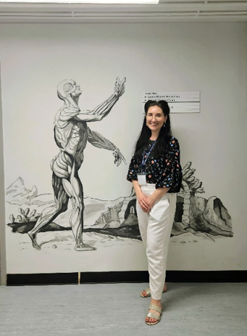
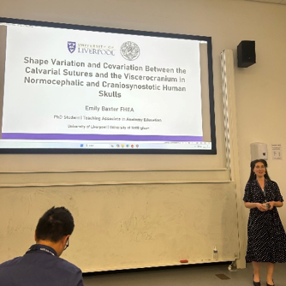
Copyright: If you submit images you must either own the copyright to the image or have gained the explicit permission of the copyright holder for the image to be submitted as part of the report for upload to the Society’s website, Newsletter, social media and so forth. A copyright statement must accompany each report if relevant. Answer N/A not applicable, YES or NO in the box below
N/A
SIGNATURE | E.J Baxter |  | DATE | 20.07.2026
If submitted electronically, a type-written name is acceptable in place of a hand-written signature
File: AS-Award-Report-Form-171023 – International Conference

