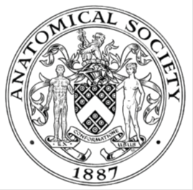
_______________________________________________________________________________________
AWARDEE REPORT FORM
_______________________________________________________________________________________

NAME |  | Avanthika Sivakumar
TWITTER HANDLE* optional
UNIVERSITY |  | University of Oxford
NAME OF AWARD |  | Barclay-Smith Travelling Fund
PURPOSE OF AWARD conference/event attended/organised (full name) with city and dates.
The award provided financial support for me to attend and present a poster at the Anatomical Society Winter Meeting held in Anglia Ruskin University in Chelmsford from 17-19 December 2025.

REPORT: What were your anticipated benefits?
Minimum number of words between 200-400. Please write in coherent paragraphs.
From an academic perspective, I believed the conference would provide exposure to a broad range of novel research within anatomy and related disciplines, allowing me to gain insight into areas beyond my immediate field of study. Given my background as a pre-clinical medical student is in basic science and laboratory-based research, I anticipated that engaging with clinically oriented and education-focused anatomical research would help contextualise my own work within a wider translational framework.

I was also looking forward to the opportunity to develop my scientific communication skills. Presenting a poster at a national conference would improve my ability to clearly explain my research to individuals with varying levels of expertise, including clinicians, educators, and fellow researchers. I also expected that interacting with other conference attendees would allow me to receive constructive feedback, helping to refine both my current project and my approach to future research dissemination. I also believed that the various conference workshops would expose me to new diagnostic and data analysis applicable to a broad spectrum of applications.

I also hoped to build professional connections through engaging with other medical students, early-career researchers, and established, gaining insight into potential future research directions, and better understand career pathways within medicine and anatomy. Overall, I viewed the conference as an opportunity to broaden my academic perspective while strengthening transferable skills.
COMMENTS: Describe your experience at the conference / lab visit / course / seminar/ event.
Minimum number of words between 200-400. Please write in coherent paragraphs.
My experience at the Anatomical Society Winter Meeting was highly engaging and intellectually stimulating. The conference featured a wide variety of posters and oral presentations covering diverse topics ranging from initiatives in anatomical education aimed at streamlining teaching for medical students, to clinically focused research comparing surgical approaches for hip arthroplasties.

The workshops were a particularly valuable aspect of the conference. One memorable session involved ultrasound imaging of the upper limb on cadavers. During this workshop, I had the opportunity to converse with rheumatologists and gain insight into how ultrasound imaging of joints and tendons is used to diagnose various pathological conditions. This was especially interesting as my prior exposure to ultrasound imaging had been limited to vascular applications, and the session broadened my understanding of its diagnostic versatility.

The ethics workshop was also thought-provoking, for it prompted me to consider under what circumstances the public display of human remains should be permitted and which professions most critically require access to cadaveric material, particularly given the scarcity of donors. The session broadened my worldview by highlighting the ethical responsibilities associated with anatomical education and research, and raised important questions regarding informed consent, particularly whether donors truly understand what they consent to when allowing public viewing of their remains.

Overall, the conference provided a rich learning environment that combined scientific discussion and skills development.

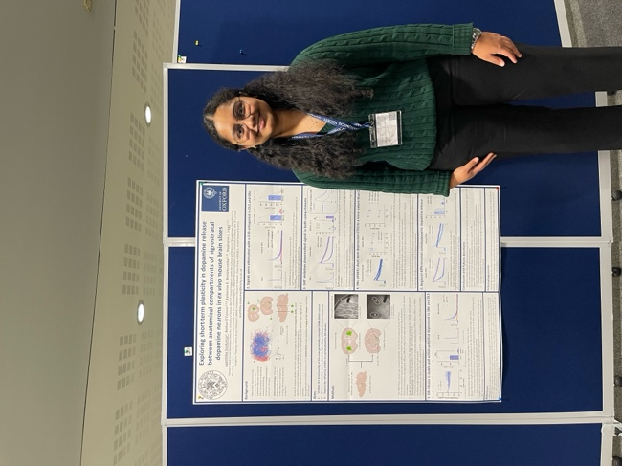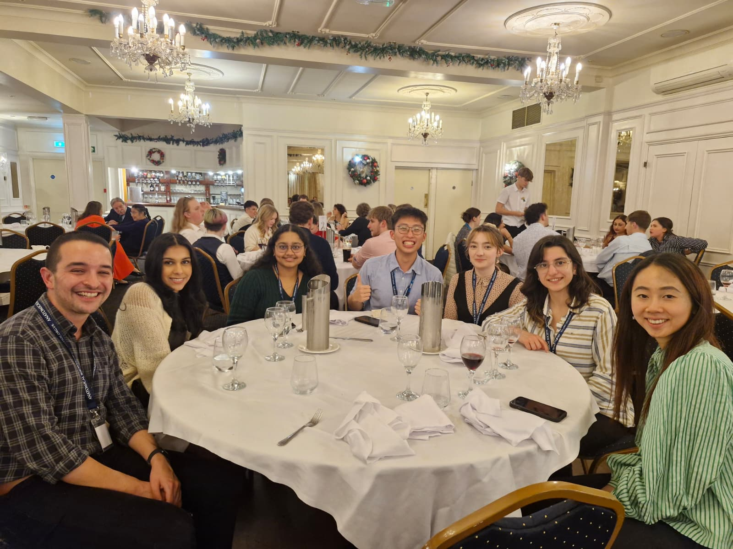
Consent was obtained from individuals in the photo to be used in this report.

REPORT: In relation to skills, what were the most important things you gained? (does not apply to equipment grant. For public engagement/outreach awards what did your audience gain and how did you evaluate success?
Minimum number of words between 200-400. Please write in coherent paragraphs.
One of the most important skills I developed at the conference was the ability to effectively introduce and pitch my research to a diverse audience. While presenting my poster, I engaged with individuals ranging from medical students to clinical anatomists and PhD researchers, many of whom worked in fields that differed substantially from the cellular neuroscience focus of my project. Learning to adapt my explanations to suit different levels of expertise and interests allowed me to communicate my work more clearly and confidently. This approach also enabled me to gain diverse perspectives and feedback that I would not have obtained had I presented my work in a fixed and static manner.

In addition to communication skills, the conference expanded my conceptual understanding of anatomy and biomedical research. I was exposed to new topics, including surgical perspectives on femoroacetabular impingement as a cause of arthritis in young individuals, as well as research exploring lysosomal dysfunction in Parkinson’s disease. Serendipitously, the latter aligns closely with a project I will be undertaking in the coming academic year, and I had the opportunity to speak with the presenter afterwards to pick her brains on some questions I had about the topic.

Having primarily studied in basic science and wet lab settings, I found it fascinating to learn about studies conducted on cadavers to identify anatomical variations, as well as projects employing robust qualitative methods to evaluate medical student perspectives on anatomy teaching. These experiences broadened my understanding of how different research approaches can be used to address complex scientific and educational questions.
REPORT: How do you think you will put this learning experience into practice in the future? For public engagement/outreach awards how with the materials/knowledge generated by this activity be used in the future?
Minimum number of words between 200-400. Please write in coherent paragraphs.
This being my first conference as a medical student, I have had numerous learning experiences that I hope to apply to my future research work. When presenting research in the future, I may consider preparing an “elevator pitch” style explanation of my project that can be easily adapted to different audiences. This will allow me to quickly and effectively communicate the core aims and significance of my work, while tailoring the level of detail to suit the listener’s background and interests. I believe I might also review conference programmes or booklets in advance to identify presentations and individuals that align with my research interests, as that might help me make effective use of networking opportunities and engage in targeted discussions that are likely to be mutually beneficial.

More broadly, I hope to apply the interdisciplinary perspectives gained at the conference to my academic development. Exposure to clinically oriented research, educational studies, and ethical discussions has encouraged me to think more holistically about the impact and context of my work. I will aim to remain mindful of ethical considerations, translational relevance, and audience engagement in both my research and communication activities.

Data Protection/GDPR: I consent to the data included in this submission being collected, processed and stored by the Anatomical Society. Answer YES or NO in the Box below
YES
Graphical Images: If you include graphical images you must obtain consent from people appearing in any photos and confirm that you have consent. A consent statement from you must accompany each report if relevant. A short narrative should accompany the image. Answer N/A not applicable, YES or NO in the box below
YES
Copyright: If you submit images you must either own the copyright to the image or have gained the explicit permission of the copyright holder for the image to be submitted as part of the report for upload to the Society’s website, Newsletter, social media and so forth. A copyright statement must accompany each report if relevant. Answer N/A not applicable, YES or NO in the box below
YES
SIGNATURE | Avanthika Sivakumar |  | DATE | 23/12/2025
If submitted electronically, a type-written name is acceptable in place of a hand-written signature
File: AS-Award-Report-Form-171023 – International Conference

