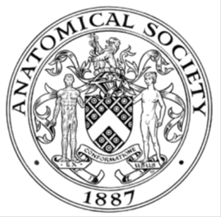
_______________________________________________________________________________________
AWARDEE REPORT FORM
_______________________________________________________________________________________

NAME |  | Mutahira Lone
TWITTER HANDLE* optional
UNIVERSITY |  | University College Cork
NAME OF AWARD |  | Symington Bequest Travel Fund
PURPOSE OF AWARD conference/event attended/organised (full name) with city and dates.
Participation in the 22nd Congress of the International Federation of Associations of Anatomists (IFAA) ‘Anatomy for Everyone’, Melbourne, Australia, 13th to 16th August 2026.

REPORT: What were your anticipated benefits?
Minimum number of words between 200-400. Please write in coherent paragraphs.
Attending the conference was an important opportunity for me to share my research and, importantly, to showcase the work of my PhD students to an international audience. I presented three posters based on my students’ research, which provided valuable opportunities to discuss their projects with anatomists and anatomy educators from different countries. I anticipated that receiving feedback from colleagues with diverse expertise would help both me and my students to further develop the research, while also supporting them in progressing their work towards publication and future dissemination.

I also had the opportunity to participate in a symposium and deliver an oral presentation on a collaborative project involving colleagues from different institutions. This was particularly beneficial as it allowed me to share our work with a wider international audience and to learn from researchers approaching similar research questions from different perspectives. It was particularly interesting and reassuring to see other anatomists exploring similar issues through a comparable lens, while also gaining new perspectives that could inform our own work. I anticipated that these discussions would help strengthen existing collaborations and potentially lead to new opportunities for collaborative research.

One of the most rewarding aspects of attending the conference was meeting anatomists and anatomy educators from around the world, including people whom I had previously met virtually through webinars and other online activities. Having the opportunity to finally meet these colleagues in person, exchange ideas, engage in conversations and debates, and discuss different approaches to anatomy education and research was extremely valuable. I particularly enjoyed learning about innovative practices being developed in different institutions and countries. These informal conversations, often over coffee between sessions, provided insights and ideas that would not necessarily emerge through formal presentations alone.
COMMENTS: Describe your experience at the conference / lab visit / course / seminar/ event.
Minimum number of words between 200-400. Please write in coherent paragraphs.
Attending the 22nd Congress of the International Federation of Associations of Anatomists (IFAA), with the theme ‘Anatomy for Everyone’, was an extremely valuable and enriching professional experience. As an anatomy educator and researcher, it provided an opportunity to engage with the wider international anatomy community, share experiences and reflect on the changing landscape of anatomy education and research. The scale and diversity of the congress were particularly valuable, as I was able to engage with anatomists and educators working in a wide range of areas and from different educational and cultural contexts.

A particularly rewarding part of the congress was being able to contribute to the scientific programme through my PhD students’ research posters and oral presentations. I presented three posters based on the work of my PhD students, participated in a symposium and delivered an oral presentation on a collaborative project involving colleagues from different institutions. Having the opportunity to discuss this work with an international audience generated valuable conversations, feedback and new perspectives. I particularly enjoyed seeing how anatomists from different countries approached similar educational and research questions, sometimes from very different perspectives, but often with common aims and challenges. The questions and discussions around the presentations also provided opportunities to explore ideas for further research and collaboration.

The plenary lectures, symposia and parallel sessions were equally stimulating and exposed me to innovative approaches across anatomy, education, technology, research and professional practice. I found it particularly valuable to move beyond my own areas of expertise and learn about work being undertaken in other parts of the anatomical sciences.

Perhaps one of the most memorable aspects of the congress was the opportunity to meet colleagues in person whom I had previously encountered through webinars and online meetings. The informal conversations over coffee, during breaks and at social events were often just as valuable as the formal programme, allowing ideas to be exchanged more openly and naturally. Overall, the congress provided an excellent combination of academic engagement, professional development, international networking and genuine collegiality within the global anatomy community.

REPORT: In relation to skills, what were the most important things you gained? (does not apply to equipment grant. For public engagement/outreach awards what did your audience gain and how did you evaluate success?
Minimum number of words between 200-400. Please write in coherent paragraphs.
One of the most important benefits of attending the congress was the opportunity to further develop my skills in academic communication and research dissemination. Presenting my work required me to communicate research findings clearly and effectively to an international audience with diverse areas of expertise. The experience encouraged me to think carefully about how complex research can be presented in a concise, accessible and engaging manner, while also responding appropriately to questions and discussion.

The conference also strengthened my networking and collaborative skills. Meeting anatomists and anatomy educators from different countries provided opportunities to exchange ideas about research, teaching and educational innovation. I particularly valued conversations with colleagues whose experiences and institutional contexts differed from my own, as these discussions challenged me to consider alternative approaches and perspectives. Several of these conversations have the potential to develop into exciting future professional and research collaborations.

Another important skill I gained was the ability to critically reflect on my own practice. Attending a wide range of presentations and symposia allowed me to observe how researchers communicate their work, structure arguments and engage audiences. It also encouraged me to reflect on approaches that could be incorporated into my own teaching, research supervision and presentations.

Importantly, the experience also enhanced my skills as a research supervisor. Presenting my students’ work internationally enabled me to consider their research from a broader perspective and to identify opportunities for further development and dissemination. Overall, the congress strengthened my communication, networking, critical reflection and research dissemination skills, while providing valuable international perspectives that I can bring back to my academic role.

REPORT: How do you think you will put this learning experience into practice in the future? For public engagement/outreach awards how with the materials/knowledge generated by this activity be used in the future?
Minimum number of words between 200-400. Please write in coherent paragraphs.
I intend to apply the learning and perspectives gained from the congress across my teaching, research and postgraduate supervision. One of the most immediate benefits has been the opportunity to reflect on different approaches to anatomy education through the plenary talks and symposia attended and how these might be adapted within my own teaching environment. The congress showcased a wide range of innovative approaches, including the use of technology, digital resources, creative pedagogies and collaborative approaches to learning. These ideas will inform my ongoing development of teaching activities and learning resources, particularly in relation to making anatomy education more engaging, inclusive and accessible to students with different learning needs.

The experience will also directly inform my research supervision. Through presenting three posters based on my PhD students’ work, I received feedback and suggestions from international colleagues that can help strengthen these projects and identify potential avenues for future dissemination and publication. I will continue to encourage my students to engage with the international anatomy education community and to develop their confidence in presenting and discussing their research.

The collaborative nature of the congress has also encouraged me to pursue further international research collaborations. The conversations and connections I developed during the meeting provide opportunities to share expertise and develop joint projects. I hope to build on these relationships and collaborate with international colleagues soon.

Finally, I will incorporate the experience into my own professional development by continuing to critically evaluate my teaching and research practices in light of what I have learned. The congress provided new ideas, challenges with teaching anatomy and broadened my understanding of developments within the anatomical sciences. I anticipate that these reflections will have a lasting impact on my teaching, research, supervision and wider contribution to the anatomy education community.

Data Protection/GDPR: I consent to the data included in this submission being collected, processed and stored by the Anatomical Society. Answer YES or NO in the Box below
Yes
Graphical Images: If you include graphical images you must obtain consent from people appearing in any photos and confirm that you have consent. A consent statement from you must accompany each report if relevant. A short narrative should accompany the image. Answer N/A not applicable, YES or NO in the box below
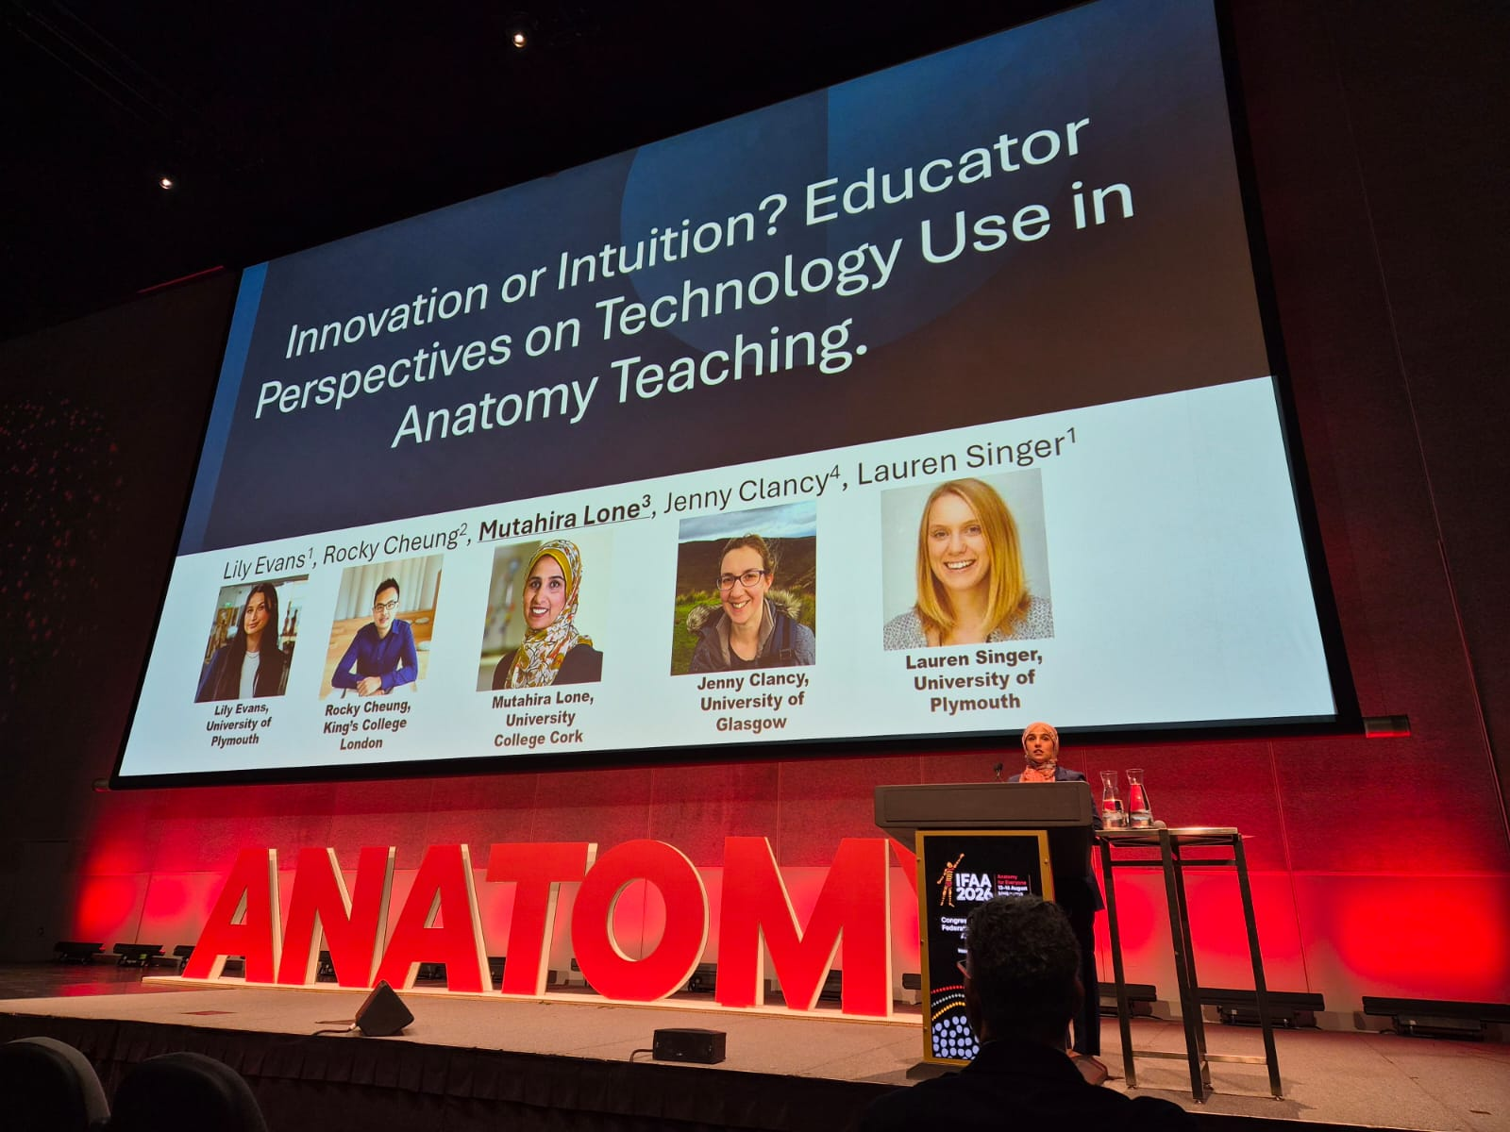

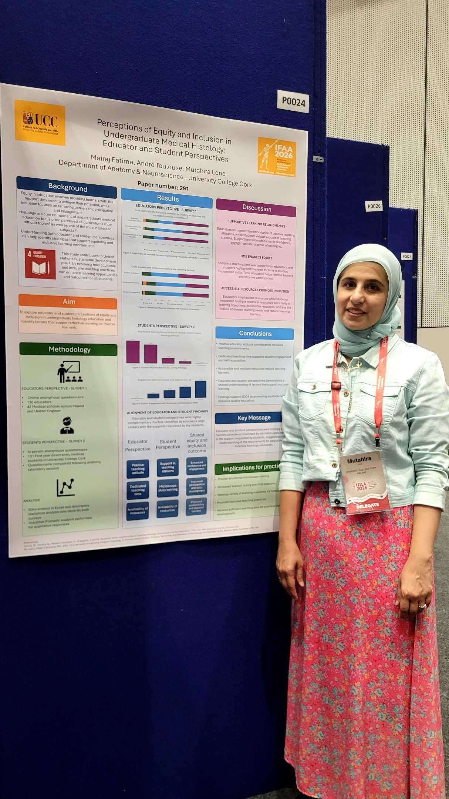

Copyright: If you submit images you must either own the copyright to the image or have gained the explicit permission of the copyright holder for the image to be submitted as part of the report for upload to the Society’s website, Newsletter, social media and so forth. A copyright statement must accompany each report if relevant. Answer N/A not applicable, YES or NO in the box below
N/A
SIGNATURE | M.Lone |  | DATE | 10.09.26
If submitted electronically, a type-written name is acceptable in place of a hand-written signature
File: AS-Award-Report-Form-171023 – International Conference

