The Veggie Brain
Anatomy is best learnt with a hands-on approach especially for organs as complex as the brain, so this resource was created with ease of accessibility and cost in mind. The veggie brain is easy to make and can help students identify the relative anatomical positions of some major structures in the brain. It can also be made anywhere with a few cheap items; the cauliflower, broccoli, some cocktail sticks and paper.
The cauliflower looks like a brain with its grooves mimicking the sulci and gyri in the brain. The broccoli floret with its many branches looks similar to the cerebellum and is stuck to the cauliflower with a cocktail stick. The rest of the cocktails sticks are made into flags with colour coded paper because this resource is accompanied by a mix and match association activity. Colour coded flags are used to identify parts of the brain marked with a specific colour and at the end of a lesson or personal study, students can match associated words, phrases and functions with the correct area of the brain.
How to make the Veggie Brain’
- Wash the cauliflower and chop in half from the top. It is better if the stalk is still on the cauliflower as this can help make a clear distinction between the pons and medulla
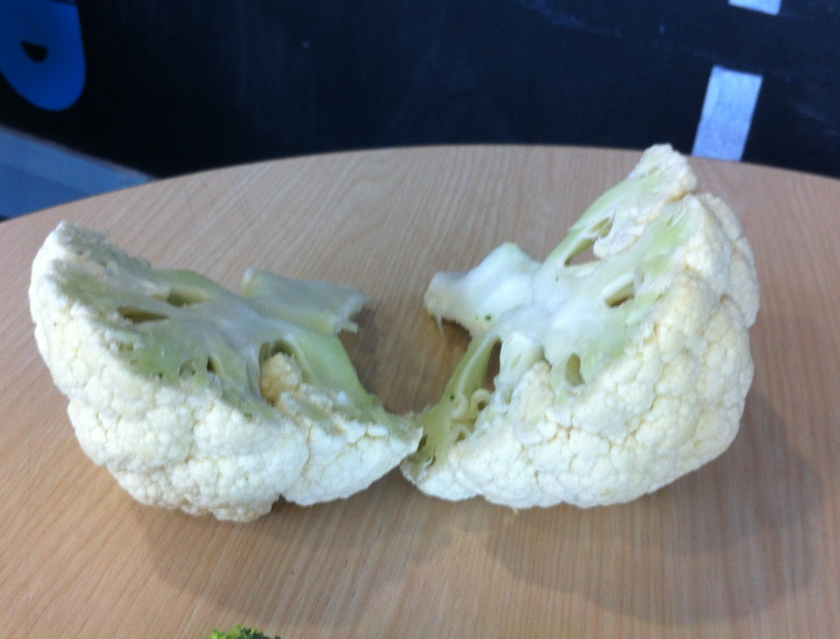

- Cut the broccoli floret in half and attach to the posterior end of the cauliflower by making a small groove and sticking it broccoli with a cocktail stick
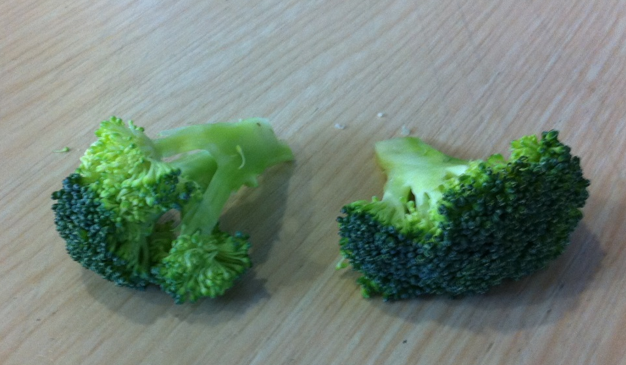
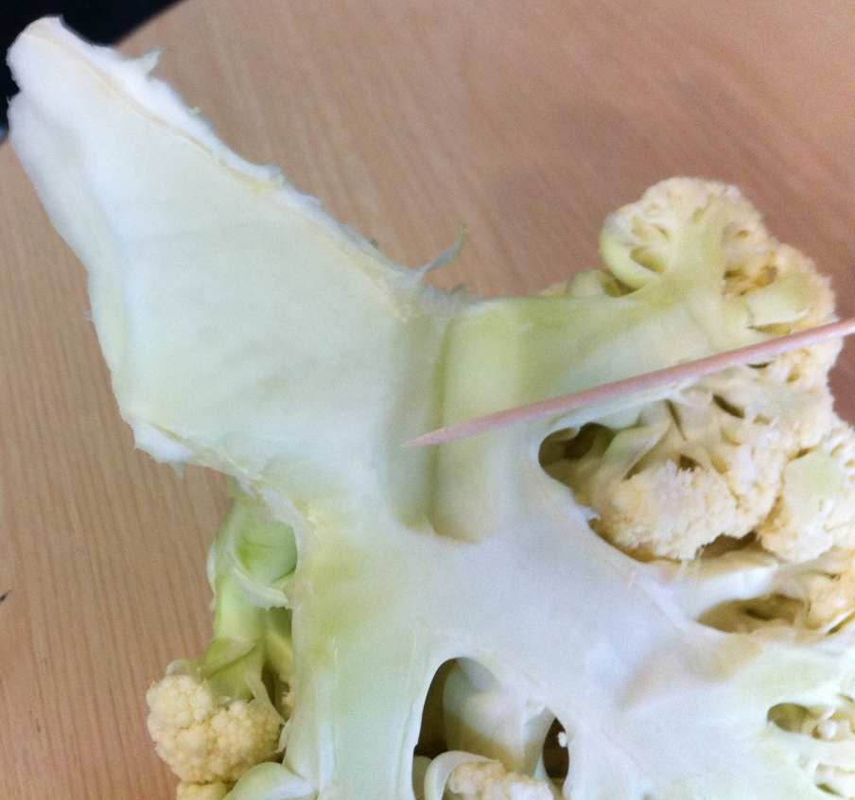
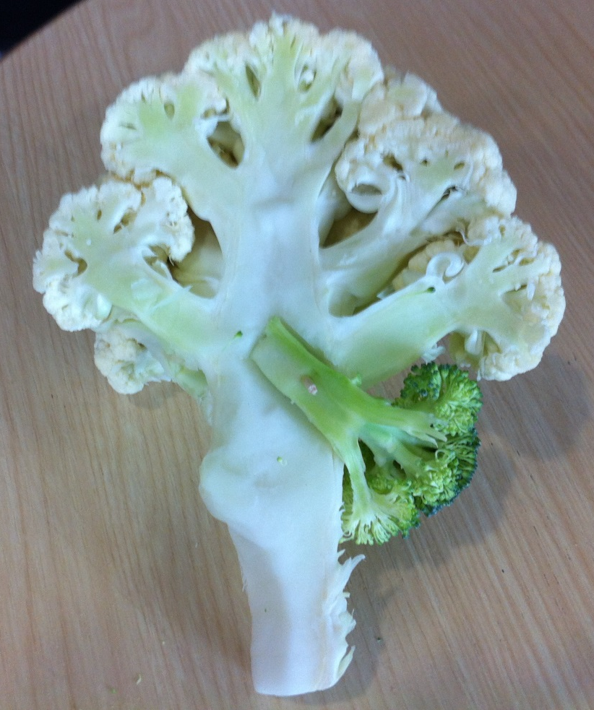
- Carve to desired shape.
Now cut out the flags tops, and using cocktail sticks, attach them together with glue. These can then be pinned to the different veggie brain areas- according to each colour coded title.
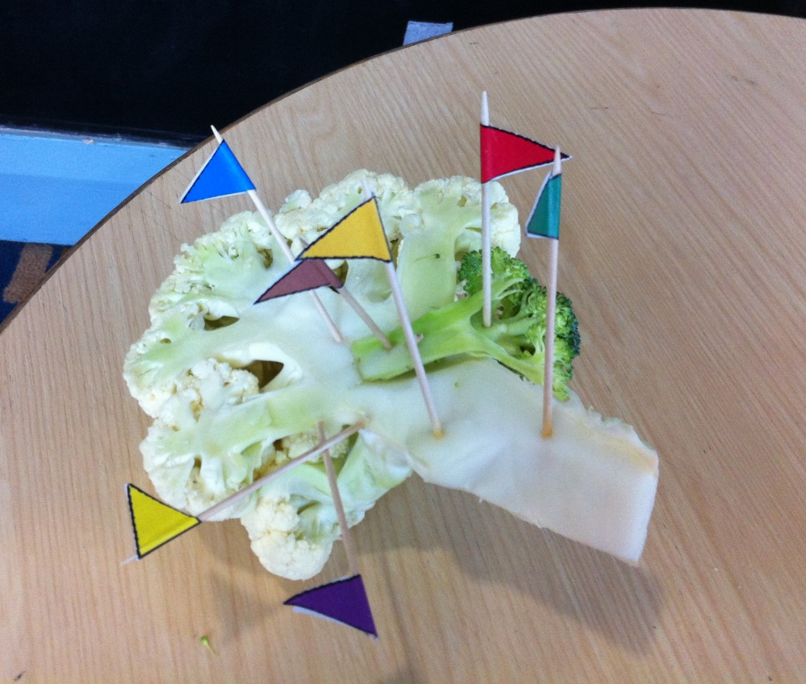
The different uses and functions of each brain area are listed beneath the colour coded titles. You may wish to cut these functions and titles out too, along with the pictures. Mix these up, and then set the titles out in order. Try and put the function with the correct title, and at the same time, pin the ‘flags’ to the correct brain area.
