
_______________________________________________________________________________________
AWARDEE REPORT FORM
_______________________________________________________________________________________

NAME |  | Dr Isma Liza Mohd Isa
TWITTER HANDLE* optional
UNIVERSITY |  | University of Galway, Ireland and National University of Malaysia
NAME OF AWARD |  | Symington Bequest
PURPOSE OF AWARD conference/event attended/organised (full name) with city and dates.
Participation in the 22nd Congress of the International Federation of Associations of Anatomists (IFAA), Melbourne, Australia, 13th to 16th August 2026 as a speaker and chair for the symposium entitled ‘Neuromusculoskeletal biology: Mechanistic insights, disease modelling to therapeutic advances’.

REPORT: What were your anticipated benefits?
Minimum number of words between 200-400. Please write in coherent paragraphs.
Attending the 22nd Congress of the International Federation of Associations of Anatomists (IFAA) provided an invaluable opportunity to disseminate my latest research findings and showcase collaborative work with my colleagues and postgraduate students to an international audience. I received constructive feedback from experts, which will help strengthen my ongoing and future research projects.

The congress enabled me to exchange ideas with leading experts in anatomy, tissue engineering, regenerative medicine, and neuroscience research, while gaining valuable insights into the latest advances in anatomical sciences, disease modelling, and translational biomedical research worldwide. In particular, I learned about emerging technologies such as organoid and organ-on-a-chip platforms, biomaterials, regenerative medicine, and innovative approaches to anatomy education.

The congress also provided me excellent networking opportunities to establish new relationships with international delegates, fostering future multidisciplinary collaborations, research partnerships, potential grant applications and external examiners. These interactions will strengthen existing collaborations while creating opportunities for future joint publications, international research initiatives and postgraduate external examination.

Furthermore, the congress allowed me to keep up to date with emerging educational approaches, cutting-edge anatomical research, and innovative teaching technologies from around the globe. The knowledge and collaborations gained from this meeting will support the development of innovative disease models and regenerative therapies for musculoskeletal disorders, enhance my teaching and postgraduate supervision, increase the international visibility of my research, and contribute to future high-impact scientific publications and competitive research funding applications.
COMMENTS: Describe your experience at the conference / lab visit / course / seminar/ event.
Minimum number of words between 200-400. Please write in coherent paragraphs.
The congress provided an excellent opportunity to engage with a diverse international community of anatomists, clinicians, biomedical scientists and educators from around the world. It created a valuable platform to strengthen existing collaborations while establishing new professional networks that may lead to future multidisciplinary research partnerships.

I had the opportunity to disseminate my latest research findings during a symposium talk and discuss my work with delegates, receiving constructive feedback and valuable suggestions from experts in the field. The scientific programme was of an exceptionally high standard, featuring inspiring keynote lectures and symposia on neuroscience and cell biology, anatomical sciences education, tissue engineering, and regenerative medicine. Given my research interests in neuroscience and cell biology, I found the sessions on brain-on-a-chip and organoid technologies particularly insightful. These presentations provided valuable perspectives on emerging research trends and their translational applications, inspiring new ideas that I plan to incorporate into my future research.

The poster sessions showcased high-quality research from both early-career and established investigators, stimulating meaningful scientific discussions and knowledge exchange. In addition, the industry exhibition highlighted the latest innovations in anatomical education and research technologies, including advanced silicone-based three-dimensional anatomical models and other teaching resources.

In conclusion, the congress significantly enhanced my scientific knowledge, expanded my international network, and generated new ideas that will strengthen my research, teaching, supervision, and future collaboration.

REPORT: In relation to skills, what were the most important things you gained? (does not apply to equipment grant. For public engagement/outreach awards what did your audience gain and how did you evaluate success?
Minimum number of words between 200-400. Please write in coherent paragraphs.
Through plenary lecture, keynote talks, symposia and scientific discussions, the congress significantly enhanced my knowledge of regenerative medicine, neuroscience and advanced disease modelling technologies.

In particular, I gained a deeper understanding of organoid and organ-on-a-chip platforms for modelling human diseases. These physiologically relevant models more accurately recapitulate tissue architecture, cellular interactions, than conventional in vitro models, offering valuable opportunities for mechanistic studies and therapeutic development.

I also gained valuable insights into recent advances in regenerative medicine, particularly the roles of the tissue microenvironment, autophagy, and cell fate determination in embryonic development and tissue regeneration. These emerging concepts reinforced the importance of understanding cellular interactions and developmental biology when designing regenerative therapies.

The knowledge gained is directly applicable to my current research on intervertebral disc degeneration and discogenic low back pain, where I am developing a human disc-on-a-chip platform to investigate patient-specific disease mechanisms and evaluate novel therapeutic strategies. In particular, I had a long discussion with an anatomist from Chile provided valuable insights of biomechanical principles, which could be incorporating into disease modelling.

Overall, the congress strengthened my scientific knowledge, provided new technical perspectives, and enhanced my ability to integrate cutting-edge technologies into both my research programme and postgraduate student supervision.

REPORT: How do you think you will put this learning experience into practice in the future? For public engagement/outreach awards how with the materials/knowledge generated by this activity be used in the future?
Minimum number of words between 200-400. Please write in coherent paragraphs.
The knowledge and experience gained from the conference will be directly applied to both my research and teaching activities. In particular, I will incorporate the latest advances in organoid and organ-on-a-chip technologies into my ongoing research on intervertebral disc degeneration and discogenic low back pain. These emerging micro-physiological models will support the development of more physiologically relevant disease models that better replicate human pathology, enabling improved investigation of disease mechanisms and the evaluation of novel therapeutic strategies. I also plan to incorporate biomechanical concepts discussed with international experts into the further development and validation of my disc-on-a-chip platform.

The insights gained into regenerative medicine, particularly studying the developmental of organ and the roles of the tissue microenvironment, autophagy, and cell fate determination, will help my future research direction and identify new therapeutic targets for musculoskeletal diseases.

In teaching, the latest advances in silicone-based three-dimensional anatomical models have inspired new approaches to anatomy education through interactive and hands-on learning. As I am actively involved in three-dimensional (3D) printing, I intend to apply these concepts to develop cost-effective, anatomically accurate 3D-printed teaching models for anatomical education.

I will share the knowledge gained with colleagues and postgraduate students through research meetings, seminars, and teaching sessions. I also intend to strengthen collaborations with international researchers and industry partners, leading to future joint research projects, collaborative grant applications, and scientific publications.

Data Protection/GDPR: I consent to the data included in this submission being collected, processed and stored by the Anatomical Society. Answer YES or NO in the Box below
Yes
Graphical Images: If you include graphical images you must obtain consent from people appearing in any photos and confirm that you have consent. A consent statement from you must accompany each report if relevant. A short narrative should accompany the image. Answer N/A not applicable, YES or NO in the box below
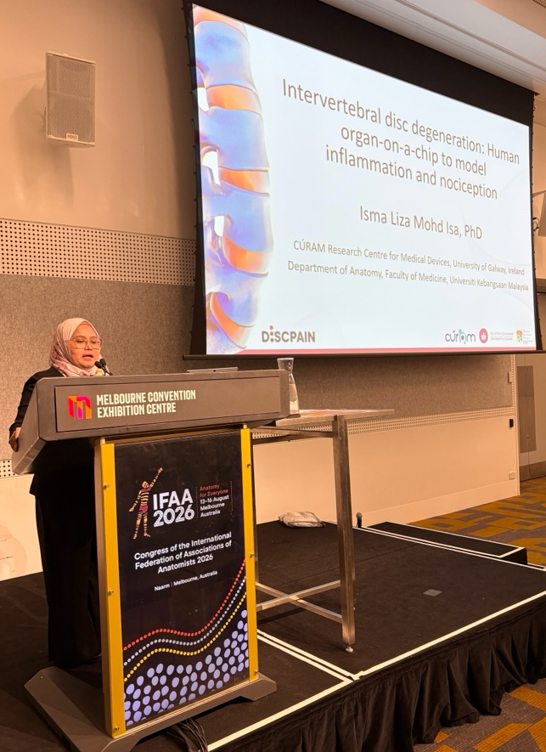
Yes
Isma presented her latest research at the symposium, focusing on the development of an organ-on-a-chip platform to model intervertebral disc degeneration.

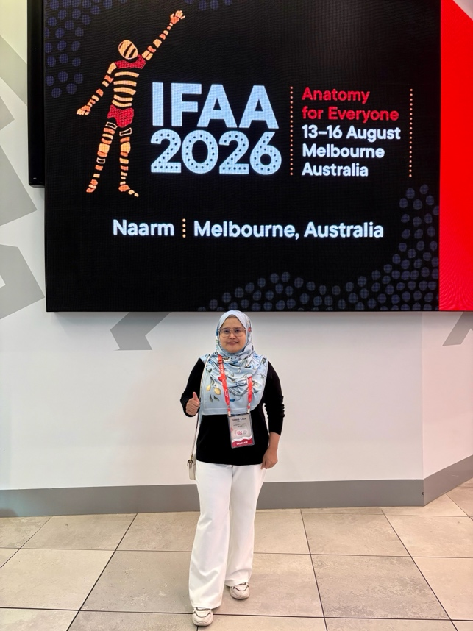
Isma at the 22nd Congress of the IFAA, Melbourne, Australia

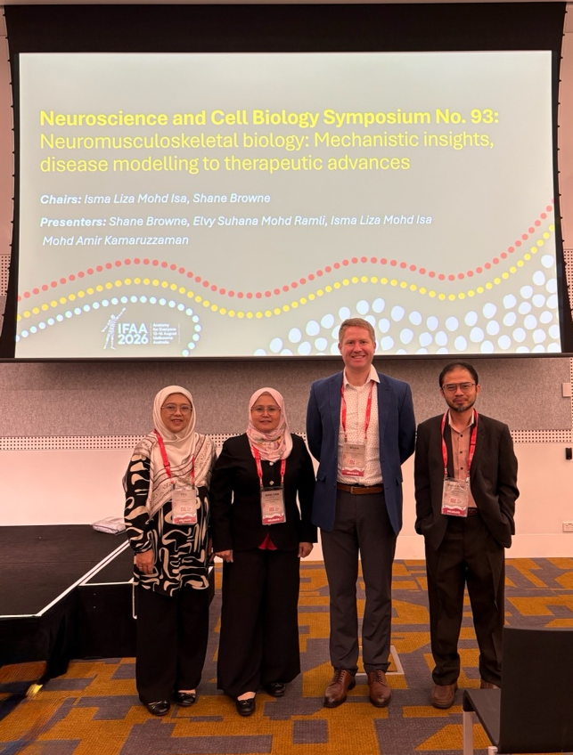
Symposium speakers (left to right): Elvy Suhana Mohd Ramli, Isma Liza Mohd Isa, Shane Browne, and Mohd Amir Kamaruzzaman at Symposium ‘Neuromusculoskeletal Biology: Mechanistic Insights’, Disease Modelling to Therapeutic Advances, 22nd Congress of the IFAA

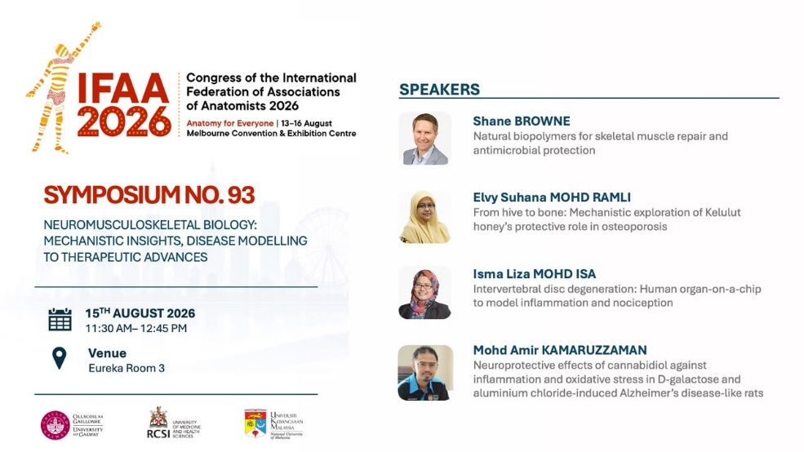

Speaker line-up for the symposium ‘Neuromusculoskeletal biology: Mechanistic insights, disease modelling to therapeutic advances’
Copyright: If you submit images you must either own the copyright to the image or have gained the explicit permission of the copyright holder for the image to be submitted as part of the report for upload to the Society’s website, Newsletter, social media and so forth. A copyright statement must accompany each report if relevant. Answer N/A not applicable, YES or NO in the box below
Yes
SIGNATURE |  |  | DATE | 21/08/2026
If submitted electronically, a type-written name is acceptable in place of a hand-written signature
File: AS-Award-Report-Form-171023 – International Conference

