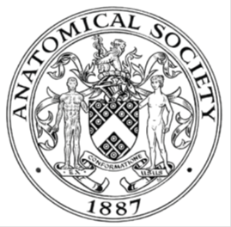
_______________________________________________________________________________________
AWARDEE REPORT FORM
_______________________________________________________________________________________

NAME |  | Claire Smith
TWITTER HANDLE* optional |  | AN040MY
UNIVERSITY |  | University of Sussex
NAME OF AWARD |  | Symington Bequest Fund
PURPOSE OF AWARD conference/event attended/organised (full name) with city and dates.
International Federation of Associations of Anatomy (5th-8th September 2024, Seoul).

REPORT: What were your anticipated benefits?
Minimum number of words between 200-400. Please write in coherent paragraphs.
Having attended IFAA before I knew that it was going to be a very busy conference with lots of new colleagues to meet, and established connections to catch up on. I was especially hoping to have many discussions around the use of anatomical material for different groups. I was hoping to explore the themes of consent and understand more about different global practices.

Having been invited to showcase ‘My Dead Body’ I was interested to hear individuals opinions and to discuss the impact of this work and the wider context of public display. Especially when in the media. The intersection of seeing donor material in person or via digital media is also of interest me, and I was keen to find out from conference presentations the latest updates on this area.

In additions to conference talks, I was looking forward to viewing the posters and in advance had especially identified those that focused on new teaching methodologies and digital innovations.

A number of BSMS colleagues, including PhD student had abstracts accepted and I was anticipating supporting them, but also engaging in wider discussion of the areas of their work. These included VR, ultrasound in teaching. The use of ‘Dodge’ embalming, and the organising of fresh frozen material.
COMMENTS: Describe your experience at the conference / lab visit / course / seminar/ event.
Minimum number of words between 200-400. Please write in coherent paragraphs.
The conference schedule was a packed on and I firstly presented in a symposium on public display of human tissue, and was in for some tough questions. The room was full, and the debate really covered a lot of concerns anatomists have, but mostly centred on protecting donors. For me the benefit of this is that there is open and collective discussion. An important opportunity to separate out fact, fiction, and opinion. With only a few examples globally of public display this area can be grouped together without the details being fully understood. Consent and profit, emerged as a key theme that separated out the different examples.

I the. presented the work the BSMS team had undertaken on My Dead Body, and the team hosted a showing of the documentary. Questions focused on the ethics of the activity and the consent in place. Particular comments were about the narrative of the donor and how usually this doesn’t occur. I learnt in other talks about a different approach to the connect of donors and families, with families invited into the DR to see donors.

I contributed to a symposium on innovation in curriculum design, and it reflected the work of many at BSMS in the spiral and patient centred approach. Continuous assessment was a feature of others curriculums, that is maybe an emerging trend in the UK.

I attended all sessions by BSMS colleagues and noted areas of discussion for future team meetings, or PhD supervisions. There was many times during the day when I didn’t see them, everyone was busy having new conversations, so it was nice to catch up at the end of the day. The discussions of the day, continued into the evening attending welcome events. This further facilitated meeting of the international community.
REPORT: In relation to skills, what were the most important things you gained? (does not apply to equipment grant. For public engagement/outreach awards what did your audience gain and how did you evaluate success?
Minimum number of words between 200-400. Please write in coherent paragraphs.
For me the most important aspect of this conference is in gaining a wider understanding of the sector in which we all operate. The mix of ideas from across the globe that bring in differences in law, local regulations, laboratory and teaching practices, and local cultures.

More specifically from this conference I gained a deeper understanding of the range of thoughts on the use of donor material for difference audiences. This involved a spectrum of ideas from the ‘anyone should be able to access any donor material’ to the ‘only future doctors, dentists should access donor material’. Of course there were a lot of opinions in the range. It was quite difficult at times to untangle perceptions and grouping together of all things. For example public display that has happened in a hotel in the USA, plastination events, My Dead Body documentary. The discussions were important to tease out where similarities are and where they are clear differences.

Discussions that are difficult, are always challenging in some way, and I continued to use my skills of listening, understanding, and articulating different sides of opinions. This is important though, we cannot always agree with each other. Progress rarely happens if we do, but the skills I continue to develop are finding ways through such complex issues in a professional way.

REPORT: How do you think you will put this learning experience into practice in the future? For public engagement/outreach awards how with the materials/knowledge generated by this activity be used in the future?
Minimum number of words between 200-400. Please write in coherent paragraphs.
For me this learning experience will be put into practice in my approach to my research in body donation. In the context of public display I will be continuing to raise questions and practice in this area, with a focus on transparency and establishing best practice. As the London and South East Committee of Anatomists agrees a way forward for a different process for consent for public display, the conference was very helpful in situating where UK practice is leading, and where there are ethical issues that need more time and attention. Recognising that not every anatomist, or anatomy department will have the same opinion.

In exploring the various talks and posters on new practice. It was very helpful to pick up on tips and ideas in relation to Virtual Reality use that I have taken back to BSMS. The how to ensure there is a learning gain is an important area for me. Not all advances in practice or technology actually enable this, and to some degree should be free to explore and sometimes not work out. Trial and error, was an important feature in the digital innovation areas. Sharing this is really important as collectively it helps us all.

The talks that focused on equality, diversity and inclusion I found to be of interest and these reflected the work we have put into the 6th Edition of Crash Course. This area is a journey and its always interesting to find out how others are approaching this and the presented work made me think of how I can help ensure teaching material better reflects the populations that medical and allied health care professions serve.

Data Protection/GDPR: I consent to the data included in this submission being collected, processed and stored by the Anatomical Society. Answer YES or NO in the Box below
Yes
Graphical Images: If you include graphical images you must obtain consent from people appearing in any photos and confirm that you have consent. A consent statement from you must accompany each report if relevant. A short narrative should accompany the image. Answer N/A not applicable, YES or NO in the box below
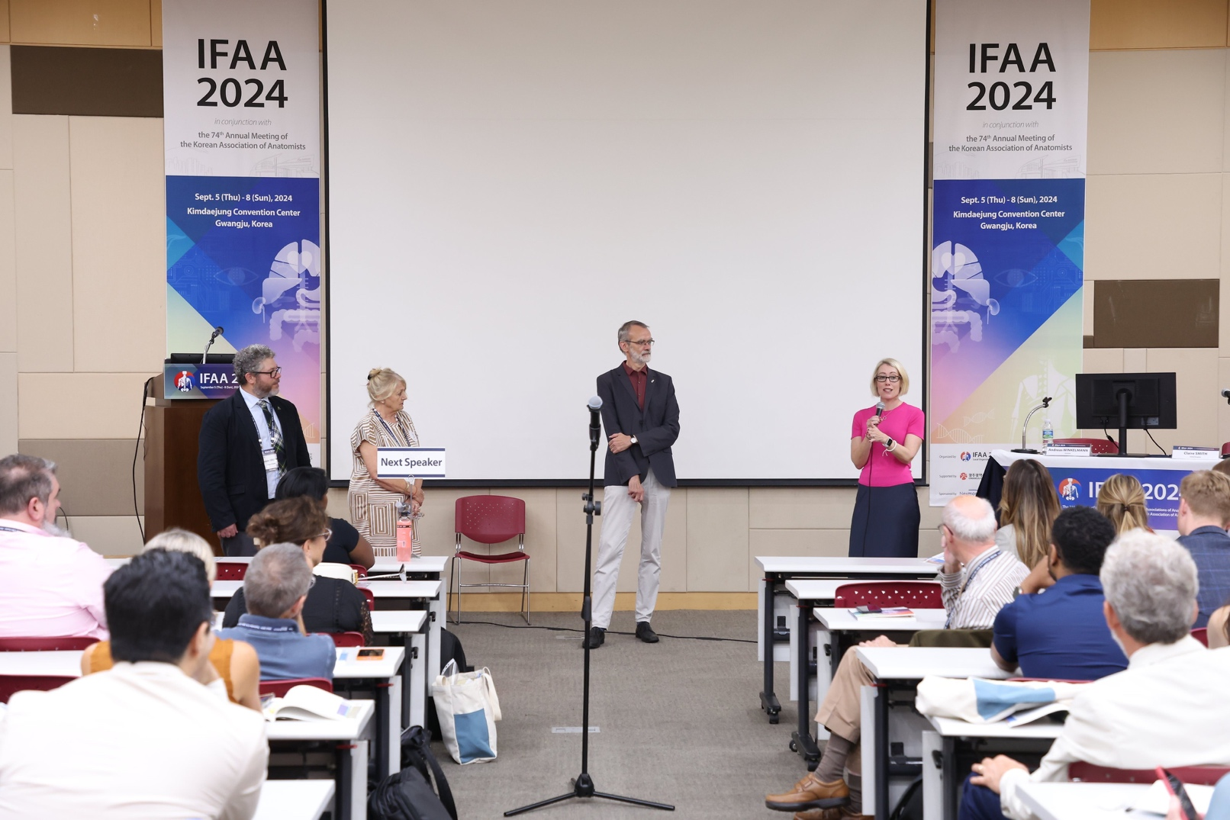

Question Time after the symposium, with presenters Prof B. Kramer, Prof J. Organ, Prof. A. Winkelmann and Prof C. Smith.

I am seeking consent from the named speakers in this pictures.

Copyright: If you submit images you must either own the copyright to the image or have gained the explicit permission of the copyright holder for the image to be submitted as part of the report for upload to the Society’s website, Newsletter, social media and so forth. A copyright statement must accompany each report if relevant. Answer N/A not applicable, YES or NO in the box below
Yes

SIGNATURE | c.f.smith |  | DATE | 21/10/24
If submitted electronically, a type-written name is acceptable in place of a hand-written signature
File: AS-Award-Report-Form-171023 – International Conference

