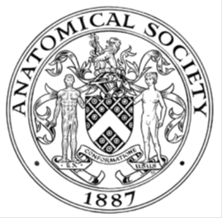
_______________________________________________________________________________________
AWARDEE REPORT FORM
_______________________________________________________________________________________

NAME |  | Cambridge University Surgical Society
TWITTER HANDLE* optional |  | Instagram: natanatomycompetition, camsurgsoc
UNIVERSITY |  | University of Cambridge
NAME OF AWARD |  | Support for Student Societies 2025/26
PURPOSE OF AWARD conference/event attended/organised (full name) with city and dates.
Anatomy textbooks as prizes for top ranking candidates in the National Anatomy Competition 2026, held at the Human Anatomy Centre, Downing Site, University of Cambridge (Saturday 22 March 2026).

REPORT: What were your anticipated benefits?
Minimum number of words between 200-400. Please write in coherent paragraphs.
The anticipated benefits of The National Anatomy Competition 2026 were to encourage interest in anatomical sciences, promote excellence in anatomical knowledge, and to bring together like-minded, ambitious students from across the United Kingdom. The goals of this competition were three-fold; academic, interpersonal and educational.

Students were challenged to apply their anatomical knowledge to a range of questions and relate underlying anatomy to a wide set of clinical scenarios. Many of these questions involved strong problem-solving elements, including interpretation of clinical images and a physical ‘steeplechase / spotter’ examination. This steeplechase examination gave students the opportunity to learn from real human tissue prosections, which was a unique opportunity for many students whose universities do not employ cadaver-based anatomical teaching methods.

Another benefit was to enhance anatomical education by encouraging deeper reading in anatomy, and the event included lectures from surgeons with special interests in anatomical education and research in the afternoon. These showcased links between core anatomy and surgical approaches and highlighted the ongoing importance of cadaveric anatomical research and the clinical implications of these studies.

In addition, the competition aimed to act as a platform for networking, bringing together students with an interest in anatomy from across the UK to encourage discussion and foster collaboration between like-minded students.

COMMENTS: Describe your experience at the conference / lab visit / course / seminar/ event.
Minimum number of words between 200-400. Please write in coherent paragraphs.
After promoting the competition across the country, the competition was completely sold out, with 60 students from 20 different universities signing up to attend!

The day began with registration and refreshments, and hearing the volume of chatter between students during the introductory refreshments gave me a sense of the excitement that students were feeling for this novel experience.

During the steeplechase and written papers, it was rewarding to see our participants engaging deeply with the questions we had created, and we could see the determination with which they approached the challenging set of questions designed to make them apply their core anatomical knowledge to different situations.

Lunch gave participants the opportunity to debrief and discuss answers, as well as to meet each other and form collaborations. Many of the demonstrators assessing the steeplechase paper, who were all clinical anatomists or retired surgeons, were kind enough to stay for lunch and made themselves available to enthusiastic students to talk to and learn from their experience and expertise.

Following lunch, we had two excellent talks by Mr Theophilus Asumu and Mr Chandra Pasapula, both orthopaedic surgeons with a special interest in anatomical education and research. The first talk was on the applied anatomy of the knee, showing how fundamental anatomy shapes surgical approaches, whilst the second talk was on cadaveric methods in anatomical research, and how this has helped uncover the true role and importance of the spring ligament!

REPORT: In relation to skills, what were the most important things you gained? (does not apply to equipment grant. For public engagement/outreach awards what did your audience gain and how did you evaluate success?
Minimum number of words between 200-400. Please write in coherent paragraphs.
Our audience gained the opportunity to apply their anatomical knowledge to a wide range of scenarios to compete for a national prize, meet other bright ambitious students from across the UK and learn about specialist areas of anatomical research.

Feedback was received in the form of a written feedback form filled out by all participants, as well as informal conversations during the day and at the end of the event. We are proud of our written feedback, in which 100% of students said that they would recommend the competition to other students and 98% said that they would attend again. We received consistently positive feedback on the written exam, steeplechase, lectures, and opportunities for networking.

Our feedback has demonstrated how this competition has encouraged a deeper interest in anatomical sciences. The ‘steeplechase examination’ was the most common answer that students gave as their ‘best part of the day’, showcasing how much they valued this method of assessing anatomy. We also received positive feedback on the diverse range of embryological topics included in our written paper, helping promote interest in human development by including specialist embryological topics that students may not have come across in the core medical school curriculum. Lastly, by linking underlying anatomy to common clinical presentations, this helped give students a platform for further learning and facilitating deeper understanding of these conditions.

Our audience also gained an insight into the anatomical basis of orthopaedic surgery, as well as into how cadaveric anatomical studies continue to shape the field of orthopaedics, and we received much positive feedback on both talks. Thanks again to Mr Theophilus Asumu and Mr Chandra Pasapula for preparing and delivering these insightful lectures!

We used strict MSCAA rules in our exam paper this year, and we feel that our wider spread of results compared to last year reflects that we have found an appropriate level of difficulty for the questions, allowing the best students to truly stand out. Some participants felt that our questions could match their medical school anatomy curriculum more closely, and whilst we aim to create a number of questions beyond the curriculum to encourage and reward extra reading, this is something that we hope to work on next year to make the competition questions as relevant as possible.

REPORT: How do you think you will put this learning experience into practice in the future? For public engagement/outreach awards how with the materials/knowledge generated by this activity be used in the future?
Minimum number of words between 200-400. Please write in coherent paragraphs.
In terms of our audience, we anticipate that this learning experience will encourage a deeper understanding and interest in anatomy, which will be put into practice by facilitating a deeper understanding of human development and how different clinical conditions arise. The lecture on the applied anatomy of the knee will help encourage interest in clinical anatomy in surgery, and the lecture on cadaveric research will help drive interest in anatomical research and highlight this as an exciting element to a career as a doctor that students may not have considered previously.

The positive feedback from this competition shows great potential for anatomy-focused outreach activities to different audiences. We anticipate this event will help encourage partnerships for similar initiatives, as well as inspiring anatomy competitions to be held at a more local scale in medical schools across the country.

Personally, lessons learned from this experience include writing a wide range and large number of exam questions using strict MSCAA guidelines. As a question-writing team, the process of writing questions has helped further our understanding of human anatomy, as well as about anatomical education and assessment. Having a paper of questions all in a uniform style, with many additional questions we chose not to include will help create a question bank for future editions of this competition.

Other lessons learnt from this experience include the process of growing our national presence. We advertised nationally through social media and by contacting medical schools and societies across the country. This is the first year that we completely sold out the event, with more universities represented than ever, demonstrating strong nationwide interest in this anatomy competition. We anticipate this event to be even more popular next year and are already exploring options to expand capacity to allow as many students as possible to participate! We will also continue to document logistics, structure, and feedback to improve future events.

Another long-term goal of this event is to create a syllabus and, potentially, a teaching element in the build-up to this competition, using a number of sample questions to illustrate anatomical concepts and encourage deeper thinking and problem solving in anatomy.

Data Protection/GDPR: I consent to the data included in this submission being collected, processed and stored by the Anatomical Society. Answer YES or NO in the Box below
YES
Graphical Images: If you include graphical images you must obtain consent from people appearing in any photos and confirm that you have consent. A consent statement from you must accompany each report if relevant. A short narrative should accompany the image. Answer N/A not applicable, YES or NO in the box below
Winners –
1st place: Vincent Huang, Imperial College London (right)
Joint 2nd place: Sid Nayak (centre), Amaan Akhtar (left), both University of Cambridge
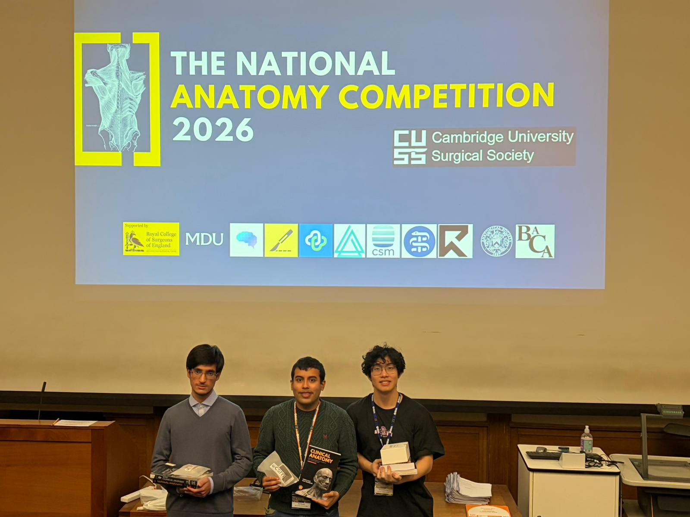
Copyright: If you submit images you must either own the copyright to the image or have gained the explicit permission of the copyright holder for the image to be submitted as part of the report for upload to the Society’s website, Newsletter, social media and so forth. A copyright statement must accompany each report if relevant. Answer N/A not applicable, YES or NO in the box below
YES
SIGNATURE | Luca De Flammineis |  | DATE | 28/04/2026
If submitted electronically, a type-written name is acceptable in place of a hand-written signature

