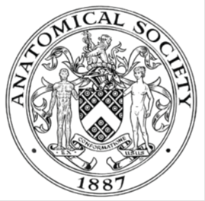
_______________________________________________________________________________________
AWARDEE REPORT FORM
_______________________________________________________________________________________

NAME |  | Mutahira Lone
TWITTER HANDLE* optional
UNIVERSITY |  | University College Cork
NAME OF AWARD |  | Public Engagement and Outreach Award 2024/25 Round 6
PURPOSE OF AWARD conference/event attended/organised (full name) with city and dates.
“Inside Anatomy: A Virtual Reality Journey” at Department of Anatomy and Neuroscience at UCC, Cork on 22nd October 2025.

REPORT: What were your anticipated benefits?
Minimum number of words between 200-400. Please write in coherent paragraphs.
The World Anatomy Day event at University College Cork (UCC) was designed as an inclusive outreach initiative aimed at sparking curiosity and appreciation for human anatomy among diverse audiences. The anticipated benefits of this event extended beyond simple anatomical learning; it sought to make anatomy accessible, engaging, and relevant to a wider community through hands-on experiences and technology-enhanced learning. By inviting primary and secondary school students, as well as postgraduate students from non-science backgrounds, we aimed to bridge the gap between science and the general public, demystifying the human body in an enjoyable and interactive way.

One of the main anticipated benefits was to inspire younger students to develop an early interest in the life sciences and consider potential future studies in anatomy, medicine, or related health disciplines. Exposure to real anatomical models and Virtual Reality (VR) technology offered an immersive experience that could enhance understanding and retention, while also showcasing how modern anatomy teaching integrates digital innovation. For non-science postgraduate participants, the event provided an opportunity to engage with scientific learning in an accessible and non-intimidating setting, fostering interdisciplinary curiosity and appreciation of the human body’s complexity.

Another anticipated benefit was the professional development of the MSc Human Anatomy students who led the outreach. Acting as demonstrators and facilitators, they were able to strengthen their communication, teamwork, and teaching skills, while gaining confidence in presenting complex anatomical information to audiences of varied ages and educational backgrounds. This leadership experience also supported their understanding of public engagement and the importance of making anatomy education inclusive and approachable.
Overall, the event aimed to cultivate a sense of wonder, learning, and collaboration across disciplines and age groups, aligning with the goals of the Anatomical Society’s outreach initiatives to promote anatomy education within and beyond academic settings.

COMMENTS: Describe your experience at the conference / lab visit / course / seminar/ event.
Minimum number of words between 200-400. Please write in coherent paragraphs.
Organizing and hosting the World Anatomy Day event at University College Cork (UCC) was an immensely rewarding experience for both the MSc Human Anatomy students and myself as the event coordinator. The outreach brought together a diverse audience, including primary and secondary school students as well as postgraduate students from non-scientific disciplines. Our goal was to make anatomy engaging and approachable through interactive learning, and the enthusiasm and curiosity displayed by visitors far exceeded our expectations.

The event featured a variety of interactive stations, including anatomical models, 3D specimens, and VR demonstrations that allowed participants to explore the human body in an immersive manner. These activities captivated the younger students, who were particularly fascinated by the VR experience, while the hands-on models provided an effective way to connect abstract anatomical concepts to tangible structures. For many of the non-science postgraduate students, this was their first opportunity to explore anatomy in such an interactive way, leading to lively discussions and a newfound appreciation for the subject.

Equally significant was the experience for our MSc Human Anatomy students, who led the outreach activities. They took ownership of their stations, explained complex anatomical ideas in accessible language, and adapted their teaching style according to the audience’s age and background. This experience enhanced their communication and leadership skills and gave them a sense of pride in representing anatomy to the wider community. Many expressed that the event strengthened their confidence in public engagement and inspired them to consider outreach as a valuable part of their professional identity.

Overall, the event was a celebration of learning, curiosity, and collaboration. It demonstrated how anatomy can be communicated beyond academic walls and how technology, enthusiasm, and teamwork can transform traditional teaching into an inclusive and inspiring experience.

REPORT: In relation to skills, what were the most important things you gained? (does not apply to equipment grant. For public engagement/outreach awards what did your audience gain and how did you evaluate success?
Minimum number of words between 200-400. Please write in coherent paragraphs.
The World Anatomy Day outreach event provided valuable skill development opportunities for both the MSc Human Anatomy students and the diverse audience who participated. The two key outcomes of this activity were the empowerment of the MSc students to lead and design their own outreach sessions, and the engagement of school and postgraduate participants through innovative, technology-enhanced anatomy teaching.
For the MSc Human Anatomy students, the experience was transformative in terms of leadership, creativity, and communication skills. I assigned each group of four students a specific anatomical topic and granted them full autonomy in planning and delivering their teaching sessions. While they had access to anatomical models, they were encouraged to incorporate their own ideas and approaches to make their presentations interactive and engaging. This flexibility nurtured their confidence, independence, and teamwork, while also allowing them to apply pedagogical principles in real-life settings. The students demonstrated impressive initiative by developing different teaching strategies, from model-based explanations to interactive question sessions, digital engagement and exercise led sessions.

The grant from the Anatomical Society was instrumental in enabling the purchase of three VR licences, which significantly enhanced the learning experience. One MSc group focused on integrating VR into their outreach, creating an immersive and accessible way for participants to explore the human body. They also implemented screencasting, allowing bystanders to observe the VR experience in real time, thereby extending engagement to a wider audience. This creative use of technology not only made anatomy more exciting but also helped demystify complex structures for younger learners and non-science participants.
Evaluation of the event’s success was based on participant feedback, observation, and student reflection.

The enthusiasm of the visitors, active participation in all sessions, and the MSc students’ reflective reports all highlighted the event’s impact in fostering curiosity, inclusion, and confidence. The activity thus succeeded in achieving its dual goal of meaningful public engagement and student skill development.

REPORT: How do you think you will put this learning experience into practice in the future? For public engagement/outreach awards how with the materials/knowledge generated by this activity be used in the future?
Minimum number of words between 200-400. Please write in coherent paragraphs.
The World Anatomy Day event at University College Cork (UCC) has laid a strong foundation for future public engagement activities that promote anatomy education in innovative and inclusive ways. Although smaller outreach events have been held in the past, this year’s initiative was unique in both scale and scope. With around 200 school students and their teachers participating, it was the largest anatomy outreach event ever organized by our department. The overwhelmingly positive feedback from participants and teachers has encouraged us to make this an annual event, potentially expanding it further to include more schools and diverse community groups.

The success of this initiative has demonstrated the value of empowering MSc Human Anatomy students to take ownership of teaching and outreach. Many of these students, including those from non-science backgrounds, gained their first experience of leading educational sessions through this event. Their creativity, confidence, and enthusiasm showed that when learners are trusted with autonomy and supported with appropriate resources, they can develop into capable and reflective educators. In future iterations, this student-led model will continue to be refined and embedded into the MSc curriculum as a form of experiential learning and professional development.

The materials and digital resources generated during this activity, including the use of VR and screencasting technology, will continue to be valuable teaching tools. The VR licences purchased through the Anatomical Society grant will be used in outreach and teaching sessions, allowing more students and community participants to benefit from immersive anatomy experiences. In addition, the event’s planning framework and feedback collected from attendees will serve as a guide for developing similar large-scale outreach initiatives.

Overall, this experience has strengthened our commitment to integrating creativity, inclusivity, and public engagement into anatomy education and has inspired ongoing collaboration between students, educators, and the wider community.

Data Protection/GDPR: I consent to the data included in this submission being collected, processed and stored by the Anatomical Society. Answer YES or NO in the Box below
Yes
Graphical Images: If you include graphical images you must obtain consent from people appearing in any photos and confirm that you have consent. A consent statement from you must accompany each report if relevant. A short narrative should accompany the image. Answer N/A not applicable, YES or NO in the box below
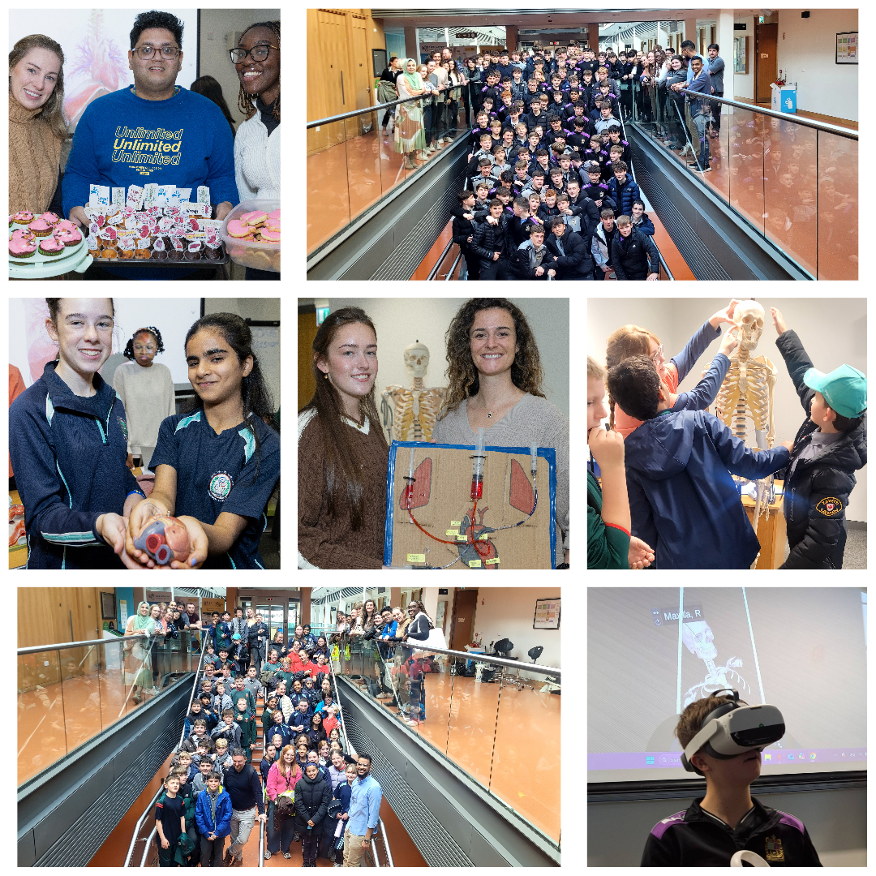

Top Left: MSc Human Anatomy students with cupcakes and anatomy pun toppers.
Top Right: MSc Human Anatomy students, staff of Department of Anatomy and Neuroscience UCC along with teachers and students from Presentation Brothers College.
Middle Row Right: Glasheen Girls students holding a model of the heart.
Middle row middle: MSc Human Anatomy students with their project of blood circulation.
Middle row left: St Joseph’s students learning with a skeleton.
Bottom Left: MSc Human Anatomy students, staff of Department of Anatomy and Neuroscience (UCC) along with teachers and students from Glasheen Girls and St Joseph Boys national schools.
Bottom right: VR used for showing anatomy to students from Presentation Brothers College. Screencasting in the background.

Yes, I have consent forms signed by the parents of the students in primary school. For the secondary school students, the parents signed a consent form for pictures to be taken at both school and out of school events. I also have consent from the MSc Human Anatomy students.
Copyright: If you submit images you must either own the copyright to the image or have gained the explicit permission of the copyright holder for the image to be submitted as part of the report for upload to the Society’s website, Newsletter, social media and so forth. A copyright statement must accompany each report if relevant. Answer N/A not applicable, YES or NO in the box below
Yes, I have copyright for the pictures.

SIGNATURE | M.Lone |  | DATE | 09.11.25
If submitted electronically, a type-written name is acceptable in place of a hand-written signature
File: AS-Award-Report-Form-171023 – International Conference

