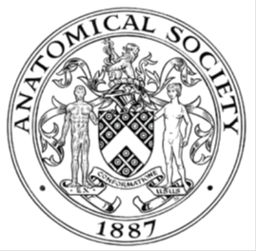
_______________________________________________________________________________________
AWARDEE REPORT FORM
_______________________________________________________________________________________

NAME |  | Alix Hudson
TWITTER HANDLE* optional
UNIVERSITY |  | University of Liverpool
NAME OF AWARD |  | Barclay-Smith Travelling Award 25/26 (Round 4)
PURPOSE OF AWARD conference/event attended/organised (full name) with city and dates.
To attend and present a poster presentation at the Anatomical Society Summer Meeting, University of Bristol, Bristol, 15th-17th July 2026.

REPORT: What were your anticipated benefits?
Minimum number of words between 200-400. Please write in coherent paragraphs.
One of the primary benefits of attending the Anatomical Society Summer meeting was the opportunity to present my recent work investigating the anatomy of the spring ligament and its variants. As a part-time PhD student in musculoskeletal biology investigating the anatomy and biomechanics of the midtarsal joint of the foot, the conference theme of ‘musculoskeletal anatomy” was well aligned with my current research topic and my research interests. My abstract explores a topic within my first chapter of my thesis and the opportunity to present some of my findings for discussion and dissemination was a valuable opportunity that allowed me to improve my skills in science communication and develop as a researcher.

Whilst having previously attended Anatomical Society conferences, this was the first time that I presented my own work. At previous conferences I have found discussions with researchers about their work to be highly stimulating and rewarding, and I was particularly excited to experience this when presenting my own work to help gain new insights and perspectives. Connecting with other anatomists within my specific research field was another perceived benefit of attending the conference, as it would allow me to engage in discussions regarding research and to develop new ideas that I could incorporate into my research practice.

COMMENTS: Describe your experience at the conference / lab visit / course / seminar/ event.
Minimum number of words between 200-400. Please write in coherent paragraphs.
The conference schedule for the three days was filled with talks that covered a range of topics within musculoskeletal sciences, and it was an amazing experience to hear about the range of research techniques within this field. Talks from Professor Charlotte Miller and Dr Zoe Davis were a particular highlight, as hearing about locomotion adaptations of quadrupedal animals was interesting, and it was a fun change from the bipedal locomotion that I study within my PhD.

I was given the opportunity to present a poster presentation about my research on the spring ligament, and prior to attending the event I was quite nervous, as this was the first time I had presented my work at a conference. Once the poster was pinned, the nerves quickly went away as everyone who engaged with me at my poster were kind, engaged and asked a variety of interesting questions. On many occasions these discussions would develop into conversations about the scope of my research and people would share their experiences in this area of anatomy and their own work. A memorable discussion I had was with a foot and ankle clinician who shared his experiences of surgical repair of the spring ligament, which lead to a highly interesting conversation about variations in structure, surgical approaches, and the impacts of aging on ligament structure and integrity.

Throughout the conference I took the time to visit other posters across the conference space, and it was amazing to see the range of topics covered, hear about people’s research experiences, and take away new ideas on how I can improve my own research and poster presentation skills. Attending the Anatomical Society Summer conference was a rewarding and enjoyable experience, and I am grateful for the Anatomical Society for allowing me the opportunity to attend and present my work.

REPORT: In relation to skills, what were the most important things you gained? (does not apply to equipment grant. For public engagement/outreach awards what did your audience gain and how did you evaluate success?
Minimum number of words between 200-400. Please write in coherent paragraphs.
Presenting my poster and communicating my research to others during the different poster sessions was a valuable experience that allowed me to develop a wide range of skills. Firstly, in the creation of my poster for which I had to summarise my key findings and present them in a visually engaging manner. When creating the poster, I had the opportunity to receive feedback from supervisors and colleagues to refine the poster which was particularly useful for learning how to summarise information as succinctly as possible to prevent the poster feeling overwhelmed with text.

My skills in communication were developed as I had to summarise my research into a clear and concise presentation that I could easily adapt to suit my audience. One of the most rewarding aspects of this experience was the discussions I could engage in with other attendees who were interested in my work. This allowed me to gain new perspectives on the research I was presenting and engage in discussion about the other aspects of my research and the next steps. Lastly, my ability to expand on points, respond to questions, and my confidence with presenting was developed. These are skills that I value highly and will be of great benefit as I continue to progress with my PhD and the eventual viva.

REPORT: How do you think you will put this learning experience into practice in the future? For public engagement/outreach awards how with the materials/knowledge generated by this activity be used in the future?
Minimum number of words between 200-400. Please write in coherent paragraphs.
This conference was a wonderful opportunity that has contributed to my professional development and there are several aspects of this experience that I will be bringing forward into my practice. Watching the oral presentations was a valuable experience as it allowed me to observe different presentation styles and see the ways in which presenters caught the attention of the room and drew them into their talk. This has given me several ideas that I can incorporate in my own research presentations, which is something I will take forward with me within my PhD and when attending (and hopefully presenting at!) future conferences.

I gained practical skills and knowledge in presenting a poster presentation which will allow me to strengthen my future work in this area. The discussions I had with attendees allowed me to further develop and strengthen my discussion of my data verbally, and it has given me guidance on how to approach writing up this work to highlight key points and how to strengthen my figures.

One of the main take aways from this experience is the importance of connecting with fellow anatomists and early career researchers, who made this a fantastic experience and have opened my eyes to new research techniques and interests that I can take forward with me in future research.

Data Protection/GDPR: I consent to the data included in this submission being collected, processed and stored by the Anatomical Society. Answer YES or NO in the Box below
YES
Graphical Images: If you include graphical images you must obtain consent from people appearing in any photos and confirm that you have consent. A consent statement from you must accompany each report if relevant. A short narrative should accompany the image. Answer N/A not applicable, YES or NO in the box below
YES.
Images contain my poster presentation in digital format and an image of myself with the poster. Please note that images containing cadaveric pictures have been redacted in line with departmental policies.
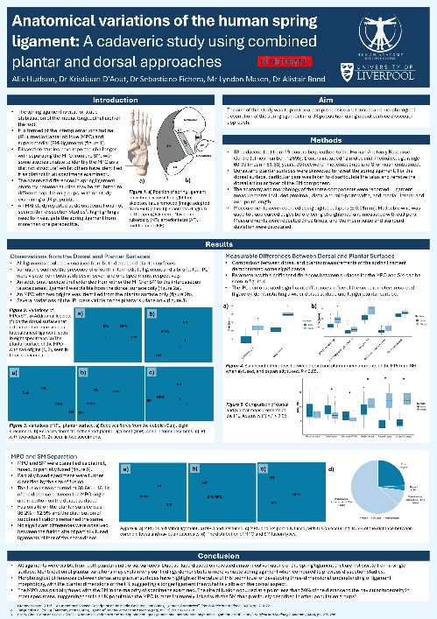
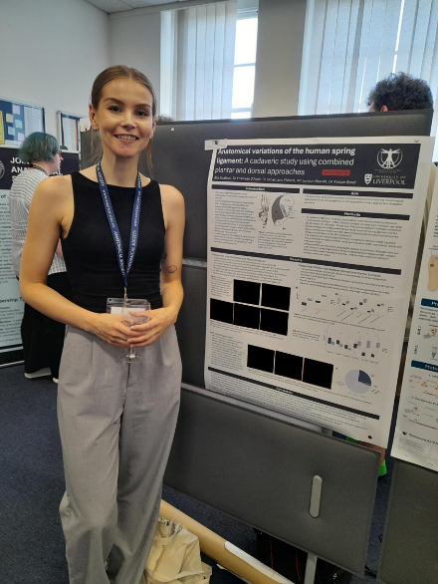

Copyright: If you submit images you must either own the copyright to the image or have gained the explicit permission of the copyright holder for the image to be submitted as part of the report for upload to the Society’s website, Newsletter, social media and so forth. A copyright statement must accompany each report if relevant. Answer N/A not applicable, YES or NO in the box below
YES

SIGNATURE | Alix Hudson |  | DATE | 22/07/2026
If submitted electronically, a type-written name is acceptable in place of a hand-written signature
File: AS-Award-Report-Form-171023 – International Conference

