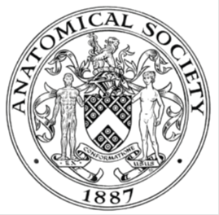
_______________________________________________________________________________________
AWARDEE REPORT FORM
_______________________________________________________________________________________

NAME |  | Cambridge University Surgical Society
TWITTER HANDLE* optional
UNIVERSITY |  | University of Cambridge
NAME OF AWARD |  | Support for Student Societies 2024/25
PURPOSE OF AWARD conference/event attended/organised (full name) with city and dates.
Book awards for top ranking candidates in our National Anatomy Competition 2025 at the Human Anatomy Centre, Downing Site, Cambridge (Saturday 22 March 2025).

REPORT: What were your anticipated benefits?
Minimum number of words between 200-400. Please write in coherent paragraphs.
The National Anatomy Competition held in Cambridge aimed to showcase and promote the importance of anatomical sciences while inspiring academic excellence and fostering collaboration among participants. The anticipated benefits spanned multiple dimensions—academic, interpersonal, and professional development.
The competition was expected to challenge participants to go beyond textbook learning and engage in innovative problem-solving, reinforcing their mastery of anatomical concepts. By incorporating interactive tasks and case-based challenges, the event sought to strengthen participants’ confidence and their understanding of anatomy’s critical role in healthcare. Another major goal was to expose attendees to developments in anatomical science and its applications in modern medicine through keynote talks.
On an interpersonal level, the competition provided an invaluable opportunity for networking and collaboration among students, educators, and professionals from across the country. Fostering connections through teamwork and shared learning experiences was a key objective, with the potential to form lasting academic partnerships and professional relationships.
Lastly, the competition aimed to create a national platform for recognising exceptional talent in anatomy, raising awareness about its importance among younger students and the general public. By engaging with the community and offering opportunities for aspiring anatomists, the event hoped to inspire future generations and highlight the rewarding possibilities within anatomical sciences.
With these anticipated benefits, the competition aspired to leave a lasting impact on participants and the broader community, establishing itself as a milestone event in the promotion of anatomy.

COMMENTS: Describe your experience at the conference / lab visit / course / seminar/ event.
Minimum number of words between 200-400. Please write in coherent paragraphs.
Organising and running the National Anatomy Competition in Cambridge was both an exhilarating and rewarding experience. The event was the culmination of months of meticulous planning, where every detail was carefully considered to create a stimulating and memorable day for all participants.
The day began with a palpable sense of excitement as students and educators from across the country arrived, eager to showcase their anatomical knowledge and skills. As the organiser, I took great pride in welcoming everyone and seeing the diverse mix of attendees—each bringing their own passion and perspective to the competition. The initial registration and introductions set a collaborative and positive tone for the day ahead. I also had the pleasure to welcome the volunteers for the day, many of whom were senior demonstrators for which I needed to explain how they were going to mark our pointer questions.
Throughout the event, I had the privilege of overseeing a range of activities, from the first steeplechase paper and the following single-best-answer paper. It was incredibly fulfilling to witness the enthusiasm and dedication of the participants as they tackled each paper with determination and engagement.
One of the most memorable aspects of the event was hearing keynote talks, which set the tone for an engaging and enriching experience. The first talk focused on anatomy in emergency medicine by emergency medicine doctor Dr Mike Scott, highlighting the critical role anatomical knowledge plays in life and limb-saving interventions. The second addressed anatomy in head and neck surgery by consultant head and neck surgeon Miss Ekpemi Irune, offering insights into its complexities and the importance of the multidisciplinary team in making these complex cases possible.
As the event drew to a close, I felt a deep sense of accomplishment. The day had successfully brought together people passionate about anatomy, fostered learning and connection, and demonstrated the power of a shared academic pursuit. I look forward to seeing how this event inspires future endeavors and contributes to the continued promotion of anatomical sciences.

REPORT: In relation to skills, what were the most important things you gained? (does not apply to equipment grant. For public engagement/outreach awards what did your audience gain and how did you evaluate success?
Minimum number of words between 200-400. Please write in coherent paragraphs.
The National Anatomy Competition provided an invaluable opportunity for public engagement and outreach, fostering curiosity and appreciation for anatomical sciences among a broad audience. By doing a competition, candidates got first-hand experience participating in a National Competition with national prizes (crucial for core surgical training portfolio points) at stake.
Additionally, attendees gained insights into the practical and essential applications of anatomy, especially in emergency medicine and head and neck surgery. The keynote talks highlighted the relevance of anatomy in critical medical scenarios, which resonated not only with students pursuing healthcare careers but also with non-specialists interested in the intersection of science and medicine. These presentations aimed to bridge the gap between academic knowledge and its real-world implications, making the content accessible and engaging for individuals of varying backgrounds.
Participants also gained a sense of community and shared purpose, as the event celebrated academic achievement and the importance of teamwork. This environment encouraged networking and collaboration, enabling attendees to connect with peers, educators, and professionals. For younger students, the event served as an inspirational platform, sparking interest in anatomy and its applications in healthcare and beyond.
Success was evaluated through multiple channels, including post-event surveys, informal feedback conversations, and direct observation of participant engagement throughout the day. The overwhelmingly positive feedback highlighted the event’s impact, with many attendees appreciating the clarity of the talks, the relevance of the topics, and the overall experience of the day. Additionally, the level of audience participation during the discussions and Q&A sessions demonstrated the event’s success in fostering curiosity and dialogue.
These measures underscored the effectiveness of the competition in achieving its outreach objectives.

REPORT: How do you think you will put this learning experience into practice in the future? For public engagement/outreach awards how with the materials/knowledge generated by this activity be used in the future?
Minimum number of words between 200-400. Please write in coherent paragraphs.
The materials and knowledge generated during the National Anatomy Competition will serve as valuable resources for future initiatives aimed at promoting anatomical sciences and inspiring academic excellence. The steeplechase and single-best-answer paper themselves provided foundations on which to improve the challenge experiences for participants. As no candidates scored over 50%, discussions were made to write questions that involve more critical thinking in future years to help distinguish the outstanding from the good candidates. Many questions this year appeared simply too difficult to solve by intuition/critical thinking.
The two keynote talks, focusing on anatomy in emergency medicine and head and neck surgery, were designed to be informative and accessible. Their content can be adapted into educational materials, such as lecture outlines, visual aids, or summaries, for use in workshops, seminars, or future competitions.
Furthermore, the discussions and questions raised during the event provided insights into the areas of anatomy that generate the most interest and curiosity among participants. This feedback will inform the development of future events, ensuring that they remain relevant and engaging. It also highlights potential topics for further outreach, such as interactive talks or public demonstrations addressing these areas.
The event has also laid the groundwork for creating a template or framework for organizing similar competitions in the future. Lessons learned from this experience—logistics, structure, and participant engagement—will be documented and shared with colleagues and collaborators to improve future iterations of the event.
Lastly, the success of the event helps demonstrate the potential for anatomy-focused outreach activities to captivate and educate diverse audiences. This can encourage partnerships with schools, universities, and professional organizations to expand the reach and impact of similar initiatives.

Data Protection/GDPR: I consent to the data included in this submission being collected, processed and stored by the Anatomical Society. Answer YES or NO in the Box below
YES
Graphical Images: If you include graphical images you must obtain consent from people appearing in any photos and confirm that you have consent. A consent statement from you must accompany each report if relevant. A short narrative should accompany the image. Answer N/A not applicable, YES or NO in the box below
YES

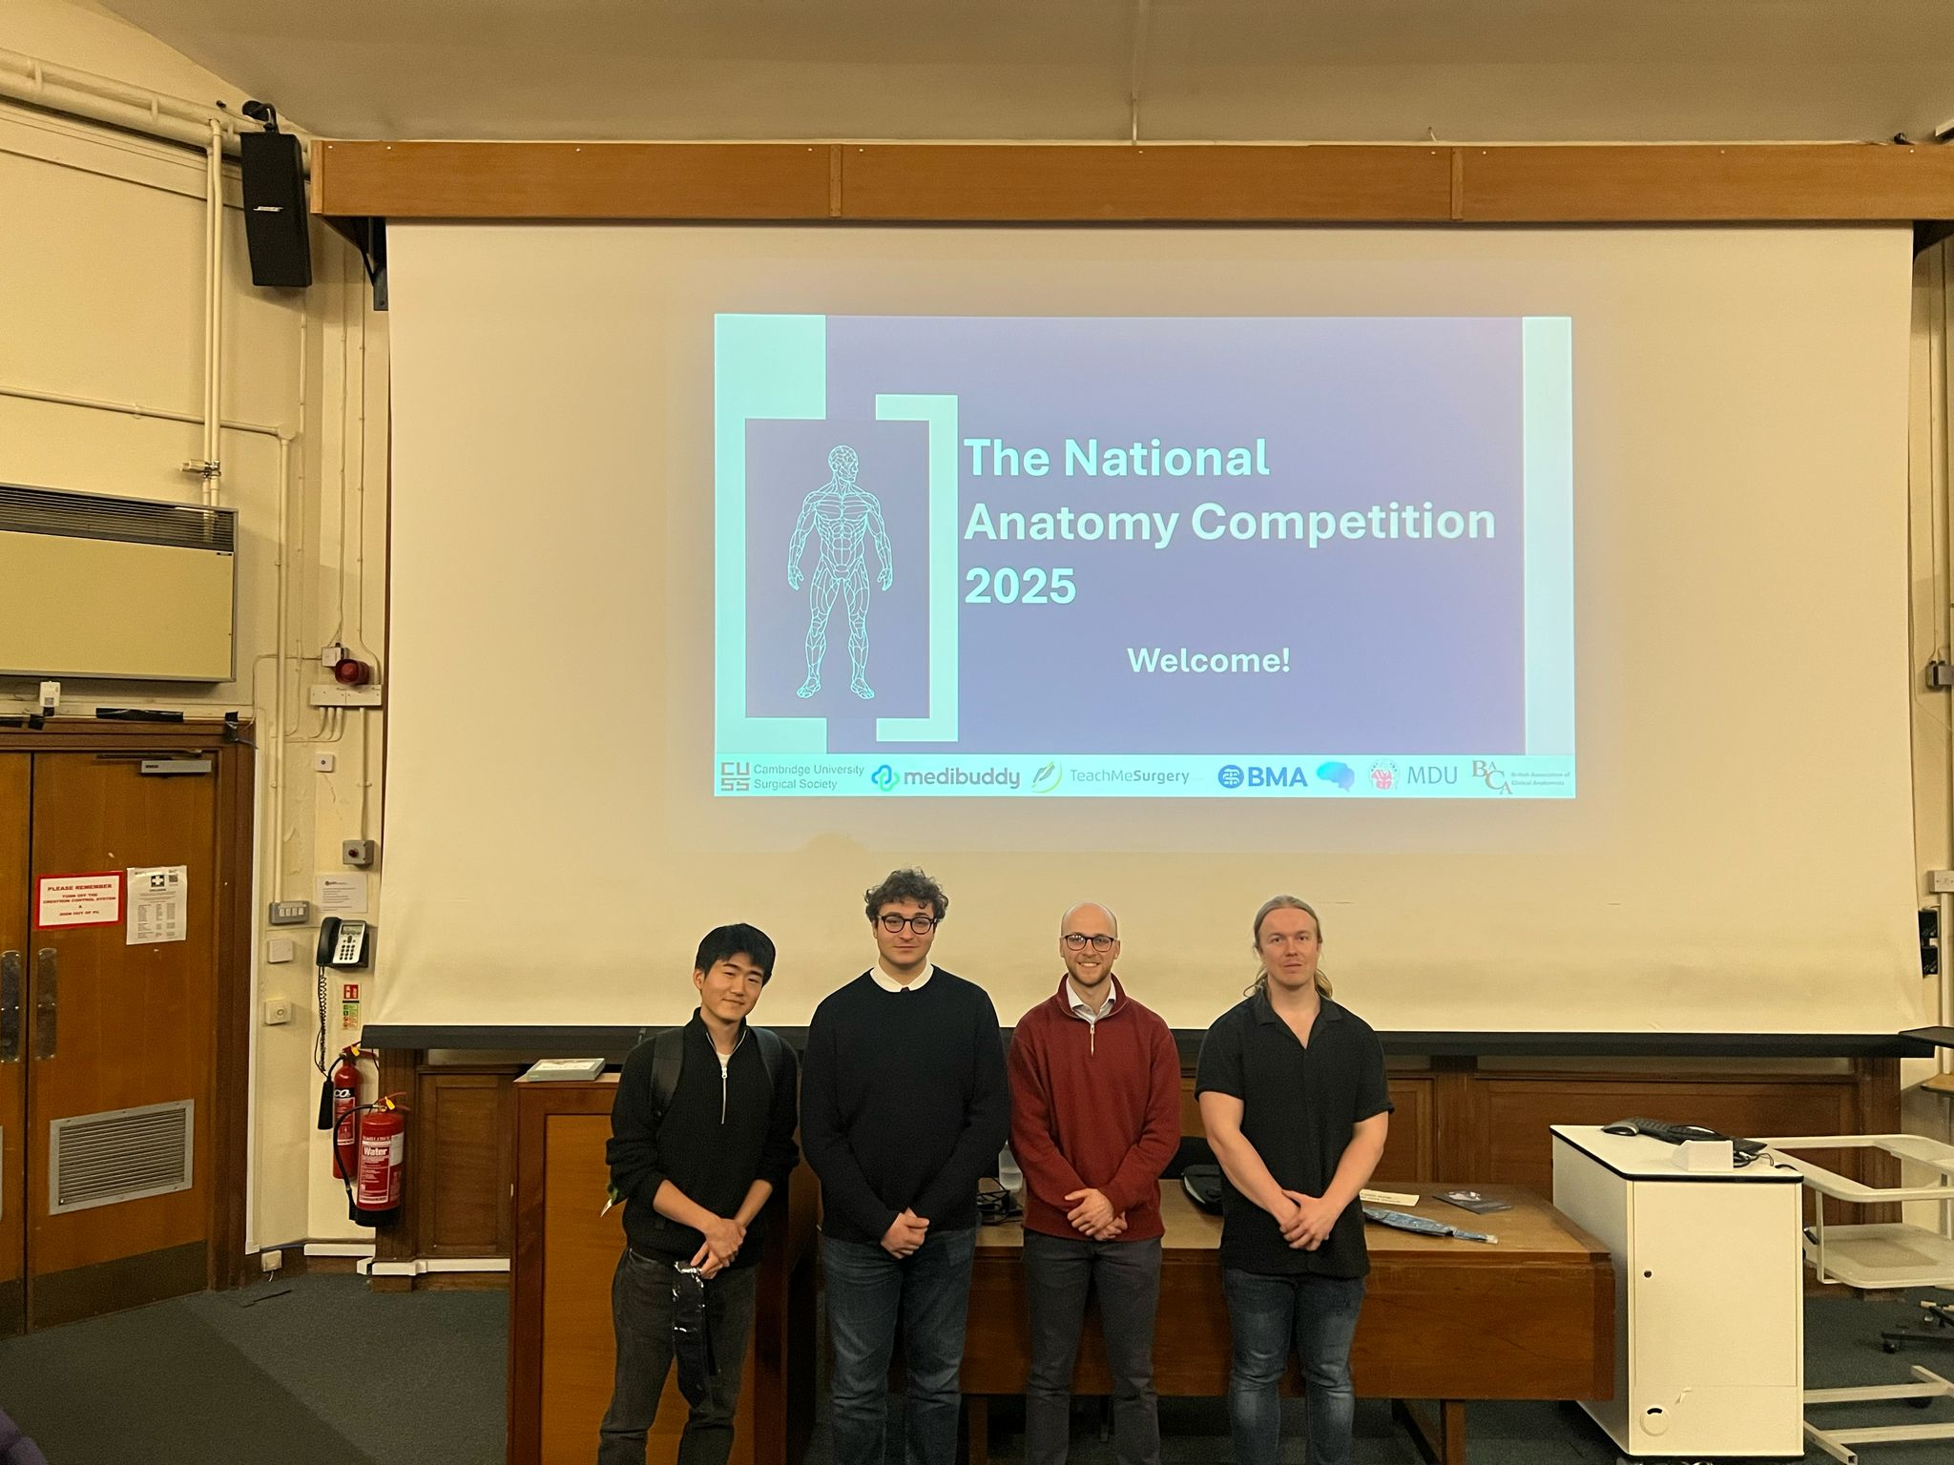

National Anatomy Competition 2025 winners!
(From left to right – Hyung-Jun Kwon, Samuel Craig, Luca De Flemmineis, Scott McKee)

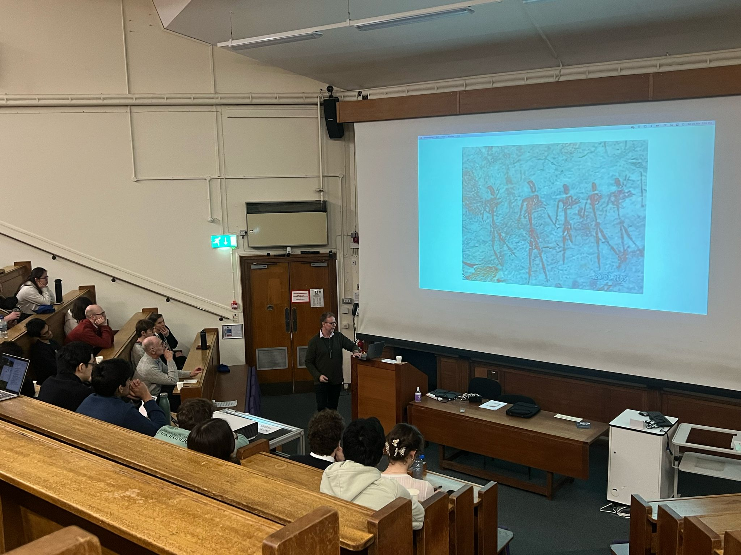

Dr Mike Scott, our first keynote speaker and visitor from New Zealand, giving us background into medical practice in New Zealand.
Copyright: If you submit images you must either own the copyright to the image or have gained the explicit permission of the copyright holder for the image to be submitted as part of the report for upload to the Society’s website, Newsletter, social media and so forth. A copyright statement must accompany each report if relevant. Answer N/A not applicable, YES or NO in the box below
YES
SIGNATURE | Ken Li |  | DATE | 25/3/25
If submitted electronically, a type-written name is acceptable in place of a hand-written signature
File: AS-Award-Report-Form-171023 – International Conference

