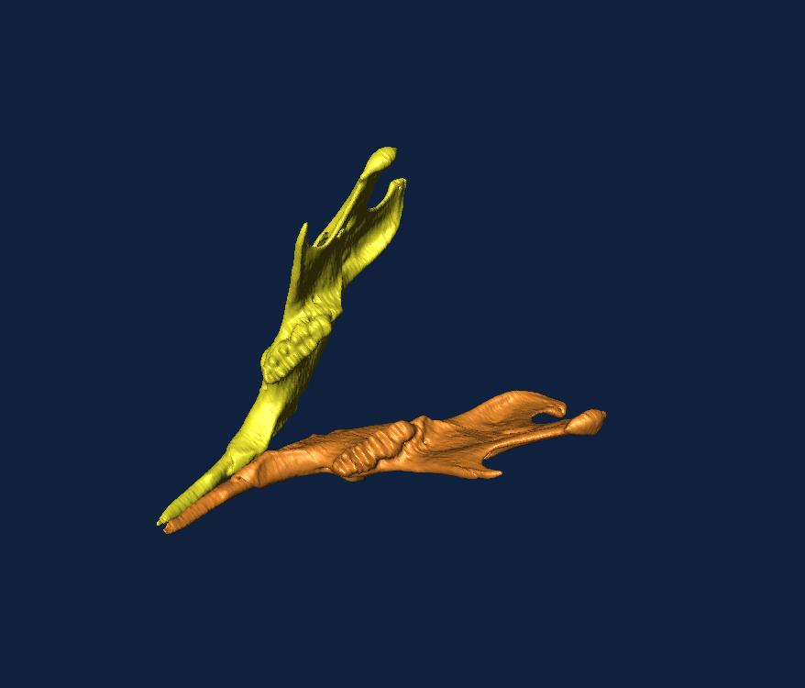
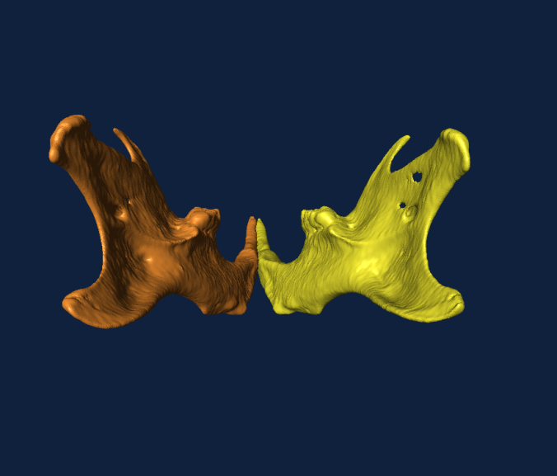
The Symington Bequest – Report

Integration and Modularity with Geometric Morphometrics; Museum of the Institut Catal de Paleontologia Miquel Crusafont, Sabadell; April 10-13, 2012
Transmitting Science is a company that aims to transfer scientific knowledge at different levels through lectures, conferences and courses; utilising instructors who are experts in their field. This course entitled: Integration and Modularity with Geometric Morphometrics was taught by Dr. Chris Klingenberg, senior lecturer at the University of Manchester. With 11 attendees the course provided approximately 40 hours of lectures, discussions, practical examples, group work and finally presentations of work carried out and developed throughout the four day course.
The course aimed to provide an overview of morphometric approaches to the investigation of morphological integration and modularity. These concepts of modularity and integration were discussed and explored in different contexts such as development, individual variation and evolutionary change. Theoretical foundations were presented in lectures, followed by relevant ‘hands-on’ demonstrations of analytical techniques and software. Additionally participants of the course had brought with them their own morphological data and time was allocated each day for small groups to discuss and apply theory and techniques learnt during the course to their data. Finally work carried out throughout the course was presented to and discussed within the entire group.
I am currently undertaking a PhD at the Centre for Anatomical and Human Sciences at the Hull York Medical School, my research project aiming to investigate assess morphological integration, modularity, functional plasticity and relative optimisation in the craniofacial skeleton. The aim is to be achieved through the exploration of long and short faced morphologies in mice, with a sample consisting of three strains of mice; two mutants and one ‘wild-type.’ Key methodologies used in this research include Geometric Morphometric techniques, particularly Principal Component Analysis and Partial Least Squared Analysis. Consequently this course was highly relevant and beneficial to my education and PhD research. Throughout my time participating in this course I developed many analytical skills as well as enhanced understanding of the topics covered that will prove invaluable throughout my future research. Additionally results and discussion of analyses carried out during the course on my own data sets were thought provoking, leading me to reassess some of my previous approaches to my project and facilitating further development of analyses I had previously carried out.
Overall this was a highly valuable and rewarding course that provided not only a fantastic development of my understanding but also provided great inspiration and a background on which to progress my PhD research project.
I would like to take this opportunity to thank the Anatomical Society for providing funds that allowed my attendance at this extremely useful and enjoyable course.
Hester Baverstock
(Postgraduate student, Centre for Anatomical and Human Sciences, Hull York Medical School)

