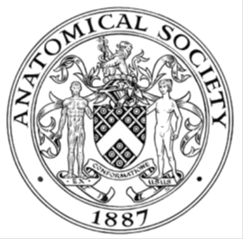
_______________________________________________________________________________________
AWARDEE REPORT FORM
_______________________________________________________________________________________

NAME |  | Maricci Basa
TWITTER HANDLE* optional
UNIVERSITY |  | King’s College London
NAME OF AWARD |  | Barclay-Smith Travel Fund
PURPOSE OF AWARD conference/event attended/organised (full name) with city and dates.
2026 Anatomical Society Summer Meeting in Bristol, England from Wednesday 15th July to Friday 17th July

REPORT: What were your anticipated benefits?
Minimum number of words between 200-400. Please write in coherent paragraphs.
As a final‑year PhD student whose research focuses on the development and evolution of mandibular structures in snakes, I anticipated that attending the conference would offer a valuable platform to present one of my thesis data chapters. I saw this as an opportunity to share my findings with an audience of morphologists and developmental biologists, whose expertise and perspectives could help refine my interpretations and strengthen the overall impact of my work. I was particularly keen to receive constructive feedback from researchers who approach similar questions from different methodological or conceptual angles, as this kind of interdisciplinary dialogue often reveal nuances that can be overlooked when working in isolation.

Beyond presenting, I expected that observing how other researchers communicated their work would help me distill the key messages of my own research and improve the clarity and accessibility of my presentation. Engaging with talks across a range of anatomical topics encouraged me to think more broadly about how my findings fit into larger conversations in evolutionary morphology and developmental biology. The informal discussions I had with peers throughout the meeting were equally thought‑provoking, offering fresh insights that are already proving beneficial as I prepare my thesis submission, defence, and future publications.

I also hoped to expand my academic network, particularly with developmental and evolutionary biologists based in Bristol. Chatting with invited speakers, notably Prof Chrissy Hammond and Dr Katrina Jones, as well as connecting with peers at the Early Careers Social, introduced new perspectives that continue to shape my developing interests in regeneration, biomechanics, and evolutionary morphology.

COMMENTS: Describe your experience at the conference / lab visit / course / seminar/ event.
Minimum number of words between 200-400. Please write in coherent paragraphs.
I attended the pre-conference workshop “Applied comparative anatomy: Investigating functional morphology in vertebrates as a tool for anatomy education”, led by Dr Natalia Trepp. It was a very fun hands-on workshop which allowed us to examine how anatomical structures and systems vary across a wide selection of vertebrate animals. What I personally found very interesting was seeing how diverse the digestive and reproductive systems are across different species, and how highly specified the anatomical elements are in these systems. For example, different gut tissue textures in a horse, gizzard wall hardness in granivorous vs carnivorous birds, and how a species of armadillo give birth to identical quadruplets. As a craniofacial scientist it was delightful to observe other anatomical systems, outside of the head, in an interactive way.

I attended the meeting to primarily present findings from the second chapter of my thesis through a presentation titled “What makes a hypermobile mandible? The development of the intramandibular hinge in snakes”. I received great questions on my work which allowed me to think more critically about my research going forward. I also found that the wide array of anatomical work presented at the meeting were well-selected and thoroughly engaging, which displayed the interdisciplinary nature of anatomical science very well.

The early careers social and gala dinner were also very well organised. They offered fun interactions which allowed me to become acquainted with peers outside of the academic setting.

REPORT: In relation to skills, what were the most important things you gained? (does not apply to equipment grant. For public engagement/outreach awards what did your audience gain and how did you evaluate success?
Minimum number of words between 200-400. Please write in coherent paragraphs.
In terms of skills, the conference provided several important developmental opportunities that have already had a meaningful impact on my confidence and professional growth. I received constructive feedback on how I presented my work, which significantly boosted my confidence in giving talks to larger and more diverse audiences. This experience helped me strengthen my science communication abilities, particularly in explaining complex developmental and evolutionary concepts in a clear, engaging, and accessible way. I became more aware of how to tailor my non‑mammalian research content to audiences who may be more familiar with mammalian systems, and I learned how effective storytelling can make specialised material more memorable and relatable.

The conference also played a major role in improving my professional networking skills. Engaging with anatomists and functional morphologists encouraged me to articulate my research more fluidly in interdisciplinary settings, and to actively listen to how others frame their own work. Conversations about different anatomical systems and their functional relationships were especially insightful, deepening my comparative anatomy understanding and reinforcing the importance of viewing biological structures as interconnected rather than isolated. This broader perspective will shape how I formulate future research questions and how I situate my work within wider evolutionary and developmental narratives.

Additionally, visiting Bristol and interacting with researchers based there gave me valuable insight into collaborative research environments and potential future partnerships. Seeing how other lab groups work together in such a supportive setting helped me appreciate the importance of academic culture and environment in shaping long‑term career development.
REPORT: How do you think you will put this learning experience into practice in the future? For public engagement/outreach awards how with the materials/knowledge generated by this activity be used in the future?
Minimum number of words between 200-400. Please write in coherent paragraphs.
The summer meeting has given me a set of skills and insights that I will actively put into practice as I hope to move forward in my research career. Receiving strong feedback on how I presented my work has encouraged me to take on more opportunities for public speaking, and I now feel more confident tailoring complex anatomical concepts to different audiences. This will be invaluable for future conference talks, departmental seminars, and public engagement events.

Networking with anatomists and functional morphologists has expanded my professional circle and opened doors for future collaborations. I plan to maintain these connections and explore joint projects that integrate complementary expertise. These conversations also helped me refine how I frame my research questions, making my work more interdisciplinary and outward‑looking. Learning about other anatomical systems and how they interconnect was genuinely stimulating. This broader perspective will help shape how I design future studies.

Finally, spending time in Bristol highlighted the value of supportive, collaborative research environments. I intend to seek out similar spaces, such as Liverpool and Dublin, and potentially pursue future training or research visits there. Overall, this experience will influence how I communicate, collaborate, and conceptualise my work for hopefully years to come.

Data Protection/GDPR: I consent to the data included in this submission being collected, processed and stored by the Anatomical Society. Answer YES or NO in the Box below
YES
Graphical Images: If you include graphical images you must obtain consent from people appearing in any photos and confirm that you have consent. A consent statement from you must accompany each report if relevant. A short narrative should accompany the image. Answer N/A not applicable, YES or NO in the box below
YES

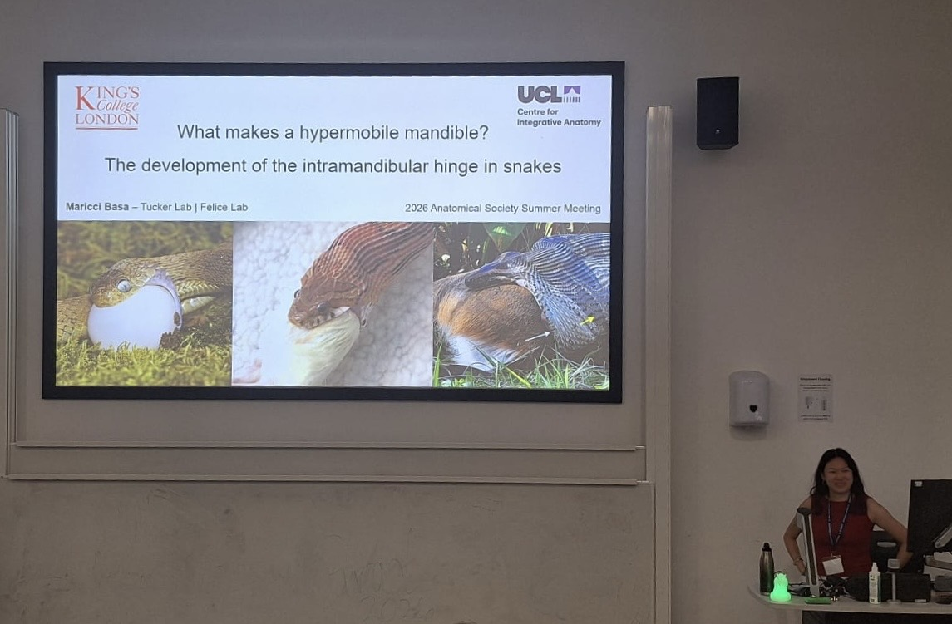
Presenting my work on the development of a flexible mandibular joint present in snakes

Copyright: If you submit images you must either own the copyright to the image or have gained the explicit permission of the copyright holder for the image to be submitted as part of the report for upload to the Society’s website, Newsletter, social media and so forth. A copyright statement must accompany each report if relevant. Answer N/A not applicable, YES or NO in the box below
YES

SIGNATURE | M Basa |  | DATE | 21/07/2026
If submitted electronically, a type-written name is acceptable in place of a hand-written signature
File: AS-Award-Report-Form-171023 – International Conference

