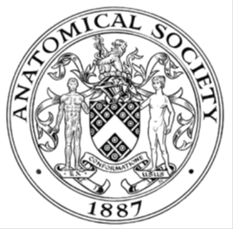
_______________________________________________________________________________________
AWARDEE REPORT FORM
_______________________________________________________________________________________

NAME |  | Dr. Megan Kruskie, PhD
SOCIAL MEDIA HANDLE
UNIVERSITY |  | University of Aberdeen
NAME OF AWARD |  | Public Engagement and Outreach Awards 2025/26 – Round 5
PURPOSE OF AWARD conference/event attended/organised (full name) with city and dates.
The purpose of this award was to provide funding for World Anatomy Day events at the University of Aberdeen. Dr. Hubaira Khan and I were excited to organise these opportunities for our community. This year, we collaborated with Explorathon Family Discovery Day to bring learning anatomy to children and families from Aberdeen and Aberdeenshire on September 27th. We hosted a second event on October 15th that aimed to engage University of Aberdeen staff and students as well as members of the public in anatomy learning.

This funding allowed us to purchase materials for hands-on activities, prizes for an anatomy trivia game, and hold an art contest where students and staff from the University of Aberdeen could submit a piece of anatomy themed art to win a prize in a public vote. This funding allowed us to provide subsistence for our essential student and staff volunteers without whom these events could not have been successful.

REPORT: What were your anticipated benefits?
Minimum number of words between 200-400. Please write in coherent paragraphs. 308 words
This two-part event series aimed to create awareness, promote scientific curiosity, and improve anatomical knowledge for the members of the public in Aberdeen. By offering anatomy education in accessible locations and in bite-sized pieces, we hoped to inspire the wider community to develop a better understanding of anatomy and its essence, not only in health and medicine but everyday life. Trained anatomy educators and medical and anatomy student volunteers used anatomical models and hands-on activities to help participants of all levels appreciate how the human body is structured and how it functions. We hoped that the events would also help participants understand the relevance of anatomy in healthcare and biomedical sciences, which can help kids especially explore potential career pathways and form a sense of belonging within the scientific community. We aimed to achieve these benefits by having students from different disciplines volunteering at the events to engage attendees in conversations about their career paths and how they use anatomy every day. While teaching about anatomy, we hoped to also engage the public in conversations about body donation to dispel some of the hesitancy and make individuals more comfortable talking about what happens in an anatomy facility. We honoured our body donors through displaying reflective artwork, poetry, and essays by University of Aberdeen students and staff to convey the importance of body donation in teaching and research. Without our body donors our work and teaching would not be possible, so we feel that it is important to have these conversations when engaging in outreach. We hoped that this event will benefit our student volunteers as well. The planned activities, such bite-sized anatomy lessons and face or arm painting, would reinforce their anatomical knowledge. We hoped that this would also be an opportunity for them to develop organizational, science communication, and teamwork skills and be engaged with anatomy education.

COMMENTS: Describe your experience at the conference / lab visit / course / seminar/ event.
Minimum number of words between 200-400. Please write in coherent paragraphs. 386 words
For our first event, we had several activities planned aimed at engaging younger children in anatomy as that was the target audience for the event. We had four kid-friendly activity stations: 1. For colouring print outs of anatomically accurate organs, 2. Playdough to build an organ or a cell, 3. Anatomy-themed face painting, and 4. Gelatine brains for dissection. The brains were made from gelatine, food colouring, and evaporated milk to make them opaque, and we placed pipe cleaners and pompons inside the mixture to represent pathways and basal ganglia you would see when performing a dissection. We had another table where we displayed plastic anatomical models of the heart, brain, and skull to give bite-sized anatomy lessons. Additionally, we had diverse types of artwork submitted for showcase at this event. We had a board to display some of the pieces that could hang and displayed the rest on the table. Small anatomy-themed prizes were available for anyone who engaged with our table. There were around 600 attendees and seven University of Aberdeen student and Anatomy staff volunteers who helped with facilitating the event over the course of the day.

For our second event, we set up a display with several activities aimed at an adult audience. We had an anatomy-themed trivia game, where participants could draw a question from beginner, intermediate, or advanced levels. If they got the answer correct, they could spin the wheel to pick an anatomy-themed prize such as a bookmark, pen, sticker, or sweets. We also had several plastic anatomical models of the brain, heart, and skull available for bite-sized anatomy lessons. At this event, we held the contest where the public could vote on their favourite piece of art that was submitted. Fifteen pieces of art were submitted and the vote allowed us to award a first-prize and joint second-prize winners, who all received gift cards for winning. There were around 100 attendees and another seven University of Aberdeen student and staff volunteers that helped with facilitating the event over the course of the day.

In summary, both events were successful at engaging the public with the anatomical sciences and providing medical and anatomy students opportunities to work on science communication skills and promote the work that they do in anatomy. There was strong engagement from both participants and volunteers.

REPORT: In relation to skills, what were the most important things you gained? (does not apply to equipment grant. For public engagement/outreach awards what did your audience gain and how did you evaluate success?
Minimum number of words between 200-400. Please write in coherent paragraphs. 289 words
As an anatomy educator, I am well-versed in communicating anatomical content to adult audiences such as my students. However, it isn’t often that I get to engage with younger students. This event allowed me to refine my science communication skills and adapt to a younger audience. It was really rewarding to see how much the younger children already knew about anatomy and how keen they were to learn more.

Benefits to the audience were assessed through observed engagement and informal feedback and conversations from participants. We developed an evaluation tool and posted a QR code for the survey at both events, but unfortunately no one responded to the survey. With how busy the tables were, we think that it got missed and learned for next year to make it more obvious to attendees or use paper-based evaluation tools to make it more accessible. For our first event, many parents came to chat with the volunteers about how much their children enjoyed coming to our tables to learn about anatomy, some stating that it was the highlight of the event for them. We had high engagement with the gelatine brain dissections and went through all eight brains that we prepared rather quickly as attendees were very keen to learn dissection skills. While dissecting or making organs with playdough, participants asked many questions about the anatomy of those structures and were asked follow up questions to test and improve their existing knowledge. We also received good informal feedback from the second event, with many people who stopped by excited to play the trivia game and test their anatomical knowledge. Participants at this event also spent a significant amount of time viewing the artwork, with 85 people engaging in the voting activity.

REPORT: How do you think you will put this learning experience into practice in the future? For public engagement/outreach awards how with the materials/knowledge generated by this activity be used in the future?
Minimum number of words between 200-400. Please write in coherent paragraphs. 282 words
This learning experience has given me the confidence and skills to organize future public outreach events to promote the anatomical sciences here in Aberdeen. From this experience, I also gained events organisational skills. Previously I have assisted in the development and facilitation of science outreach events, but this was the first time I was able to organize one myself from the ground up. I learned how to do the ‘behind the scenes’ things that large events require, including coordinating with facilities for the use of space, purchasing, and coordinating submissions an art competition. These are valuable skills that I can use in the future to organize outreach or other types of events.

The materials that were purchased with this Public Engagement and Outreach award will allow our department to continue to engage the public in the anatomical sciences in fun and interactive ways. With the exception of prizes, giveaways, and consumables for gelatine brain making, we used the funding to purchase items that can be used time and time again. Since this was the first time we tried these activities, we used this opportunity to pilot them and took notes during the event for how to improve the instructions and activities. The most well received activity we included was the gelatine brain dissection. This is something that we plan to do again in the future, likely as a standalone outreach event incorporating more neuroanatomy content and experimenting with ways to include more structures inside of the brains to make dissection more exciting.

Additionally, these events allowed us to form a connection with the public outreach team at the university, which has opened the doors for further public engagement with the anatomical sciences.

Data Protection/GDPR: I consent to the data included in this submission being collected, processed and stored by the Anatomical Society. Answer YES or NO in the Box below
YES
Graphical Images: If you include graphical images you must obtain consent from people appearing in any photos and confirm that you have consent. A consent statement from you must accompany each report if relevant. A short narrative should accompany the image. Answer N/A not applicable, YES or NO in the box below
Images included to not show any individuals.

Photo 1: Our table set up for our World Anatomy Day event at Explorathon Family Discovery Day on September 27th and the art exhibit.

Photo 2: Example of a dissected gelatine brain we made. We put pipe cleaners and pompons inside to represent the pathways and basal nuclei you might see when dissecting a real brain. Also featured are some organs participants made out of playdough.

Photo 3: Our table set up for our event for our World Anatomy Day event on October 15th and the art exhibit.

Copyright: If you submit images you must either own the copyright to the image or have gained the explicit permission of the copyright holder for the image to be submitted as part of the report for upload to the Society’s website, Newsletter, social media and so forth. A copyright statement must accompany each report if relevant. Answer N/A not applicable, YES or NO in the box below
YES, all submitted photos were taken by me, Megan Kruskie
SIGNATURE | Megan Kruskie |  | DATE | 22-10-2026
If submitted electronically, a type-written name is acceptable in place of a hand-written signature
File: AS-Award-Report-Form-310726

Photo 1:
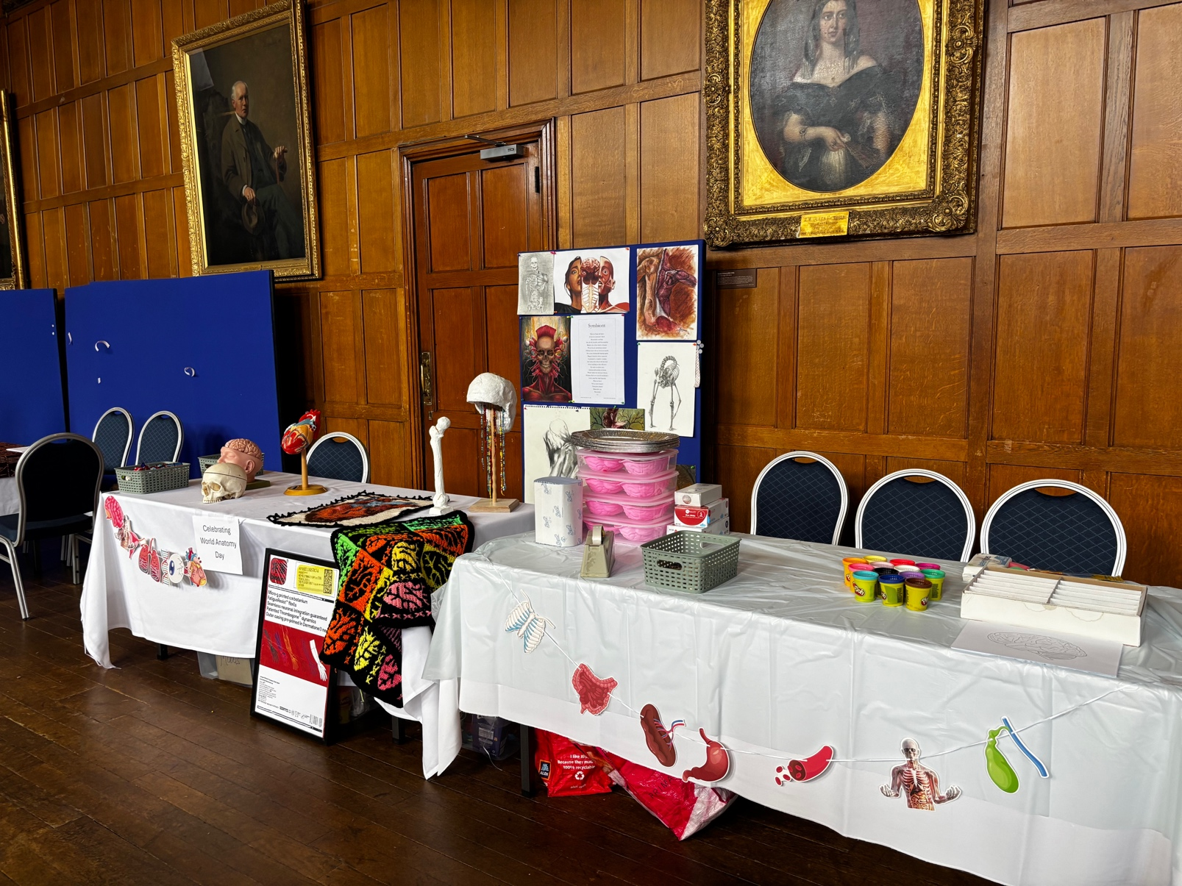

Photo 2:
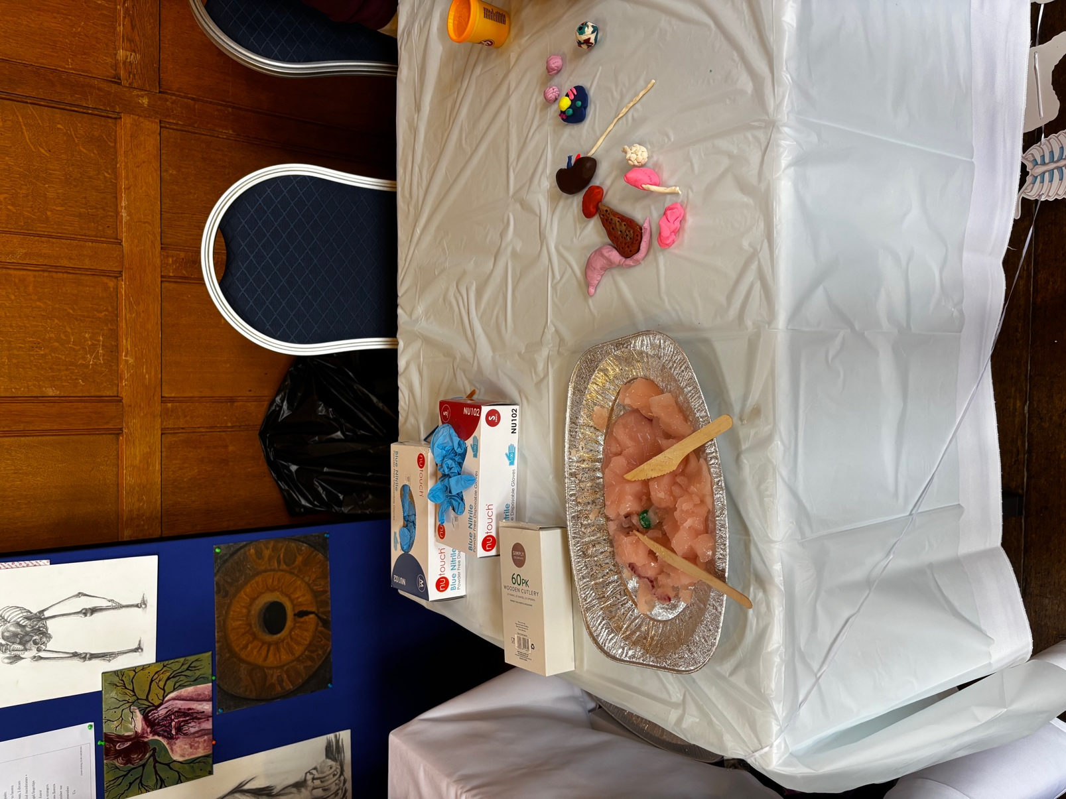
Photo 3:
