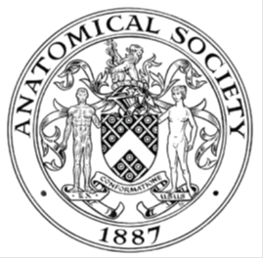
_______________________________________________________________________________________
AWARDEE REPORT FORM
_______________________________________________________________________________________

NAME |  | Juliette Hughes
TWITTER HANDLE* optional
UNIVERSITY |  | University of Liverpool
NAME OF AWARD |  | Barclay Smith Travelling Award
PURPOSE OF AWARD conference/event attended/organised (full name) with city and dates.
Attendance at Anatomical Society Summer Meeting 2026 at the University of Bristol. 15th to 17th July 2026.
Theme: Musculoskeletal Anatomy.

Abstract submitted on my Anatomy Research Development Award (funded by Anatomical Society) project titled “Just before the dawn; the role of the calcified cartilage in osteoarthritis”.

REPORT: What were your anticipated benefits?
Minimum number of words between 200-400. Please write in coherent paragraphs.
As an early career lecturer establishing an independent research programme in musculoskeletal biology, my main aim was to present findings from my Anatomical Society Anatomy Research Development Award (ADRA) project, Darkest just before dawn: the role of the calcified cartilage in osteoarthritis, to the wider anatomical community. Delivering an ADRA presentation offered an excellent opportunity to disseminate the outcomes of Society-funded research while receiving expert feedback that would strengthen the project's future dissemination after discussion and feedback. It also provided an opportunity to highlight that adaptability and resilience is needed in research, as unforeseen circumstances can change a projects directions: a key thing for other ECR’s to consider in their careers.

I also anticipated benefiting from the meeting's strong focus on musculoskeletal anatomy, which is a key area of interest for my own research. The programme included invited lectures and presentations spanning biomechanics, skeletal biology, musculoskeletal ageing, tendon biology and advanced anatomical imaging, providing an ideal opportunity to broaden my understanding of emerging developments within the field.

Equally important was the opportunity to expand my professional network. I hoped to establish connections with researchers working across anatomy and musculoskeletal science, discuss complementary methodologies and explore opportunities for future collaboration. As I continue to establish my research independence, developing these relationships is invaluable for future grant applications and multidisciplinary projects. I expected the meeting to enhance my confidence in presenting research as an early career academic, communicating scientific findings to diverse audiences and engaging in constructive scientific discussion.

As a Lecturer in Anatomy at the University of Liverpool, I also anticipated that attending the meeting would enhance my teaching. Exposure to current anatomical research, innovative methodologies and emerging areas of musculoskeletal science would allow me to incorporate contemporary examples into undergraduate teaching, ensuring that students are exposed to research-led education and appreciate the relevance of anatomy to modern biomedical science.

COMMENTS: Describe your experience at the conference / lab visit / course / seminar/ event.
Minimum number of words between 200-400. Please write in coherent paragraphs.
The Meeting was an engaging and rewarding scientific meeting that brought together researchers working across a broad range of anatomical disciplines. The programme combined invited lectures with presentations from early career researchers, creating an excellent environment for learning, discussion and networking. I particularly enjoyed attending talks on musculoskeletal biology, biomechanics and comparative anatomy (different for me!), alongside opportunities to visit the Bristol Comparative Anatomy Museum and participate in the conference dinner. These activities created an open and supportive atmosphere that encouraged scientific discussion throughout the meeting at all career levels.

A particular highlight was delivering my ADRA presentation, Darkest just before dawn: the role of the calcified cartilage in osteoarthritis. Presenting immediately following an invited lecture provided a platform to showcase findings from my Anatomical Society-funded research to colleagues with expertise in anatomy and musculoskeletal biology. The presentation generated valuable discussion/questions and potential future research directions.
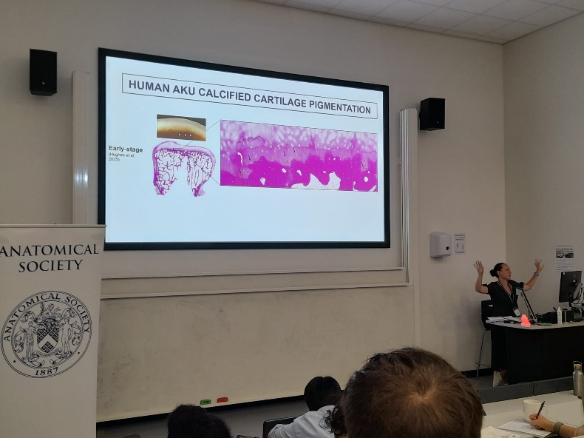
Caption: Presentation of my ARDA award with this slide highlighting the role of the calcified cartilage towards joint destruction in the rare disease alkaptonuria.

Beyond my own presentation, I particularly valued the opportunity to engage with fellow early career researchers/anatomists and established investigators during poster sessions, coffee breaks and the conference dinner. These informal discussions often led to insightful conversations about research challenges, methodological approaches and academic careers in anatomy. I also enjoyed learning about research outside my immediate field (particularly comparative anatomy), broadening my research exposure.

Overall, the meeting reinforced the importance of the Anatomical Society as a supportive community for early career researchers and provided an excellent opportunity to disseminate Society-funded research while developing valuable professional connections.

REPORT: In relation to skills, what were the most important things you gained? (does not apply to equipment grant. For public engagement/outreach awards what did your audience gain and how did you evaluate success?
Minimum number of words between 200-400. Please write in coherent paragraphs.
One of the most valuable skills I am continuing to develop is scientific communication and my confidence as a teaching/research lecturer. Presenting my research to an audience with expertise spanning multiple areas of anatomy challenged me to communicate deeper biological and disease concepts clearly while tailoring discussions to researchers with different backgrounds. This is directly transferable to my teaching, where communicating challenging anatomical concepts clearly is essential for student learning. Exposure to a wide range of presentation styles also provided valuable insight into effective scientific storytelling and audience engagement, which I will incorporate into both my lectures and student research supervision.

Networking was another significant area of professional development. As an early career researcher, initiating conversations with established investigators, discussing potential collaborations and building lasting professional relationships is an essential skill. The supportive atmosphere of the meeting made it possible to develop new connections.
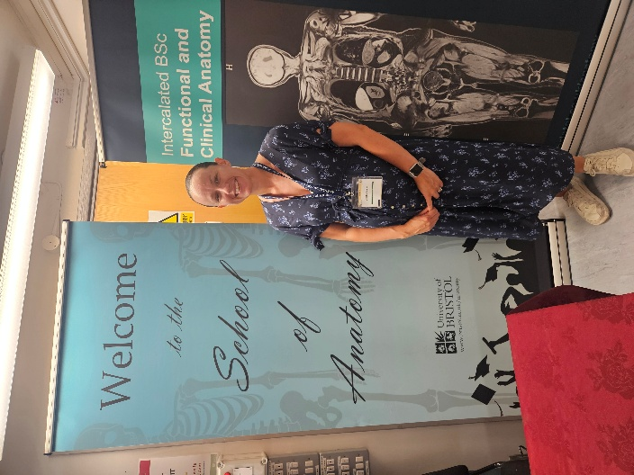
Caption: Anatomical Society Summer 2026, hosted by the School of Anatomy, University of Brsitol.

Finally, attending presentations across a broad range of anatomical disciplines expanded my knowledge of research techniques and technologies. Learning about new imaging approaches and experimental models has already prompted me to consider how these methods could be incorporated into my own musculoskeletal research programme. Collectively, the meeting strengthened both my scientific and professional skills and has increased my confidence as I continue to establish my independent research career.

REPORT: How do you think you will put this learning experience into practice in the future? For public engagement/outreach awards how with the materials/knowledge generated by this activity be used in the future?
Minimum number of words between 200-400. Please write in coherent paragraphs.
The experience gained from attending the Anatomical Society Summer Meeting will have a lasting impact on both my research and teaching. The feedback received during my ADRA presentation will be incorporated into the preparation of manuscripts arising from the project and will help shape future studies investigating the role of calcified cartilage in osteoarthritis.

The meeting reinforced the importance of multidisciplinary approaches to understanding musculoskeletal disease. Exposure to research spanning biomechanics, imaging technologies and comparative anatomy has encouraged me to think more broadly about experimental design and the integration of complementary techniques within my own work.

One of the most immediate impacts will be on my teaching within the University of Liverpool's Anatomy programmes. The meeting exposed me to contemporary advances in musculoskeletal anatomy, biomechanics, imaging and skeletal biology that may enrich my lectures and practical teaching sessions. Incorporating examples from current research enables students to appreciate how fundamental anatomy underpins disease mechanisms, biomedical discovery and clinical innovation.

More broadly, the meeting has reinforced the close relationship between research and teaching. Remaining actively engaged with the Anatomical Society enables me to bring the latest developments in anatomical science/teaching directly into the classroom, ensuring that students benefit from a research-informed curriculum while simultaneously strengthening my own research programme.

I am extremely grateful to the Society for supporting both the research itself through an Anatomy Research Development Award and its dissemination through the Barclay Smith Travelling Award. I look forward to continuing to contribute to future Anato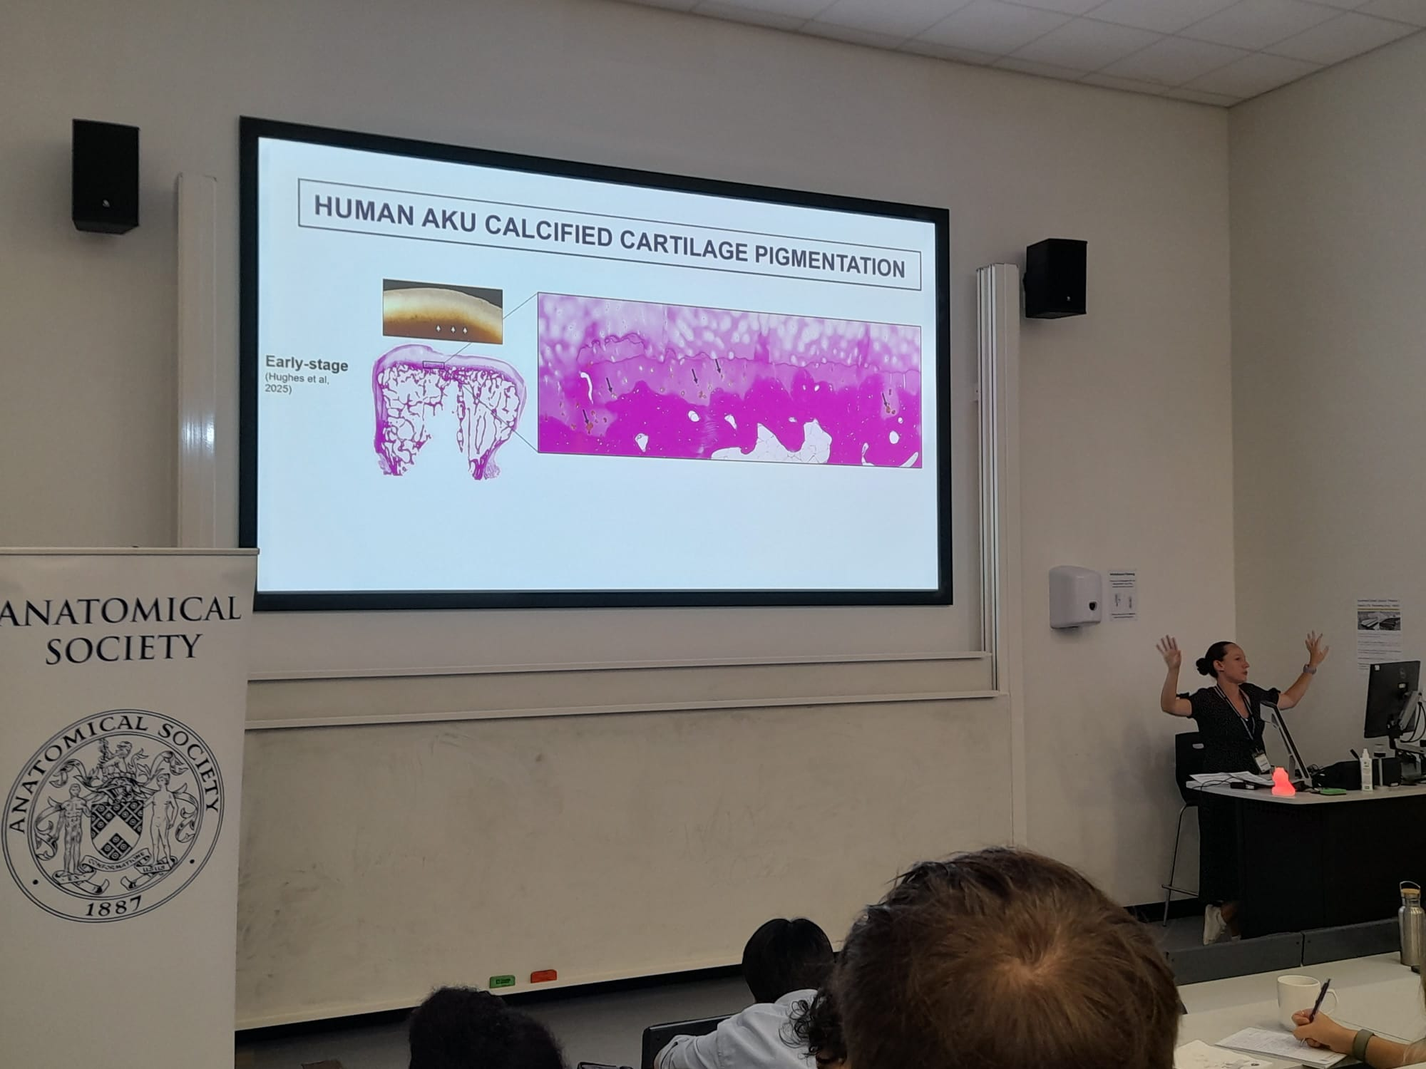mical Society meetings.
Data Protection/GDPR: I consent to the data included in this submission being collected, processed and stored by the Anatomical Society. Answer YES or NO in the Box below
Yes
Graphical Images: If you include graphical images you must obtain consent from people appearing in any photos and confirm that you have consent. A consent statement from you must accompany each report if relevant. A short narrative should accompany the image. Answer N/A not applicable, YES or NO in the box below
Yes

Copyright: If you submit images you must either own the copyright to the image or have gained the explicit permission of the copyright holder for the image to be submitted as part of the report for upload to the Society’s website, Newsletter, social media and so forth. A copyright statement must accompany each report if relevant. Answer N/A not applicable, YES or NO in the box below
N/A

SIGNATURE | 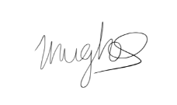 |  | DATE | 23/07/2026
If submitted electronically, a type-written name is acceptable in place of a hand-written signature
File: AS-Award-Report-Form-171023 – International Conference

