
_______________________________________________________________________________________
AWARDEE REPORT FORM
_______________________________________________________________________________________

NAME |  | Betzy Manners
TWITTER HANDLE* optional |  | @Betzy_Manners
UNIVERSITY |  | Liverpool University
NAME OF AWARD |  | Symington Bequest Fund 2024/25 - Round 2
PURPOSE OF AWARD conference/event attended/organised (full name) with city and dates.
To attend and present a poster at the Anatomy Connected 2025 – Hosted by American Association of Anatomy. Between the dates of 28th – 31st of March 2025. In Portland, Oregon USA.

REPORT: What were your anticipated benefits?
Minimum number of words between 200-400. Please write in coherent paragraphs.
The Anatomy Connected conferences, hosted by The American Association of Anatomy, attract approximately 1,000 anatomists and experts globally, featuring over 100 speakers and 500 poster presentations. Attending offers a valuable opportunity to connect with diverse professionals across the field. These networking opportunities could significantly advance my academic career both during and beyond my PhD studies. I anticipate developing meaningful collaborations through engaging discussions about my research, potentially leading to future joint projects or publications with fellow researchers who share complementary interests.

Personally, presenting my work at such a prestigious conference will enhance my ability to articulate and defend my research when faced with questions from experienced anatomists. The constructive feedback from established experts could highlight unforeseen strengths and limitations in my methodology, potentially revealing new research directions I hadn't previously considered.

Furthermore, these conferences serve as vital knowledge exchanges in anatomical science. By attending various presentations and poster sessions, I expect to gain insights into innovative techniques and approaches that might help resolve challenges I'm currently facing in my research. The opportunity to seek advice from individuals who may present methodologies that I want to apply will be largely beneficial in accelerating my progress and improving the overall quality of my work.

I have also planned to meet with staff from Oregon State University (OSU) to solidify a strong working relationship with them. This collaboration will be instrumental in expanding my data collection efforts for my PhD research. By engaging with their team, I hope to leverage their expertise and resources, which will greatly enhance the scope and depth of my work. Building a partnership with OSU will provide access to additional datasets, advanced technologies, and potentially open doors for future collaborative projects that will further enrich my academic journey.
COMMENTS: Describe your experience at the conference / lab visit / course / seminar/ event.
Minimum number of words between 200-400. Please write in coherent paragraphs.
The conference provided an exceptional opportunity to engage with a diverse range of presentations—both directly relevant to my PhD research and others that illuminated the breadth of contemporary anatomical research. Some of the most useful and informative talks that I attended covered topics such as comparative anatomy, evolutionary morphology and anatomical education.

Attending alongside my mentor, Prof. Magdalena Muchlinski, and primary supervisor, Dr. Alana Sharp, proved invaluable for networking purposes. Through their introductions, I connected with numerous researchers whose expertise aligns with my work. Notably, I was able to meet several colleagues with whom I had previously communicated only via email, transforming these digital connections into meaningful professional relationships. Meeting with both Devon Quick and Lindsay Biga from OSU was incredibly beneficial for the progress of my PhD. Following this meeting, I had the opportunity to visit OSU for a lab trip, where I not only gathered valuable data for my research but also took the chance to mentor some of the students. This hands-on experience was invaluable in advancing my work and building meaningful connections within the academic community. The professional relationship with Devon, Lindsay, and the team at OSU will continue to grow and play a significant role in the development of my PhD throughout the coming years.

My poster presentation exceeded expectations, attracting significant attention and generating productive discussions. Attendees offered thoughtful insights and shared their experiences related to my research topic. These conversations yielded innovative approaches to potential challenges I might encounter and sparked ideas for methodological refinements. Perhaps most importantly, several researchers expressed interest in maintaining contact for future collaborative projects, creating tangible opportunities for expanding my research network and enhancing the impact of my work. The conference fostered several meaningful connections that I intend to maintain as professional friendships.

REPORT: In relation to skills, what were the most important things you gained? (does not apply to equipment grant. For public engagement/outreach awards what did your audience gain and how did you evaluate success?
Minimum number of words between 200-400. Please write in coherent paragraphs.
Attending the conference significantly enhanced several crucial professional skills. My confidence in presenting, discussing, and defending my research improved markedly through interactions with numerous colleagues and experts. The experience refined my ability to communicate complex ideas effectively—a skill that will substantially benefit my PhD progression. I received specific praise for the visual design of my poster presentation, establishing a successful template I can refine for future academic communications.
The networking opportunities yielded extensive professional relationships with researchers from diverse backgrounds and expertise levels. These connections have already generated multiple potential collaboration prospects. Perhaps most valuable was my introduction to specialists working directly in my field, creating potential pathways for expanding the scope and impact of my research. These relationships may prove instrumental in addressing challenges and identifying new research directions as my work progresses.
I also learned that the value of attending conferences extends beyond the professional connections you make. It is equally important for establishing a personal presence and becoming embedded in the world of anatomical academia. I believe this skill is crucial for enhancing the visibility of my research, facilitating future publications, and expanding its impact.

This experience has significantly boosted my confidence and reinforced my enthusiasm for my research. Presenting my preliminary results to such a broad audience appears to have generated substantial interest among colleagues who may follow my future work and publications. Moving forward, I plan to participate in similar international conferences to nurture these valuable professional relationships and continue building my academic network.

REPORT: How do you think you will put this learning experience into practice in the future? For public engagement/outreach awards how with the materials/knowledge generated by this activity be used in the future?
Minimum number of words between 200-400. Please write in coherent paragraphs.
I intend to maintain connections with colleagues I met during this experience, potentially leading to research collaborations, reciprocal university visits, and joint public engagement initiatives. The visit to Oregon strengthened my relationship with my mentor Prof. Magdalena Muchlinski, and corresponding colleagues at OSU, solidifying promising connections that could lead to sustained transatlantic partnerships. These relationships may facilitate future visits from the American colleagues to the University of Liverpool for collaborative research or outreach events.

The confidence and knowledge I have gained from presenting my first poster at an international conference will be invaluable in future presentations and research endeavours. This experience has enhanced both my professional and personal development. Additionally, the materials and insights from this activity will help inform any future public engagement efforts, enabling me to communicate my research more effectively and reach a wider audience.

Looking ahead, I am eager to apply the skills I have developed through this opportunity in attending future conferences. I aim to not only participate actively in these events but also to contribute meaningfully by continuing to deliver my own presentations, sharing my insights, and fostering impactful discussions within these professional environments. Having already established some key professional relationships, attending future conferences such as Anatomy Connected 2026 will serve to further solidify these connections and expand collaboration opportunities, ensuring continued growth and success in my research and outreach efforts.
I am extremely grateful to the Anatomy Society for supporting my attendance to my first international conference, enabling me to develop several key skills and international academic connections.
Data Protection/GDPR: I consent to the data included in this submission being collected, processed and stored by the Anatomical Society. Answer YES or NO in the Box below
Yes
Graphical Images: If you include graphical images you must obtain consent from people appearing in any photos and confirm that you have consent. A consent statement from you must accompany each report if relevant. A short narrative should accompany the image. Answer N/A not applicable, YES or NO in the box below
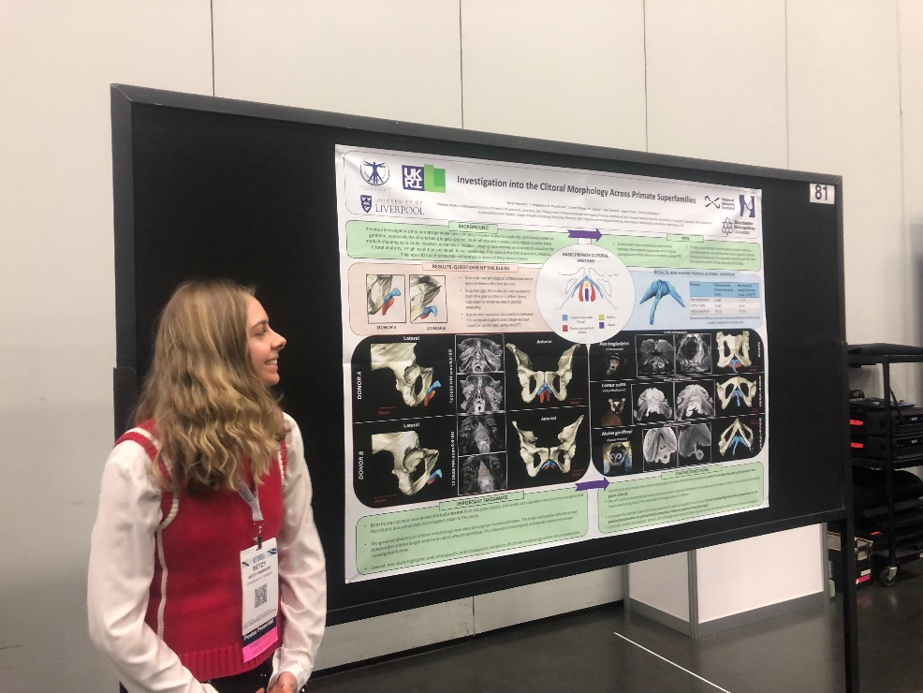
Copyright: If you submit images you must either own the copyright to the image or have gained the explicit permission of the copyright holder for the image to be submitted as part of the report for upload to the Society’s website, Newsletter, social media and so forth. A copyright statement must accompany each report if relevant. Answer N/A not applicable, YES or NO in the box below
I own the copyright to this image.
SIGNATURE | Betzy Manners |  | DATE | 08/04/2025
If submitted electronically, a type-written name is acceptable in place of a hand-written signature
File: AS-Award-Report-Form-171023 – International Conference

File: SBF2425 Report Manners website version 140425

