The cerebellum is located on the side of the brain and is often referred to as the brain. 40% of all the located in the brain are in the cerebellum. It works the level of consciousness. The function of the cerebellum is that it acts as a co-ordinator of movement such as walking. It can relay information to the and spinal cord. The cerebellum continually compares the brain’s with its actions and makes any necessary modifications such as stopping yourself from falling. This is an example of within the system.

Inferior nervous little motor cortex intentions neurons
Below communication voluntary
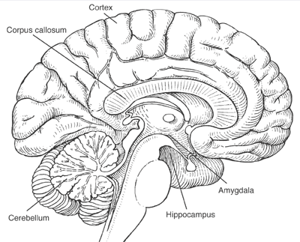

Image reference: http://pubs.niaaa.nih.gov/publications/arh284/images/tapert.gif

