
_______________________________________________________________________________________
AWARDEE REPORT FORM
_______________________________________________________________________________________

NAME |  | Dr Jennifer Paxton
TWITTER HANDLE* optional |  | @Dr_JZP
UNIVERSITY |  | University of Edinburgh
NAME OF AWARD |  | Departmental Seminar grant
PURPOSE OF AWARD conference/event attended/organised (full name) with city and dates.
This award was used to invite Dr Rebecca Rolfe, Assistant Professor at Trinity College Dublin, to give a seminar on her research at the Anatomy Research Seminar Series at the University of Edinburgh. Dr Rolfe travelled to Edinburgh on the 21st April 2026.

REPORT: What were your anticipated benefits?
Minimum number of words between 200-400. Please write in coherent paragraphs.
I was introduced to Dr Rolfe in 2025 when I was invited to give a seminar at Trinity College Dublin by Rebecca and her team. This was based on my work in anatomically-related musculoskeletal tissue engineering and while there, it was clear that Dr Rolfe and I shared many common research interests and themes. Now, in 2026, I was very keen to invite Dr Rolfe to Edinburgh to share her exciting work with the Anatomy team and the wider research audience in Edinburgh. I was also very glad to be able to support a new member of the Anatomical Society research group, as Dr Rolfe has recently been awarded the New Investigator Research Studentship Award to begin this autumn.

I was anticipating an exciting, interesting and relevant research seminar with many opportunities for discussion and future collaborations. Dr Rolfe and I are hoping to form direct collaborative links and this was a wonderful opportunity to discuss her work in more detail and identify areas of crossover. Also, invitations to attend the seminar were extended to the whole anatomy team in Edinburgh, as well as undergraduate and postgraduate students on Anatomy & Development, Human Anatomy and Clinical Anatomy programmes. I was very keen to demonstrate the value of anatomical research in many related fields and help promote an excellent scientist and the Anatomical Society to a wider audience.
COMMENTS: Describe your experience at the conference / lab visit / course / seminar/ event.
Minimum number of words between 200-400. Please write in coherent paragraphs.
I thoroughly enjoyed the seminar and visit of Dr Rolfe to the University of Edinburgh. Dr Rolfe gave her seminar entitled “Stability in the Musculoskeletal System: investigating the importance of movement to understand connective tissue function”. In this, Dr Rolfe explained her fascinating work in the fields of developmental biology and the effect of movement on the form and function of musculoskeletal tissues that formed the basis of her pre and postdoctoral work at Trinity College Dublin and Imperial College London. She also presented some of her excellent work from her independent research group and shared the current research questions being tackled by her research team. Many of these were aligned with my own interests in ligament/tendon anatomy and bioengineering so this was of particular relevance to my work, but other aspects were new to me and I felt I learned a great deal from Dr Rolfe’s seminar.

Although the attendance at the seminar was less that I have anticipated (probably due to impending examinations in the undergraduate and postgraduate calendar!) the audience that attended were engaged throughout and a lively and enjoyable question session was held at the end of the talk, highlighting the interest and engagement of the audience. Indeed, Dr Rolfe’s seminar captivated those interested in neuromuscular and neuroanatomical research, identifying significant crossover of her work in other anatomical and anatomically-related fields.

REPORT: In relation to skills, what were the most important things you gained? (does not apply to equipment grant. For public engagement/outreach awards what did your audience gain and how did you evaluate success?
Minimum number of words between 200-400. Please write in coherent paragraphs.
I learned a significant amount from Dr Rolfe’s seminar and from our discussions before and after her talk. As mentioned, while much of her work was closely aligned with my own research interests, I also learned a great deal about the application of developmental anatomy in other connective tissues of the body and the possible implications for disease progression. I was also very intrigued to learn of new techniques and analyses that I could explore for my own programme of research and hope to be able to collaborate with Dr Rolfe on these in the future.

This seminar was an excellent opportunity to learn more about Dr Rolfe’s area of research and her expertise but also her future aspirations for her research and career. I was also proud to be able to support such a talented and impressive scientist working within the field of developmental anatomy and bioengineering.

I am actively promoting anatomical research within my own department at the University of Edinburgh and so being able to host Dr Rolfe was extremely valuable for this personal goal. Similarly, hosting prominent researchers in the anatomical field is extremely beneficial for my own department and the undergraduate and postgraduate anatomy students currently studying with us. It was a very valuable opportunity to promote Dr Rolfe’s work, the importance of anatomical research for the future of anatomy and also the Anatomical Society as the funder and supporter of this trip.

REPORT: How do you think you will put this learning experience into practice in the future? For public engagement/outreach awards how with the materials/knowledge generated by this activity be used in the future?
Minimum number of words between 200-400. Please write in coherent paragraphs.
As mentioned above, there were many points of scientific crossover between Dr Rolfe’s work and mine, as well as several other members of the research community at the University of Edinburgh. From this, Dr Rolfe and I have discussed plans for potential research collaborations, future grant applications and exchanges that will give opportunities for mutual benefit in the fields of developmental anatomy and bioengineering. Furthermore, Dr Rolfe’s seminar was very well received by the anatomical audience and I am hopeful that this will lead to further collaborations with the wider research groups at the University of Edinburgh. This will benefit many other areas of anatomically-related research of interest and relevance to the Anatomical Society.

I would like to thank the Anatomical Society for the financial support received to invite Dr Rolfe to Edinburgh and hear about her exciting work. Not only was it an enjoyable visit, it was a chance to reflect on the significant anatomically-related work supported by the Anatomical Society and the importance of championing and supporting other researchers in the field. I am excited to see where our future conversations and plans lead in the future and, once again, thank the Anatomical Society for their generous support and Dr Rolfe for sharing her work.

Data Protection/GDPR: I consent to the data included in this submission being collected, processed and stored by the Anatomical Society. Answer YES or NO in the Box below
YES
Graphical Images: If you include graphical images you must obtain consent from people appearing in any photos and confirm that you have consent. A consent statement from you must accompany each report if relevant. A short narrative should accompany the image. Answer N/A not applicable, YES or NO in the box below
YES consent to include image received.

Image shows Dr Rebecca Rolfe giving her seminar in the Anatomy Lecture Theatre, University of Edinburgh
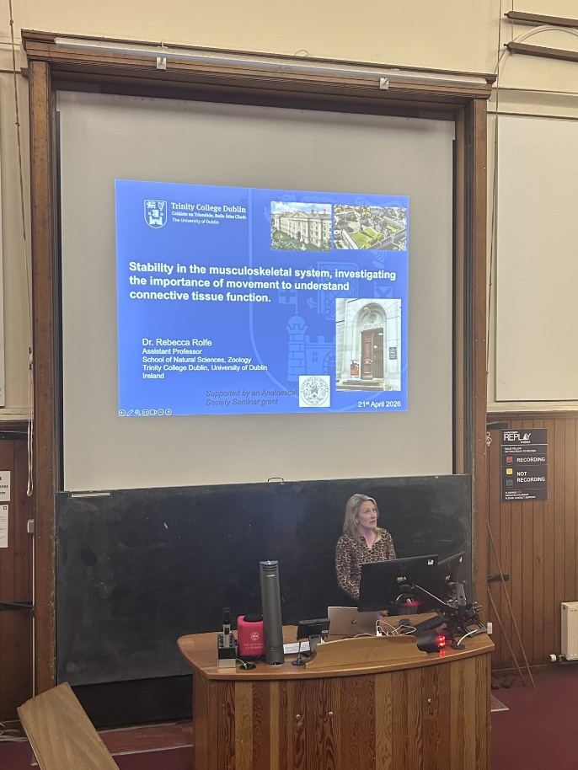
Copyright: If you submit images you must either own the copyright to the image or have gained the explicit permission of the copyright holder for the image to be submitted as part of the report for upload to the Society’s website, Newsletter, social media and so forth. A copyright statement must accompany each report if relevant. Answer N/A not applicable, YES or NO in the box below
YES

SIGNATURE | Jennifer Paxton |  | DATE | 30/4/26
If submitted electronically, a type-written name is acceptable in place of a hand-written signature
File: AS-Award-Report-Form-171023 – International Conference

