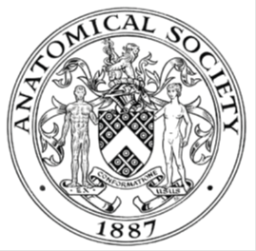
_______________________________________________________________________________________
AWARDEE REPORT FORM
_______________________________________________________________________________________

NAME |  | Dr. Alannah J Mole
TWITTER HANDLE* optional |  | @alannahmole
UNIVERSITY |  | University of Sheffield
NAME OF AWARD |  | Symington Bequest Fund 2023/24 – Round 6
PURPOSE OF AWARD conference/event attended/organised (full name) with city and dates.
Attendance at the 35th International Symposium on MND/ALS in Montreal, Canada from 6th – 8th December 2024.

REPORT: What were your anticipated benefits?
Minimum number of words between 200-400. Please write in coherent paragraphs.
Attending this international conference offered numerous anticipated benefits.

I expected to gain exposure to the latest research findings and advancements in the field of motor neuron disease (MND) research and learn about innovative experimental approaches and methodologies that could potentially be applied to my work. I also would have the opportunity to engage with the clinical side of MND research, which I do not regularly have exposure to. The event presented an opportunity to network with international experts and colleagues, exchange ideas, and establish potential collaborations, which is particularly pertinent at this time in my career when I am considering my next career steps.

Discussing my research with field leaders, particularly those with neuromuscular and neurophysiology expertise, was anticipated to provide constructive feedback to help to refine my approach and highlight the value of this technique in this space. This was the first opportunity that I have had to present work undertaken as part of my pre-fellowship, and so it was an invaluable opportunity to gain exposure and communicate complex aspects of my work on an international platform. In addition, I hoped to showcase a model marrying anatomy and neurophysiology and highlight how this can be used to gain insight into pathological mechanisms in disease that affect neuromuscular health.

The keynote speakers and discussions were anticipated to provide insight into the broader field and inspire me by providing unpublished updates on clinical trials and a chance to hear patient perspectives. Some patient advocates were invited to attend the conference, so it was also a chance to meet with these individuals.

COMMENTS: Describe your experience at the conference / lab visit / course / seminar/ event.
Minimum number of words between 200-400. Please write in coherent paragraphs.
The MNDA International symposium is a renowned platform for bringing together researchers, clinicians, and leaders from across the globe. The conference showcases the latest advancements and discussions in the field of MND research and treatment. I arrived before the conference started and so had a chance to see some of the city of Montreal. Having never been to Canada, this was a very exciting way to start the conference.

The conference began and I presented my work on the application of neuromuscular ex vivo model to MND as a poster. I had interest form several prominent experts and colleagues during all poster sessions. I received insightful questions and feedback and discussed some technical issues that others have similarly been facing with regards to staining. I gained some new ideas to resolve these issues in my own work. Constructive questions that were posed will help with future studies and interpretation of data, and when facing funding panels.

I connected with researchers and professionals from diverse backgrounds and institutions worldwide. These interactions helped me identify potential collaborations and gain exposure to a broad range of methodologies and perspectives. I attended three days of inspiring and insightful presentations by leaders in the field, which highlighted new developments and innovative techniques. The knowledge gained from attending talks has broadened my perspective and provided ideas to integrate or consider in relation to my own work.

Overall, discussions with peers and experts, and attendance at this symposium enhanced my broader appreciation of ongoing work, and how my work is situated within the larger MND research framework.

REPORT: In relation to skills, what were the most important things you gained? (does not apply to equipment grant. For public engagement/outreach awards what did your audience gain and how did you evaluate success?
Minimum number of words between 200-400. Please write in coherent paragraphs.
Those that I presented to gained insights into the development and potential applications of neuromuscular ex vivo modelling. I demonstrated this as a tool to advance our understanding of pathological mechanisms, particularly relating to origins and timing of electrophysiological dysfunction. I also highlighted how this might provide scope for a novel preclinical approach to identify and demonstrate target efficacy of therapeutics. Overall, I highlighted to my audience how this model might bridge the gap between in vitro systems and in vivo studies and its potential as a sensitive screening tool.

Since this was my first experience presenting this ex vivo model to the MND community, I improved my ability to communicate this complex scientific idea clearly and effectively to a diverse, but informed audience, which can be particularly challenging with neurophysiology. Presenting this improved my confidence in communicating. I was also interviewed by the MND Association as part of their outreach and communications platforms, which will give me exposure on their social media and website; this gave me experience in thinking on my feet and conveying my work/career in a lay way.

I evaluated the success of my participation through the quality of the discussions I had, the nature of the questions posed during my presentation, and the connections I made with others in the field. Individuals were engaged with my poster, provided constructive feedback and extended their support for my career. The opportunity to engage with cutting-edge research and witness the enthusiasm and dedication of the MND community, alongside patient interactions and testimonies, reaffirmed for me the importance and relevance of my work.

REPORT: How do you think you will put this learning experience into practice in the future? For public engagement/outreach awards how with the materials/knowledge generated by this activity be used in the future?
Minimum number of words between 200-400. Please write in coherent paragraphs.
I intend to put this learning experience into practice in several meaningful ways. Based on the discussions that I had and feedback, I am planning to refine and clarify aspects of my work/poster for future presentations. Communication and engagement skills that I have developed will also enhance how I present my work to both academic and non-academic audiences in the future. I will apply these skills to other conferences, public outreach activities, and collaborative settings to effectively communicate my findings and their implications to a range of audiences.

I aim to continue to improve how neurophysiology is conveyed to audiences to make it more accessible and show how anatomy and physiology can be combined to assess synaptic health, to examine the fundamental building blocks of synaptic transmission. I aim to continue to advocate that this can enhance our knowledge and may pave the way to finding novel targets for therapeutic intervention. By continuing to engage in outreach, I hope that I can continue to share how tools like ex vivo modelling can advance the field and therapeutic development and bridge the gap between scientific research and public understanding.

Data Protection/GDPR: I consent to the data included in this submission being collected, processed and stored by the Anatomical Society. Answer YES or NO in the Box below
YES

Graphical Images: If you include graphical images you must obtain consent from people appearing in any photos and confirm that you have consent. A consent statement from you must accompany each report if relevant. A short narrative should accompany the image. Answer N/A not applicable, YES or NO in the box below
YES
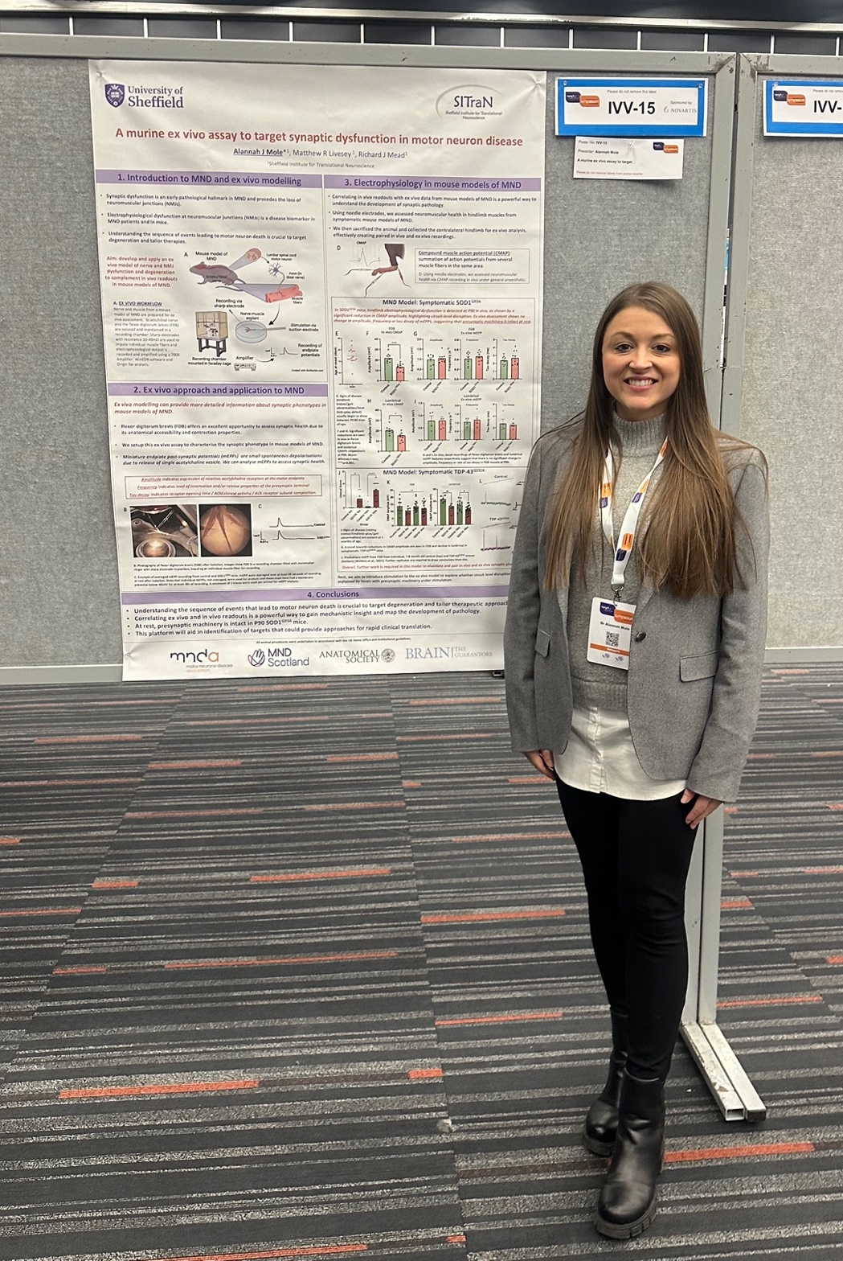
Copyright: If you submit images you must either own the copyright to the image or have gained the explicit permission of the copyright holder for the image to be submitted as part of the report for upload to the Society’s website, Newsletter, social media and so forth. A copyright statement must accompany each report if relevant. Answer N/A not applicable, YES or NO in the box below
YES

SIGNATURE | Alannah J Mole |  | DATE | 17.12.2024
If submitted electronically, a type-written name is acceptable in place of a hand-written signature
File: AS-Award-Report-Form-171023 – International Conference

