UNDERGRADUATE SUMMER VACATION SCHOLARSHIP AWARDS – FINAL SUMMARY REPORT FORM 2018/19
NB: This whole report will be posted on the Society’s website therefore authors should NOT include sensitive material or data that they do not want disclosed at this time.

Name of student:
Amit Kalra
Name of supervisor(s):
Dr. Oran Kennedy and Isabel Amado
Project Title: (no more than 220 characters)
Optimizing Light Sheet Microscopy for Musculoskeletal Research
Project aims: (no more than 700 words)
Light sheet fluorescence microscopy (LSFM) is a microscopy technique that is capable of high optical resolution, as well as excellent optical sectioning capabilities¹. In contrast to standard fluorescence microscopy, where a thin slice of the sample is illuminated perpendicular to the line of sight. For illumination, a laser light-sheet is used, i.e. a laser beam which is focused only in one direction using a cylindrical lens. As only the actual observed section is illuminated in this scenario, this method reduces any potential photodamage and/or stress on the living tissue. Also, a strong optical sectioning capability reduces the level of background signal, and thus creates images with higher contrast, compared to regular confocal images. Since LSFM takes images by using a plane of light instead of a point of light (as in confocal microscopy), it is possible to acquire images at high speeds, up to 100 - 1000 times faster than by point-scanning methods.

This project allowed us to determine the most efficient way to use Light Sheet microscopy for bone tissue. This will enable us to use these techniques to study the development of bones and joints and will enhance our understanding of a range of musculoskeletal diseases.

Our Aims
- Optimize preparation of tissue, and microscope settings, for histomorphometric assessment of bone using LSFM

- Compare output measures of LSFM with standard measures of bone assessment, MicroCT and standard histology.

Project Outcomes and Experience Gained by the Student (no more than 700 words)
Project Outcomes
- Optimize preparation of tissue, and microscope settings, for histomorphometric assessment of bone using LSFM

LSFM requires optical clearing of the target tissues, and can then create images with higher contrast compared to standard fluorescent and confocal microscopy. This is achieved using a plane of light instead of a point of light, thus reducing background signal¹. To do this we followed an established tissue clearing protocol called, CLARITY². This process involves using tissue hydrogel hybrids to stabilize biomolecules, selectively removing unwanted lipids. The next step is to use a refractive index matching solution, which allows high resolution imaging at increased depth².

Our data shows that bone tissue, from a P5 calvaria mouse model, can be optically cleared without disrupting fluorescent labelling used for LSFM.
We also show that samples can be labelled with multiple fluorescent stains for LSFM imaging.
For LSFM, samples need to be cut to a relatively small size, to fit into a particular capillary tube. Therefore, to achieve optimal results with LSFM, confocal microscopy can be used first to outline different areas of interest on a sample.

- Compare output measures of LSFM with Standard measures of bone assessment, MicroCT and standard histology.

Standard histology for bone assessment is inherently a destructive process, and is also time and resource intensive. While it can provide a high level of 2D detail, it can also be difficult to understand the entire morphology when the sample has been sectioned in this way. In addition, MicroCT can be used to assess the microstructure of a sample in 3D but is not able to show any level of biological activity in the tissue.

LSFM bridges the gap between these two methods. Our project shows LSFM has potential as an effective method of histological assessment of bone. Using fluorescent labelling we can create full 3D images of a larger sample, compared to sectioned samples, or use LSFM to instantly view sections of a sample.

Experience Gained

I have gained extensive experience with histological preparation and processing techniques. I had the opportunity to learn paraffin wax and liquid nitrogen embedding along with the associated equipment used for sectioning, on microtome and cryostat systems. I learned how to follow appropriate laboratory protocols and apply stains to samples of P5 mouse calvaria. I gained experience using H&E, Safranin O with Fast green, Masson’s Trichrome stains – and also interpreting the images they produce. I also had the opportunity to learn how to use the fluorescent stains, calcein blue and alkaline phosphatase – which are bone specific stains, and thus very relevant to this project.

Along with histological preparation, I have gained experience with general microscopy principles and fundamentals. I learned how to use microscope equipment to capture and record 2D images from stained samples of P5 mouse calvaria. I was also introduced to MicroCT scanning and how it is used in the lab to image and quantify 3D microarchitecture.

For Light Sheet Fluorescence Microscopy, I learned how to optically clear bone tissue using the CLARITY protocol and also how to add fluorescent stains to intact samples of P5 mouse calvaria. Before beginning LSFM we used confocal microscopy to examine the fluorescence of the samples and highlight areas of interest. Along with the experience of using Light Sheet microscopy, I gained experience with general image processing methods using the FluoRender program. With Fluorender, I was able to edit captured images from LSFM, Confocal microscopy and use data collected from MicroCT imaging of the Calvaria to make 3D videos.

My experience in the Tissue Engineering Research Group lab taught me fundamental skills that I will use throughout my training and future research projects. Throughout the 8 weeks, I learned how to apply scientific method to my ideas and work, and to analyse histological data. Weekly TERG meetings gave me the experience of watching and learning from other research teams and how they present their work. Additionally, I was able to practice showing my work appropriately and effectively by building presentations for Dr. Oran Kennedy. Overall, my time with Dr. Kennedy and his team was an invaluable learning experience.

Please state which Society Winter or Summer Meeting the student is intending to present his/her poster at:
Summer Meeting

Proposed Poster Submission Details (within 12 months of the completion of the project) for an AS Winter/ Summer Meeting – (no more than 300 words)
Light Sheet Microscopy: A Novel Imaging Method for Assessment of Bone Formation using a Mouse Calvaria Model

Bone formation is a crucial part of skeletal development and is disrupted in diseases like osteoporosis. Osteoporosis is characterized by a decrease in bone density and loss of structural integrity caused by an imbalance in bone remodelling.
Normally, bone formation is assessed using standard 2D histology. This method of assessment can be laborious and quite time consuming. 3D assessment of mineralised microstructure can be collected using MicroCT – but this cannot collect any biological information

Light Sheet Fluorescent Microscopy is a microscopy technique that allows multiple fluorescent targets to be imaged quickly and without photodamage. Optical sections allow the high-resolution isotropic 3D reconstruction of tissue in a non-destructive manner unlike standard histology methods.
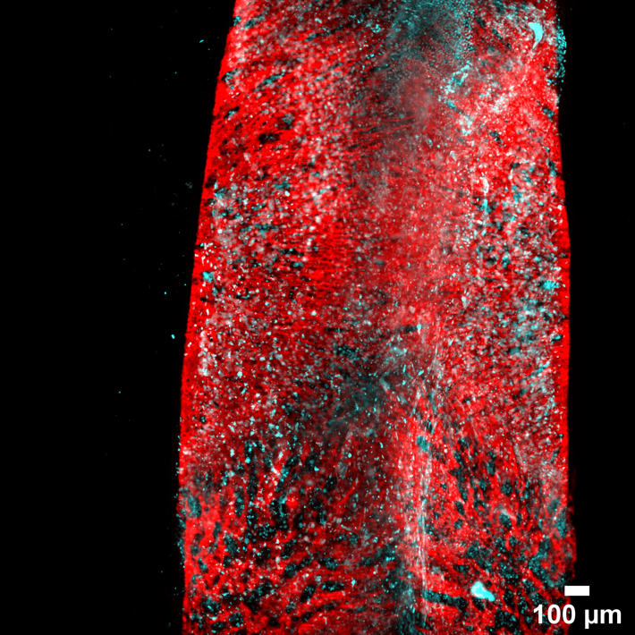
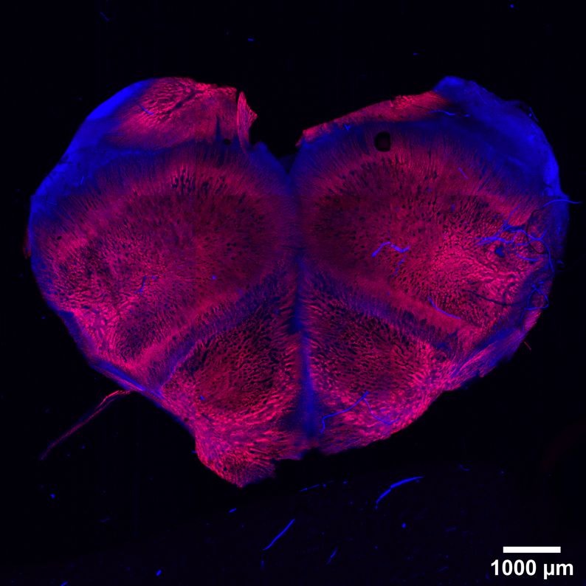

Discussion:
LSFM was successfully used to obtain a detailed 3D representation of P5 calvaria explants and compared to confocal microscopy.
LSFM provided an improved morphological understanding of bone cells and their activity using alkaline phosphatase and calcein blue fluorescent stains in P5 calvaria compared to standard histology
The CLARITY protocol did not disrupt fluorescence on the samples which were stained prior to tissue clearing.

Brief Resume of your Project’s outcomes: (no more than 200-250 words).
The title of your project and a brief 200-250 word description of the proposed/completed project. The description should include sufficient detail to be of general interest to a broad readership including scientists and non-specialists. Please also try to include 1-2 graphical images (minimum 75dpi). NB: Authors should NOT include sensitive material or data that they do not want disclosed at this time.

The Brief Resume of Project Outcomes is similar to the proposed Poster Submission Details.
Light Sheet Microscopy: A Novel Imaging Method for Assessment of Bone Formation using a Mouse Calvaria Model

Bone formation is a crucial part of skeletal development and is disrupted in diseases like Osteoporosis. Osteoporosis is characterized by a decrease in bone density and loss of structural integrity caused by an imbalance in Bone Remodelling.
Normally, bone formation is assessed using standard 2D histology. This method of assessment can be laborious and quite time consuming. 3D assessment of structure can be collected using MicroCT.

Light Sheet Fluorescent Microscopy is a microscopy technique that allows multiple fluorescent targets to be imaged quickly and without photodamage. Optical Sections allow the high-resolution isotropic 3D reconstruction of tissue in a non-destructive manner unlike standard histology methods.

Our outcome shows bone tissue, in a P5 Calvaria Mouse Model, can be optically cleared without disrupting fluorescent labelling used for Light Sheet Microscopy.
We also show samples can be labelled with multiple fluorescent stains for imaging.
For LSFM, samples need to be cut to size, to fit into a capillary tube. Therefore, to achieve optimal results with LSFM, confocal microscopy can be used first to outline different areas of interest on a sample.

Our project shows LSFM has potential as an effective method of histological assessment of bone. Using fluorescent labelling we can create full 3D images of a larger sample, compared to sectioned samples, or use LSFM to instantly view sections of a sample.

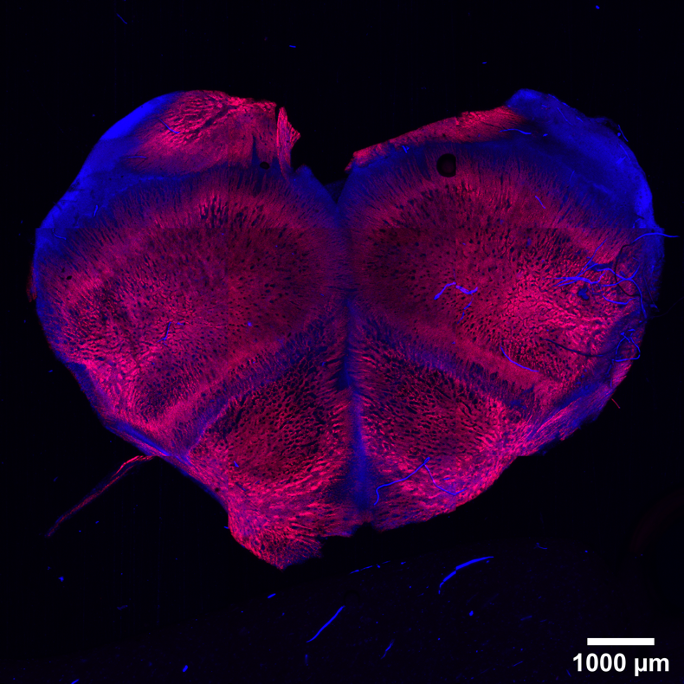

Other comments: (no more than 300 words)
- T.C. Fadero et al. J Cell Biol 2018
- Treweek J.B. et al. Nature Protocols. 2015

Signature of student...............Amit Kalra.............................Date……13/09/19……..

Signature of supervisor………Oran Kennedy........... Date……21/10/2019…….…

END OF FORM
----------------------------------------------------------------------------------------------------------------------------------------

File: USVRS 201819 KennedyKalraReportupload

