Patient History
A 20 year old female has come to the doctors with headaches and nausea. She has explained how she has fallen over a few times. Her speech seems slower and a little bit confused.
She has had no previous medical problems

Diagnostic Worksheet
Test 1 – Romberg’s Test

Experimental procedure:
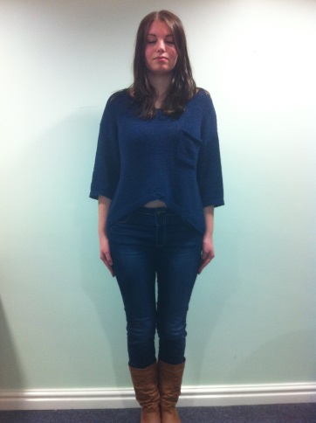
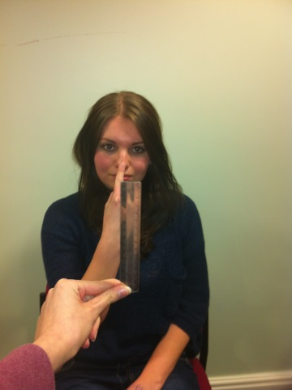
Make the patient stand with their feet together and eyes closed for 1 minute
What do you observe? eg. swaying
What do you observe? Is the finger reaching the ruler each time?

Test 2 – Finger to nose test
Experimental procedure:
With the patient seated, position a ruler in front of their face.
Get the patient to move their index finger between the ruler and
their nose
Change the position of the ruler each time
Test each hand

Test 3 – Alternating finger movements
Experimental Procedure:
Ask the patient to touch the tips of their fingers to their thumb.
Test both hands

Test 4- Alternating hand movements
Experimental procedure:
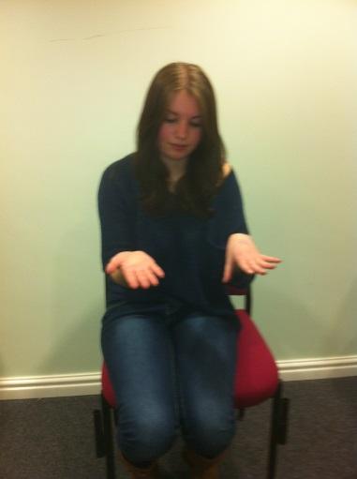
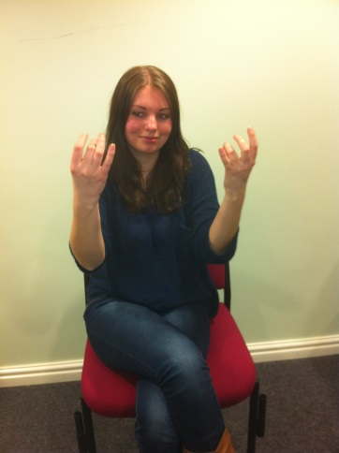
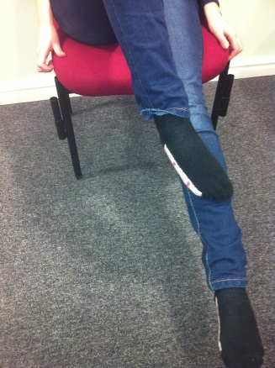
Ask the patient to first place their palm of the hand on their thigh,
What do you observe? How fast is the movement?
What do you observe? How fast is this movement?

What do you observe? Is the movement straight?

then the top of the hand.
Get them to alternate this rapidly
Test both hands

Test 5- Heel to shin test
Experimental procedure:
Get the patient to sit with their legs raised
Make them move one of their heels up and down the top of the other shin
Test both legs

