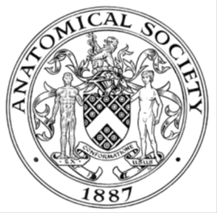
_______________________________________________________________________________________
AWARDEE REPORT FORM
_______________________________________________________________________________________

NAME |  | Lorna Brockbank
TWITTER HANDLE* optional
UNIVERSITY |  | University of St Andrews
NAME OF AWARD |  | Barclay-Smith Travelling Fund
PURPOSE OF AWARD conference/event attended/organised (full name) with city and dates.
Attending the Anatomical Society Summer Meeting 2026 in Bristol, 15th-17th of July 2026.

REPORT: What were your anticipated benefits?
Minimum number of words between 200-400. Please write in coherent paragraphs.
I was attending the Anatomical Society Summer Meeting in order to present the findings of my Master’s by Research degree. I spent a year researching arterial variations of the hand and this conference gave me the chance to present a poster to the wider anatomical community. This aimed to give me practice conveying my research to others and answer questions based on it, increasing my confidence in oral communication and in conveying complex concepts to other scientists. It also allowed me to showcase my skills and research background in the hopes of making myself known to other researchers, as I am looking for a PhD.

Another anticipated benefit of attending the conference was to network with other academics in my field. One aspect of this was to meet other early career anatomists so that I could get to know other young people who had similar experiences to me. This was especially important to me as I only work with two other young anatomists and I do not know of anyone from my undergraduate degree who is still working in anatomical academia. Another benefit of networking was to meet academics who are more experienced than myself. This was partly to put myself in a good position for any future opportunities that may come along, such as a PhD (as previously mentioned). However, I was also keen to meet more senior academics to gain their insights into the career I was beginning, and to hear any advice that they might have for the future.

Finally, at the conference I was hoping to hear about the research that is ongoing in the anatomical sciences, to learn about the most up-to-date developments in my field.

In summary, I attended the Anatomical Society Summer Meeting to present my research and to network with other anatomists.
COMMENTS: Describe your experience at the conference / lab visit / course / seminar/ event.
Minimum number of words between 200-400. Please write in coherent paragraphs.
The Anatomical Society Summer Meeting was a three day event, held in the anatomy department of the University of Bristol. I have included a photograph of myself at the conference. The first day began with a comparative anatomy workshop where we had the opportunity to examine the animal prosections held at the University. I was particularly interested in the snake prosections, as all of their organs are long and thin so that they could fit inside the body of the snake. There were Bristol anatomy students present to whom we could ask questions which greatly enhanced the experience. Additionally, we had the chance to try their virtual reality headsets to examine skeletons in a three-dimensional manner.
The talks began in the afternoon of the first day. A particularly interesting talk was given by the recipient of the Sophie Miller memorial prize, Lauren Barrett, about her PhD research into the role of the SKOR1 gene in Parkinson’s disease using mouse models. After they concluded, there was an early career anatomists’ social in the evening. This allowed me to get to know fellow young anatomists at the beginning of their careers and discuss our experiences as demonstrators and in postgraduate research. I have attached a photo I took of Bristol after the early careers social.
The second day was mainly focused on talks. A highlight of these was the presentation given by Kira Crabtree about her PhD research on the determinants of the head centre of mass in homo sapiens and pan troglodytes. She had quantified the mass of components of the head (e.g. the muscles of mastication and the brain) in order to determine which had the greatest contribution to the centre of mass in the head in each species. I was examined on my poster in the late afternoon by a panel of Anatomical Society committee members, allowing me to practice my presentation skills. The day ended with the gala dinner at a restaurant by the river. At this event, I managed to discuss possible next steps in my career with those who were more experienced than me.
The final day consisted of a morning of talks. My favourite was given by Professor Sorrel Langley-Hobbs, which focused on osteopetrosis in cats. She presented eight case reports of the cats she had come across in her career that had the condition, including images and descriptions of their symptoms.
Overall, I met many interesting people, and learnt about various anatomical fields of which I had relatively little knowledge.

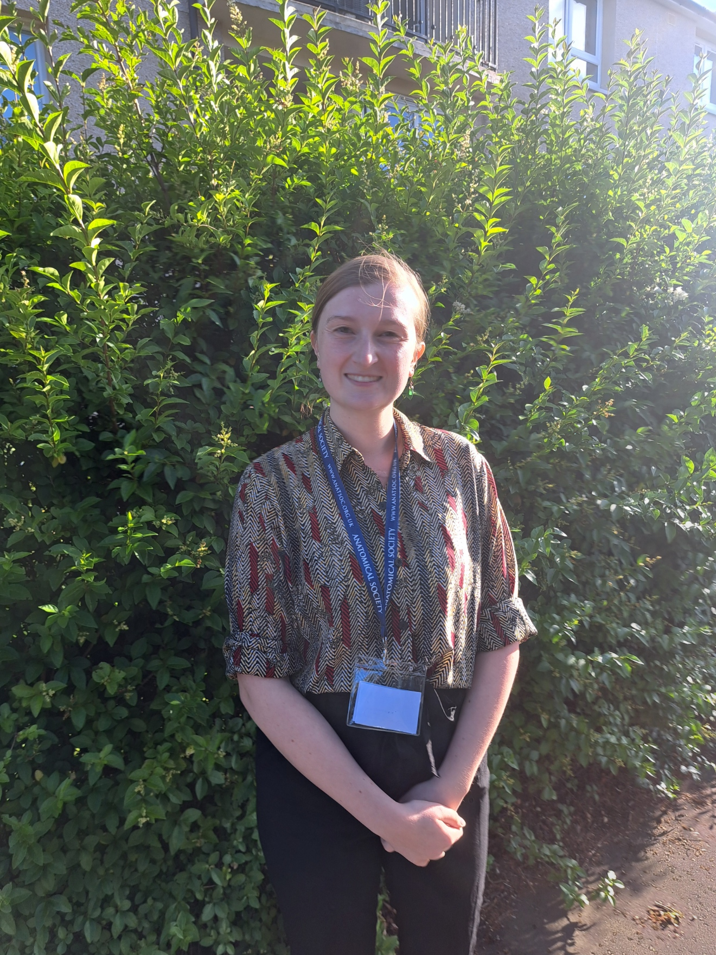
Image: me in Bristol during the conference.

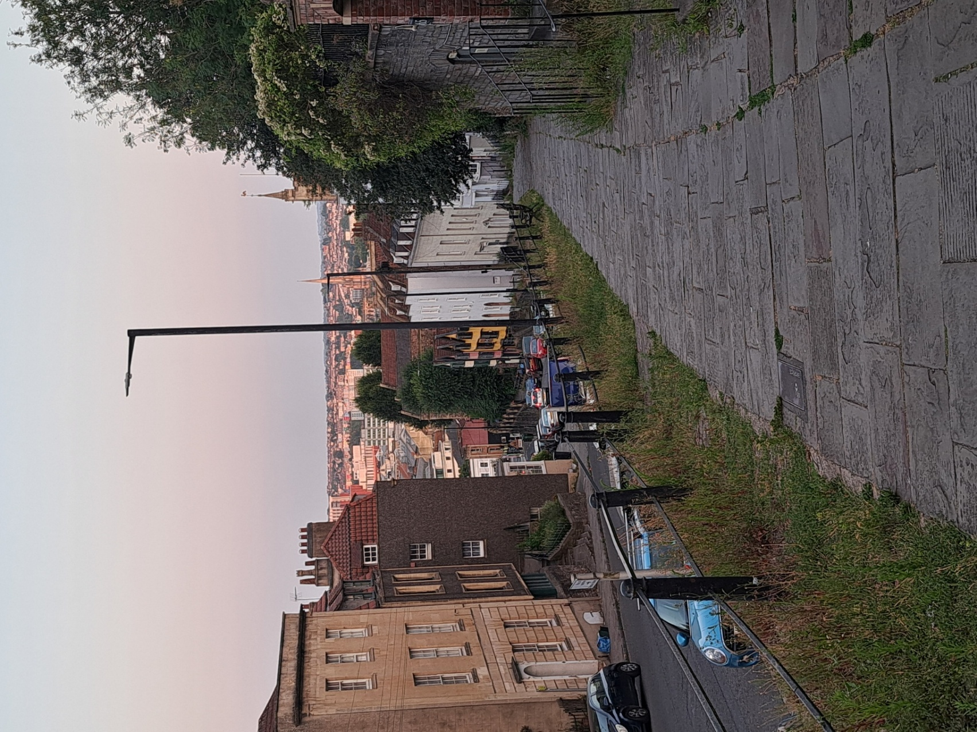
Image: the view of Bristol in the sunset after the early careers social.

REPORT: In relation to skills, what were the most important things you gained? (does not apply to equipment grant. For public engagement/outreach awards what did your audience gain and how did you evaluate success?
Minimum number of words between 200-400. Please write in coherent paragraphs.
As previously mentioned, my first aim of attending the conference was to showcase my research and gain familiarity with presenting a poster. During the poster sessions that were scattered throughout the conference, many different people came along to my poster with an interest in my research. This included senior academics and lecturers, my fellow demonstrators and postgraduate researchers, and technicians. Due to this, different individuals were interested in different aspects of my poster. In particular, one technician wanted to know how I had carried out the intra-arterial silicone injection in my project. This meant that I developed my oral communication skills to convey my research to other anatomists. What was especially important was learning how to condense the large amount of information that was in my 30,000 word thesis into an eye-catching poster, and how to further condense that into a short explanation of my project to anyone who visited it. This is something that I have only done once before in my poster presentation for my honours project, so another chance to practice was extremely valuable.

My second aim of attending the conference was to network with other anatomists, both those who were at the same stage as me and more senior academics. I managed to do this throughout the conference, during the poster presentations and the evening social events. Networking is a vital skill in academia as it allows for collaboration in projects and for sharing ideas and advice. Since I do not know many anatomists, this greatly expanded the number of people I know in the field, increasing my chances of becoming aware of future opportunities.

REPORT: How do you think you will put this learning experience into practice in the future? For public engagement/outreach awards how with the materials/knowledge generated by this activity be used in the future?
Minimum number of words between 200-400. Please write in coherent paragraphs.
My long-term goal is to become a senior member of anatomical academic staff, both in teaching and research. At the Summer Meeting I received a large amount of advice about how my future career could look and about the skills and qualifications that I would need to be able to succeed. Hearing first-hand from people more experienced and senior than me was invaluable, and it solidified for me that I am in the correct career. Additionally, since I am hoping to become a PhD student in the near future, it meant that I became more aware of possible areas of focus for future opportunities.

Moving forwards, I hope to continue anatomical research and keep presenting it to the wider academic community. Conferences such as these give me a platform to showcase my work and practise conveying it to other anatomists. Hopefully, I will progress from poster presentations to oral presentations, and become more confident over time. Since I would like to become a lecturer eventually, these communication skills are vital. Additionally, the cutting-edge scientific research from the talks fascinated me. When I return to demonstrating in September, I will be well-versed in recent developments in anatomy, which I can pass onto students in my classes. Hopefully this will inspire them to consider attending the Anatomical Society Meetings, bringing the next generation of anatomists after me.
Data Protection/GDPR: I consent to the data included in this submission being collected, processed and stored by the Anatomical Society. Answer YES or NO in the Box below
YES
Graphical Images: If you include graphical images you must obtain consent from people appearing in any photos and confirm that you have consent. A consent statement from you must accompany each report if relevant. A short narrative should accompany the image. Answer N/A not applicable, YES or NO in the box below
N/A
Copyright: If you submit images you must either own the copyright to the image or have gained the explicit permission of the copyright holder for the image to be submitted as part of the report for upload to the Society’s website, Newsletter, social media and so forth. A copyright statement must accompany each report if relevant. Answer N/A not applicable, YES or NO in the box below
N/A

SIGNATURE |  |  | DATE | 28/7/26
If submitted electronically, a type-written name is acceptable in place of a hand-written signature
File: AS-Award-Report-Form-171023 – International Conference

