UNDERGRADUATE SUMMER VACATION SCHOLARSHIP AWARDS – FINAL SUMMARY REPORT FORM 2025/26
NB: This whole report will be posted on the Society’s website therefore authors should NOT include sensitive material or data that they do not want disclosed at this time.

Name of student:

Magdalena Nedelinova Georgieva

Twitter Handle*: N/A

Name of supervisor(s):
James Sleigh, Sijiang Lui

Project Title: (no more than 220 characters)
Morphological evaluation of motor and sensory neurons in a new mouse model for SORD neuropathy

Project aims: (no more than 700 words)
The overall aim of this project was to determine how loss of sorbitol dehydrogenase (SORD) and the resulting accumulation of sorbitol affect the morphology of peripheral sensory and motor neurons.

Biallelic mutations in SORD are the most frequent cause of recessive peripheral neuropathy, yet the anatomical changes underlying the neurological dysfunction remain uncharacterised. Previous work has generated a Sord^{c.757delG} mouse model that reproduces the characteristic loss of SORD protein and subsequent sorbitol accumulation seen on patients. Longitudinal phenotyping of these mice has identified an age-dependent decline in sensory function, with impaired thermal nociception evident from three months and proprioceptive dysfunction developing by six months. Interestingly, however, there has been no clear impairment in muscle endurance or maximal strength, and no obvious abnormalities in neuromuscular junction morphology or innervation by 12 months.

Considering this, the primary aim of this project was therefore to provide a detailed anatomical assessment of the peripheral nervous system in 12 month-old wild-type, heterozygous and homozygous Sord^{c.757delG} mice. By comparing these genotypes, I aimed to establish whether the selective sensory dysfunction is accompanied by detectable changes in neuronal subtype composition, morphology, or number, and whether the relative preservation of motor function is reflected in the motor neuron anatomy.

The first objective was to characterise sensory neurons within the dorsal root ganglia (DRG) of the mice. To accomplish this, lumbar DRG sections needed to be stained with NF200 and peripherin to respectively distinguish large-area sensory neurons, including mechanoreceptors and proprioceptors, from smaller-area nociceptors (Figure 1). The proportions of these sensory subtypes can then be quantified from confocal microscopy images. This would allow us to determine whether SORD deficiency alters the sensory neuron populations and whether such changes could contribute to the previously observed deficits in thermal nociception and proprioception.

The second objective was to characterise motor neurons within the lumbar spinal cord. For this, sections were stained using choline acetyltransferase (ChAT) and neuronal nuclei (NeuN) to enable quantification and measurement of motor neuron cell bodies, including alpha and gamma motor neurons (Figure 2). These analyses would determine whether SORD deficiency produces quantifiable changes in motor neuron number or size despite the absence of measurable reductions in muscle strength or endurance.

We hypothesised that there would be relatively limited morphological changes in motor neurons, consistent with the preserved motor phenotype of homozygous mutant mice. However, we anticipated that more subtle alterations may be identified within sensory neuron populations, including perhaps changes in the relative proportions of the sensory subtypes involved in nociception and proprioception.

By the end of the project, we aimed to generate a quantitative anatomical dataset linking neuronal morphology with the functional phenotype of the SORD-CMT model. The findings aimed to provide important evidence for understanding how sorbitol accumulation selectively affects the peripheral nervous system and will complement the existing behavioural and molecular characterisation of the model. Ultimately, we aimed to collate a dataset that will strengthen the anatomical understanding of SORD-related neuropathy and contribute to the wider investigation of mechanisms underlying selective peripheral nerve dysfunction in CMT, building scope for future research and potential treatment pathways.

Project Outcomes and Experience Gained by the Student (no more than 700 words)
To achieve the above outlined aims, I had to allocate my time in the lab into four different stages: 1) sectioning, 2) staining, 3) imaging and 4) analysing. Each of which came with their own challenges and improvements.

My first task was sectioning of the mouse DRG and spinal cords. To achieve this, I used the cryostat machine in order to obtain twenty and thirty-micrometre sections, respectively. Cutting them cleanly onto slides required a level of hand-eye coordination, which I had to build up session-by-session. One skill that I especially developed throughout this was learning how to identify viable samples from sections not worth keeping, and collating them properly.

Once all of the sections were collected, I had to stain them. This turned out to be where I learned the most. My aim was to label DRG sections with NF200 and peripherin to differentiate the larger mechanoreceptor and proprioceptor neurons from the smaller nociceptors, as well as calcitonin gene-related peptide (CGRP) (Figure 1), and to label spinal cord sections with ChAT and NeuN to count and measure motor neuron cell bodies (Figure 2). In practice, my first attempts did not go to plan. The antibody concentrations did not produce reliable signal, and I had to repeat the staining several times, correcting concentrations and washing steps before the images came out cleaner and interpretable.

Once staining of the samples was completed, I successfully imaged two out of the three cohorts of DRG and spinal cord tissue using confocal microscopy, generating a substantial image dataset across all genotypes. These images are of good quality and suitable for downstream quantitative analysis. The process of imaging once again required iterative optimisation as I became more skilled at adjusting the specific image settings and improved my use of tools on the imaging software, such as using the tile tool to map out my slides for more reliable imaging. Beyond the specific techniques, I developed a strong working knowledge of confocal microscope image acquisition parameters, the importance of consistent imaging settings for downstream quantification, as well as blinded image analysis principles to reduce bias.

However, due to the time invested in repeating the staining protocol, I was not able to complete the full quantification and statistical analysis of sensory neuron subtype proportions and motor neuron counts/size within the scholarship period; this analysis is still in progress and I am continuing to work through the image sets to extract the quantifiable dataset originally proposed.

Perhaps the most important thing I learned was resilience and adaptability in the face of technical setbacks. Mistakes made during the process of learning these techniques meant I had to substantially revise my working timetable, prioritising getting the staining right over rushing into imaging and analysis with suboptimal data. This experience gave me a much more realistic understanding of the pace and unpredictability of scientific research, compared to the more structured pace of taught practical classes, and has reinforced my interest in pursuing further research experience alongside future clinical training.

Overall, while I was not able to complete full quantification within the proposed six weeks, I leave this Scholarship with a solid technical foundation in tissue sectioning, immunohistochemistry, and confocal imaging, a valuable dataset of images currently being analysed, and a much clearer understanding of what a career in anatomical and translational neuroscience research involves.
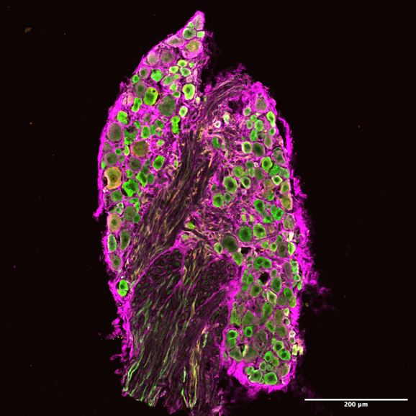

Figure 1. Immunofluorescence image of a DRG section (20x) stained for three neuronal markers: NF200 (magenta), a marker of myelinated, large-diameter A-fibre sensory neurons; peripherin (green), a marker of small-diameter, unmyelinated C-fibre neurons; and CGRP (orange), a neuropeptide marker of peptidergic nociceptive sensory neurons. Scale bar, 200 µm.

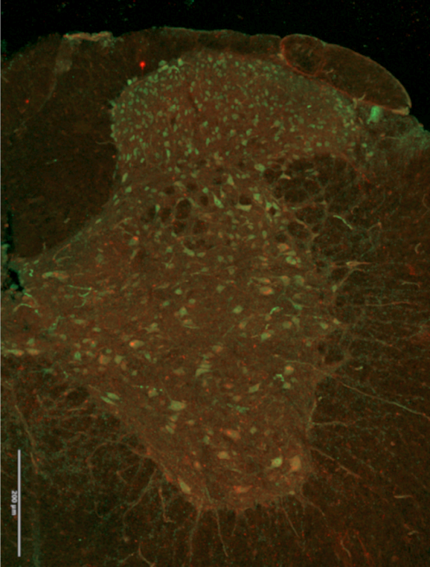

Figure 2. Immunofluorescence image of a spinal cord section (20x) stained for ChAT (red), a marker of cholinergic motor neurons, and NeuN (green), a pan-neuronal marker labeling neuronal cell bodies. Scale bar, 200 µm.

Please state which Society Winter or Summer Meeting the student is intending to present his/her poster at:
Not yet determined, but it will either be Winter 2026 or Summer 2027, depending on the meeting focus.

Proposed Poster Submission Details (within 12 months of the completion of the project) for an AS Winter/ Summer Meeting – (no more than 300 words)
Potential Title: Morphological analysis of motor and sensory neurons in mice modelling SORD neuropathy.

Details to be confirmed once final analyses have been completed over the coming months.

Brief Resume of your Project’s outcomes: (no more than 200-250 words).
The title of your project and a brief 200-250 word description of the proposed/completed project. The description should include sufficient detail to be of general interest to a broad readership including scientists and non-specialists. Please also try to include 1-2 graphical images (minimum 75dpi). NB: Authors should NOT include sensitive material or data that they do not want disclosed at this time.

Morphological analysis of motor and sensory neurons in mice modelling SORD neuropathy

Charcot-Marie-Tooth disease (CMT) is the most common inherited condition affecting the peripheral nerves, causing life-long problems with sensation and movement. One of the most frequent genetic causes of the recessive form of this disease is loss of SORD gene function, which leads to a build-up of a sugar alcohol called sorbitol in nerve tissue. Using a new mouse model carrying this mutation, my project aimed to investigate how sorbitol accumulation affects the structure of sensory and motor neurons, the nerve cells responsible for feeling and movement, in order to help explain why affected mice (and translationally patients) experience sensory problems, such as reduced pain and proprioceptive sensation, while muscle strength remains largely unaffected (in the mice).

Over the course of the Scholarship, I learned to prepare, section and stain nervous tissue from the dorsal root ganglia and spinal cord of wild-type, heterozygous and homozygous mice, using antibody labelling to distinguish different neuron subtypes under a confocal microscope. Following these steps I successfully imaged tissue from all three genotype groups, generating a high-quality image dataset that is now being analysed to quantify differences in neuron number, size and subtype composition between groups. This work will help build a clearer anatomical picture of how sorbitol accumulation selectively damages sensory, but not motor, nerve pathways, contributing to the wider understanding of CMT and supporting future development of targeted treatments.

Other comments: (no more than 300 words)
N/A

Data Protection/GDPR: I consent to the data included in this submission being collected, processed and stored by the Anatomical Society. Answer YES or NO in the Box below
YES

Graphical Images: If you include graphical images you must obtain consent from people appearing in any photos and confirm that you have consent. A consent statement from you must accompany each report if relevant. A short narrative should accompany the image. Answer N/A not applicable, YES or NO in the box below
YES
Copyright: If you submit images you must either own the copyright to the image or have gained the explicit permission of the copyright holder for the image to be submitted as part of the report for upload to the Society’s website, Newsletter, social media and so forth. A copyright statement must accompany each report if relevant. Answer N/A not applicable, YES or NO in the box below
YES

Signature of student......................................Date…26/08/2026………..

Signature of supervisor……………….............. Date…26/08/2026……….…

END OF FORM
----------------------------------------------------------------------------------------------------------------------------------------
File: USVRS Award Letter 2026 TEMPLATE V4FINAL JMJOM 270526 SLEIGH

File: USVRS 202526 Report Sleigh website no sig

