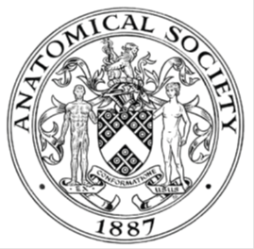
_______________________________________________________________________________________
AWARDEE REPORT FORM
_______________________________________________________________________________________

NAME |  | Catrin Rutland
UNIVERSITY |  | University of Nottingham
NAME OF AWARD |  | Anatomy for All – Making Anatomy Accessible
PURPOSE OF AWARD conference/event attended/organised (full name) with city and dates.
The purpose of this award was outreach and primary focused on producing scientific papers for young people - an innovative and forward thinking outreach opportunity, combining accessible science and the creative arts to engage people. The papers published by Frontiers reach people on a global basis from all socio-economic groups, they are inclusive, develop external relations and research impact, encourage scientific and creative teaching and learning, and highlight anatomical research and teaching excellence to the public. This project happened throughout 2020 with work carried out from the University of Nottingham and partners including the Ulster University, Twycross zoo, a teacher, industry and a science communication artist.

REPORT: What were your anticipated benefits?
The aims of our outreach were to:
- Create a minimum of 4 scientific papers for publication in the journal ‘Frontiers Young Minds’ for worldwide coverage of anatomy/anatomical based research. Full credit will be given to The Anatomical Society in the acknowledgements section of each paper, in addition to publicity releases.

- Design and create scientific art resources for use in the scientific papers and additionally for outreach and widening participation activities undertaken by The Anatomical Society and its members. Copies of the art will be available for use by all members, on the web site, for marketing materials and any other uses.

The papers aimed to portray science, especially anatomy/microanatomy, to the public which could also be used as a resource for teachers, parents and indeed the Anatomical Society and members and by other scientists as part of their outreach and engagement programmes. In addition I wanted to bring together art and science to present anatomy in a fun and innovative way.

We also wanted to reach a worldwide audience of children and adults, those in the academic world and those with no connections to anatomy or academia. Our predicted outreach was 15,000 views/downloads in the first year of publication plus outreach/engagement events and encouraging our undergraduate students who helped author some of the papers as vacation projects.

COMMENTS: Describe your experience at the conference / lab visit / course / seminar/ event.
The purpose of this grant was to produce 4 scientific papers for children and some line art from the papers for use in outreach by AS members. We also hoped for 15,000 downloads/views for the papers combined within 12 months of their publication dates. Over the last 10 months we have successfully produced 6 scientific papers with support from the Anatomical Society, which blended art and science. To date three have been published by the journal Frontiers Young Minds, an additional two have been accepted for publication in the same journal and a further paper has been completed and sent out for review by Frontiers.

We have produced the following papers:
- Blood Vessels Under the Microscope. (2020) Machado, M., Mitchell, C., Franklin, J., Thorpe, A., Rutland, C,S. Front. Young Minds. 8:151. doi: 10.3389/frym.2019.00151 https://kids.frontiersin.org/article/10.3389/frym.2019.00151 Published 13th January 2020 Altmetric score of 12.
- Can Toothache Cause Heartbreak? (2020) Clark, N., Skinner, Z., Rutland, C.S. Front. Young Minds 8:87. doi: 10.3389/frym.2020.00087
https://kids.frontiersin.org/article/10.3389/frym.2020.00087 Published 8th July 2020. Altmetric score of 8.
- Hearts, and the heartless, in the animal kingdom. (2020) Alibhai, A., Stanford, K., Rutland, S., Rutland, C.S. Front. Young Minds. 8:540440. doi: 10.3389/frym.2020.540440 https://kids.frontiersin.org/article/10.3389/frym.2020.540440 Published 02/10/2020.
- The Importance of Anatomy. Stanford, K., Rutland, S., Sturrock, C, J., Rutland, C.S. Accepted 14th June 2020 by Frontiers Young Minds.
- Skeleton growth in guinea pigs and humans. Skinner, Z., Clark, N., Rutland, S., Rutland, C.S. Accepted 30th July 2020 by Frontiers Young Minds.
- Discovery of a bone in chimpanzee hearts. Sturrock, C.J. Stanford, K., Moittie, S., Baiker, K., Redrobe, S., Rutland, C.S. Under review at Frontiers Young Minds.

PDFs of the above are all attached to the email.

The authors consisted of: 14 people from across differing career stages, with 2 undergraduate and 2 postgraduate students, 1 post-doctoral researcher, 2 technicians, 3 academics, 1 director and CEO of Twycross zoo, 1 independent artist/science communicator, 1 primary school teacher and 1 scientist in industry, from across the UK, Ireland and Portugal.

In addition to presenting different authors as role models for young people, we tried to highlight people from different backgrounds and cultures within our papers with careful consideration of gender and BAME. A good example is in the ‘Importance of Anatomy’ where we highlight historical figures ranging from Egypt, USA and UK, male and female, the first African American female doctor and other interesting people. We also highlighted the range of activities and careers that anatomists undertake, and the types of people who use anatomy.

Paper download successes to date: ‘Blood vessels under the microscope’ hit 5000 views in under 4 months, ‘Can toothache cause heartache’ hit 1000 in just 3 days. In total for the 2 papers published so far (10 months and 3 months) we have had 18,144 views/downloads, so we are confident that for all 6 papers across 12 months we will more than surpass 15,000 views/downloads for all papers. Our twitter campaign on the first two papers published had 13,265 impressions from Dr Rutlands personal twitter account alone, and in the first 12 hours our tweets had reached over 700 people for the third paper. We would also like to thank The Anatomical Society for helping to share the word on social media and also thank Anatomical Society members for enthusiastically sharing the word too. I even noticed the British Science Association sharing our work. In addition to sharing on social media (Twitter/Facebook/Instagram) and views via the Frontiers marketing campaign, I have also been invited to write a Blog on the papers for The University of Nottingham, and discussed the papers in a podcast interview for ‘STEMM Storytellers’.

Unexpected outcomes were the joy of writing for young people and getting paper acceptances (especially for our early career researchers gaining their first publication), especially during the difficult covid-19 lockdown period. One of our graduating undergraduates also gained a research post graduate place based on the strength of her CV which included this work. Another unexpected outcome is that Frontiers have started translating papers into Hebrew, one of my previous papers has already been translated and we are hoping these papers might be too.

REPORT: In relation to skills, what were the most important things you gained? (does not apply to equipment grant. For public engagement/outreach awards what did your audience gain and how did you evaluate success?
When I wrote this grant, little did I know that the need for scientific provisions online would become so important for home-schooling. Our team quickly became aware that the pandemic may affect young people, therefore instead of writing the articles in 12 months we completed the work within 6 months and added two more papers. We have had thousands of views/downloads from around the world in nearly every country. Our young reviewers (themselves from 10 different countries) gave wonderful feedback about how they had enjoyed the papers. In addition it was noted that home schooling websites were utilising our papers as part of their curriculum.

Some feedback from young people/young reviewers/parents/guardians/scientists from all over the world:

- I found the history section most interesting as I learnt how ancient the study of anatomy actually is, beginning from the prehistoric times up until now. I'm particularly interested in the involvement of women in the study of anatomy. I also know that, in the 1800's, when women were considered to be "weak" and "would probably faint during a dissection", women like Elisabeth Blackwell (the first American female doctor) and Elisabeth Garrett Anderson (the first female British doctor) proved society wrong, just like Mary Shelley and Anna Morandi Manzolini.
- The figures and images were the most interesting parts and were cute
- Being myself the Head of Anatomy at my University, I found this article EXTREMELY interesting and very well written. In fact, once published, I will definitely distribute it to the young adolescents who visit our Department during the summer school. It was very well received by the Young Reviewer, and she looks foward to more articles on similar subjects outlining the basic sciences.
- Ooooo my girls will love this.
- Great read for kids and adults about all different kind of hearts which includes a nice video of a baby chicks heart beating.
- Brilliant - love this! What a great idea for a journal as well!
- I believe that most people do not know what is different about the species in relation to the heart. Therefore, I believe that this work can help to share this information. In addition, it brings special information about the giraffe's heart, the analogy made is fantastic.

REPORT: How do you think you will put this learning experience into practice in the future? For public engagement/outreach awards how with the materials/knowledge generated by this activity be used in the future?
We hope that the materials (papers and artwork) will have an ongoing impact. The papers will remain open access on the internet. We will continue to advertise all of the papers through Frontiers Young Minds, a Blog we are writing for The University of Nottingham, via the podcast and via social media. The papers can be used by teachers, parents, other scientists undertaking outreach at any time, by anyone throughout the world. We hope we may have highlighted the journal to Anatomical Society members too, who may feel inspired t write one. Certainly I am very happy to help support anyone if they have questions. I even used the papers in widening participation outreach with 16-18 years old conducted remotely, the young people used the papers as inspiration to write their own papers.
Data Protection/GDPR: I consent to the data included in this submission being collected, processed and stored by the Anatomical Society. Answer YES or NO in the Box below
Yes
Graphical Images: If you include graphical images you must obtain consent from people appearing in any photos and confirm that you have consent. A consent statement from you must accompany each report if relevant. A short narrative should accompany the image. Answer N/A not applicable, YES or NO in the box below
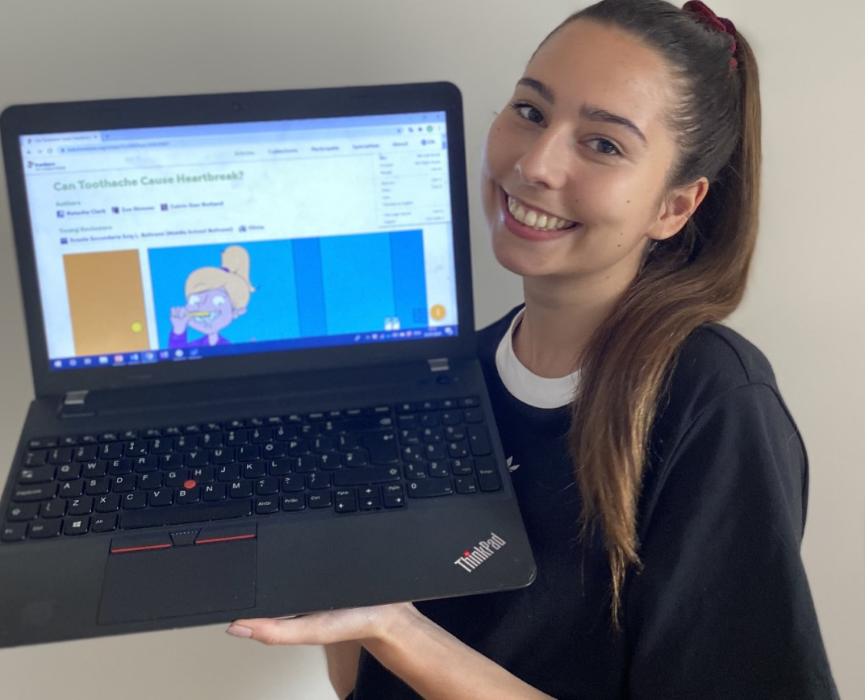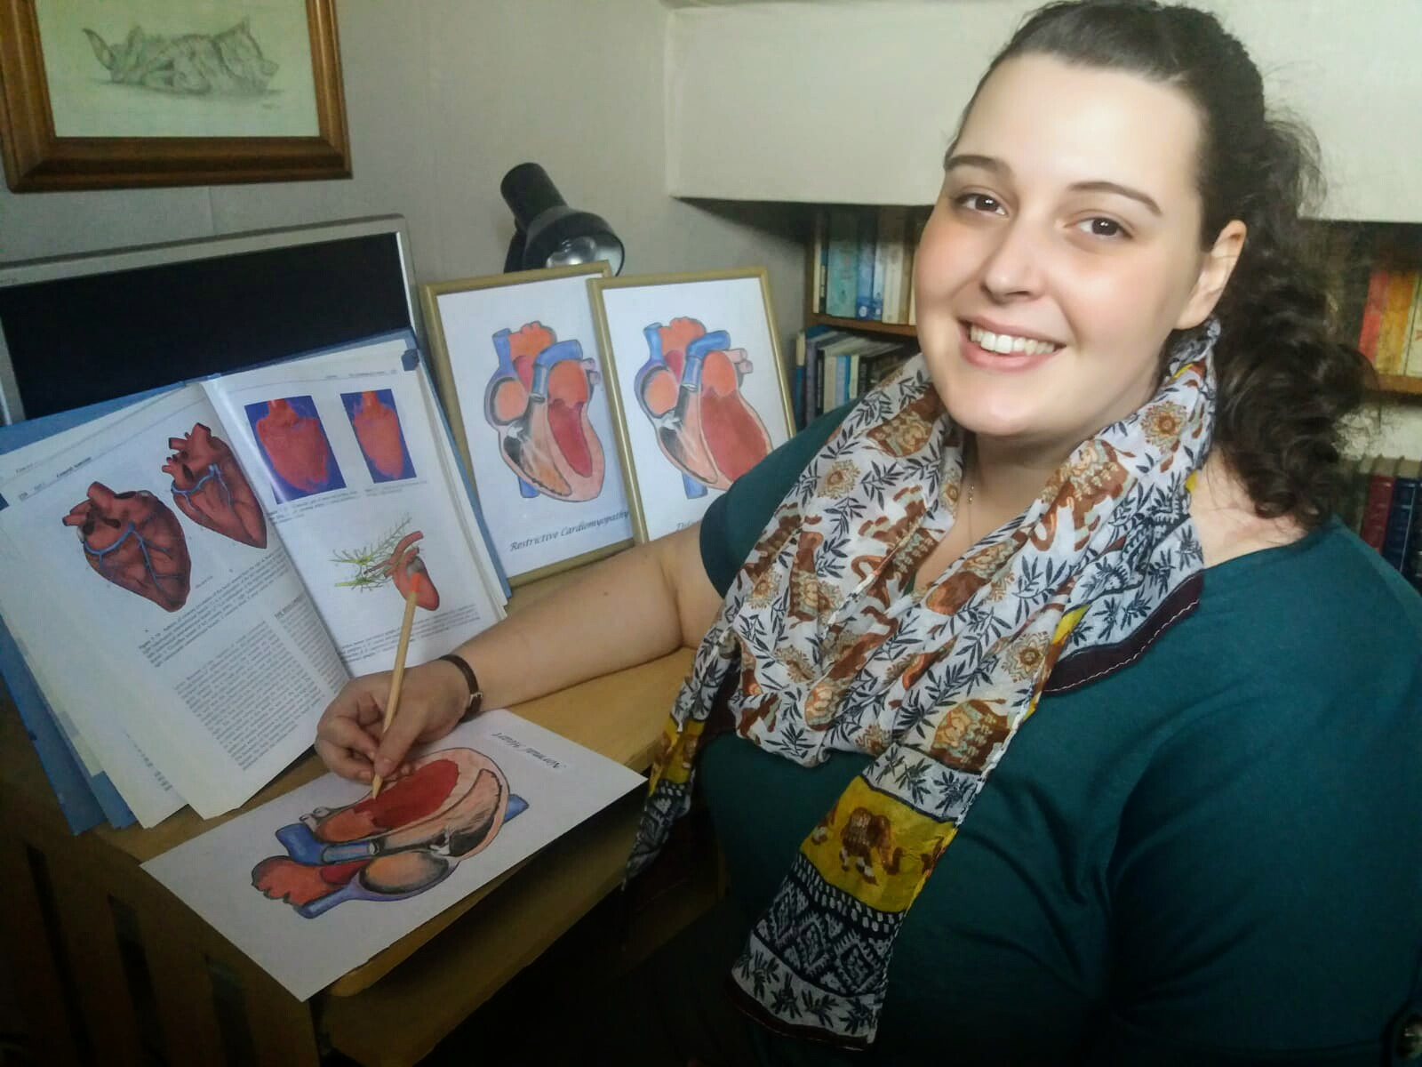
Undergraduate student authors Zoe Skinner (left) proudly showing one of our published papers and Natasha Clark (right) working on one of the papers for young people. Both have given consent for the photos to be used, they took the photos themselves so we own the copyright.
As a small part of the grant our artist produced ‘colouring in science’ pictures for young people, line art of the pictures used in some of our papers. These are included below and are copyright free:

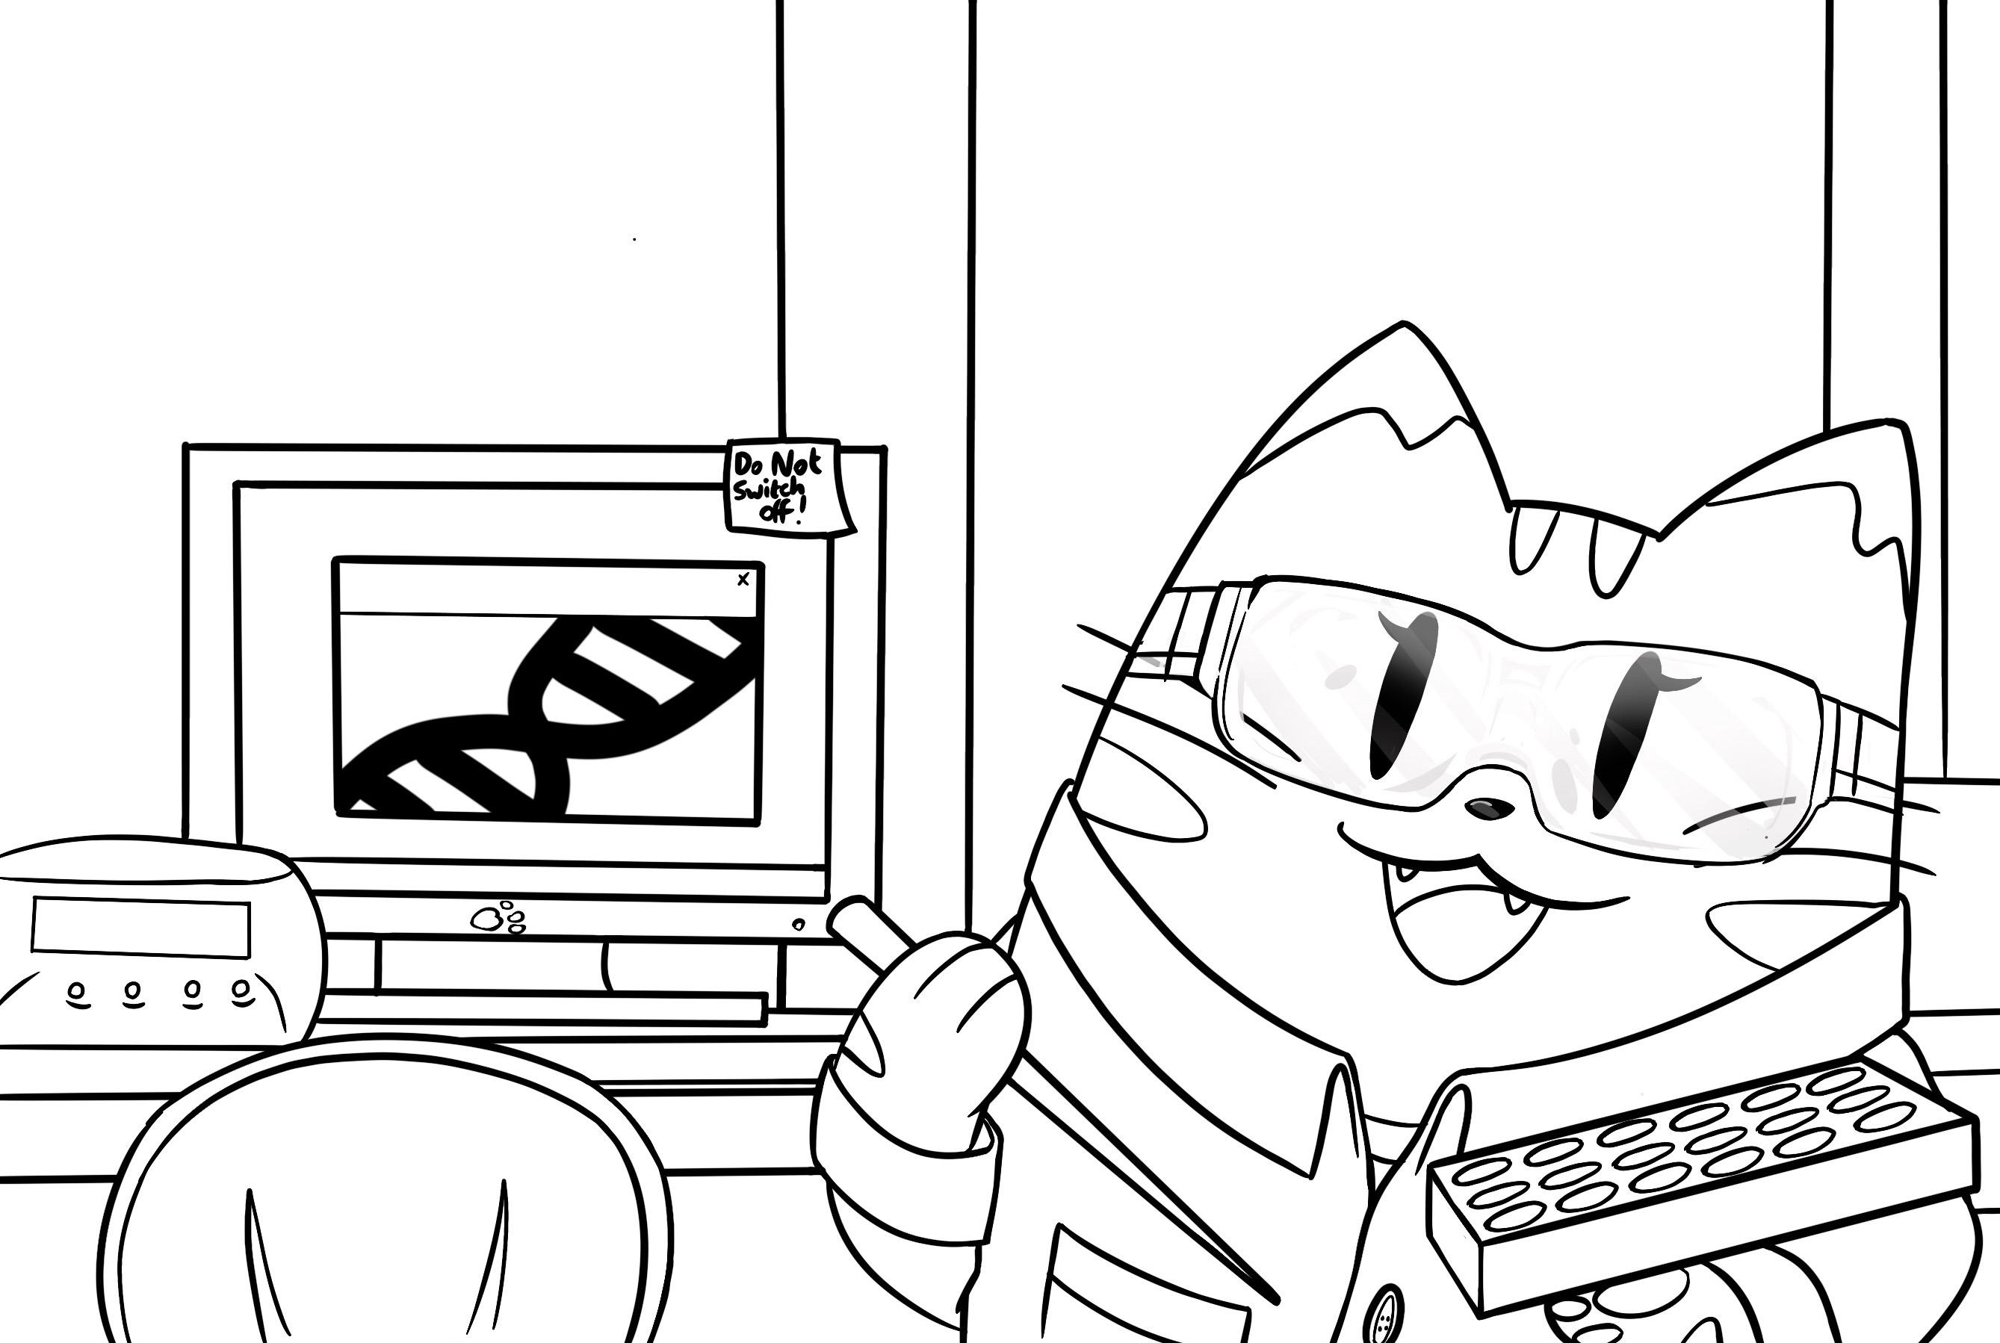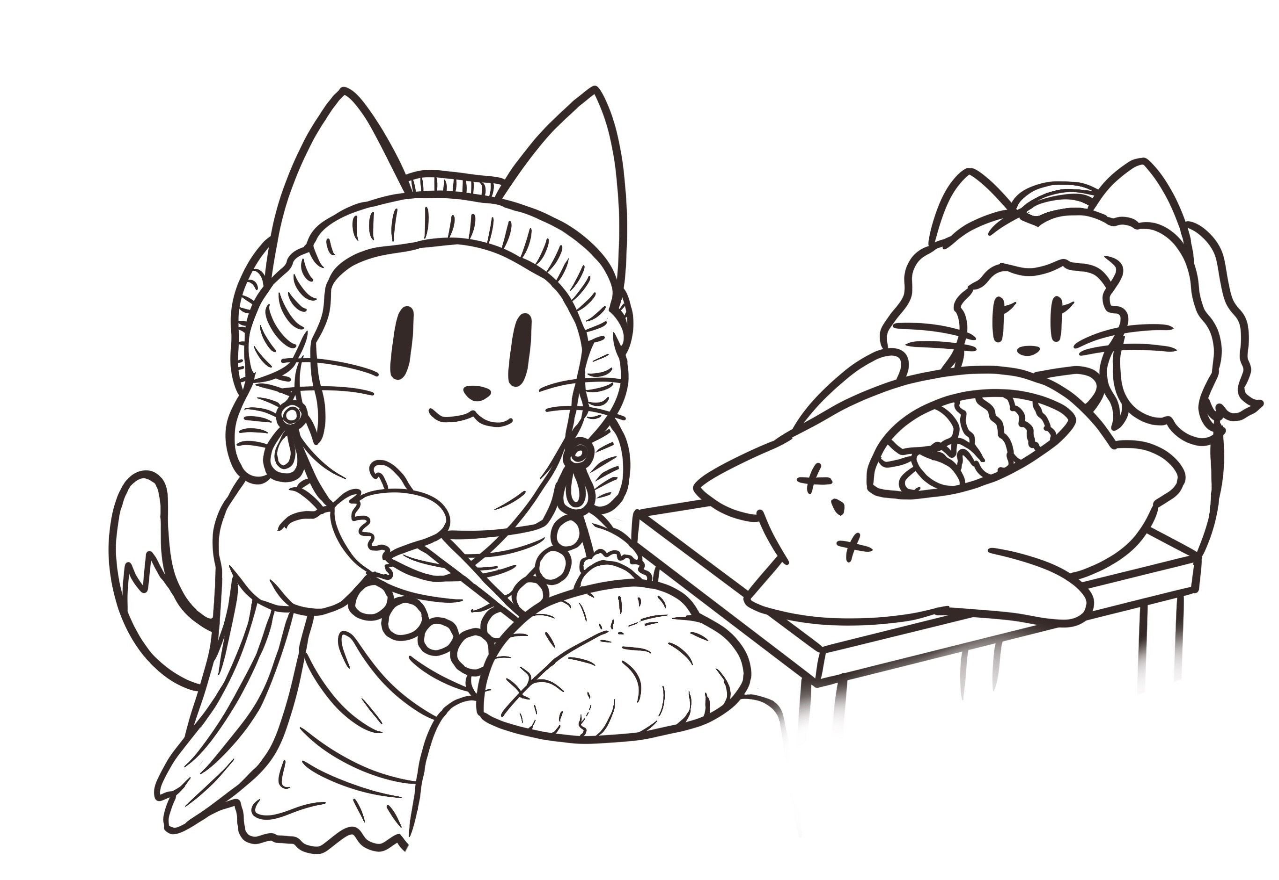

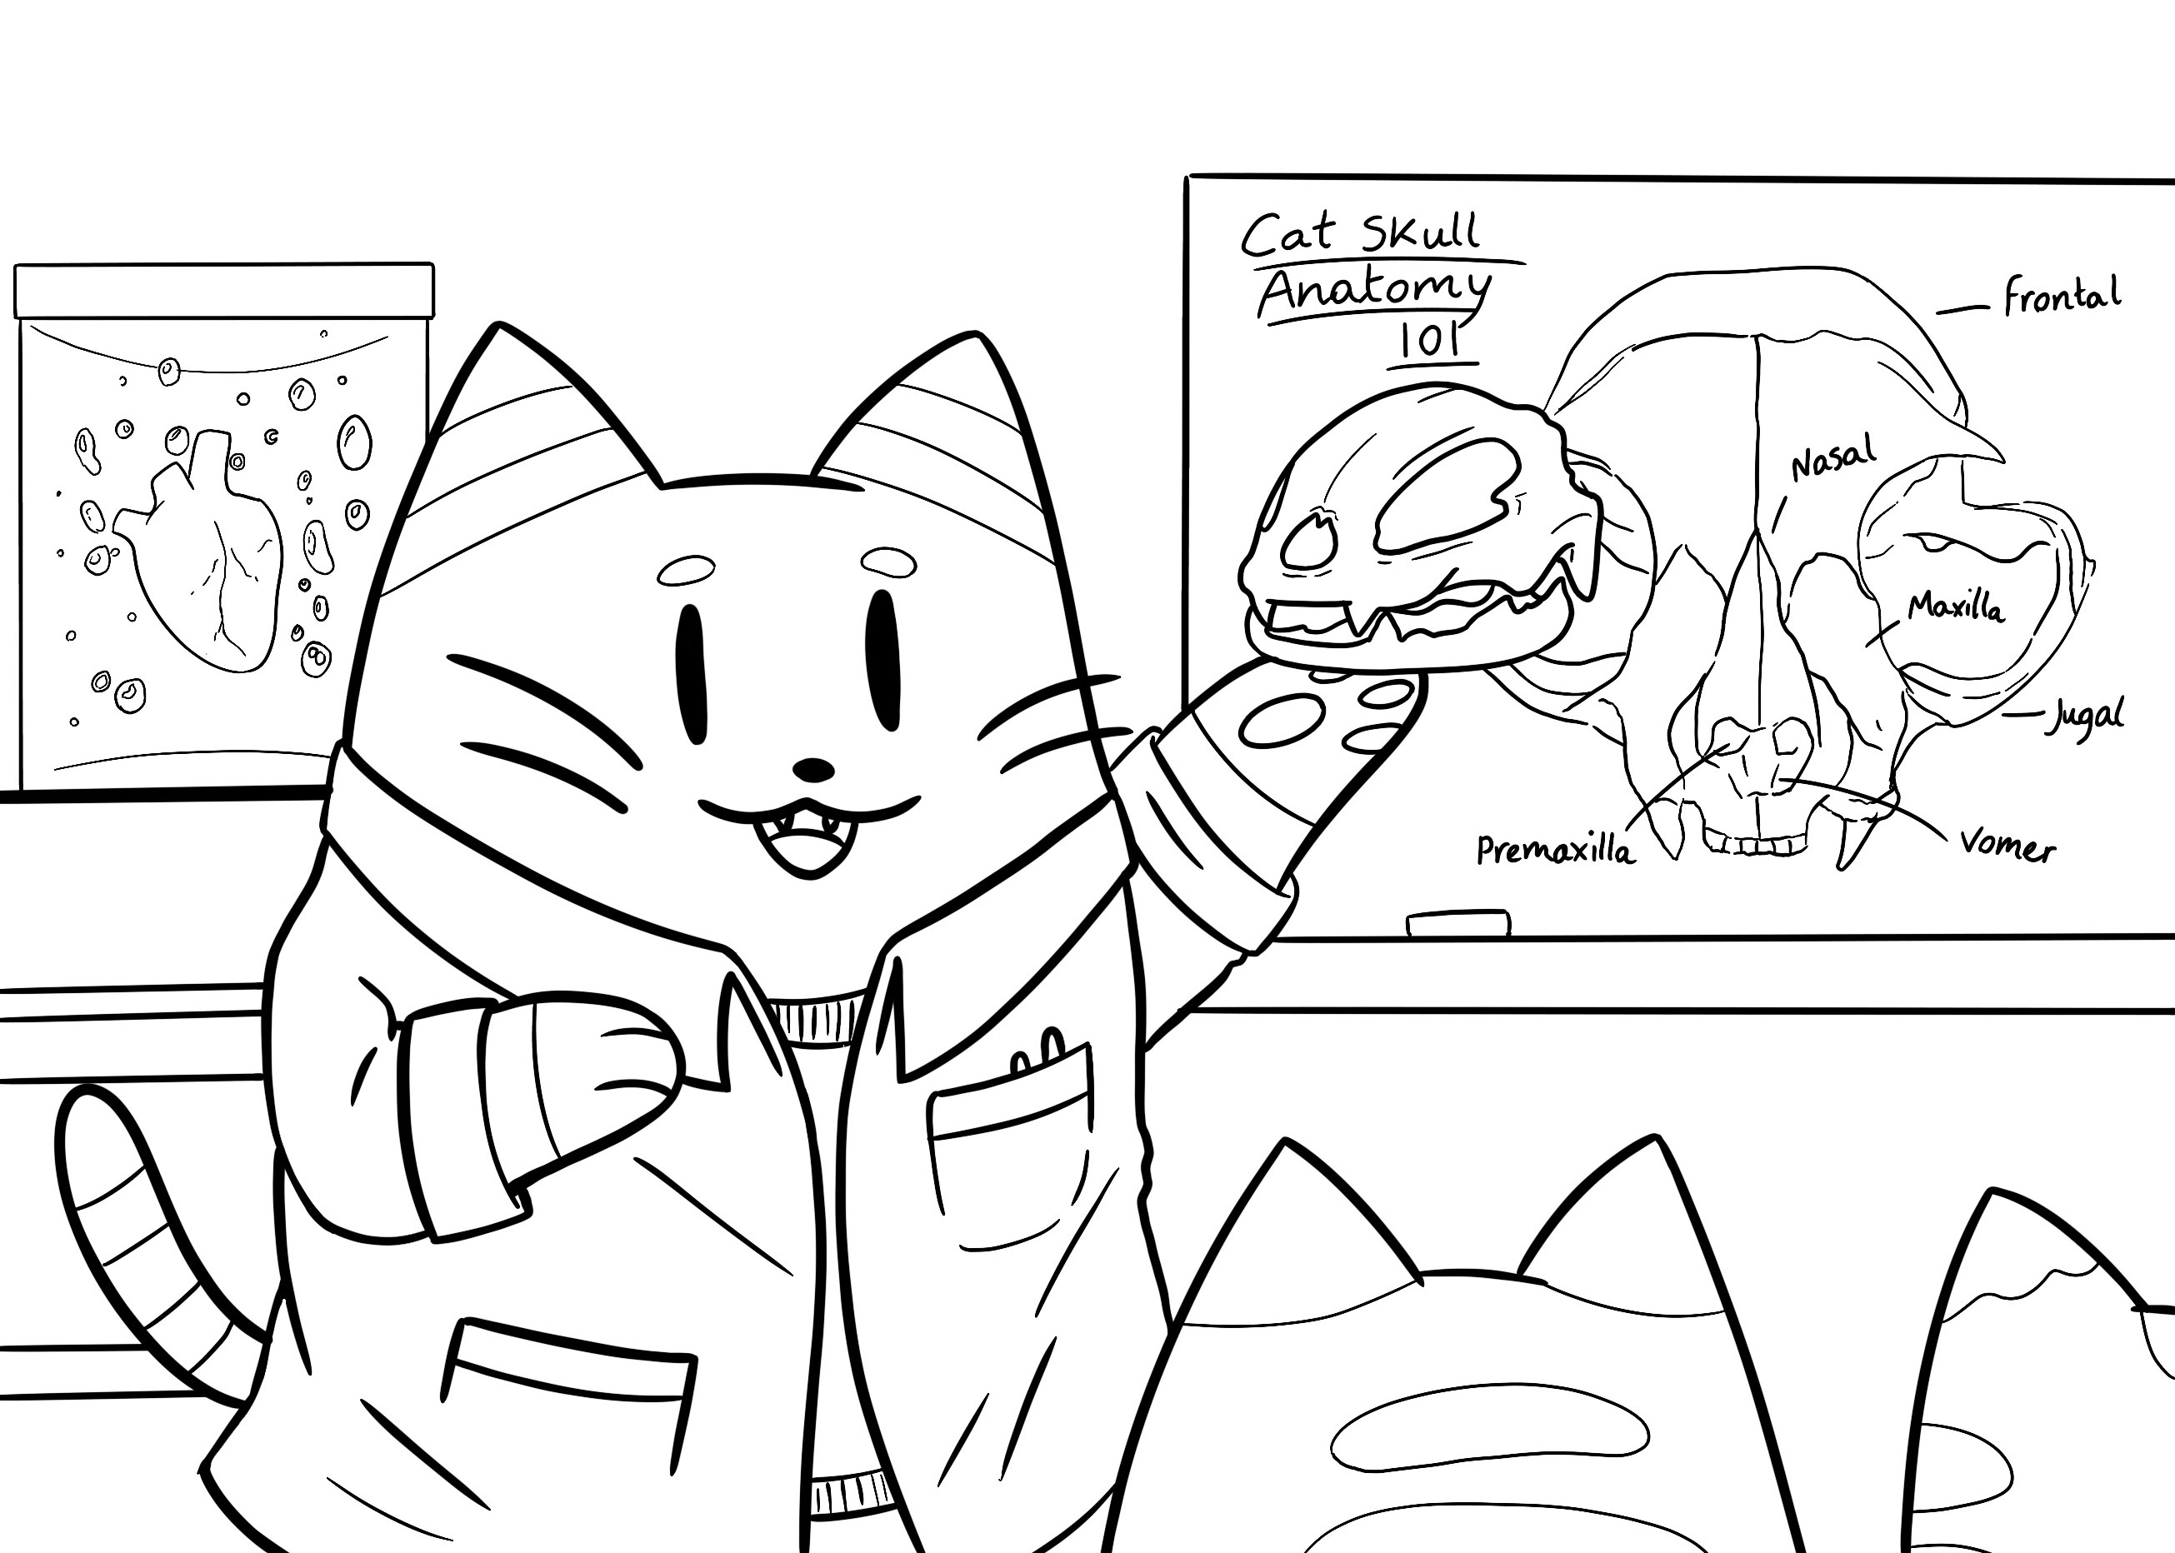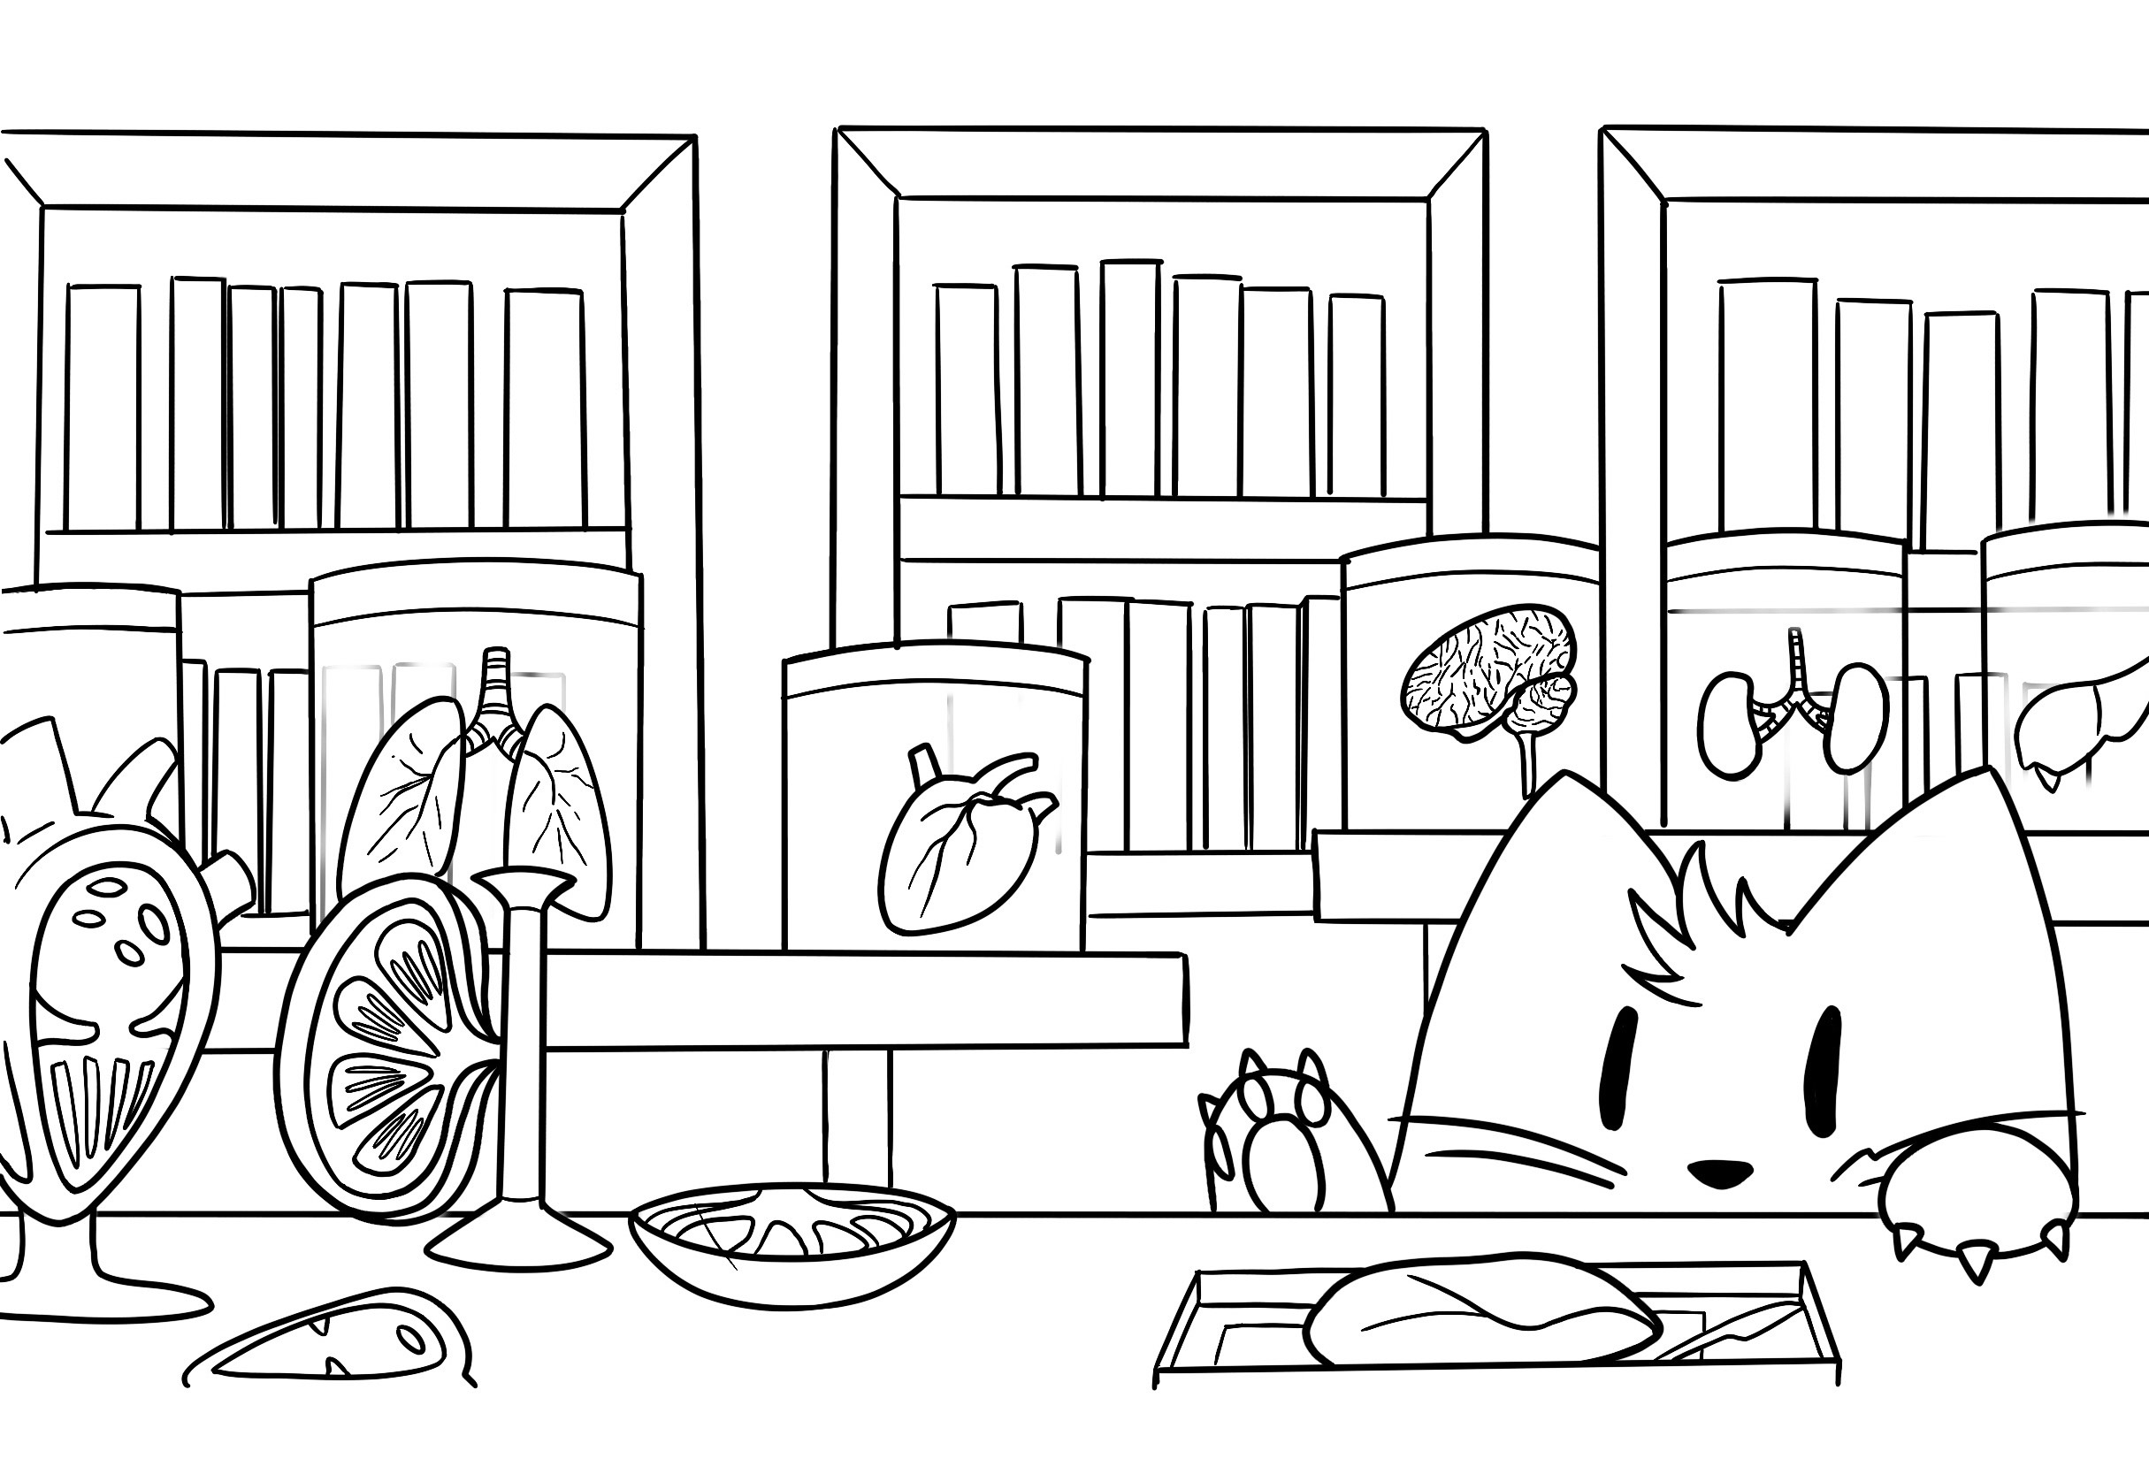

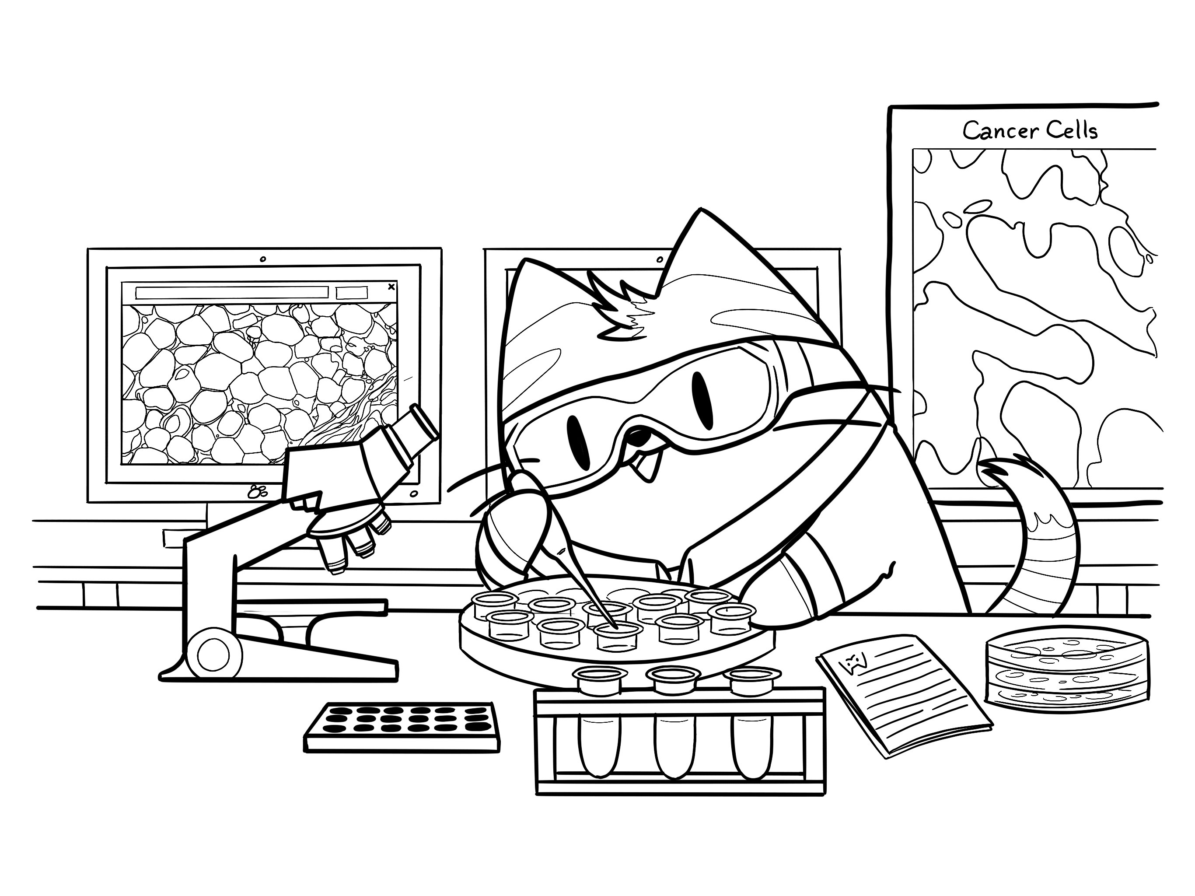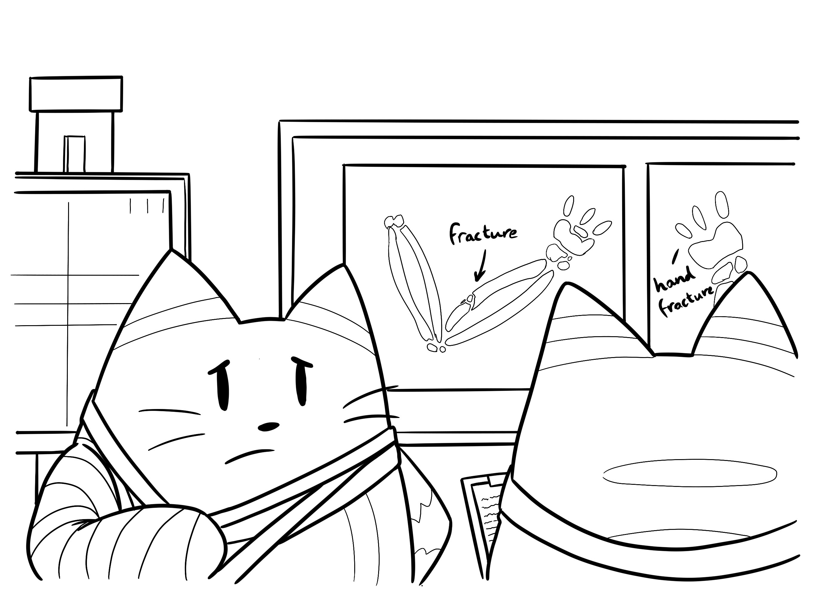

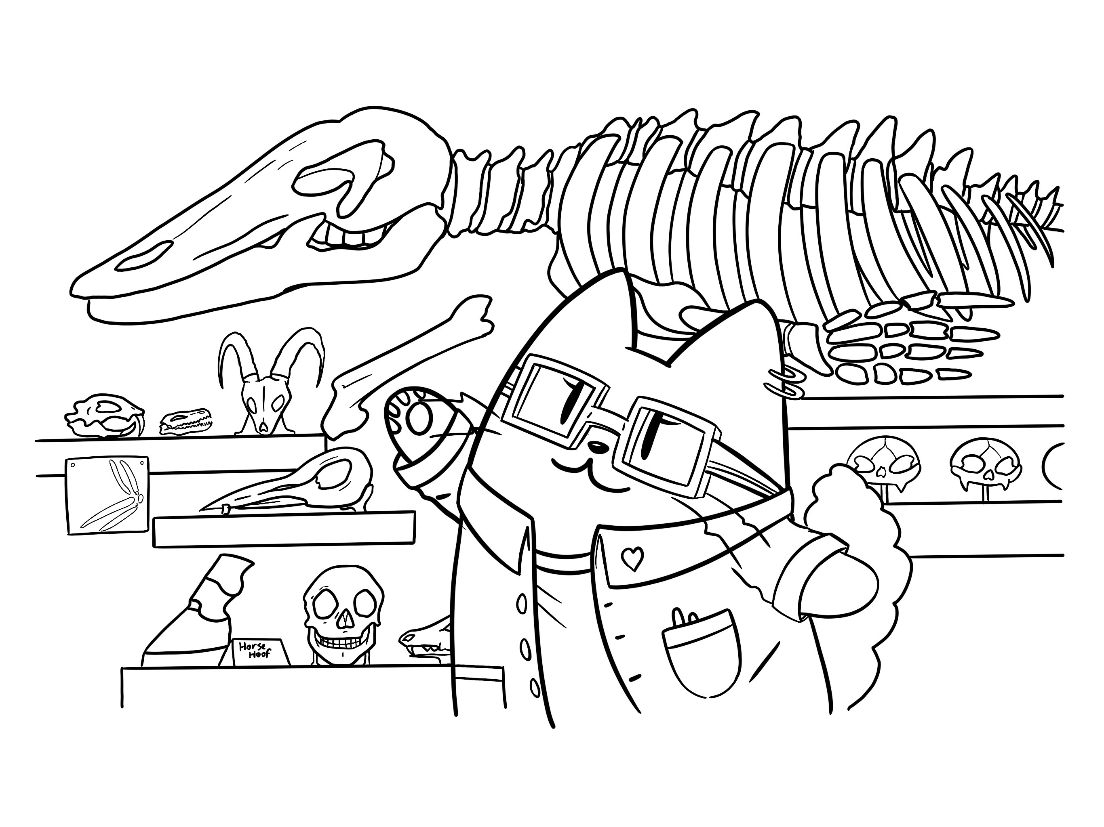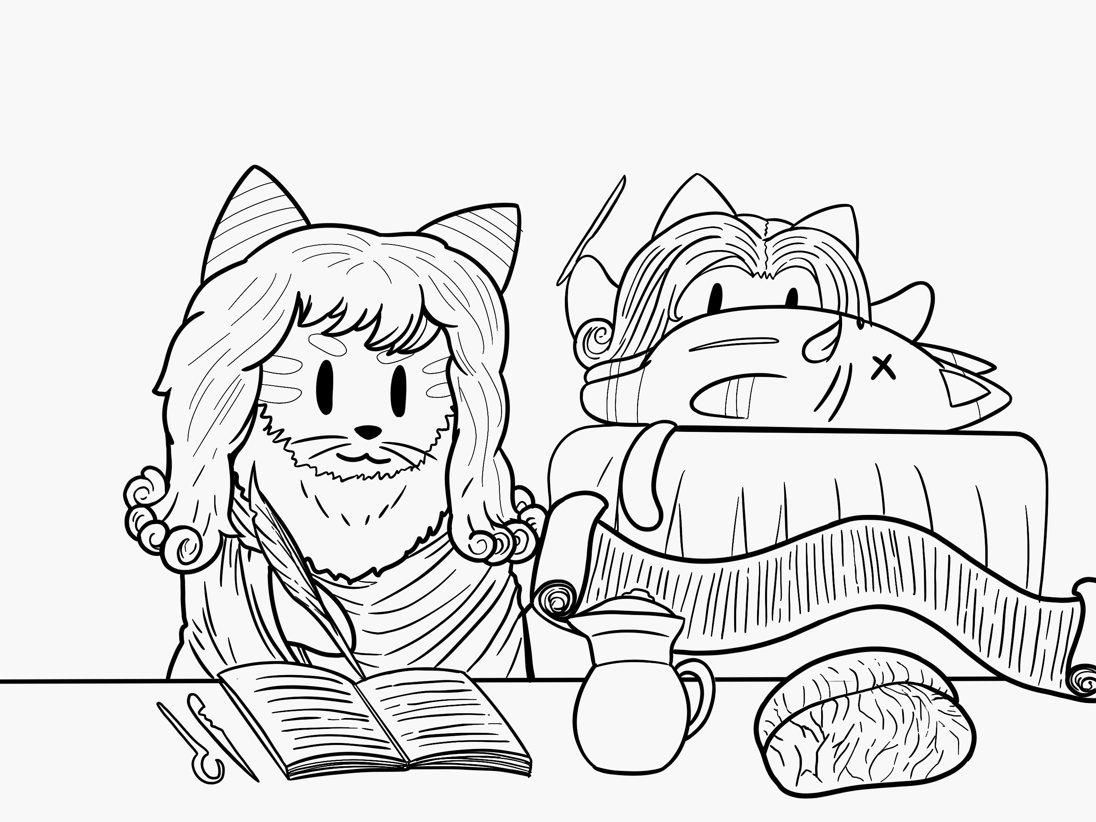

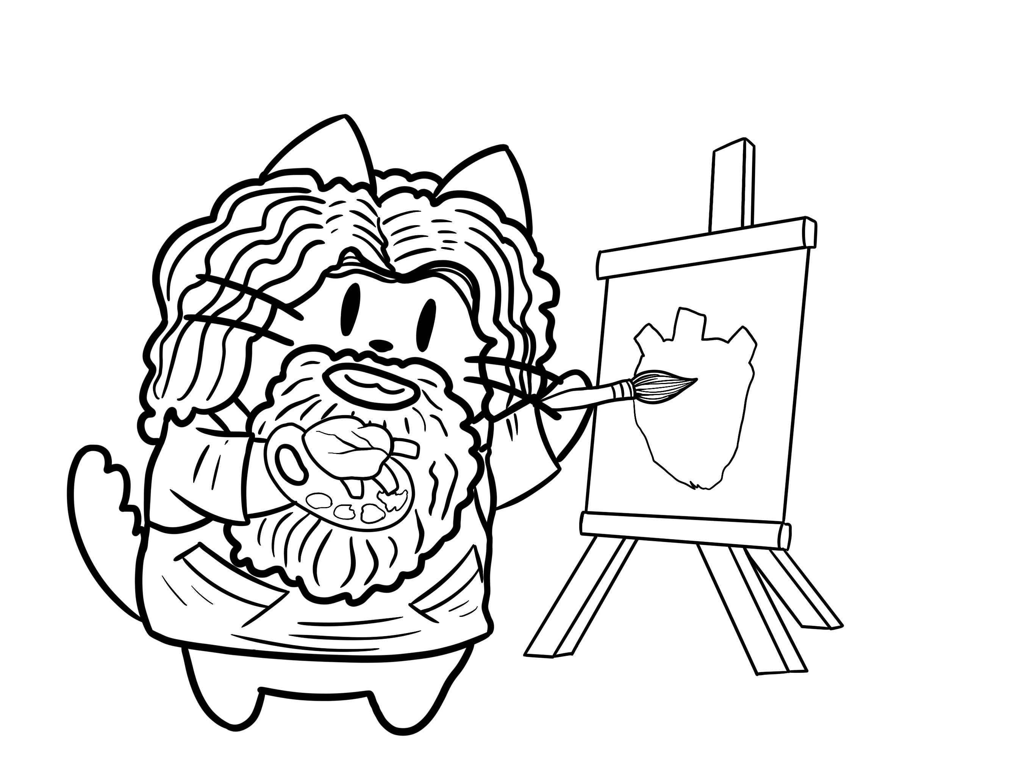

Copyright: If you submit images you must either own the copyright to the image or have gained the explicit permission of the copyright holder for the image to be submitted as part of the report for upload to the Society’s website, Newsletter, social media and so forth. A copyright statement must accompany each report if relevant. Answer N/A not applicable, YES or NO in the box below
Yes

SIGNATURE | Catrin Rutland |  | DATE | 02/10/2020
If submitted electronically, a type-written name is acceptable in place of a hand-written signature

File: AS-Award-Report-Form-190919

