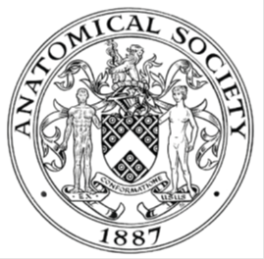

ANNUAL GENERAL MEETING 2024

The Annual General Meeting of the Anatomical Society was held at 12:30 to 13:15 GMT on Tuesday 7th January 2025, Foster Lecture Theatre 1 (Mitchell & Kenyon Cinema), Foster Building, University of Central Lancashire (UCLan), Fylde Road, Preston, Lancashire, PR1 2HE, during the Society’s Winter Scientific Meeting.

In the Chair: | Professor Tracey Wilkinson (President).
Present: | Dr Huda Al-Nhas, Professor Scott Border, Professor Alan Boyde, Professor Cecilia Brassett, Ms Sumar Chan, Dr Jeremy Chang, Dr Sarah Beth Channon, Dr Bipasha Choudhury, Dr Lauren Clunie, Ms Dearbhla Cullinane, Professor D. Ceri Davies, Dr John Delieu, Dr Emelia Deane, Dr Kate Dulohery, Dr Rehab Eltarhoni, Dr Hope Gangata, Dr Samantha Goodchild, Dr Sadia Khan, Professor Kieran McDermott, Dr Siobhan Moyes, Dr Lyndsay Murray, Ms Elena Patera, Dr Erwin Pauws, Dr Jennifer Paxton, Mr Kris Phillips, Dr Emma Saunders, Dr Sheona Shankland, Dr Hannah Shaw, Dr Barbara Shih, Mr Samuel Snowdon, Dr Elizabeth St. Clair, Professor Abigail Tucker* and Mr Liam Young.  * Joined online
In attendance: Executive Administrator | Ms Mary-Anne Piggott
In Attendance: Non-Members | Dr Sachiko Iseki, Dr Hubaira Khan, Dr Yusuf Ozaltay, Mrs Jenny Whitebread and Ms Prabajalini Wijekumar

MINUTES | ACTION
1.0 WELCOME FROM THE PRESIDENT – PROFESSOR TRACEY WILKINSON
The President, Professor Tracey Wilkinson, welcomed everyone to the Anatomical Society AGM. She reminded any non-members present that they are guests and must not participate in the proceedings.

2.0 APOLOGIES
Dr Jo Bishop, Professor Darrell Evans, Professor Laurence Garey, Professor Nathan Jeffery, Professor Radik M. Khayrullin, Dr Pedro Hect López, Professor Joanna Matthan, Emeritus Professor Stephen McHanwell, Dr Jeremy Mortimer, Dr Ciara Murphy, Emeritus Professor Susan Standring, Dr Neil P. Thomas and Dr Asha Venkatesh.
3.0 CONSIDERATION OF THE MINUTES OF THE AGM 04.01.24
The Minutes were approved. Proposer: Professor Kieran McDermott. Seconder: Dr Sarah Beth Channon. | Office
*** Minutes of the AGM 04.01.24 were attached to the Agenda.
4.0 CONSIDERATION OF MATTERS ARISING
There were no matters arising.

5.0. PRESIDENT’S AND HONORARY SECRETARY’S REPORT
Professor Tracey Wilkinson thanked the members, committees, Officers, Councillors, staff and advisers for their excellent contribution to the work of the Society over the previous year. She highlighted the successes and challenges of the past year including:
- SUCCESSES
- Relationships: The Society continues to develop its relationships with several other societies to improve our influence both nationally and internationally. The excellent International Federation of Associations of Anatomists’ (IFAA) conference in South Korea, attended by several of our members and councillors, provided a good opportunity to strengthen the Society’s relationships with this overarching body, as well as several other national associations. As one of the strategic partners of the Royal Society of Biology (RSB), it has been possible for the Society to become involved in the development of their 20-year vision, as well as their political influence on science nationally in this trying time for evidence-based information. The Society has also held meetings between the three Presidents of the British Association of Clinical Anatomists (BACA), the Institute of Anatomical Sciences (IAS) and the Anatomical Society to bring these organisations closer together and to work on some joint initiatives, as well as meetings with representatives of the Early Career Anatomists to support the next generation of scientists and educators. Among many other things, these collaborations have resurrected the Anatomy Associations Advisory Committee (AAAC), a joint initiative between BACA, the IAS and our Society, which aims to establish best practice relating to the Human Tissue Act and the use of human material for Anatomical Examination. The Society has continued to strengthen its relationship with its German colleagues in the Anatomische Gesellschaft, holding a symposium at the Society’s summer conference in Edinburgh. We are presently planning a tripartite meeting with them and the Nederlandse Anatomen Vereniging, probably to be held in 2027.
- Conferences: Two very successful and well attended meetings were held this year. The winter conference was held in Liverpool, bringing together several strands of craniofacial anatomy from evolution, biomechanics, and morphology to maxillofacial interventions. Dr Claire Tierney, Professor Nathan Jeffery and their team were thanked for an outstanding conference. In the summer, the meeting was held in Edinburgh, the first combination conference between the anatomical (Journal of Anatomy) and ageing (Aging Cell) communities since the launch of the latter journal twenty years ago. This resulted in a fascinating symposium, with truly excellent speakers from both sides making real efforts to foster understanding and collaborations, whilst including topics interesting to both communities in their talks. The organising committee of Dr Monty Montano, Dr Tamir Chandra, Ms Nelly Olova, Dr Lyndsay Murray, Dr Olivia Murray, Professor Simon Parson, Dr Eilidh Ferguson and Dr Jennifer Paxton were thanked. Papers from these two conferences will be published in both journals. Both conferences also included useful early career sessions and educational components to stimulate interest and conversations between both new and established anatomists.
- Pilot Mentorship Scheme: The pilot mentorship scheme is now up and running, with people across the academic career spectrum having been partnered with a mentor or mentee. The next aims are to roll this out to the wider sector, particularly undergraduate anatomists, and to expand the scheme to a greater number of members.
- Transparency and EDI: In terms of representation, all the standing committees have undergone a review of membership, whilst fully transparent processes for selecting members (national and international) and Deputy Chairs of Committees have been instituted, with the aim of widening participation across our membership. Opportunities have been increased for more members to engage with activities through a ‘cascade’ system, with objectives for each committee broken into smaller working groups led by one or more of the committee. These initiatives have been highly successful, and I commend the Chairs of our standing committees for their excellent efforts. Additionally, the process of selection of the next President of the Society from the Society’s more senior members as been opened up. The Society is also in the process of carrying out a review of its regulations, some of which are now out of date or do not clearly reflect the inclusivity and transparency that the Society is trying to strengthen in all that it does. These modified regulations will be presented at Council and an Annual General Meeting in due course. An Equality, Diversity and Inclusion Committee is now fully established, with action plans to ensure the embedding of these important principles in all the Society’s activities. Finally, the Society is in the process of implementing major revisions to its website, with the intention of transforming and modernising it over the next period.

- CHALLENGES
This is a challenging time for learned societies, with the transition to open access publishing sure to decrease publishing revenues in the future. Although Aging Cell is already open access, the Journal of Anatomy, our major source of income, will be negatively affected, although the Society is continuing to collaborate with its publishers to maintain journal income at a reasonable level for the time being. Other sources of income are being investigated, but it is almost certain that the provision of PhD studentships will have to be reduced at some stage, because it is the largest expenditure each year. The Society has attempted to mitigate this by developing joint PhDs with two other societies, the Royal National Institute for Deaf People and Motor Neuron Disease (Scotland) (thanks to Dr Abbie Tucker and Professor Simon Parson respectively), but these and other initiatives are unlikely to attain the levels of revenue generated previously. Although the Society’s financial reserves are healthy at present, our expenditure will need serious review over the next few years.

Another issue is the continuing rise in the demands of an academic career, which makes it more difficult for many volunteers, who support the Society selflessly and in their own time, to find opportunities to carry out activities related to organisations external to their own institutions. The thanks owed to these colleagues (see below) is therefore even more deeply felt.

- THANKS
I would like to extend grateful thanks to the Executive Administrator for her continued, excellent contribution to the work of our Society throughout the year. Additionally, the Editors in Chief, Dr Phil Cox, Dr Monty Montano, Dr James Sleigh, Dr Neil Vargesson and Professor Evie Vereecke, and Managing Editors, Mr Ed Fenton (Journal of Anatomy) and Ms Stephanie Waller (Aging Cell) contribute enormously to the Society by sustaining and supporting the Society’s major source of income. We also thank the wonderful teams we rely on to maintain the Society’s business and to enhance its practices. These include Ms Silvana Losito, Mr Paul Trevorrow and the publishing team (Wiley), Mr Keith Lawrey (now retired) and Ms Lori Frecker (Foundation for Science and Technology), Ms Kathryn Burton and her team from haysmacintyre (audit), Coutts (banking and investment), MCI Ltd and the Royal Society of Biology (political influence, website, membership), Gallagher (insurance) and Dr Hannah Webb (Meetings and Anatomy Training Programme support).
6.0 HONORARY MEMBERSHIP OFFICER’S REPORT
Apologies were received from Dr Asha Venkatesh. Professor Tracey Wilkinson reported as follows:

i. Membership Structure
The membership structure is detailed below, with membership administered by RSB Membership Services:

Membership Category | Description | Annual Subscription  £
Full Member | Members who are at least 5 years post-graduation with a primary degree pertinent to Anatomy | 70
Early Career member | Undergraduate student in Anatomy or allied degree or within 5 years of graduating | 15
Fellow | At least 7 years of full membership | 70
Honorary Fellow | Proposed to Council (may not already be members) | Free
Long-standing members | Full Members or Fellows (or a combination) for at least 30 years  At retirement have been either Full members or Fellows (or a combination for at least 15 years) | £15

Noted that further details may be obtained from the Membership Officer either directly or through the RSB office (theteam@anatsoc.org.uk) and make an informal request. Professor Tracey Wilkinson encouraged eligible members to apply for Fellowship.

ii. Total number of members compared to previous years at the end of each membership year

Noted.
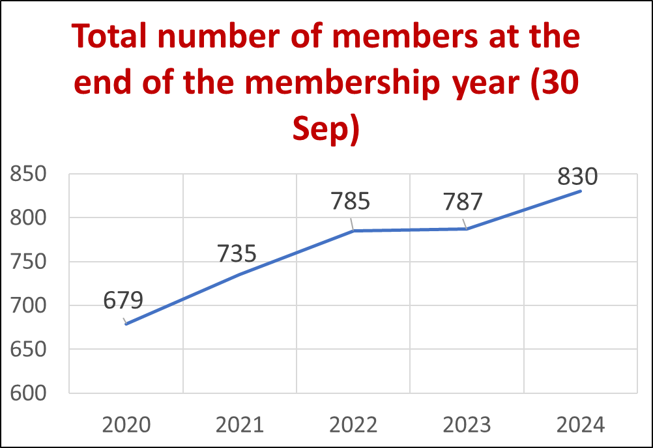

iii. Current Membership Breakdown (as at 12.12.24)
Tracey Wilkinson encouraged all those whose membership renewals were pending to renew their membership as soon as possible.

MEMBERSHIP AS AT 12.12.24
 | Renewal Pending | Renewal Update | Total
Early Career | 73 | 173 | 246
Full | 103 | 362 | 465
Fellow | 6 | 134 | 140
Total | 182 | 669 | 851

iv. Worldwide Geographical Distribution

Noted the global reach of the Society’s membership.

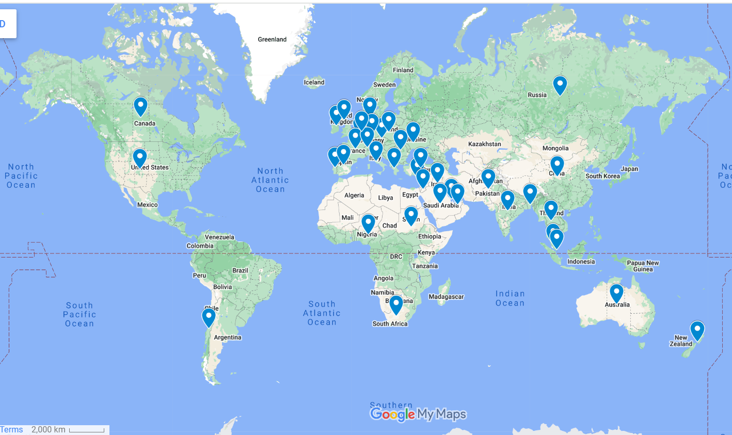
v. Thanks
Professor Tracey Wilkinson thanked Dr Asha Venkatesh and her team for their excellent work.

7.0 HONORARY TREASURER’S REPORT
Kieran McDermott reported on the Society’s finances via a series of tables and graphs, as below. He hoped that all members had read through the audited Trustees’ Annual Report and Accounts. It was noted that the Society is facing a challenging environment with regard to the expected loss of revenue from the Journals due to the impact of open access publishing. It was noted that with this in mind, the Trustees are building up its investment portfolio and reviewing expenses.

The Treasurer’s Report and the Audited Trustees’ Annual Report and Accounts was unanimously accepted.

i. Incoming Resources and Resources Expended
The total income amounted to £1,705,058, whilst total expenditure was £1,352,273.

 | 2023-24  £ | 2022-23  £
Incoming Resources | 1,705,058 | 1,617,076
Resources Expended | 1,352,273 | 1,322,434
% of incoming spent | 79 | 82

Incoming Resources and Resources Expended
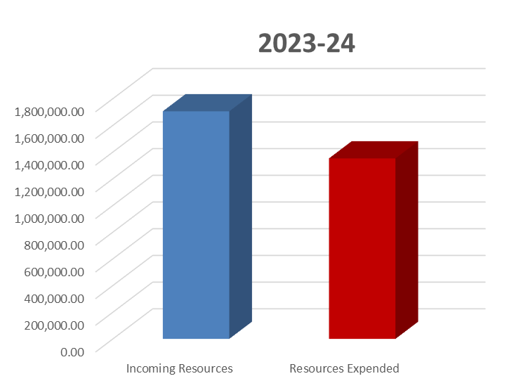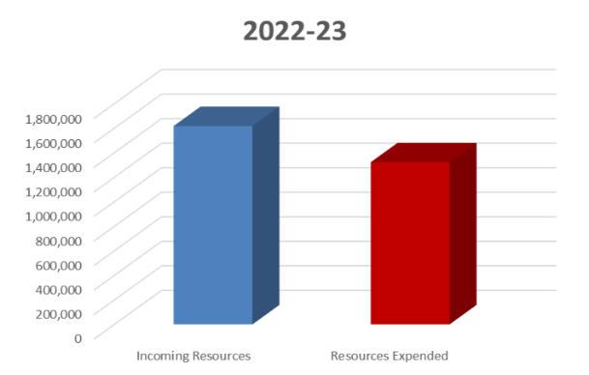

ii. Resources Expended
The majority of resources expended are on charitable activities.

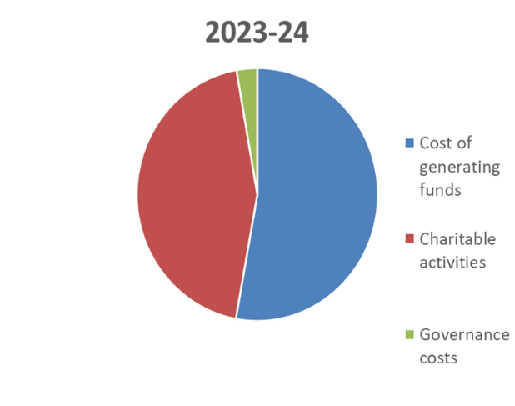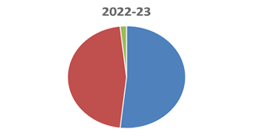

iii. Charitable Activities
The spend on charitable activities is shown below. This includes 11 PhD studentships (2 new in 2023-24 plus two new joint studentships); 2 conferences (Liverpool Winter 2023 and Edinburgh Summer 2024); Prizes, namely The Symington Memorial Prize 2024, The Dr Sophie Miller Memorial Prize, and the Best Image Presentation Prizes; Grants, namely 21 Symington Awards and 8 Undergraduate Student Summer Studentships and 2 inaugural Anatomy Research Development Awards (ARDA).

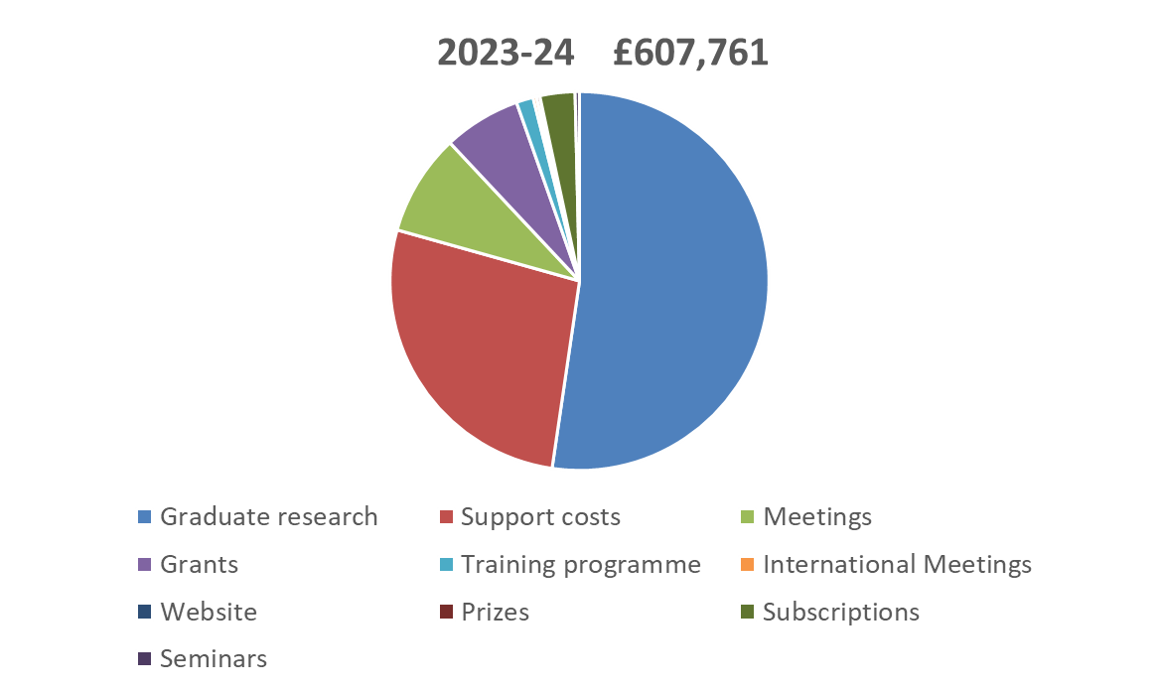

iv. Historical Comparison of Charitable Activities over a 12 Year Period
The 2018/19 peak was due to the Society hosting the successful IFAA Congress in London. 2011/2024 shows that the Society has maintained its charitable spend from the other previous years.

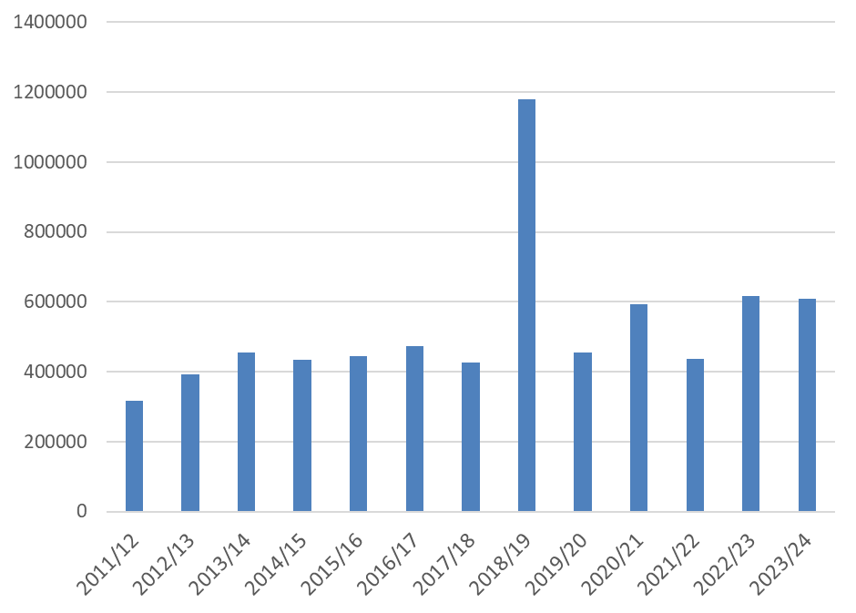

v. Balance Sheet as at 30th September 2024
The total funds as at 30th September 2024 were £6,422,634 (2023: £5,577,345), of which £490,639 (2023: £435,678) are restricted. The members of the Council continue to review the level of reserves of the Society in light of current and future planned activity. The Society and its trading subsidiary, the Company of Anatomists Limited, publish two journals, the Journal of Anatomy and Aging Cell, through Wiley publications. These journals, particularly the former, continue to be the major source of revenue for the Society, and the threat of loss of income due to open access publishing campaign continues to be monitored and reviewed together with the Society’s publisher. Aging Cell has been operating on an open access model for several years and, thus far there has been no negative impact upon the revenue from this journal. The Society is mindful of the fact that its reserves must be adequate to cover the longer-term liabilities of PhD studentships, employment costs, website and membership services and consequently maintain at least three years forward liquidity to cover all studentship costs for three years.
The value of the two main investment portfolios increased over the financial year from £3,583,366 to £4,392,566. While there was an increase in income from listed investment to £121,403 from £86,843, there were also net gains of £492,504 compared to net gains of £171,748 in the prior year from the portfolio. The Trustees, in view of the continuing low bank interest rates and under advice from its investment managers, are continuing to maintain the level of investment in the Society’s investment portfolio.

Balance sheet | 2023-24 | 2022-23
Fixed assets | £4,392,581 | £3,583,831
Current assets | £2,130,354 | £2,032,541
Creditors | £100,301 | £39,027
Total Funds Carried Forward | £6,422,634 | £5,577,345

vi. Thanks
Professor Kieran McDermott thanked Dr Jeremy Mortimer, Deputy Honorary Treasurer, Members of the Finance Committee, and Coutts for their excellent support during the year.

Professor Kieran McDermott thanked Ms Kath Burton, Partner haysmacintyre and her team for their advice and support.

Professor Tracey Wilkinson thanked Professor Kieran McDermott and his team for their excellent work.
*** Society Audited Report and Accounts for the year ended 30th September 2024 was attached to the Agenda.
8.0 JOURNALS’ BUSINESS REPORT (JOURNAL OF ANATOMY AND AGING CELL)
8.1 Journal of Anatomy
Professor Tracey Wilkinson reported as follows:
- JoA is the major income stream for the Society;
- Open access publishing will affect this income profoundly in the coming years. The impact of this is being offset by the Society’s Trustees, as far as possible, through prudent management of the Society’s investment portfolio and through the reduction of the Society’s cost base.
- New contract signed with Wiley;
- The Impact Factor has been affected by the post Covid publishing environment;
- Some excellent virtual and actual Symposium issues are published or are near completion, which should boost the JoA Impact Factor;
- The ECR Editorial Board and ECR Social Media teams are making a helpful impact on the JoA.
Professor Tracey Wilkinson thanked all the Editors-in-Chief, ably assisted by Mr Edward Fenton, Managing Editor, the Wiley team, the Journals’ Committee and in particular Professor D. Ceri Davies for his excellent contribution in relation to the contract negotiations.
8.2 Aging Cell
Tracey Wilkinson reported as follows:
- Aging Cell is going from strength to strength and is one of the top journals in its field;
- The planned conference in July 2024 in Edinburgh, which brought the ageing and anatomy communities together, was a great success, thanks to Dr Lyndsay Murray and the local organising team, and a symposium publication is in progress.
Professor Tracey Wilkinson thanked the Editor-in-Chief, ably assisted by Ms Stephanie Waller, Managing Editor, and the Wiley team.

9.0 ELECTION OF PRESIDENT-ELECT, HONORARY OFFICERS AND COUNCIL | Office
9.1 Election of a President-Elect (non-Trustee position)
That a member nominated by Council 28.11.24, Professor Abigail Tucker, be elected to the role of President-Elect with immediate effect, to the end of 2025

It was resolved, on a vote expressed in favour at the meeting, that Resolution 9.1 be approved. The voting was unanimous plus 7 proxy votes.
9.2 Election of the Honorary Officers
- That Dr Asha Venkatesh (University of Aberdeen) be elected to the post of Membership Officer, for a 2nd term with immediate effect, to the end of 2027.
It was resolved, on a vote expressed in favour at the meeting, that Resolution 9.2(i) be approved. The voting was unanimous plus 7 proxy votes.
Noted: Proxy Voting Forms were received from: Dr Jo Bishop, Professor Darrell Evans, Professor Radik M. Khayrullin, Dr Pedro Hect López, Professor Emeritus Stephen McHanwell, Dr Jeremy Mortimer and Professor Abigail Tucker.
9.3 To receive the results of the election of 2 Ordinary Councillors (Ballot closing date 30th December 2024)
Professor Cecilia Brassett announced the results of the ballot, and the following 2 Ordinary Councillors were duly elected:  - Ordinary Councillor – Dr Caroline Curtin (RCSI).  - Ordinary Councillor – Mr Luke Reid (Brighton and Sussex Medical School) | Office
Professor Cecilia Brassett thanked all those who had stood for election and congratulated those who had been elected to Council effective from 7th January 2025. She particularly encouraged all those who had stood for election and not been successful this time round to stand again in the future.
9.4 Officer Casual Vacancies filled by Council during the year
(i) Noted that Dr Catherine Hennessy resigned (maternity leave) from the post of Website Media and Communications Officer 05.01.24 (ratified by 15.02.24 Council) thereby creating a casual vacancy to 28.11.24.
(ii) Noted that Dr Kate Dulohery was elected to the post of Website Media and Communications Officer by 15.02.24 Council to fill a casual vacancy to 28.11.24.
(iii) Noted that Dr Kate Dulohery resigned from the post of Website Media and Communications Officer at 28.11.24 Council.
(iv) Noted that Dr Catherine Hennessy was elected to the post of Website Media and Communications Officer by 28.11.24 Council to fill the elected vacancy to the end of 2026.
(v) Noted that Professor Katherine Linehan resigned from the post of Equality, Diversity and Inclusion (EDI) Officer at 28.11.24 Council, thereby creating a casual vacancy to the end of 2025.

(vi) Noted that Professor Nathan Jeffery resigned from the post of Research Officer 02.12.24 thereby creating a casual vacancy to the end of 2025.
(vii) Noted that Dr Eilidh Ferguson resigned (maternity leave) from the post of Meetings Officer at 02.05.24 Council thereby creating a casual vacancy to the end of 2025.
(viii) Noted that Dr Lyndsay Murray was elected to the post of Meetings Officer by 02.05.24 Council to fill the casual vacancy to May 2025.
9.5 Ordinary Councillor- Early Career/Postgraduate Casual Vacancy filled by Council during the year
(i) Noted that Dr Rebecca Shepherd resigned from the post of Ordinary Councillor at 23.07.24 Council, thereby creating a casual vacancy to the end of 2025.
(ii) Noted that Dr Marise Heyns resigned from the post of Ordinary Councillor at 28.11.24. Dr Kate Dulohery returned to complete the end of her first term of elected trusteeship from 28.11.24 Council to the end of 2024, after which she stands for a second term as an Ordinary Councillor.
10.0 STANDING COMMITTEES AND OTHER COMMITTEES
The list below of Committee members of the Standing and Other Committees was ratified by the AGM. It was noted that there will be some additional changes to this list during 2025. Professor Tracey Wilkinson reported that all members are welcome to apply to the Committee Chair to be considered for membership of a Committee where there is a vacancy. She was delighted that the Society’s Committees are becoming more representative of the Society as a whole.  Professor Tracey Wilkinson welcomed all those who are continuing to serve and to new members to the Society’s Committees in 2025 and thanked those stepping down from the Society’s Committees for their service. | ALL  Office
  Committee | New Committee members 2024/25 | Committee Members stepping down during or at the end of 2024
  Education |  | Dr Rebecca Quinn
  Equality Diversity and Inclusion (EDI) |  | Professor Katherine Linehan (Chair)
  Finance
  Journals | Dr Lyndsay Murray | Dr Eilidh Ferguson  Professor Nathan Jeffery
  Meetings | Dr Lyndsay Murray (Chair)  Dr Rocky Cheung  Dr Phil Cox | Dr Eilidh Ferguson (Chair)
  Membership | Dr Munesh Khamuani (Deputy Chair) | Dr Sheona Shankland (Deputy Chair)
  Research Advisory |  | Professor Nathan Jeffery (Chair)
  Website Media and Communications Committee | Mr Kris Phillips  Dr Elna Patera  Dr Claire Conway | Dr Rebecca Shepherd (Deputy Chair)
  Prizes and Awards (not a Standing Committee)
Education  (Chair + 7 members) | EDI  (Chair, Deputy + 3 members) | Finance  (Chair, Deputy + 7 members) | Journals  (Chair, Treasurer, Meetings Officer, Research Officer, Education Officer + 3 members) | Meetings  (Chair + 5 members)
Chair: Education Officer  Hannah Shaw | Chair:  (Vacancy) | Chair: Honorary Treasurer  Kieran McDermott | Chair: President Tracey Wilkinson | Chair: Meetings Officer  Lyndsay Murray 02.05.24 to May 2025;  Eilidh Ferguson May 2025-
Deputy  Sarah Channon | Deputy  Scott Paterson | Deputy Treasurer  Jeremy Mortimer | Deputy  Ceri Davies | Deputy  (Vacancy 02.05.24 to May 2025)  Lyndsay Murray to 02.05.24
Members  Claire Smith  Clemens Kiecker  Ceri Davies  Michelle Welsh  Claire Fitton  (Vacancy) | Members  Hope Gangata  Siobhan Moyes  Michelle Welsh and Emma Bailey (Job share) | Members  Joanna Matthan  Ceri Davies  Tracey Wilkinson  Imelda McGonnell  Gerard O’Keeffe  (Vacancy)  (Vacancy) | Members  Simon Parson  Treasurer  Kieran McDermott  Meetings Officer  Lyndsay Murray 02.05.24 to May 2025  Research Officer  (Vacancy)  Education Officer  Hannah Shaw  (Vacancy) | Members  Phil Cox  Rocky Cheung  Jemima Chukwu  Councillor Early Career  Danya Stone
Co-opted  Councillor Early Career  Danya Stone  Early Career Member  Lily Evans  International Overseas Member  Reddy Sreenivasulu |  |  |  | Co-opted  Rebecca Shepherd  Claire Tierney  Membership Officer  Asha Venkatesh  Education Officer  Hannah Shaw  Website Media and Communications Committee Officer  Catherine Hennessy from 28.11.24 to 13.02.25  Kate Dulohery  13.02.25 to 17.07.25
Membership  (Chair + 5 members) | Research Advisory  (Chair + 5 members) | Website Media and Communications Committee*  (Chair + Newsletter Editor +5 members) | Prizes and Awards  (Not a Standing Committee)
Chair: Membership Officer  Asha Venkatesh | Chair: Research Officer  (Vacancy) | Chair: Website Media and Communications Officer  Catherine Hennessy | Chair: Honorary Secretary  Joanna Matthan
Deputy  Munesh Khamuani | Deputy  (Vacancy) | Deputy and Newsletter Editor  Kate Dulohery | Deputy Secretary  Cecilia Brassett
Members  Seaneen MacDougall  Wendy Birch  Hazel Allardyce  (Vacancy) | Members  Jamie Davies  Susan Evans  Andrea Streit  Early Career Member: Alannah Mole | Members  James White  Tom Flanagan  Claire Conway  Kris Phillips  Elena Patera | Members  President  Tracey Wilkinson  Treasurer  Kieran McDermott
Co-opted
Meetings Officer
Lyndsay Murray
Education Officer
Hannah Shaw
Finance Committee
Kieran McDermott
Gavin Clowry
Jennifer Paxton

11.0 AUDITORS
It was resolved to re-appoint haysmacintyre LLP as the Society’s auditors. Proposer: Professor Kieran McDermott. Seconder: Professor D. Ceri Davies.
12.0 AS RESEARCH STUDENTSHIP AWARDS
Professor Cecilia Brassett reported that 3 awards were made by 28.11.24 Council, as shown in the table below. Professor Brassett extended her congratulations to the awardees and reported that the standard of applications was high. She encouraged all those who were not successful to apply again in the future.
SENIOR STUDENTSHIPS

Lead Supervisor: Dr Philip Cox
University: University College London
Co-Supervisors : Dr Jesse James Hennekam
University: University of Maastricht
Project Title: The influence of island evolution and domestication on size-shape relationships in the anatomy of Caprinae
Student: TBA
Project Resume

Lead Supervisor: Regius Professor Simon H. Parson
University: University of Aberdeen
Project Title: Microvascular defects beyond the spinal cord: a detailed morphological investigation
Student: TBA
Project Resume - to follow
EARLY CAREER INVESTIGATOR STUDENTSHIP
Lead Supervisor: Dr Claire Conway
University: Royal College of Surgeons in Ireland (RCSI)
Co-Supervisor: Dr Caroline Curtin
University: Royal College of Surgeons in Ireland (RCSI)
Project Title: The Development of a Library of Digital Reanimated Mitral Valves
Student: TBA
Project Resume - to follow

13.0 FELLOWSHIPS AND HONORARY FELLOWSHIPS
13.1 Honorary Fellowships
Professor Tracey Wilkinson announced that two Honorary Fellowships of the Society had been awarded for session 2023/24, namely Professor Roger Keynes for services to anatomy research and Dr David Heylings for services to anatomy education and in particular to the Society’s Anatomy Training Programme.
13.2 Fellowship
Professor Cecilia Brassett reported that two Fellowships of the Society had been awarded for session 2023/24 to Dr Ciara Murphy and Dr Zubeyde Bayram-Weston. Professor Cecilia Brassett encouraged eligible members to apply for Fellowship.
13.3 The New Fellow of the Year Award 2024
Professor Cecila Brassett reported that Dr Ciara Murphy was the New Fellow of the Year for session 2023/24.
14.0 THE SYMINGTON MEMORIAL PRIZE 2024
Professor Tracey Wilkinson reported that on the recommendation of the Prizes and Awards Committee, Council unanimously approved Dr Bipasha Choudhury (University of Manchester) as the 2024 Award Recipient of the Symington Memorial Prize 2024, one of the Society’s two most prestigious awards.  Schedule 2 Clause 6 to the Regulations is reproduced below.  The Symington Memorial Prize in Anatomy  A prize, known as the Symington Memorial Prize in Anatomy, was founded in 1920 by the Symington Memorial Committee of Queen’s University Belfast, in commemoration of Professor Johnson Symington MD, FRS, who occupied the Chair of Anatomy in that University from 1893 to 1917. The prize is awarded by the Academic Council of Queen’s University on the recommendation of the Council of the Anatomical Society, which will seek the advice of its Education Committee. Awards are made at about two-yearly intervals. The period between the awards and their value may vary according to the income from the fund and other factors. The prize shall be awarded for contributions to the advancement of Anatomy, including education in Anatomy, by a Member of the Anatomical Society not of professorial standing.  Afternote: An encomium was read out by Professor Cecilia Brassett for Dr Bipasha Choudhury on the last day of the Society’s winter Meeting at University of Central Lancashire (UCLan), Preston: (08.01.25):  ENCOMIUM  The Symington Memorial Prize is one of the Anatomical Society’s two most prestigious awards. This award is given every two years. Originally established in 1920 by the Queen's University of Belfast in commemoration of Professor Johnson Symington, who was a former President of the Anatomical Society, the prize is awarded by the Academic Council of Queen's University on the recommendation of the Council of Anatomical Society, which sought the advice of its Education Committee. The award is made for contributions to the advancement of Anatomy, including education in Anatomy, by a Member of the Anatomical Society not of professorial status.  Dr Bipasha (Bip) Choudhury graduated with a medical degree from the University of Manchester in 2003. After this, she worked in a number of hospitals in the Northwest of England in different specialities including acute medicine, colorectal surgery, and orthopaedics. She then moved into full-time teaching, first as an anatomy demonstrator in 2005, a teaching fellow in 2006, and completed her PhD in medical education in 2017. She is a Reader in Anatomy at the University of Manchester and teaches topographical anatomy to a wide range of students. She teaches anatomy and histology to students on many different degree programmes, including medicine, dentistry, optometry, midwifery and life sciences. She also teaches physiology and pharmacology practical skills to medical and dental students. In addition to her teaching commitments, she is a Person Designated under the Human Tissue Act 2004, and is also the Deputy Programme Director for the Postgraduate Certificate in Medical and Health Education. Her research interests are in anatomy education, with her PhD being on the Anatomical Student Experience.  Within her own institution, Dr Choudhury has a sustained record of effective delivery of anatomy teaching and student support. This is evidenced by excellent student feedback and her publications regarding the use of innovative methods of teaching, including the use of 3D printing and flipped classroom to enhance student engagement and learning. She has made a significant contribution to the design and development of existing and new teaching programmes in Manchester. She created a noval approach to the traditional assessment format based on anatomical prosections, focussing on the need for comprehension of function and clinical relevance rather than mere identification of structures.  Dr Choudhury is also actively engaged in anatomical activities outside her own institution. She was an External Examiner for the University of Glasgow from 2017 to 2022, and is currently the External Examiner for the Preston Campus of the American University of the Caribbean. She has been a member of the Anatomical Society since 2008. Her main area of service to the anatomical community has been through her role as Meetings Secretary of the British Association of Clinical Anatomists, which she held for 7 years from 2017 to 2023. She organised their bi-annual scientific meetings efficiently and competently, and she was always very supportive to students and trainees who were giving oral or poster presentations at these national conferences. Her fellow-Councillors at BACA were especially impressed by the way in which she overcame the challenges posed by the COVID-19 pandemic, when in person meetings were not possible. Undeterred by this limitation, Dr Choudhury made a wise decision to use the Zoom webinar platform to continue with regular online meetings. These were known as "BACA Beats" and were greatly appreciated by all attendees, as they promoted constructive dialogue and fruitful exchange of ideas with regard to best practice in teaching anatomy remotely. During a period when many anatomists both in the UK and abroad were in need of new ideas for course delivery, these online meetings provided them with encouragement and inspiration.  Furthermore, Dr Choudhury is very active in outreach events, as she is especially enthusiastic about inspiring future generations about anatomical sciences. She has published several children's books on the human body for ages 6-9, with Dorling Kindersley. Her first book "Human Body" in the DK Findout! series, was published in September 2017. Further titles include "The Body Book" and "My Very Important Human Body Encyclopaedia". It is a rare gift to be able to explain a complex subject in simple terms to the general public and especially to very young readers.  Both Professor Jo Matthan and I have had the privilege of working with Dr Choudhury for several years as a fellow Councillor on BACA, and what stands out to us is that she is genuinely service-oriented, soft-spoken and considered. She does not draw unnecessary attention to herself, is all about the job and maintains a wonderful level of professionalism. She is well-respected by all and works well across our different societies to promote both clinical and anatomical knowledge.  In view of all her contributions to anatomy teaching, anatomical education research, and efforts to bring anatomical knowledge to the general public, Dr Choudhury is indeed a worthy recipient of the 2024 Symington Memorial Prize. | Office
15.0 REPRESENTATIVES ON INTERNATIONAL AND NATIONAL BODIES
Professor Tracey Wilkinson reported that the Society’s Councillors are delegates to/representatives to a number of national and international organisations including those listed below. She thanked all the delegates/representatives for their hard work.

- National
  - Royal Society of Biology (RSB)
  - British Association of Clinical Anatomists (BACA)
  - Institute of Anatomical Sciences (IAS)
  - Anatomy Associations Advisory Committee (AAAC)
  - Understanding Animal Research (UAR)
  - Daphne Jackson Trust
- International
  - International Federation of Associations of Anatomists (IFAA)
  - European Federation for Experimental Morphology (EFEM)
  - Trans-European Pedagogical Anatomy Research Group (TEPARG)

Professor Tracey Wilkinson also thanked Dr Jeremy Mortimer and Ms Danya Stone for their work with our Early Career members.

16.0 ANY OTHER BUSINESS
16.1 To receive the names of those serving on Council for 2025 from the President
The list of Officers and Council comprising 11 Officers and 6 Ordinary Councillors as Trustees.
was unanimously ratified. The President-Elect, Professor Abigail Tucker, will also be attending Council to the end of 2025 (non-Trustee position) .

HONORARY OFFICERS (11)
- LIST OF HONORARY OFFICERS. Nominated by Council elected by the membership.

OFFICE | HOLDER | TO END OF | CURRENT  TERM* | MAXIMUM TERM
President | Professor Tracey Wilkinson  (Birmingham) | 2025 |  | 1  (of three years)
Honorary Secretary | Professor Joanna Matthan  (Newcastle) | 2025 | 1 | 2  (each of three years)
Deputy Secretary | Professor Cecilia Brassett  (Cambridge) | 2025 | 1 | 2  (each of three years)
Honorary Treasurer | Professor Kieran McDermott  (Limerick) | 2025 | 2 | 2  (each of three years)
Deputy Treasurer | Dr Jeremy Mortimer  (Bristol) | 2025 | 1 | 2  (each of three years)
Meetings Officer | Dr Lyndsay Murray  (Edinburgh)  [Casual Vacancy from 05.02.24 to 01.05.25– Dr Lyndsay Murray elected by 02.05.24 Council as a Director/Trustee. LM to then resign as a Director/Trustee at 01.05.25 Council].  Dr Eilidh Ferguson  (Glasgow)  Resigned as a Director/Trustee 02.05.24 Option b Regulation 14 maternity leave. To be elected at 01.05.25 Council as a Director/Trustee and complete the rest of her 1st term] | Casual Vacancy  02.05.24 to 01.05.25  2025 | Casual Vacancy  02.05.24 to  01.05.25  1 | 2  (each of three years)
Education Officer | Dr Hannah Shaw  (Cardiff) | 2026 | 1 | 2  (each of three years)
Research Officer | Casual Vacancy | 2025 | Casual Vacancy from 04.01.24 | 2  (each of three years)  After casual vacancy ends
Membership Officer | Dr Asha Venkatesh  (Aberdeen) | 2027 | 2 | 2  (each of three years)
Website, Media and Communications Officer | Dr Catherine Hennessy  (BSMS)  Catherine Hennessy to resign at 13.02.25 Council (maternity leave)  Dr Kate Dulohery to be elected to WMCC at 13.02.25 Council to 17.07.25.  Kate Dulohery to resign 17.07.25 (maternity leave).  17.07.25 to February 2026 a casual vacancy will ensue.  February 2026 Council Catherine Hennessy to be elected to complete the remainder of her 2nd term of office. | 2026 | 2 | 2  (each of three years)
Equality, Diversity and Inclusion (EDI) Officer | Casual Vacancy | 2025 | Casual* Vacancy from 04.05.23 | 2  (each of three years)  After Casual Vacancy ends
- ‘Current term’ relates to this election cycle it does not relate to the total number of terms that an individual may have served in this capacity

ORDINARY COUNCILLORS (6)
b) LIST OF ORDINARY COUNCILLORS. Nominated and elected by the Membership.

OFFICE | HOLDER | TO END OF | CURRENT TERM* | MAXIMUM TERM*
OFFICE | HOLDER | TO END OF | CURRENT TERM* | MAXIMUM TERM*
Ordinary Councillor | Dr Sheona Shankland  (University of Lancaster) | 2026 | 1 | 2 (each of three years)
Ordinary Councillor | Casual Vacancy from 23.07.24 to end of 2025)  Either  Dr Caroline Curtin  (RCSI)  Or  Mr Like Reid  (BSMS) | 2025 | 1 | 2  (each of three years)
Ordinary Councillor | Vacancy to the end of 2027  Either  Dr Caroline Curtin  (RCSI)  Or  Mr Luke Reid  (BSMS) | 2027 | 1 | 2  (each of three years)  After the Casual Vacancy ends
Ordinary Councillor | Assistant Professor Denis Barry  (Trinity College Dublin) | 2025 | Casual* Vacancy | 2  (each of three years)  After the Casual Vacancy ends
Ordinary Councillor | Dr Neil Thomas  (University of Liverpool) | 2026 | 1 | 2  (each of three years)
- ‘Current term’ relates to this election cycle it does not relate to the total number of terms that an individual may have served in this capacity

16.2 Thank You to Officers and Councillors
Professor Tracey Wilkinson thanked those Officers and Councillors stepping down for their service to the Society and welcomed the new Officers and Councillors:

To Officers and Councillors stepping down:
- Professor Nathan Jeffery (Research Officer)
- Professor Katherine Linehan (EDI Officer)
- Dr Marise Heyns (Ordinary Councillor)
- Dr Kate Dulohery (WMCC Officer and Ordinary Councillor)
To those Officers and Councillors joining
- Dr Asha Venkatesh (Membership Officer 2nd term)
- Dr Caroline Curtin (Ordinary Councillor)
- Mr Luke Reid (Ordinary Councillor)
To the President-Elect joining
- Professor Abigail Tucker

Professor Tracey Wilkinson encouraged members to put their names forward for Council vacancies and to keep re-applying as it often takes a number of attempts to become a Councillor. She thanked the membership for their continued enthusiasm and support.
The meeting closed at 13:15 GMT.
17.0 DATE OF NEXT MEETING
The 2025 AGM will be held during the Scientific Meeting at Anglia Ruskin University (ARU), January 2026. The exact date will be confirmed in due course. Afternote: The 2026 AGM will be held 18th December 2025.
Professor Tracey Wilkinson – President (Chair)
File: AGM 070125 Minutes v3 FINAL TW 181125

