UNDERGRADUATE SUMMER VACATION SCHOLARSHIP AWARDS – FINAL SUMMARY REPORT FORM 2018/19
NB: This whole report will be posted on the Society’s website therefore authors should NOT include sensitive material or data that they do not want disclosed at this time.

Name of student:
Ms. Melody Cui Sun
Name of supervisor(s):
Dr. Denis Barry
Project Title: (no more than 220 characters)
Investigating the impact of beta-hydroxybutyrate, L-glutamine and pyruvate on the SH-SY5Y neuroblastoma cell line during development
Project aims: (no more than 700 words)
The ketogenic diet consists of four parts fat to one part combined protein and carbohydrate ratio, supplemented with vitamins and minerals. The reduction in carbohydrate intake leads to a metabolic state known as ketosis, in which ketone bodies are produced and used as an alternative energy source. During maternal ketosis ketone bodies can cross the placenta, and while the ketogenic diet is popular due to its benefits in weight loss, the neurological impact of ketone bodies on the developing foetal brain remains unknown. The first goal of this project was to test the effects of the ketone body beta-hydroxybutyrate (BHB) on the development of neural cells. The cell line used in these experiments was the SH-SY5Y neuroblastoma cell line, commonly used in neurobiology research for in vitro experiments.

Cell culturing is the process of growing cells in a sterile controlled environment. Cell culture media contains various components such as carbohydrates, amino acids, and serum and can vary drastically from experiment to experiment. The second goal of this project was to investigate whether certain components in culture media impact cell development. Experimentation on cell growth without different media components is necessary to investigate whether changes in cell growth is solely due to ketosis or also due to other factors present in media. Variations in culture media during experimentation may contribute to the current lack of consensus on the impact of ketone bodies on brain development. L-glutamine and pyruvate was investigated due to their role in anaplerotic metabolism.

Project Outcomes and Experience Gained by the Student (no more than 700 words)
The following is an outline of the work I have undertaken and the experience gained during this research project.

Plating Cells
SH-SY5Y cells were grown in 96-well plates and split into twelve groups with varying media components. The first six groups included media with regular glucose at 5mM (RG), low glucose at 1mM (LG), no glucose (NG), no glucose with no pyruvate (NO P), no glucose with no L-Glutamine (NO LG), and no glucose with no pyruvate and no L-glutamine (NO P, NO LG). The next six groups were a repeat of the first six except with the addition of 10mM BHB to each group. Each group had a total of three repeat wells. Each well had an initial plating density of 5,000 cells. This procedure was undertaken in a sterile laminar flow hood and completed plates were placed in incubation at 37˚C.

Four plates were cultured per experiment and each plate was analysed at 48, 72, 96 or 120 hours. Each experiment was repeated three times. All throughout the 10 weeks, extra SH-SY5Y cells were maintained in T-75 culture flasks. These cells were kept healthy and split when necessary.

Through these procedures, I gained experience in sterile lab techniques, pipette techniques, cell seeding, plating, culturing, feed and sub-culturing.

The outline of each experimental template is shown below:
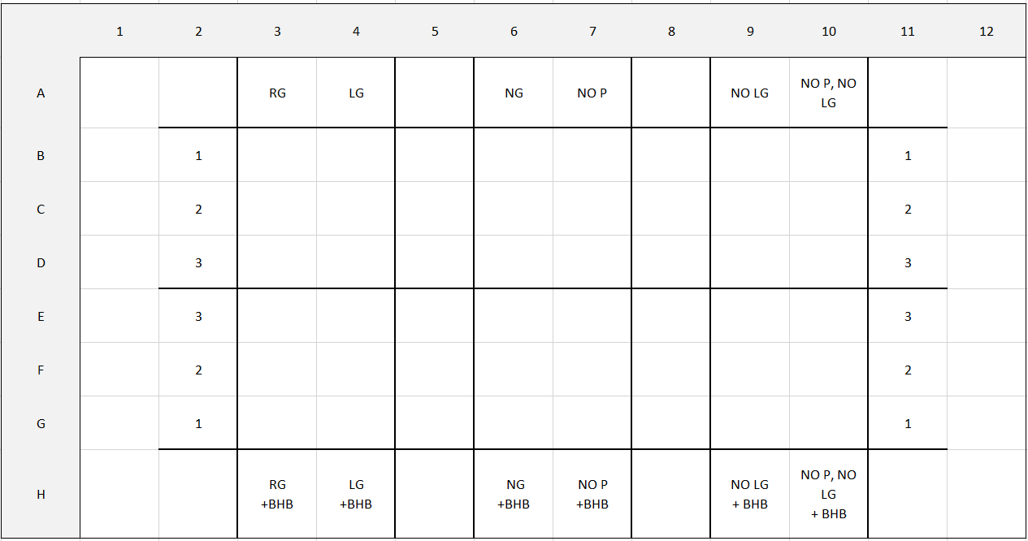
Fixing Cells
Plates were fixed at 48, 72, 96 or 120 hours using 4% paraformaldehyde.

Immunocytochemistry
Following fixing, plates were then processed from immunochemistry. Actin and DAPI immunocytochemistry staining was used to assess cell area, cell process length and ratio of process to cells. Through these procedures, I gained experience in calculating dilution factors, care with light sensitive fluorescent stains and immunocytochemistry staining.

Image Acquisition
For image acquisition, the Olympus IX-81 motorised epifluorescent microscope was used along with the software CellSens. Three random fields were selected per well and imaged at both actin and DAPI channels. Brightfield images were also taken. All images were taken at a magnification of 20x.

Through this I learned how to operate a motorised microscope, how to use CellSense and how to programme the software CellSens for automatic image acquisition.

Data Analysis
Following image acquisition, data analysis was completed using the software Fiji (ImageJ 2). Microsoft excel was used to tabulate the data generated from Fiji. Macros were created to speed up the data analysis process. Actin staining showed cell area, and total cell area was measure per image. DAPI staining showed nuclei count and total cell count was measured for the same cells. Total cell area was then divided by total cell count to get average cell area. This was repeated for each of the three random fields per well. NeuronJ was used to assess cell process length via tracing.

Through this I learned how to extract data, how to organise data and how to operate analysis software. I also learned how to code using Macros to automate some of the processes for data analysis.

An example of data analysis is shown below, a section of a worksheet for cell area:
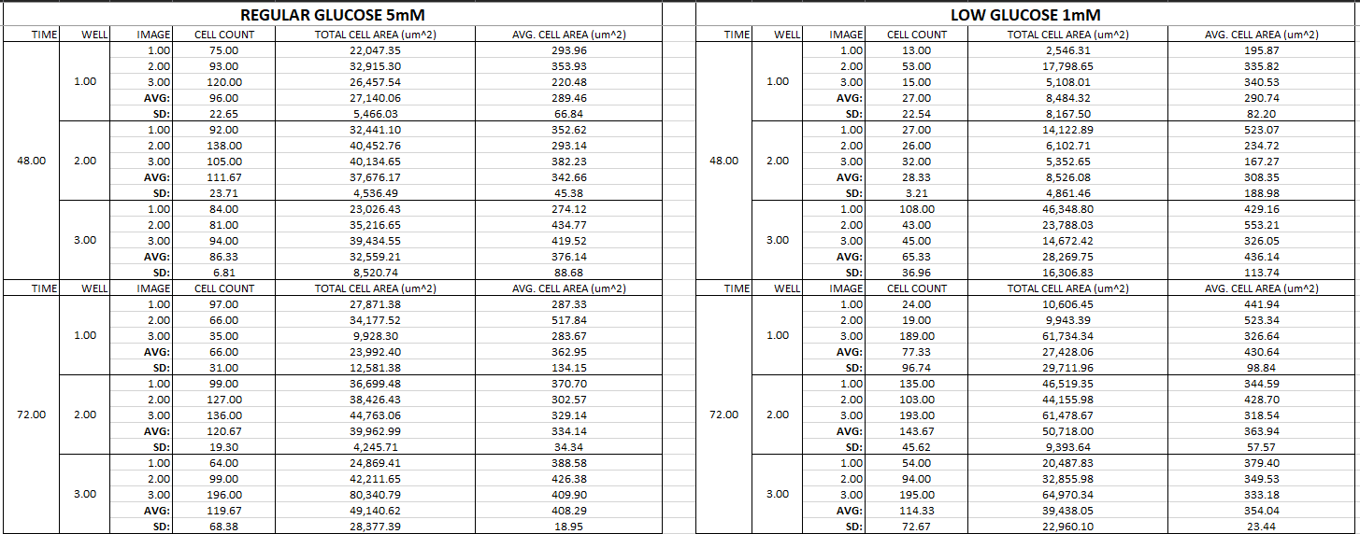
Statistical analysis
Statistical analysis was done using Prism 7. Two-way ANOVA and one-way ANOVA analysis (with Bonferroni correction for multiple comparisons) was used to test for differences between groups. No statistical significance was found between any groups in cell area, cell process length or ratio of processes to cells.

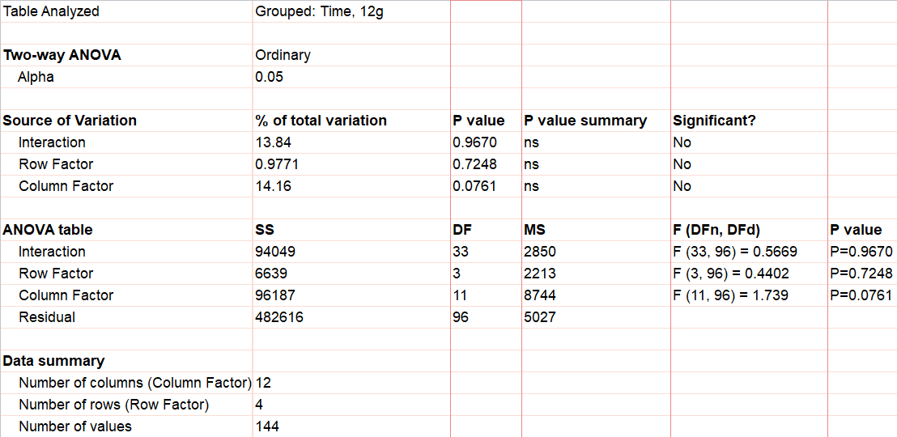
An example of statistical results is shown below, results from a two-way ANOVA analysis:

Discussion
These results show that for this experiment, BHB, pyruvate and L-glutamine had no affect on cell volume, cell process length or process:cell ratio at any timepoint. These results also show that glucose deprivation had no effect at any timepoint.

The data may be affected by technical issues. High cell aggregation leads to overlap of cells when viewing through a microscope. This causes cell area measurements to be inaccurate when cell confluency is high. This also causes cell processes to be hidden in cell clusters and leads to cell process number counts to be inaccurate. In future experimentation, lowering the initial plating density may help with this issue. Other technical issues include loss of cells from pipetting and lack of glucose starvation prior to plating.

I have learned a wide variety of techniques and procedures during this research project, as outlined above. From this, I have gained valuable insight into how a lab is organised, how projects are organised and how to write and carry out protocols.

Please state which Society Winter or Summer Meeting the student is intending to present his/her poster at:
Summer Meeting 2020, Glasgow

Proposed Poster Submission Details (within 12 months of the completion of the project) for an AS Winter/ Summer Meeting – (no more than 300 words)
The student plans to register and submit a poster for the 2020 Summer Meeting. The poster will include details of the research carried out thus far in the lab along with future plans, supplemented with images and graphs.

Brief Resume of your Project’s outcomes: (no more than 200-250 words).
The title of your project and a brief 200-250 word description of the proposed/completed project. The description should include sufficient detail to be of general interest to a broad readership including scientists and non-specialists. Please also try to include 1-2 graphical images (minimum 75dpi). NB: Authors should NOT include sensitive material or data that they do not want disclosed at this time.

Investigating the impact of beta-hydroxybutyrate, L-glutamine and pyruvate on the SH-SY5Y neuroblastoma cell line during development

This experiment aimed to investigate the effect of beta-hydroxybutyrate on the development of SH-SY5Y neuroblastoma cells. In addition to this, common cell culture media supplements L-glutamine and pyruvate were investigated for their potential influence on the effect of beta-hydroxybutyrate.

SH-SY5Y cells were grown in 12 different media groups, as outlined below in Figure 1. Cells were successfully grown in each media group and examined for differences in cell volume, process length and process:cell ratio at 48, 72, 96 and 120 hours. Figure 1 compares Actin and DAPI stained multichannel images from each group.

No significant differences were observed between groups at any timepoint when analysed with one-way ANOVA. These results show that beta-hydroxybutyrate, L-glutamine and pyruvate had no effect on cell volume, cell process length or process:cell ratio. Additionally, pyruvate and L-glutamine had no influence on the effect of beta-hydroxybutyrate. An increasing trend in cell area and process length was observed in all groups with beta-hydroxybutyrate at 48 hours. Figure 2 depicts these results graphically.

In summary, this work shows that beta-hydroxybutyrate does not effect the development of SH-SY5Y cells. This is in line with other work that shows that ketone bodies do not have a rescuing effect on glucose deprived cells. Pyruvate and L-glutamine does not influence cell development or ketone body action and thus, they may be added as supplements to cell culture media in future in-vitro experiments investigating the ketogenic diet without impacting results. This work will contribute to ongoing research which aims to systematically identify how various cell culture supplements can influence the growth and survival of cells, eventually creating a standardised protocol for investigating the ketogenic diet.

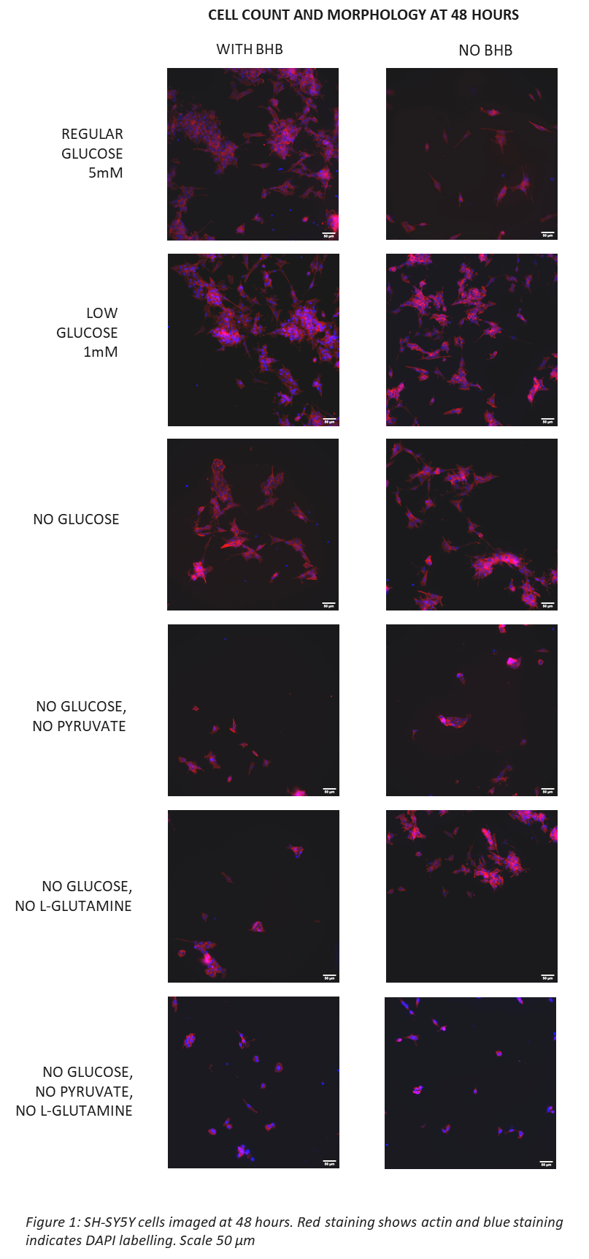
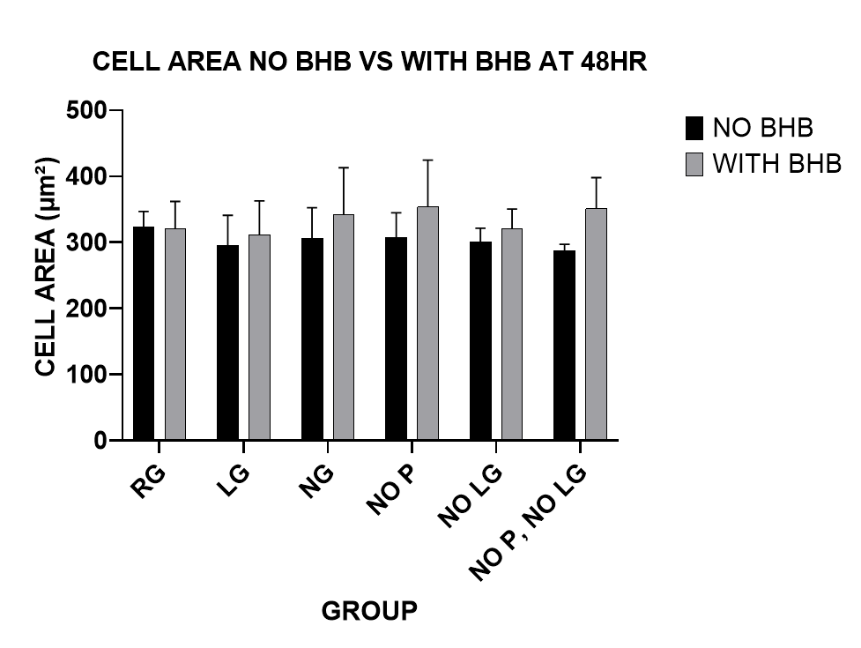
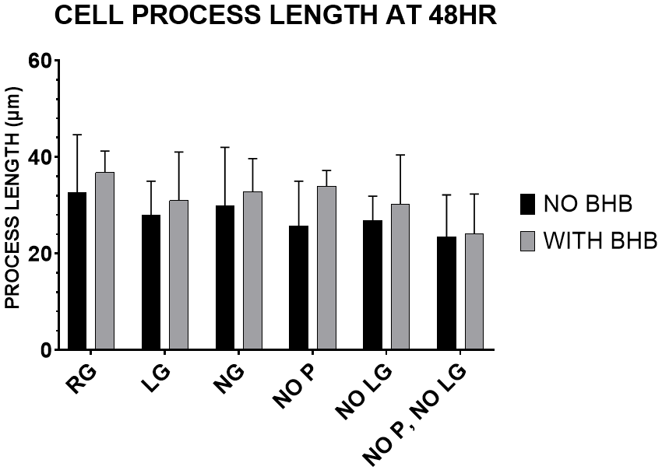
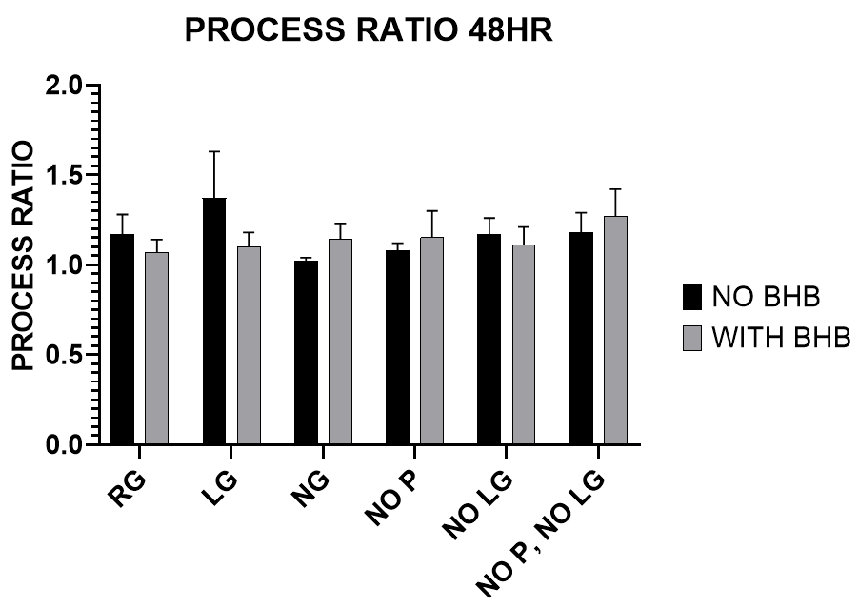
Figure 2: Graphs showing cell area, process length and process:cell ratio at 48 hours, comparing cells with no beta-hydroxybutyrate (NO BHB) with cells supplemented with beta-hydroxybutyrate (WITH BHB). Groups were analysed for differences using Two-Way ANOVA with Bonferroni corrections. No significances were found. RG=Regular glucose, LG=Low glucose, NG=No Glucose, NO P= No Pyruvate, NO LG = No L-Glutamine, NO P/NO LG = No pyruvate, no L-Glutamine.
Other comments: (no more than 300 words)

Signature of student........ Melody C.S. ............................Date..23-9-2019……..

Signature of supervisor…….. Denis Barry Date 23-9-2019

END OF FORM
----------------------------------------------------------------------------------------------------------------------------------------

File: USVRS 201819ReportBarryandCuiSun- no sigs

