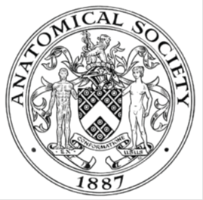
_______________________________________________________________________________________
AWARDEE REPORT FORM
_______________________________________________________________________________________

NAME |  | Sheffield Anatomy Society
TWITTER HANDLE* optional |  | Instagram handle: Sheffieldanatomysoc
UNIVERSITY |  | University of Sheffield
NAME OF AWARD |  | Support for Student Societies 2024/25 Round 3 deadline 20.02.25
PURPOSE OF AWARD conference/event attended/organised (full name) with city and dates.
Conference titled: The Future of Anatomy: Innervations at the Intersection of Tech and Science
Sheffield
22/02/25

REPORT: What were your anticipated benefits?
Minimum number of words between 200-400. Please write in coherent paragraphs.

Benefits for Attendees
For undergraduates in dental, medical, and biomedical fields, this conference offers vital exposure to the cutting edge of anatomy education, showcasing technologies like VR, AR, and AI image analysis. Expert talks, such as Dr. Birks' on radiology and AI, and Drs. Purchase and Meza-Escobar on digital teaching will enhance their understanding of complex structures through innovative visualization. The event also provides career inspiration by highlighting emerging interdisciplinary fields and offers valuable networking with experts. Like Dr. Birks' planned participation, interactive sessions ensure a dynamic learning experience.
Furthermore, the clinical relevance of AI in radiology (Dr. Birks) and applied anatomy (Dr. Varsou) will bridge theoretical knowledge with practical healthcare applications. Insights into the future of education from Dr. Varsou and Fanny Mozu-Simpson will prepare students for evolving learning environments. Witnessing the abstract competition can also inspire future research endeavours.
Resident doctors will benefit from crucial continuing professional development, staying updated on advancements in anatomical imaging, AI in radiology, and innovative teaching. This enhances their clinical skills and understanding of AI's impact on diagnostics and treatment (Dr. Birks). The conference also introduces new educational tools for potential use in their teaching roles and offers networking opportunities with leading researchers. Understanding generative AI's potential in higher (Dr. Varsou) and medical (Fanny Mozu-Simpson) education can inform their learning and teaching practices.
For teenagers from the Sheffield widening participation programme, the conference can ignite a passion for STEM by showcasing the exciting intersection of anatomy and advanced technology. Engaging presentations will demystify complex topics, highlighting the real-world relevance of science in healthcare. Experiencing a university environment and interacting with academics can raise aspirations for higher education. Hearing from enthusiastic experts will offer valuable inspiration, and interactive elements will make learning more impactful for these young learners.

Benefits for Organisers
Organising this conference allows the University of Sheffield to showcase its leadership in innovative anatomy education and research, enhancing its reputation. It serves as a valuable student recruitment tool, particularly within the local widening participation programme, fostering a diverse student body. The event facilitates society's development by providing a platform for academics to share their expertise and network. It also promotes knowledge exchange within the academic and clinical communities and strengthens community engagement. The interdisciplinary focus can foster new research and educational collaborations. Recognising student excellence through the abstract competition motivates students and highlights their talent. Finally, the conference offers valuable feedback on current teaching methods and future development areas.

COMMENTS: Describe your experience at the conference / lab visit / course / seminar/ event.
Minimum number of words between 200-400. Please write in coherent paragraphs.
The anatomy conference on technology and AI was a whirlwind of activity for me. Juggling the responsibilities of general event support kept me on my toes, ensuring the smooth flow of registration, guiding attendees, and assisting the speakers. However, the moments I could step back and engage with the presentations were truly enriching. Dr. Birks' interactive session on radiology images particularly captured my attention, allowing for hands-on learning and a deeper understanding of anatomical structures through a technological lens.
Beyond the practical demonstrations, the intellectual stimulation of the talks was significant. I found myself drawn to the discussions surrounding the integration of AI in medicine and education. Driven by a concern for sustainability, I posed a challenging question regarding the environmental impact of the increasing reliance on AI, prompting a thoughtful response about energy consumption and the need for eco-conscious development. Furthermore, considering the human element in healthcare, I questioned the panel on the adaptability of clinicians to such rapidly evolving, cutting-edge technologies, sparking a debate about training, resistance to change, and the crucial balance between technological advancement and human expertise.
Witnessing the enthusiasm of the undergraduates and the keen interest of the widening participation students was inspiring. The abstract competition showcased the innovative thinking of the next generation. While my role involved a fair amount of logistical support, the opportunity to actively participate in the intellectual discourse and engage with the future of anatomy and AI made the day a thoroughly rewarding and thought-provoking experience.

REPORT: In relation to skills, what were the most important things you gained? (does not apply to equipment grant. For public engagement/outreach awards what did your audience gain and how did you evaluate success?
Minimum number of words between 200-400. Please write in coherent paragraphs.
My involvement in the anatomy conference, while including general support duties, was a significant opportunity for personal and professional growth, leading to the development of several key skills. Juggling the logistical demands of the day – assisting with registration, directing attendees, and supporting speakers – honed my organisational and time management skills. I learned to prioritize tasks and ensure the smooth flow of the event under pressure. When unexpected issues arose, I had to exercise problem-solving skills to find quick and effective solutions. Interacting with a diverse group of attendees and presenters throughout the day significantly improved my communication skills, requiring clarity and professionalism in my interactions. Working alongside the other organizers also strengthened my teamwork abilities.
From the audience's perspective, the anatomy conference on technology and AI offered many benefits. Current and potential dental, medical, and biomedical undergraduates gained invaluable exposure to cutting-edge innovations in their field, witnessing firsthand how technologies like VR, AR, and AI are transforming anatomy education and clinical practice.

Moreover, the opportunity to network with leading experts and peers created valuable connections for future learning and professional development. For those considering their academic futures, particularly the teenagers from the widening participation programme, the conference served as an inspiring introduction to the possibilities within STEM, showcasing the real-world applications of science and technology in medicine and potentially sparking a passion for further study.. Resident doctors benefited from continuing professional development, staying updated on the latest advancements in anatomical imaging and AI applications relevant to their clinical practice. They also gained insights into innovative teaching methodologies they might incorporate into their own roles. Overall, the audience gained knowledge, inspiration, networking opportunities, and a clearer understanding of the evolving landscape of anatomy and its intersection with technology and AI.

REPORT: How do you think you will put this learning experience into practice in the future? For public engagement/outreach awards how with the materials/knowledge generated by this activity be used in the future?
Minimum number of words between 200-400. Please write in coherent paragraphs.
The knowledge gleaned from this anatomy conference on technology and AI promises significant future applications for both my own development and the diverse audience it served. For me, my direct involvement in the logistical aspects of the event has provided invaluable practical experience in event organization. This firsthand understanding of efficient flow management, effective attendee guidance, and comprehensive speaker support will directly inform my future participation in similar endeavors, allowing me to contribute more effectively and strategically. Furthermore, the constant interaction with a wide range of individuals, from renowned experts to enthusiastic students, has honed my communication and interpersonal skills, fostering my ability to articulate information clearly and build rapport across diverse groups – a crucial asset in any collaborative environment. The intellectual engagement required to formulate insightful and challenging questions during the presentations has demonstrably strengthened my critical thinking and analytical abilities, skills that will undoubtedly benefit my future learning and professional pursuits, enabling me to approach complex topics with a more discerning and inquisitive mindset. Moreover, the act of confidently posing these questions and participating in discussions with leaders in the field has significantly boosted my confidence in sharing my perspectives and engaging with cutting-edge ideas within scientific and technological domains. Finally, the comprehensive insights I gained into the practical applications of AI and other advanced technologies within the realms of anatomy and medicine will undoubtedly shape my future learning trajectory and professional interests, potentially guiding me towards further exploration and specialization in these rapidly evolving areas.
For the varied audience, the knowledge acquired at the conference offers a range of future benefits tailored to their specific stages and interests. Undergraduate students, for instance, can leverage their exposure to innovative teaching methodologies and digital resources to enhance their study habits and seek out more engaging learning tools for mastering the complexities of anatomy. Their newfound understanding of the pervasive impact of AI on fields like radiology and clinical practice can also inform their academic choices, encouraging them to focus on areas aligned with future trends in healthcare. The networking connections forged at the event could potentially lead to valuable mentorship opportunities or even early involvement in research projects. Resident doctors, already immersed in clinical practice, can directly apply their enhanced knowledge of advanced anatomical imaging techniques and the burgeoning applications of AI to improve diagnostic accuracy and refine treatment planning strategies within their respective specialties. Moreover, their exposure to innovative teaching methodologies can inform their roles as educators and mentors, allowing them to incorporate more effective and engaging techniques in their own teaching endeavors. For the inspired teenagers from the widening participation programme, the conference may well serve as a pivotal moment, potentially igniting a lasting passion for STEM fields and influencing their crucial academic choices in the years to come. Their firsthand experience within a university setting and direct interaction with accomplished academics can demystify the often-intimidating world of higher education, building their confidence and encouraging them to pursue their scientific curiosities with greater conviction. Even for a more general audience with an interest in scientific progress, the insights gained into the revolutionary impact of technology and AI on the fundamental understanding and practice of medicine can foster a greater appreciation for scientific advancements and their profound potential to shape the future of healthcare for all. Furthermore, exposure to novel learning modalities might encourage a broader adoption of digital resources for lifelong learning across diverse subject areas. In essence, the conference served as a powerful catalyst, not only for my own skill development but also for equipping a diverse audience with valuable knowledge, inspiration, and connections that hold the potential to shape their academic, professional, and personal trajectories in an increasingly technologically driven world

Data Protection/GDPR: I consent to the data included in this submission being collected, processed and stored by the Anatomical Society. Answer YES or NO in the Box below
YES

Graphical Images: If you include graphical images you must obtain consent from people appearing in any photos and confirm that you have consent. A consent statement from you must accompany each report if relevant. A short narrative should accompany the image. Answer N/A not applicable, YES or NO in the box below
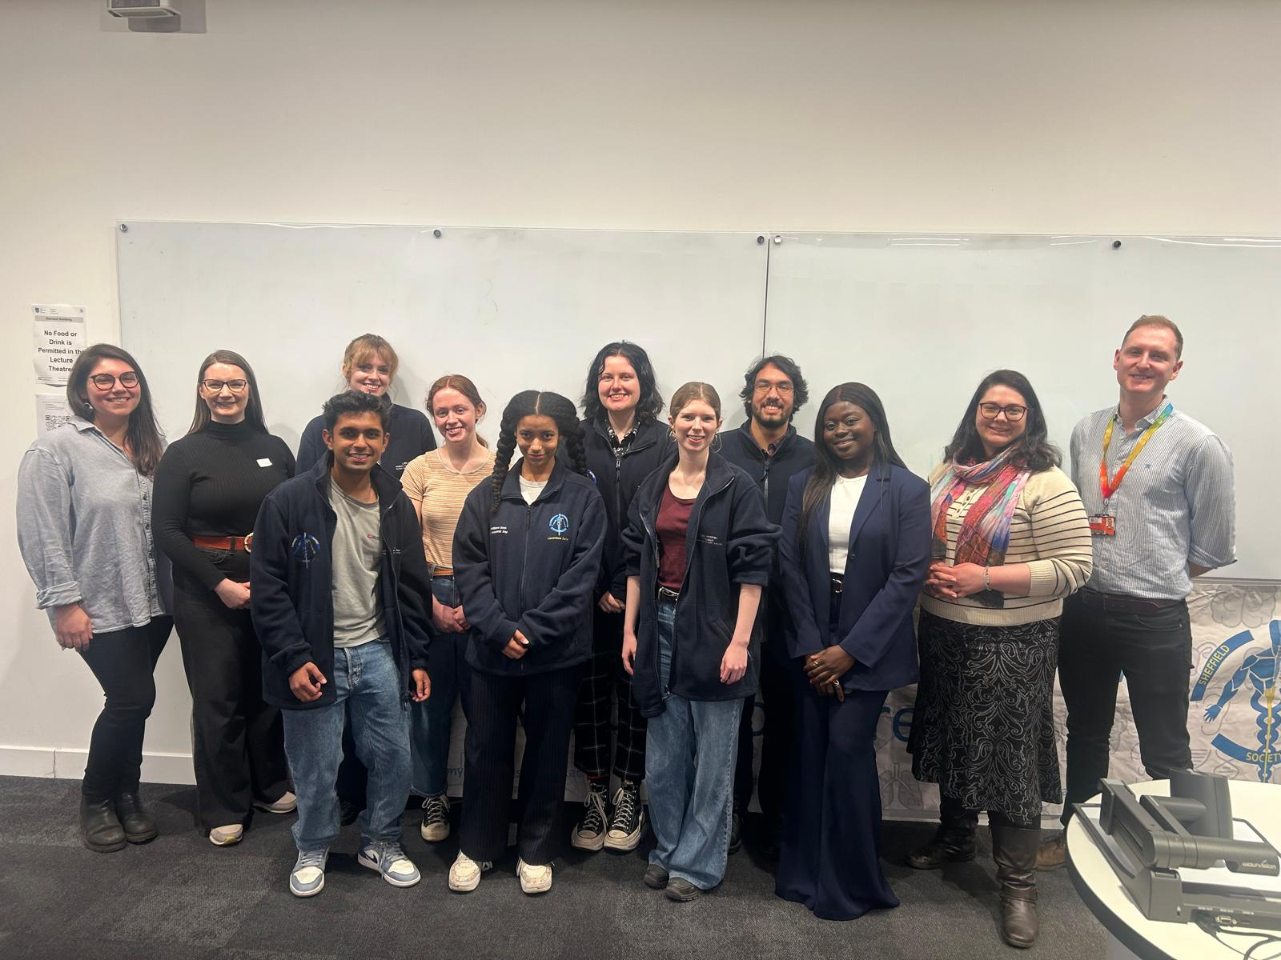
Our wonderful guest speakers and abstract competition winner pictured with this years committee.

Verbal consent was given by everyone included in this photo to be used in this report and any publications that use it.

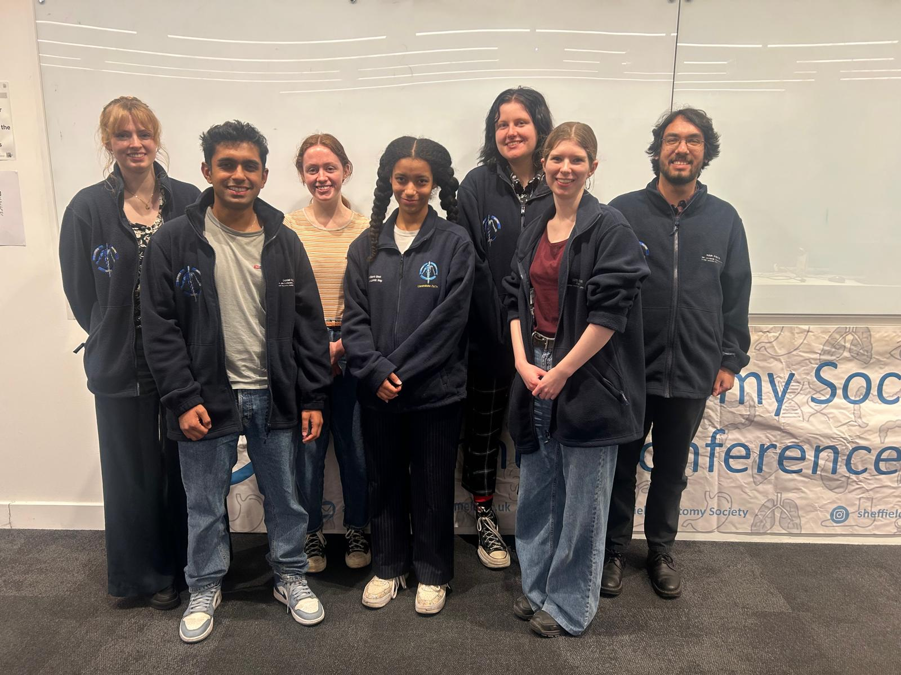

This year's committee comprised of medical, biomedical and dental students, pictures at the conference.
Verbal consent was given by everyone included in this photo to be used in this report and any publications that use it.
Copyright: If you submit images you must either own the copyright to the image or have gained the explicit permission of the copyright holder for the image to be submitted as part of the report for upload to the Society’s website, Newsletter, social media and so forth. A copyright statement must accompany each report if relevant. Answer N/A not applicable, YES or NO in the box below
N/A
SIGNATURE | Denya Williams Goss |  | DATE | 14/04/2025
If submitted electronically, a type-written name is acceptable in place of a hand-written signature
File: AS-Award-Report-Form-171023 – International Conference

