Adhesion signalling in embryo-epithelial interactions at implantation

Supervisor
Professor John D Aplin
Manchester University

Studies of implantation are technically challenging, and much of the literature is based on examining embryos or endometrium in isolation, missing the local intercellular interactions that provide the key to a better understanding. We have developed in vitro approaches to early implantation using mouse or human embryos, or growth or adhesion factor-coated microbeads, in coculture with human epithelial monolayers.

It is clear that a number of adhesion/signalling pathways cooperate to mediate implantation, so that if one is abrogated, others may compensate. We seek to understand the individual components and then develop ways to enhance them and ultimately help improve implantation rates in ART/IVF. We plan to make epithelial cells stably deficient in each of three key implantation components: osteopontin, integrin αvβ3 and ErbB4 (HB-EGF receptor). We will then test ways of enhancing the residual pathways: growth factor stimulation, addition of exogenous adhesion ligand, expression of constitutively active pathway mediators, and increasing proteolytic cleavage of OPN into its more active 45kDa fragment. Assays of embryo attachment and adhesion of ligand-coated beads (including detailed morphological evaluation of the developing interface) will be used to document the effects of these manipulations; the former assays the living system while the latter allows components of specific signalling pathways to be studied independently.

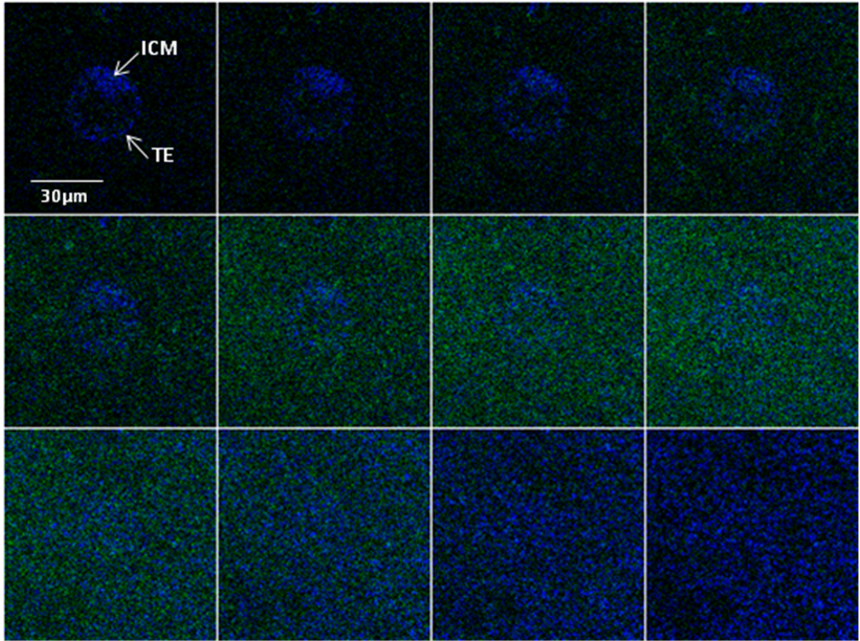
Top

Bottom

Confocal optical section series showing a blastocyst with an intact inner cell mass (ICM) and trophectoderm (TE) stably attached to an epithelial cell monolayer. CD164 (sialomucin) staining (green) is associated with the apical epithelial cell surface; though its intensity varies, its distribution is not perturbed around the embryo. Blue nuclear stain (DAPI) reveals the fine structure of the embryo (top sections) and the undisturbed confluent epithelial monolayer (bottom). In subsequent stages of implantation, embryos displace and break through the epithelial layer.

