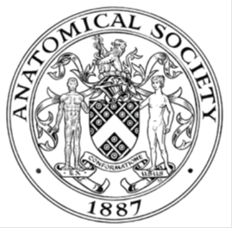
_______________________________________________________________________________________
AWARDEE REPORT FORM
_______________________________________________________________________________________

NAME |  | Elena Patera
TWITTER HANDLE* optional |  | @ArtedelCuerpoH1
UNIVERSITY |  | University of Liverpool
NAME OF AWARD |  | Symington Bequest Travel Fund
PURPOSE OF AWARD conference/event attended/organised (full name) with city and dates.
Participation in the 22nd Congress of the International Federation of Associations of Anatomists (IFAA) ‘Anatomy for Everyone’, Melbourne, Australia, 13th to 16th August 2026.

REPORT: What were your anticipated benefits?
Minimum number of words between 200-400. Please write in coherent paragraphs.
By attending the 22nd Congress of the International Federation of Associations of Anatomists (IFAA) with theme ‘Anatomy for Everyone’, I anticipated a range of benefits that could significantly enhance both my professional development and practices across different domains of anatomy. Since I had two abstracts accepted as oral presentations, I anticipated that I would help my digital game-based learning resource gain more visibility, to showcase my work and my progress with my PhD so far, improve my oral presentation skills as well as network with fellow anatomists with whom I share similar interests. The congress offered several sessions across 4 main domains: (1) Anatomical Sciences Education, (2) Anatomy for Everyone, (3) Ethics, Law and Humanities and (4) Surgery and Clinical Anatomy, therefore, I anticipated to learn about teaching practices enhanced by technology, innovative assessment methods, updates and challenges on body donation programs across different countries, and different quantitative and qualitative research methods for use within the field of anatomy education. As the conference had a great reach, with delegates attending from all around the world, I anticipated a great benefit in networking that would have allowed me to discuss with fellow delegates about shared interests, exchange ideas as well as meet in person various anatomists that I only knew through their scholarly output and LinkedIn. I was also very interested in the symposia that were going to take place during the conference, where I anticipated that I would learn about (1) advances in gamified learning and associated challenges with their practical incorporation into curricula, (2) the opportunities available out there for supporting the professional development of anatomists, particularly early career anatomists or anatomists who did not previously receive any training on pedagogy, and (3) global challenges in attaining ethically sourced bodies and associated regulatory frameworks and practical interventions.

COMMENTS: Describe your experience at the conference / lab visit / course / seminar/ event.
Minimum number of words between 200-400. Please write in coherent paragraphs.
Attending the22nd Congress of the International Federation of Associations of Anatomists (IFAA) with theme ‘Anatomy for Everyone’ was an invaluable experience. The plenary talks were very enlightening. I particularly enjoyed the plenary talk by aboriginal Australian writer and academic Marcia Langton who talked about ‘Anatomy, racial scientism and eugenics in Australia’ who discussed how racial scientism manifests today through eugenics (i.e., the ideology behind improving human species by selective breeding), digital media amplification, biased interpretations of health data and intelligence to rebrand discredited biological hierarchies as objective facts. One of the things highlighted in this talk, was about the importance of knowing the history, and the atrocities that occurred against certain groups of individuals as this can act as a shield against modern pseudoscience. Another plenary talk that I found fascinating was the one delivered by renowned physiotherapist Dr Sue Mayes, who talked about ‘Fouettés on Phalanges: Anatomy Embodied and Applied’. A key message I took away from this talk was how the field of anatomy does not exist in isolation, but it is instead intertwined with other disciplines including arts and dance.

During the congress, I had the opportunity to deliver two oral presentations related to my PhD. My first presentation formed part of the session "Immersive and Digital Learning Technologies—VR, AR and 3D.” My presentation was titled ‘Enhancing Interactivity in a Neuroanatomy Game-Based Learning Resource Using a Web-Based User-Interface/User-Experience Design Platform’. During this talk, I discussed how I have used Figma, a web-based UI/UX design platform, to increase the interactivity within my digital game-based learning resource 'Anatomy of the Cranial Nerves'. Interactivity is key within GBL resources, hence the use of such platforms that do not require programming or coding skills can be really valuable. After my talk, some delegates approached me and informed me about certain tools that I was not aware of, and I could potentially use to enhance the interactivity within my resource, as well as how I can collaborate with certain educators who do work with specific software for game-based learning.

My second presentation was delivered in the session "Creative, Multimodal and Practical Pedagogical Approaches.” It was titled ‘Enhancing a cranial nerve digital game-based learning resource using multimedia learning principles and professional anatomical illustrations. This presentation was based on my collaboration with Canadian biomedical illustrator, Katelyn Moore, who produced anatomical illustrations showcasing the pathway of each cranial nerve. My talk discussed how the integration of professional anatomical illustrations, together with principles of multimedia learning, could help enhance the quality and educational value of my GBL resource.
REPORT: In relation to skills, what were the most important things you gained? (does not apply to equipment grant. For public engagement/outreach awards what did your audience gain and how did you evaluate success?
Minimum number of words between 200-400. Please write in coherent paragraphs.
This was my second major international conference, and first International Federation of Associations of Anatomy conference I attended, and it certainly allowed me to gain valuable skills in communication, networking, sharing my work with fellow anatomists, as well as appreciating other perspectives.

The conference helped me improve my public speaking skills and to appreciate what effective delivery of a presentation looks like when the audience has varying educational and professional backgrounds. It also helped me learn how I need to articulate complex topics clearly and engagingly within a specific timeframe whilst enduring the enough contest is given. In addition, it allowed me to improve my networking skills as I networked with professionals from various backgrounds all around the world, and that enabled me to exchange ideas and potentially establish collaborative relationships.
The symposia sessions, panel discussions and oral presentations I attended further enhanced my active listening skills as by paying attention to what the presenters were saying, thinking about their topic as they talked, I was picking up the important points and how I can incorporate them in my practice where possible. That helped me develop and shape my own ideas as well as understand a topic from different perspectives, pick up on new insights, challenge my own assumptions, or think of ways to expand on what was presented. In addition, observing how other individuals present allows me to pick up specific strategies some individuals use to catch their audience’s attention, how to make their presentations more appealing as well as how they respond to questions at the end of their presentation, ultimately helping me improve my own approach toward presenting, engaging with the audience and answering questions.

REPORT: How do you think you will put this learning experience into practice in the future? For public engagement/outreach awards how with the materials/knowledge generated by this activity be used in the future?
Minimum number of words between 200-400. Please write in coherent paragraphs.
The congress has definitely left me with a lot of concepts to reflect on, learn more about and engage more.

A symposium I attended titled ‘It’s qualitative, but is it quality? Understanding rigour in qualitative anatomical sciences education research’ has provided me with really useful information on qualitative research methods, and different types of methods that help increase the rigour of this type of research, which I will definitely employ within the qualitative studies I will conduct as part of my PhD research.

Another symposium I attended titled ‘Addressing the needs of global challenges in attaining ethically sourced bodies: Are there alternate frameworks as practical interventions’ has definitely left me with some thoughts on how regulatory frameworks governing the acquisition of human bodies for education and research can become improved along with practical strategies and recommendations that I can feedback to the bequeathals team of my institution to help improve the clarity over what exactly donors consented to.

Overall, all the information and knowledge I acquired during this conference will come in handy, as it will be either used to revise my teaching practice or supplement it, or it will help shape my opinions and perspective over certain topics that I am hoping to publish some scholarly output in the future.
Data Protection/GDPR: I consent to the data included in this submission being collected, processed and stored by the Anatomical Society. Answer YES or NO in the Box below
Yes

Graphical Images: If you include graphical images you must obtain consent from people appearing in any photos and confirm that you have consent. A consent statement from you must accompany each report if relevant. A short narrative should accompany the image. Answer N/A not applicable, YES or NO in the box below
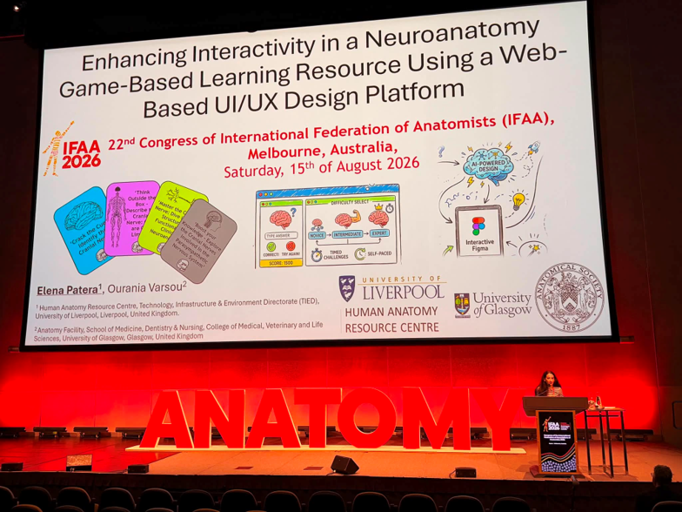

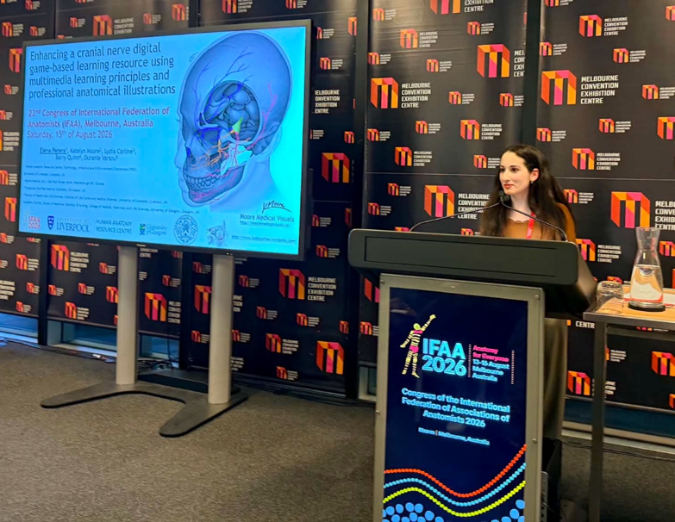

Copyright: If you submit images you must either own the copyright to the image or have gained the explicit permission of the copyright holder for the image to be submitted as part of the report for upload to the Society’s website, Newsletter, social media and so forth. A copyright statement must accompany each report if relevant. Answer N/A not applicable, YES or NO in the box below
N/A

SIGNATURE | Elena Patera |  | DATE | 18/08/2026
If submitted electronically, a type-written name is acceptable in place of a hand-written signature
File: AS-Award-Report-Form-171023 – International Conference

