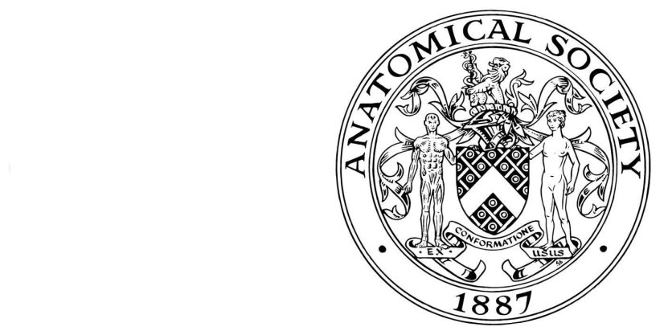
Bursary Application Form
Anatomical Society Training Programme by distance learning
Session start 1 September 2019
The Anatomical Society is pleased to make financial bursaries available to Society members who have been accepted on to the Society’s Training Programme. The bursary is available for each year of the programme (normally up to a maximum of 2 years) and application for it must be made each year. The bursary of £350 per module (up to £700 per year) is designed to be used for the module fee of £250 and to provide some funds for applicants to use in attending the residential course or other related expenses. Please note that the bursary applicant will be required to pay the module fee(s) (£250 per module) at the beginning of the year, and that the bursary will be paid out only after successful completion of the summer residential school.

Bursary applications will only be considered for applicants who are paid up members of the Anatomical Society, who have successfully registered for the Training Programme, and who have paid their registration fee.
All sections of the form must be completed.

1 APPLICANT’S DETAILS |  |  |  |  |  |  |  |  |  |  |  | Contact Address
Dr/Mr/Mrs/Miss/Ms etc.
First names in full
 |  |  |  |  |  |  |  |  |  |  |  | Postcode
Preferred first name
 |  |  |  |  |  |  |  |  |  |  |  | Telephone number (including code) |  |  |  |  | Ext
 |  |  |  |  |  |  |  |  |  |  |  | Day
Surname/family name |  |  |  |  |  |  |  |  |  |  |  | Eve
 |  |  |  |  |  |  |  |  |  |  |  | Email address
Your date of birth (example 23 March 1975)
Day |  |  |  | Month |  |  |  | Year
Membership of the Anatomical Society since:

2 MODULES (SESSION 2019/20)

Please indicate which module(s) you will be undertaking

 | MODULE | CREDITS | Please tick module(s) in session 2018/19
1. | ATP3 TRUNK  (RESIDENTIAL COURSE JULY 2020) | 20
2. | ATP2 NEUROANATOMY  (RESIDENTIAL COURSE JULY 2020) | 20

3 BURSARY APPLIED FOR:

Please indicate which bursary you are applying for:

Bursary | Amount | Please tick which bursary you are applying for
One module | £350
Both modules | £700

Please fill out the table below with your bank details.

UK bank account | Name of account holder
 | Bank name
 | Sort code
 | Account number
Bank account outside UK | Name of account holder
 | Address of account holder (if different to above)
 | Name of bank
 | Address of bank
 | IBAN (International Bank Account Number)

Applicant’s Signature |  | Date

4. DATA PROTECTION:-

I consent to the data included in this submission being collected processed and stored by the Anatomical Society | No |  | Yes |  | Please tick one box

Please return your completed (preferably typewritten) Bursary Form by E-MAIL to the Anatomical Training Programme Management Board c/o maryanne.piggott@kcl.ac.uk

File: ATP-Bursary-Form-2019–v1-100519

