UNDERGRADUATE SUMMER VACATION SCHOLARSHIP AWARDS – FINAL SUMMARY REPORT FORM 2015/16
NB: This report will be posted on the Society’s website therefore authors should NOT include sensitive material or data that they do not want disclosed at this time.

Name of student:
Jemma Franklin
Name of supervisor(s):
Dylan Sweetman
Project Title: (no more than 220 characters)
Retinoic acid in limb muscle development
Project aims: (no more than 700 words)
Background:
During development proliferative muscle precursors delaminate from limb level somites and migrate into the developing limb. In the limb they form two tissue blocks, the dorsal and ventral muscle masses, and only then do they begin to express specific markers of muscle differentiation, such as Myf5 and MyoD, in a stereotyped temporal pattern (Mok et al., 2015). This process is regulated by a range of signaling molecules and provides an excellent model to study fundamental questions of cell migration, fate and differentiation (Buckingham et al., 2003; Buckingham and Vincent, 2009; Christ and Brand-Saberi, 2002; Duprez, 2002) as well as having important implications for understanding muscle growth and regeneration in adults (Tajbakhsh, 2009).

Recently we have shown that interactions between FGF18 and retinoic acid can influence limb muscle differentiation. While FGF18 in the distal limb promotes expression of differentiation markers RA from the flank maintains these cells in a proliferative precursor state where they express Pax3 (Mok et al., 2014). However the response of these muscle precursors to retinoic acid is complex and previous work has shown that RA can also promote differentiation (Chen and Li, 2016; Reijntjes et al., 2010). One possible explanation of these contradictory results is that RA might have different effects depending on its concentration so, while high levels in the proximal limb might inhibit myogenic differentiation, lower levels more distally could promote it.

Aims and objectives:
We will use chicken embryos to directly test this hypothesis. We will graft beads soaked in different concentrations of RA into developing limb buds and determine their effects on myogenesis using in situ hybridization for a range of markers including Pax3, which labels proliferative muscle precursors and MyoD, which are expressed during early myoblast commitment.
These experiments will provide fundamental insights into the regulation of muscle cell differentiation during development and will feed directly into ongoing research programmes in my lab.

Experimental methods:
We will graft beads soaked in retinoic acid or antoagonists of RA signalling at various concentrations into developing limb buds (Mok et al., 2014). We will then determine their effects on muscle cell differentiation by in situ hybridisation using a range of muscle specific makers such as MyoD and Pax3.

Project Outcomes and Experience Gained by the Student (no more than 700 words)
Outcomes: chicken embryos were grafted with beads soaked in ATRA at either 4μg/ml or 0.4μg/ml. These embryos were then incubated for 24h, harvested and expression of MyoD and Pax3 examined by in situ hybridisation. MyoD was downregulated after treatment with both 4μg/ml and 0.4μg/ml ATRA although this effect was stronger at higher concentrations. Pax3 also appeared to be downregulated, suggesting an effect on early stages of myogenesis.

Although these results have not confirmed our original hypothesis they have reinforced the data supporting a role for RA in limb myogenesis and extended this to the hindlimb. The project has also extended our previous analysis by providing data about the effects of RA on Pax3 as well as MyoD.

Having had no previous lab experience, this was a great opportunity to learn about basic techniques in a professional environment. It was easy to ask questions and I was able to learn about details that weren’t necessarily part of my project but were interesting nonetheless. I am confident with in situ hybridisations and with bead grafting techniques, which will help me greatly when applying for Masters courses and PhDs later this year. I feel as though I have gained a great understanding of the research process, and what it takes to work in academia, and I’m excited to pursue my goal to continue in the world of research, and eventually become a lecturer.

Please state which Society Winter or Summer Meeting the student is intending to present his/her poster at:
Winter 2016

Proposed Poster Submission Details (within 12 months of the completion of the project) for an AS Winter/ Summer Meeting – (no more than 300 words)
Limb muscles are derived from Pax3 expressing migratory myoblasts which delaminate from the hypaxial somite, migrate into the limb and then begin to differentiate and express muscle determination genes such as MyoD. Expression of these genes is regulated by a combination of inductive and repressive signals including interactions between FGF18 and retinoic acid. In early limb buds high concentrations of RA prevent FGF18 from inducing MyoD. However in later limb buds this repression is relieved and myogenic gene expression is activated.

One open question in this system is whether or not RA has differing effects at different concentrations. One model suggests that RA synthesis in the flank provides high levels in early limbs but, as the myoblasts migrate further into the extending limb, they experience lower RA levels. It is possible that in this case the role of RA changes and it acts as an inducer of myogenesis.

To test this hypothesis we grafted beads soaked in either high or low levels of ATRA into the limbs buds of developing chicken embryos. We then assessed the effects on myogenesis using in situ hybridisation for Pax3 and MyoD. We found that both concentrations could reduce MyoD expression although this effect was dose dependant at more apparent at higher concentrations. We also saw reductions in Pax3 expression suggesting that the effects on MyoD expression could be a result of changes to the earlier proliferative myoblast population.

Brief Resume of your Project’s outcomes: (no more than 200-250 words).
The title of your project and a brief 200-250 word description of the proposed/completed project. The description should include sufficient detail to be of general interest to a broad readership including scientists and non-specialists. Please also try to include 1-2 graphical images (minimum 75dpi). NB: Authors should NOT include sensitive material or data that they do not want disclosed at this time.

During development the cells that will make the muscles of the limbs migrate into the developing limbs and then begin to differentiate. This process is controlled by signalling molecules from other tissues and regions of the embryo one of which is the vitamin A derivative retinoic acid (RA). We know that high concentrations of this molecule can block the ability of muscle cells to activate the genetic programme needed to differentiate into mature, functional muscle cells; however, it is possible that lower levels can promote muscle formation and this could be an important mechanism to regulate muscle development in embryos.

To test this we used chicken embryos as a model. They are large, easy to manipulate and, importantly, the gene networks regulating muscle development are closely related to those of other vertebrates, including humans. We grafted beads that had been soaked into different concentrations of RA into developing limbs and then measured their effects on muscle gene expression using in situ hybridisation, a technique that allows to detect where and when muscle genes are being expressed.

Expression of MyoD, a gene needed for muscle cell differentiation, was decreased by both high and low concentrations of RA.

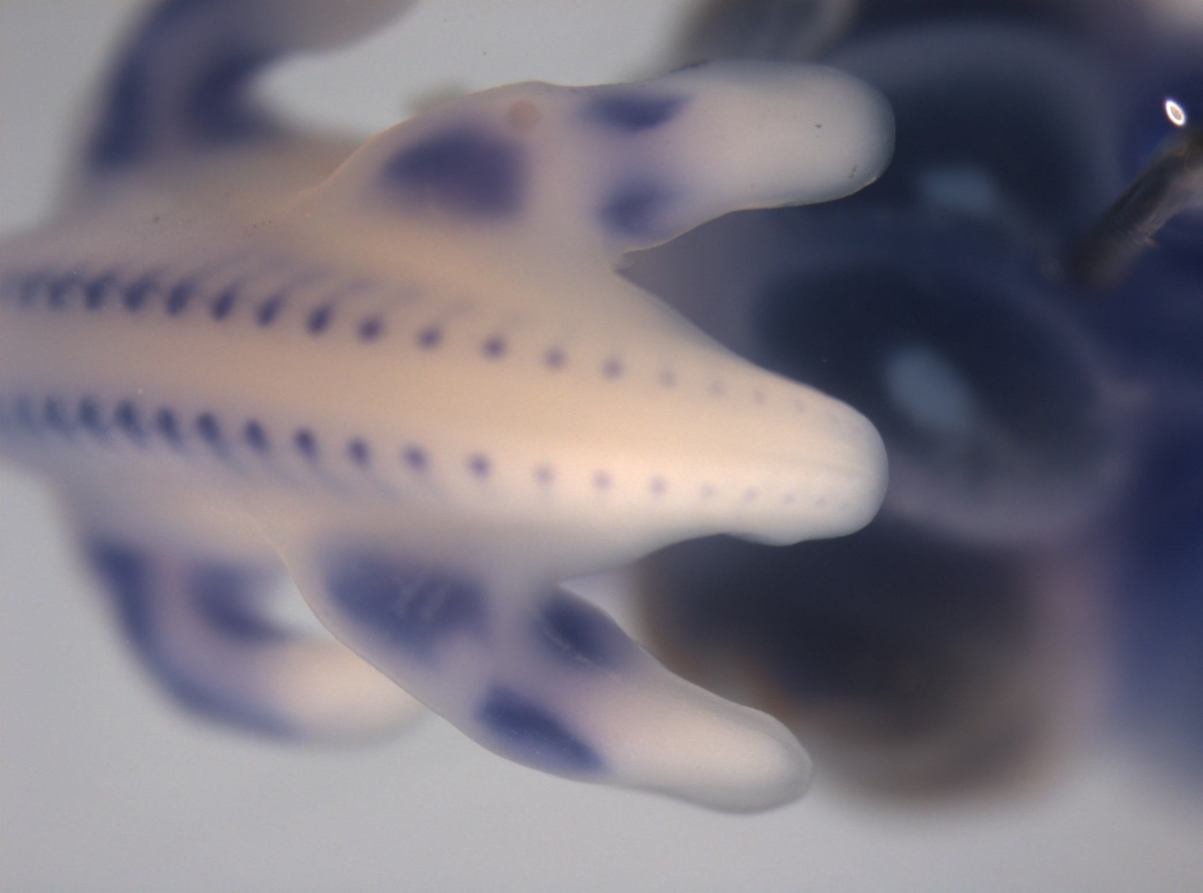
4.0mg/ml ATRA bead grafted into the limb bud of a stage HH24 chicken embryo. In situ hybridisation for MyoD show developing muscles in blue. Staining close to where the bead was grafted is reduced showing a reduction in muscle cell production in that area.

Other comments: (no more than 300 words)

Signature of student Date: 08/11/2016

Signature of supervisor Date: 08/11/2016
END OF FORM
----------------------------------------------------------------------------------------------------------------------------------------
File: USVRSReport201516SweetmanandFranklinwebsite

