UNDERGRADUATE SUMMER VACATION SCHOLARSHIP AWARDS – FINAL SUMMARY REPORT FORM 2020/21
NB: This whole report will be posted on the Society’s website therefore authors should NOT include sensitive material or data that they do not want disclosed at this time.

Name of student:
Natalia Penar
Name of supervisor(s):
Jamie Davies
Project Title: (no more than 220 characters)
Optogenetic Shroom3 in branching morphogenesis
Project aims: (no more than 700 words)
Branching morphogenesis occurs in development of many internal organs, including kidneys and lungs. Tissue branching involves symmetry-breaking, causing some cells to become branch leaders while other cells remain in place. This symmetry-breaking is not well understood.

The project aimed to test one of the hypotheses on branching formation. The hypothesis was that mechanical curvature can directly influence branching, with convexity encouraging and concavity inhibiting cell advance. Shroom3 protein drives actin to associate with myosin (McGreevy et al., 2015). It localises in the apical membrane of epithelial and endothelial cells, and thus Shroom3 activation leads to apical constriction and epithelial folding (Loebel et al., 2016).

In the project, Madin-Darby Canine Kidney (MDCK) cells with optically-activated Shroom3 (OptoShroom) were used. Wild type MDCK cells in 3D cultures undergo branching when treated with HGF. The aim of this project was to see if OptoShroom-containing MDCK cysts in 3D culture would undergo branching without HGF when OptoShroom is activated with blue light.

An additional aim of the project was to create a protocol for creating mixed cysts of OptoShroom-containing and wild type cells for future experiments.

References:

McGreevy EM, Vijayraghavan D, Davidson LA, Hildebrand JD. Shroom3 functions downstream of planar cell polarity to regulate myosin II distribution and cellular organization during neural tube closure. Biol Open. 2015 Jan 16;4(2):186-96.

Loebel DA, Plageman TF Jr, Tang TL, Jones VJ, Muccioli M, Tam PP. Thyroid bud morphogenesis requires CDC42- and SHROOM3-dependent apical constriction. Biol Open. 2016 Jan 15;5(2):130-9. doi: 10.1242/bio.014415.

Project Outcomes and Experience Gained by the Student (no more than 700 words)

Project outcomes:

Cell culture plates containing both wild type and OptoShroom-containing cells were prepared in red light and kept in darkness. At days 11 to 13 after starting the culture, one plate was illuminated with blue light, while the other one remained in darkness.

Images of illuminated cysts (3 per well in a 24-well plate) were taken before illumination and 24 h, 48 h and 72 h after the start of illumination. Images were also taken 24 h after illumination was ceased. The images of cysts in the non-illuminated condition were taken at corresponding times.

At all imaging times, wild type cysts were of regular shape, and mostly had single lumens. OptoShroom cysts had multiple lumens, and were of less regular shapes. Statistical analysis and comparison of images before and 72 h after illumination has indicated that OptoShroom cysts were elongating and their symmetry was breaking (p = 0.003 when compared to wild type and p = 0.08 when compared to non-illuminated OptoShroom, in which some symmetry-breaking could have occurred due to weak OptoShroom assembly in the dark).

Additionally, a protocol for developing mixed cysts was created, indicating that cysts containing both wild type and OptoShroom cells can form. Patches of specific cell type tended to form due to colony growth from single cells but cysts with more scattering were also observed.

Experience gained:

I was trained in creation and maintenance of both 2D and 3D cell cultures. I have learnt to use an inverted microscope and to statistically analyse obtained images. I gained experience in designing experiments, understanding their outcomes and localising the sources of errors in the experiments.

Please state which Society Winter or Summer Meeting the student is intending to present his/her poster at:
Summer Meeting Bangor, Wales 2022

Proposed Poster Submission Details (within 12 months of the completion of the project) for an AS Winter/ Summer Meeting – (no more than 300 words)
Optogenetic Shroom3 in branching morphogenesis

Branching is a process important in development of organs such as lungs and kidneys. Branching occurs when one of the cells starts to grow more than the others, becoming the leader of branch’s tip. The project’s hypothesis was that mechanical forces make some cells to grow more than others, with convexity encouraging growth and concavity inhibiting it.

The project used Madine-Darby Canine Kidney (MDCK) cells that form cysts in 3D culture and are capable of branching when treated with HGF. MDCK cells were engineered to contain a light-activated version of Shroom3 protein (OptoShroom). Shroom3 drives actin-to-myosin association (McGreevy et al., 2015). Shroom3 localises on the apical domain of cells (Figure 1). Its activity promotes apical constriction, leading to epithelial deformation (Loebel et al., 2016).

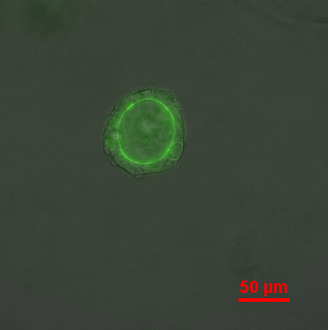

Figure 1. OptoShroom (green) localises on the apical side of MDCK cysts.

The project’s aim was to test whether OptoShroom activation would cause some cells to grow more than others and become branch leaders. Wild type and OptoShroom cysts were cultured in darkness. Half of the cysts were illuminated with blue light at days 11 to 13.

The comparison of cyst images before and 72 hours after the start of illumination indicated that OptoShroom cysts were elongating and their symmetry was breaking (p = 0.003 when compared to wild type and p = 0.08 when compared to non-illuminated OptoShroom, in which some symmetry-breaking could have occurred due to weak OptoShroom assembly in the dark; Figure 2).

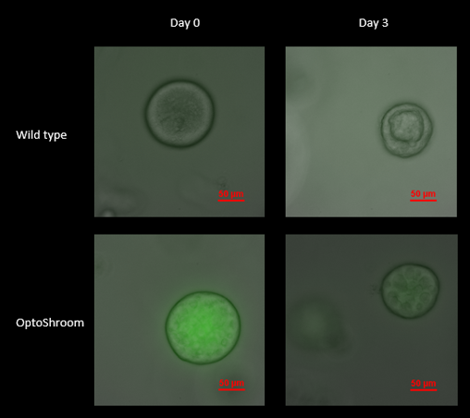
Figure 2. At illumination day 0, both wild type and OptoShroom cysts had round, regular shapes. At day 3, OptoShroom cysts were elongated and their symmetry was broken, while wild type cysts morphology did not change.

The outcomes indicate that mechanical curvature might be a mechanism for branch formation, however further studies are needed.

References:

McGreevy EM, Vijayraghavan D, Davidson LA, Hildebrand JD. Shroom3 functions downstream of planar cell polarity to regulate myosin II distribution and cellular organization during neural tube closure. Biol Open. 2015 Jan 16;4(2):186-96.

Loebel DA, Plageman TF Jr, Tang TL, Jones VJ, Muccioli M, Tam PP. Thyroid bud morphogenesis requires CDC42- and SHROOM3-dependent apical constriction. Biol Open. 2016 Jan 15;5(2):130-9. doi: 10.1242/bio.014415.

Brief Resume of your Project’s outcomes: (no more than 200-250 words).
The title of your project and a brief 200-250 word description of the proposed/completed project. The description should include sufficient detail to be of general interest to a broad readership including scientists and non-specialists. Please also try to include 1-2 graphical images (minimum 75dpi). NB: Authors should NOT include sensitive material or data that they do not want disclosed at this time.
Optogenetic Shroom3 in branching morphogenesis

During development, tissues undergo changes in their shape. One of such morphogenetic events is branching, present in organs like lungs and kidneys. This project aimed to investigate the mechanism through which branching occurs. Branching takes place when one of the cells starts to grow more than the others, becoming the branch tip leader. It was hypothesised that mechanical forces are causing some cells to grow more than the others, with convexity encouraging growth and concavity inhibiting it.

Madine-Darby canine kidney (MDCK) cells were engineered to contain a light-activated protein, Shroom3 (OptoShroom). Shroom3 localises on one site of the cysts that are formed by MDCK cells. When activated, it causes tissue folding. In the project, light was shone on cells to investigate if mechanically-induced curvature will make some of the cells become branch leaders. After 72h of illumination, OptoShroom MDCK were elongating more than wild type cysts, and their symmetry was breaking more. The difference was not as big when compared to non-illuminated OptoShroom cysts, probably due to some Shroom3 activation even in darkness. The project provided pilot data indicating that mechanical influences might be involved in tissue branching, however further studies are needed.

Figure 1. OptoShroom (green) localises on the apical side of MDCK cysts.

Figure 2. At illumination day 0, both wild type and OptoShroom cysts had round, regular shapes. At day 3, OptoShroom cysts were elongated and their symmetry was broken, while wild type cysts morphology did not change.

Other comments: (no more than 300 words)

Data Protection/GDPR: I consent to the data included in this submission being collected, processed and stored by the Anatomical Society. Answer YES or NO in the Box below
YES
Graphical Images: If you include graphical images you must obtain consent from people appearing in any photos and confirm that you have consent. A consent statement from you must accompany each report if relevant. A short narrative should accompany the image. Answer N/A not applicable, YES or NO in the box below
N/A
Copyright: If you submit images you must either own the copyright to the image or have gained the explicit permission of the copyright holder for the image to be submitted as part of the report for upload to the Society’s website, Newsletter, social media and so forth. A copyright statement must accompany each report if relevant. Answer N/A not applicable, YES or NO in the box below
YES

Signature of student............Ms Natalia Penar...............Date…09.09.2021………..

Signature of supervisor………Professor Jamie Davies……... Date…10 Sept 2021

END OF FORM
----------------------------------------------------------------------------------------------------------------------------------------
File: USVRS20-21ReportDaviesandPenar website nosig- uploaded130921

