UNDERGRADUATE SUMMER VACATION SCHOLARSHIP AWARDS – FINAL SUMMARY REPORT FORM 2017/18
NB: This whole report will be posted on the Society’s website therefore authors should NOT include sensitive material or data that they do not want disclosed at this time.

Name of student:
Zahra Waheed
Name of supervisor(s):
Dr Lemonia Chatzeli
Project Title: (no more than 220 characters)
Defining branching morphogenesis in the mouse submandibular gland using a quantitative approach
Project aims: (no more than 700 words)
Branching morphogenesis is an iterative process by which a simple epithelial placode (thickening) is finally fashioned into a complex ductal network. Branching allows for efficient packing of a large surface area of epithelium into a small volume to maximise metabolic exchange- making it a crucial feature for the correct embryological development of organs such as the lungs, kidney, pancreas and salivary gland. Understanding how such an organisation is achieved within these organs can provide key clues into the molecular mechanisms behind disease pathology.

The developing salivary gland- specifically the submandibular gland (SMG)- is an extensively studied model organ for branching morphogenesis (Hsu and Yamada, 2010). Mammals have three paired salivary glands, the parotid, the submandibular (SMG) and the sublingual (SL). The parotid glands are found at the back of the mouth, between the upper and lower jaw, whereas the SMG and SL are situated under the tongue. In the mouse, both the SMG and SL are closely associated with one another.
Branching morphogenesis in the SMG begins at E12.5 (Tucker, 2007) with clefting, which divides the initial bud of tissue into several buds. Following this, a diverse combination of cellular behaviours such as apoptosis, migration and differentiation (Knox and Hoffman, 2008) contribute to duct formation and elongation, and a complex branched tree complete with mucus/serous producing acini can be observed within three days (Harunaga, Hsu and Yamada, 2011). Much is known about the molecular events governing branching morphogenesis in the salivary gland, but knowledge on branching patterns is yet to be fully revealed.

To generate the entire tubular network, branching morphogenesis usually follows one of two routes: a stochastic pathway where the decision to branch and point of branching appears to be random, or a predefined pathway where the pattern of branching is pre-determined within the genetic material (Wang et al, 2017). Current literature on cultured SMGs suggests branching in these organs could be a stochastic process (Harunaga, Hsu and Yamada, 2011; Wang et al, 2017). Interestingly, in a recent study on other stochastically branching organs such as the mammary gland, kidney and human prostate, the authors propose a random self-annihilating walk model to explain the dynamics of stochastic branching (Scheele et al, 2017). Here it was shown that cells at the tips of branches have a proliferative activity and extend themselves into the surrounding environment in a random fashion. However, when in the vicinity of a neighbouring branch, the model demonstrates that the tip cells become quiescent, and “terminate” the branch. This raises the question as to whether this mode of branching is conserved even in the salivary glands.
Thus, the main objective of this project is to use experimental and computational approaches to investigate how mouse submandibular and sublingual glands are organised into a branching network. Specific aims were:

- to create a 3D reconstruction of the branching tree of the mouse salivary glands at different embryonic stages, using image analysis software: namely Image J and Imaris
- to extract topological information from the 3D rendering, namely: 3D branch co-ordinate points, branch diameter and trajectory and to determine branch generations (i.e mother and daughter branches)
- to compare the complexity of these networks across different embryo stages, specifically E15.5, E16.5 and E18.5
- to establish a marker staining to facilitate manual outlining/3D reconstruction

References:
Harunaga, J., Hsu, J.C. and Yamada, K.M. (2011). Dynamics of salivary gland morphogenesis. Journal of Dental Research, 90(9), pp.1070-1077.

Knox S.M. and Hoffman M.P. (2008). Salivary gland development and regeneration. In: Wong DT, editor. Saliva diagnostics. Blackwell Publications, Ames, pp. 3–13.

Scheele, C.L.G.J., Hannezo, E., Muraro, M.J., Zomer, A, et al. (2017). Identity and dynamics of mammary stem cells during branching morphogenesis. Nature, 542, pp.313-317.

Tucker, A.S. (2007). Salivary gland development. Seminars in Cell and Developmental Biology, 18(2), pp.237-244.

Wang, S., Sekiguchi, R., Daley, W.P. and Yamada K.M. (2017). Patterned cell and matrix dynamics in branching morphogenesis. Journal of Cell Biology, 216(3). pp.559-570.

Project Outcomes and Experience Gained by the Student (no more than 700 words)
A direct output of the project was a final, 3D rendering of the branching tree of the mouse E15.5, E16.5 and E18.5 SMG and SL, based on manual tracings of the ducts. We tested several markers such as Keratin 14 and the lectin DBA (Dolichos Biflorus Agglutinin) to obtain a clear visualisation of the ductal cells and acinar cells respectively, with minimal background noise. We were then able to optimise the manual tracing of the salivary gland ducts. More generally, the project led to the establishment of a rigorously fine-tuned protocol to generate a 3D model of the branching tree of mouse salivary glands using Image J; one in which topological information could be successfully and accurately extracted and then saved as a spreadsheet. Numbers were assigned to each point of branching, and mother and daughter branches were recorded. The 3D co-ordinates of branch points were also recorded, as well as it’s physical topology- i.e whether the branch was curvy rather than straight.

Experience gained included mouse anatomy and embryo dissection, where I learned how to carefully dissect submandibular and sublingual glands, parotid and lacrimal glands from E15.5, E16.5, E18.5 and P1 mouse embryos.

I learned how to prepare specimens for immunofluorescence microscopy and practiced performing the steps of direct and indirect immunostaining including blocking, antibody incubation, nuclear staining and mounting of the coverslips. I also learned tips on how to maximise light penetrance during tissue imaging by using clearing agents (Rapiclear). We used combinations of antibodies against aquaporin 5, DBA and keratin-14 to determine which markers allow effective visualisation of the acini and ductal cells of the SMG and SL. This was done in order to facilitate manual outlining of the salivary gland ducts. To investigate cell proliferation across the salivary gland, we additionally stained for Edu, a thymidine analogue that binds to the DNA during the S phase of the cell cycle. I have also enhanced my ability to perform calculations to prepare chemical solutions.

I learned about the different ways to section tissue. I gained experience in using a microtome to produce thin wax sections of a sample, and in using a vibratome to cut thicker sections of tissue samples embedded in low-melting-point agarose. As these machines have sharp blades and can be hazardous if not used correctly, I was given training on how to safely handle these machines.

Through working with image analysis specialists, I have been able to enhance my existing skills and understanding of Image J. I learned about the mathematical basis behind some image processing functions such as skeletonize and neurite tracer, and when it is appropriate to use these. I also learned how to generate 3D reconstructions of the salivary gland branching tree in Imaris, and what the limitations of each software are in the context of this project.

In addition, I gained practical experience in genotyping and PCR, to verify the mouse lines from which we obtained salivary glands.

Finally, I was trained to use a confocal microscope, which involved configuring the wavelength settings for the lasers, performing tile scans, optimising the image by changing the gain and performing multiple scans. I also gained a thorough understanding of each step and setting.

Overall this project helped to enhance my understanding of developmental biology and also mouse genetics. I learned crucial skills on how to critically evaluate experimental data and communicate the findings through regular supervisor meetings. Additionally, this project highlighted to me the importance of collaboration in science.

Please state which Society Winter or Summer Meeting the student is intending to present his/her poster at:
AS Winter Meeting – York 2018

Proposed Poster Submission Details (within 12 months of the completion of the project) for an AS Winter/ Summer Meeting – (no more than 300 words)

The mammalian salivary gland is a saliva producing and secreting exocrine organ, and the important physiological functions of saliva are well known. The salivary gland itself is a paired structure and there are three main types: the parotid, the submandibular (SMG) and sublingual (SL). The latter two are closely associated with each other and the SMG is one of the most commonly studied salivary glands in culture. Extensive branching morphogenesis is required to establish the highly branched ductal network of this epithelial organ, but despite the molecular mechanisms being widely characterized, very little is known about the precise arrangement and pattern of branching. Here we establish a 3D model of the mouse SMG and SL of E15.5, E16.5 and E18.5 embryos in order to investigate the branching pattern within these glands. to achieve this we first identified effective immunofluorescent markers to track the ductal and the salivary gland epithelium (K14). We then reconstructed the branching tree using ImageJ before developing an image analysis protocol for 3D reconstruction. Comparisons of the submandibular 3D renderings suggested an increase in complexity with increasing developmental stage, which mainly occurs between E15.5 to E16.5. Further work on this project will enable a greater insight into the branch decisions of the submandibular gland and reveal more about salivary gland development. Overall this project has helped to successfully establish an essential research tool that can be used to aid these future studies.
Brief Resume of your Project’s outcomes: (no more than 200-250 words).
The title of your project and a brief 200-250 word description of the proposed/completed project. The description should include sufficient detail to be of general interest to a broad readership including scientists and non-specialists. Please also try to include 1-2 graphical images (minimum 75dpi). NB: Authors should NOT include sensitive material or data that they do not want disclosed at this time.

Defining branching morphogenesis in the mouse salivary gland using a quantitative approach

The purpose of this project was to investigate how the mouse salivary gland is precisely organised into a highly complex network of tubes through an epithelial remodelling process common to several organs- branching morphogenesis. Our project studied the submandibular gland (SMG) as it is an extensively used model of branching morphogenesis. Deviating away from signalling pathways and molecular interactions which are already well characterised in the literature, we instead focussed on the topological branching pattern of the submandibular gland and established for the first time a 3D reconstruction of the branching tree. We then compared the complexity of this tree across different embryonic stages to further explore gland development.

To achieve our aim, we first immunostained embryonic stage 15.5, 16.5 and 18.5 SMG and sublingual gland tissue (as both salivary glands are closely associated to each other, see figure 1a) with Keratin 14 to stain the salivary gland epithelium and to clearly visualize the ducts and acini. We then used Image J to manually trace the ducts and obtain a 3D reconstruction.
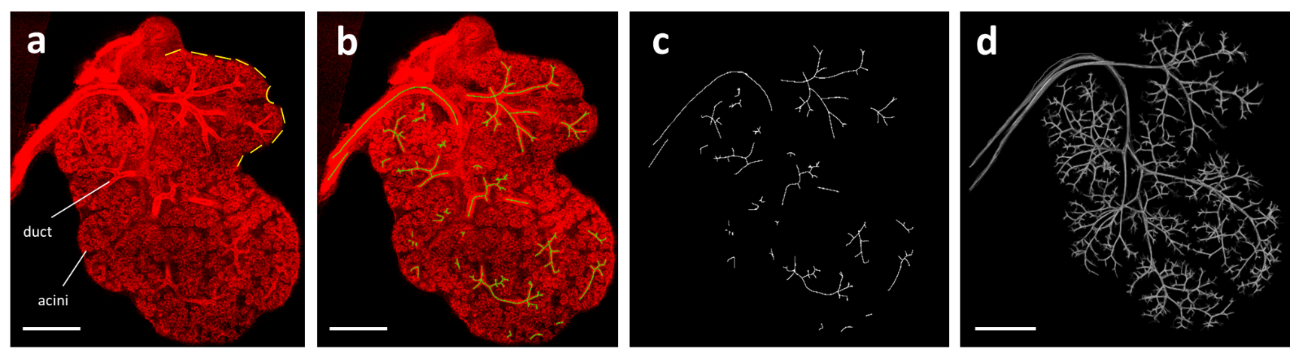

Figure 1: Diagram of workflow for the 3D reconstruction of the mouse salivary gland. Gland shown is at embryonic stage 16.5. Scale bars are 500μm. A) Immunostaining of salivary gland tissue with Keratin-14. The smaller SL gland is indicated by a dashed yellow line and a single duct and two acini have been labelled for clarity. B) Manual ductal tracing was performed in Image J in each image slice of the image stack, until ducts were no longer visible. C) Tracings were isolated from the image and pre-processed before using the 3D Viewer Image J plugin to generate the final 3D branching tree in D). Branching measurements were then recorded in a spreadsheet.

When comparing the submandibular gland branching tree at different embryonic stages, our 3D renderings suggest that the complexity of the tree highly increases between E15.5 to E16.5 while SMGs transitioning from E16.5 to E18.5 seems to have a moderate increase in the number of branches generated. (Figure 2). Interestingly the rounds of branches varied within a given subtree suggesting that branching follows a stochastic process. This analysis has established a template for studying the topology of branching which will aid in understanding salivary gland branching morphogenesis.
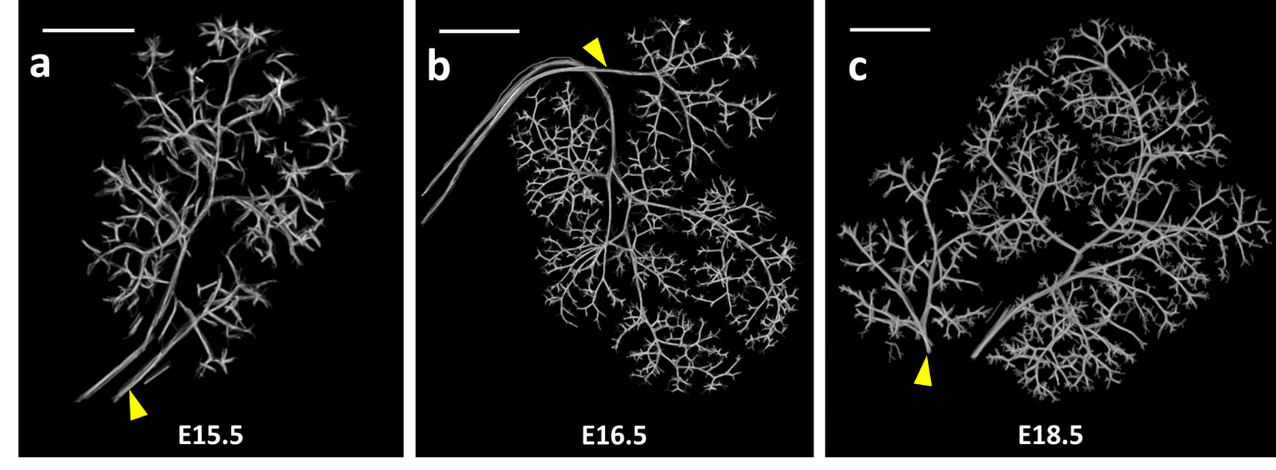

Figure 2: 3D reconstructions of the SMG at three different embryonic stages. The main duct of the SL gland is indicated by the yellow arrow. All scale bars are 500μm.

Other comments: (no more than 300 words)
We would like to thank Dr Richard Butler and Peter Humphreys for their excellent technical assistance and expertise with this project.

Signature of student..........Ms Zahra Waheed.......Date…28/09/2018………..

Signature of supervisor………Dr Lemonia Chatzelli ........ Date…28/09/2018.…

END OF FORM
----------------------------------------------------------------------------------------------------------------------------------------
File: USVRS-AwardandBursaryTemplateLetter 2018-v3FINALGDPR-210518 – Dr Lemonia Chatzeli

File: USVRS-ReportChatzeliWaheednosigwebsiteupload041018-v3FINAL

