UNDERGRADUATE SUMMER VACATION SCHOLARSHIP AWARDS – FINAL SUMMARY REPORT FORM 2017/18
NB: This whole report will be posted on the Society’s website therefore authors should NOT include sensitive material or data that they do not want disclosed at this time.

Name of student:
Oscar Romilly
Name of supervisor(s):
Kieran McDermott
Project Title: (no more than 220 characters)
Effects of maternal immune activation on astro- and microgliogenesis in the developing rodent CNS– analysis of cellular morphological changes using confocal microscopy.
Project aims: (no more than 700 words)
The aim of this project was to design and carry out an experiment that would detail the development of astrocytes under particular conditions. Specifically, it would compare between the various traits of astrocytes developed in offspring which were exposed to maternal inflammation antenatally, and a control group which had not been exposed to such inflammation. These traits included morphology, organisation, size and specific protein expression of the astrocytes. Offspring were exposed to maternal inflammation by injecting the mother with LPS solution. LPS is found in the outer-membrane of many pathogenic bacteria, and so is known to elicit a strong immune response in many animals. LPS injection was performed at two different stages of development; one at embryonic day 12 (E12) and the other at embryonic day 16 (E16). Those which were not being exposed to maternal inflammation instead had the mothers injected with a saline solution. Both groups of offspring were sacrificed and had their tissues processed at postnatal day 14 (P14). Tissue from each organism was taken from four separate places within the spinal cord, this was done so that the whole cord would be accurately represented, rather than a single area being over-represented. Through this experiment, evidence could be gathered that would either support or would not support the hypothesis that maternal inflammation is a significant risk factor for neurodevelopmental disorders in the offspring. As well as potentially proving the correlation between maternal inflammation and these disorders, the project could also have helped discover the specific mechanism of activation of the disorders and, in doing so, provide insight into the inhibition or prevention of the resulting damage. Once the data had been acquired from the two groups, the result of the experiment would be interpreted by graphing characteristics from the groups against each other and establishing if there were any statistically significant differences. In the event that significant difference could be observed in the data sets, it could be concluded that the hypothesis was successfully supported.

Project Outcomes and Experience Gained by the Student (no more than 700 words)
The experiment was successfully completed and yielded 440 images from which to draw data. These 440 images were taken across four groups; two inflammation exposed groups (LPS) and two unexposed groups (saline). These groups were divided across microscopy slides, each with four tissues samples. Five images were taken from each tissue sample, the locations of the images were designed to properly represent all tissue regions, including white and grey matter, and ventral, dorsal and intermediate regions. The samples were stained for Glial Fibrillary Acidic Protein (GFAP). The histology was successful, as there was positive staining in both the LPS and saline tissues – though there was some background staining, the staining of the astrocytes themselves was significantly more intense, and so they were easily distinguishable. The astrocytes were easily identifiable due to their characteristic shape and processes. The more intense staining was also predominantly found in areas where more astrocyte development would be expected, this helped to further confirm the success of the GFAP staining. The images acquired were randomised (so to prevent bias) and analysed in a software that gave readings of fluorescence intensity from within grids (placed over a specific area depending on the region) for each image. These readings were then averaged according to their region, then unrandomized and the figures for each region were compared across groups (LPS against saline) and any differences were noted. The numerical analysis was necessary as there was no observable difference in quantity, protein expression or morphology between the LPS group and saline group astrocytes, and more sensitive analysis was clearly needed to register the subtle contrast. Over the course of the experiment, I gained experience in a number of areas and was introduced to multiple skills and instruments. I was trained in using a cryostat microtome, which was used to recover suitable tissue sections for analysis. I was also trained in histology, which was necessary to stain the tissue for imaging. I was shown how to prepare PBS for tissue washing, mix antibody solutions, use histology equipment and apply stains to the tissue, and gained a lot of experience in this as I had to repeat the activity multiple times over the course of the experiment. After acquiring and staining the tissue samples, I had to image them and so had to learn some skill in microscopy. I used a confocal microscope to take the images and spent a significant amount of time using the equipment and software. I was introduced to many elements of lab safety and had to learn how to work in a professional setting and how to handle scientific equipment and the tissue I was working with. I was also familiarized with scientific documentation, such as Material Safety Data Sheets and protocols for carrying out different tasks.

Please state which Society Winter or Summer Meeting the student is intending to present his/her poster at:

tbc

Proposed Poster Submission Details (within 12 months of the completion of the project) for an AS Winter/ Summer Meeting – (no more than 300 words)
The poster submission will display the outcomes of the research conducted during this summer project and additional research undertaken in the applicant’s laboratory. The observations on the effect of LPS induced maternal inflammation of the normal development of astroglia in different CNS regions, as determined by widefield and confocal microscopy of GFAP immunostained astroglia will be displayed. Image analysis data highlighting changes in morphometric parameters will also be included. Inferences will be drawn from these findings on how any changes observed may lead to structural abnormalities in CNS development, potentially playing a role in the how certain neurodevelopmental disorders arise.

Brief Resume of your Project’s outcomes: (no more than 200-250 words).
The title of your project and a brief 200-250 word description of the proposed/completed project. The description should include sufficient detail to be of general interest to a broad readership including scientists and non-specialists. Please also try to include 1-2 graphical images (minimum 75dpi). NB: Authors should NOT include sensitive material or data that they do not want disclosed at this time.

This project focused on the analysis of astrocytes developed in offspring exposed to maternal inflammation versus those that were not in order to investigate whether or not maternal inflammation during pregnancy has an effect on, or is a significant risk factor for, various neurodevelopmental disorders in offspring, such as schizophrenia, autism, and epilepsy. Tissue samples from exposed and non-exposed offspring was stained for GFAP (Glial Fibrillary Acidic Protein, which is known to be expressed by astrocytes) and imaging was undertaken to make analysis of the astrocytes possible. 440 images were acquired of both white and grey matter, and ventral, dorsal and intermediate regions, in order to properly represent the whole. GFAP staining was successful in all groups, so protein expression was easily observable. However astrocyte numbers and protein expression levels were not so different between LPS and saline groups that there was obvious contrast, this necessitated image analysis software and quantitative data generation. These images were run through the imaging software that performed fluorescence intensity analysis so that the relative abundance and protein expression of the astrocytes could be compared between the two groups.

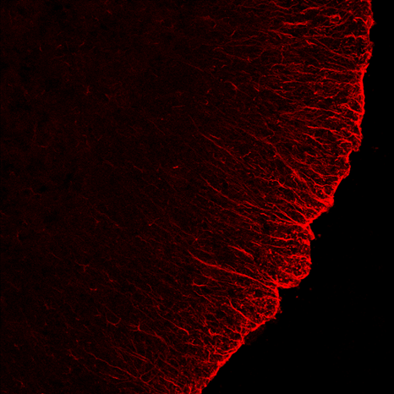

Figure 1. Postnatal day (P)16 - LPS treated: GFAP (red) staining in the spinal cord white matter

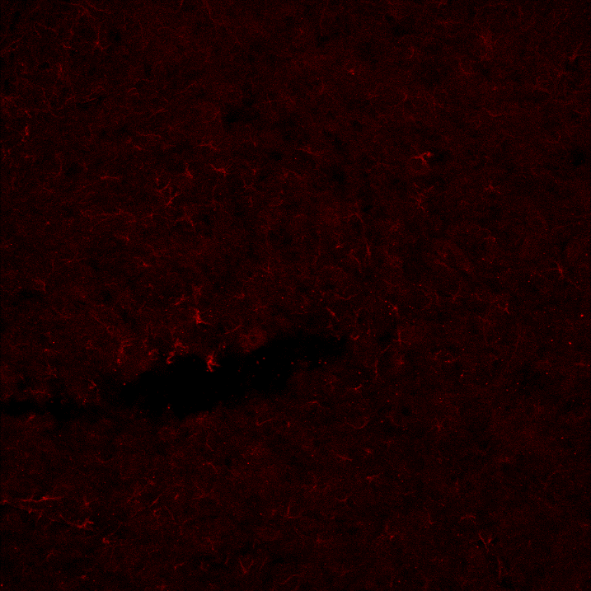

Figure 2. P16 LPS-treated: GFAP (red) staining in the ventral grey matter of the spinal cord

Other comments: (no more than 300 words)
The applicant and the student who received the summer bursary would like to express their sincere gratitude to the Anatomical Society for its support. Oscar found the experience to be of huge benefit to his understanding of how research of this kind is undertaken and it has opened his eyes to the huge variety of research questions that remain to be answered and which he may wish one day to get involved in. From the applicant’s perspective, it is always refreshing to have undergraduate students in the lab for summer projects – their enthusiasm and willingness to learn a new topic always impresses and lifts spirits within the broader group.

Signature of student.......Oscar ....Romilly........................................Date…20/10/18..

Signature of supervisor………Kieran McDermott............ Date 20/10/18

END OF FORM
----------------------------------------------------------------------------------------------------------------------------------------
File: USVRS-AwardandBursaryTemplateLetter 2018-v2FINAL-220218

