UNDERGRADUATE SUMMER VACATION SCHOLARSHIP AWARDS – FINAL SUMMARY REPORT FORM 2021/22
NB: This whole report will be posted on the Society’s website therefore authors should NOT include sensitive material or data that they do not want disclosed at this time.

Name of student:
Imogen Smith
Name of supervisor(s):
Neal Anthwal
Project Title: (no more than 220 characters)
Coordinated development of the middle and external ear: lessons from a mouse mutant
Project aims: (no more than 700 words)
Background: During development organs are formed from the integration of different tissues to produce a final complex structure. Often a single functional organ has a number of distinct embryonic origins, with components that initiate in different areas of the embryo at different time points. This is particularly true of the ear, which is divided into external, middle and inner ear compartments. Each of these parts develops from different tissues within the head (ectoderm, endoderm, mesoderm, neural crest) and forms from discrete regions at different stages (Anthwal & Thompson, 2015). For a functioning ear, the three parts, derived from different cell types, evolving and developing at different time scales, must integrate and connect together to allow continuous sound transfer. This integration requires signalling between the different parts to allow them to link up into a chain for successful sound transfer. Defects in this integration lead to conductive hearing loss (CHL), whereby sound fails to reach the inner ear (1 in 10,000 births). Such defects are either bypassed with a hearing aid or reconstruction is attempted.

Aims and Objectives: This proposal focuses on the interaction between the middle and external ear during development using the mouse as a model.
We aim to understand how defects in one part of the ear impact development in adjacent regions and will test the hypothesis that the forming membranous bones of the middle ear (tympanic ring and gonial) guide the extension of the ectodermal external ear canal, allowing integration of these two regions.

To investigate this we have focused on the Fibroblast Growth factor (FGF) family of signalling molecules. A dominant negative approach was utilised, whereby mutants produced a soluble receptor for FGFR2 which was able to competitively bind FGF ligands and prevent them from binding to endogenous membrane bound ligands. The production of soluble receptor was controlled by administration of doxycycline to allow loss of FGF signalling in a specific window during ear development. Samples were provided by a collaborator in the USA as wax blocks and analysed in London for the project.

Project Outcomes and Experience Gained by the Student (no more than 700 words)
During my 6 week summer studentship at Guy’s hospital I investigated the effect of FGF signalling from the tympanic ring on ear canal growth during embryonic development.
For my project I worked with 6 mouse heads: 2 mutant and 1 control from two time periods to allow comparison.

Preparation of samples:
The first step in my project was to process the fixed mutant samples by wax embedding, sectioning transversely with a microtome and placing on microscope slides. Through my project I have appreciated how crucial it is to be precise during these steps in order to produce intact sections of the area of interest allowing comparison at the same sectioning level between mutants and their controls.

Histology:
I then conducted trichrome staining of slides at different sectioning levels for each sample and took photos of these images using a Nikon microscope. The histology allowed the visualisation of tissue so the phenotype of the ear canal could be seen. The slides showed an obstruction in ear canal development, being much thinner and tapered in the mutants for both time frames (fig 1).
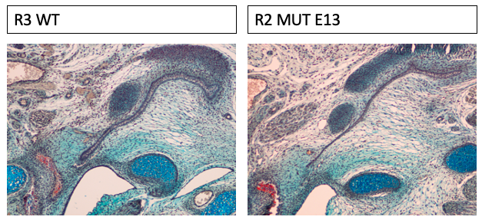

Figure 1. Comparing histology staining’s at E18.5 of control (R3 WT) vs mutant (R2 MUT) (mutation induction at E13).

Immunofluorescent staining:
I then performed immunofluorescent staining in order to identify levels of specific proteins and took photos of these using an apotome.
The first immunofluorescent staining was to identify PCNA which is a readout of proliferation. Interesting though the shape of the ear canal tip was effected with the control forming a much more bulbous structure proliferation appeared similar in both control and mutant ear canal tips.
Therefore, I performed another immunofluorescent staining using phospho-histone 3 (H3), a more specific proliferation marker as well as pan cytokeratin, in order to visual the epithelium. This immunofluorescent showed reduced proliferation at the ear canal tip in the mutants compared to the controls (fig 2).

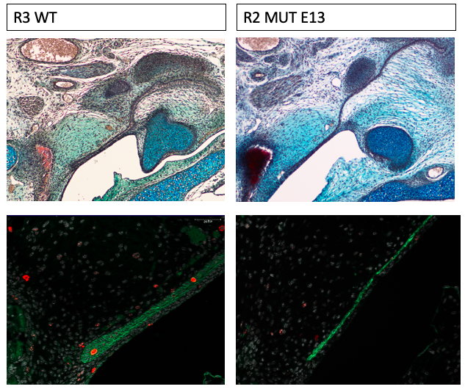

Figure 2. Immunofluorescent staining in E18.5 mouse embryos showing expression of H3 (red) and cytokeratin (green) comparing control (R3 WT) vs mutant (R2 MUT) (mutation induction at E13).

During my immunofluorescent staining I learnt how to select the appropriate primary and secondary antibodies with the correct fluorescent tag as well as being able to take stacked and tile images using the apotome.

In-situ hybridisation:
Lastly I did an in-situ hybridisation to identify mRNA levels of the transcription factor PEA3, which is upregulated in response to FGF signalling, in order to confirm that the mutation had the desired effect. This in-situ involved making the probe and performing electrophoresis in order to check that it was produced correctly. Again I used the apotome to take images. We found the level of PEA3 was reduced at the tip of the ear canal in the mutant, confirming a loss of FGF signalling (fig 3).

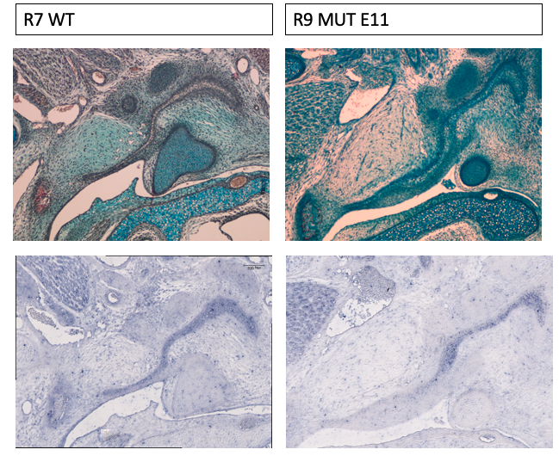

Figure 3. In-situ hybridisation in E18.5 embryos showing the expression of PEA3 (purple) comparing control (R7 WT) vs mutant (R9 MUT) (mutation induction at E11).

Overview:
Overall the data from my project highlights the importance of FGF signals for normal external ear canal development. This is shown clearly by the mutants canal having a disturbed anatomy and reduced proliferation. Despite the abnormality the canal still extend towards the tympanic ring, suggesting that Fgf signalling is necessary for normal development of the canal but not the signal that directs the canal towards the middle ear.

I have thoroughly enjoyed by summer studentship, being able to work in a lab full of talented scientists has inspired me to complete a Masters after I finish my undergrad degree and hopefully have a career in research.

Please state which Society Winter or Summer Meeting the student is intending to present his/her poster at:
Summer 2023

Proposed Poster Submission Details (within 12 months of the completion of the project) for an AS Winter/ Summer Meeting – (no more than 300 words)

During development the epithelium of the ear canal extends towards the forming middle ear to integrate these two parts of the ear and create a functional ear drum. Signals from the tympanic ring in the middle ear have been proposed to control this migration. Here we test the hypothesis that Fibroblast growth factor (FGF) signalling is an essential part of this coordinated development. A dominant negative approach was utilised, whereby mouse mutants were generated that produced a soluble version of FGF receptor 2 (FGFR2). The soluble FGFR2 was able to competitively bind FGF ligands (Fgf3, 7 and 10) and prevent them from binding to endogenous membrane bound receptors. The production of soluble receptor was controlled by administration of doxycycline to allow loss of FGF signalling in a specific window during ear development. Loss of FGF signalling through manipulation of FGFR2 during ear canal extension (Embryonic day (E)11.5 onwards) was confirmed by a reduction in Pea3 expression, a readout of active FGF signalling. The mutants displayed a change in shape of the ear canal at E18.5, with loss of the bulbous tip of the canal epithelium, associated with reduced proliferation, as shown by phospho Histone H3. This phenotype being observed when Fgf signalling was disrupted from E11.5 and E13.5. Despite the abnormal anatomy of the canal, it still managed to extend towards the tympanic ring, suggesting that Fgf signalling is required for normal development of the canal but is not necessarily the signal that directs the canal towards the middle ear. Overall the data highlights the importance of FGF signals for normal external ear canal development.

Brief Resume of your Project’s outcomes: (no more than 200-250 words).
The title of your project and a brief 200-250 word description of the proposed/completed project. The description should include sufficient detail to be of general interest to a broad readership including scientists and non-specialists. Please also try to include 1-2 graphical images (minimum 75dpi). NB: Authors should NOT include sensitive material or data that they do not want disclosed at this time.

Fibroblast Growth factor (FGF) signalling in ear canal development.

During development organs are formed from the integration of different tissues to produce a final complex structure. This is particularly true of the ear, which is divided into external, middle and inner ear compartments. In development the epithelium of the ear canal extends towards the forming middle ear to integrate the external and middle ears and create a functional ear drum. Signals from the tympanic ring in the middle ear have been proposed to control this migration.

In this projected we tested the hypothesis that Fibroblast growth factor (FGF) signalling from the tympanic ring is an essential part of coordinated development of the ear canal. We used a mouse mutant which blocks signalling through FGFR2, which was confirmed by a reduction in Pea3 expression, a readout of active FGF signalling. The ear canal of mutants with disrupted Fgf signalling from both E11.5 and E13.5 displayed an abnormal anatomy with loss of the bulbous tip, as shown through trichrome staining (fig 1). Immunofluorescence for PhosphoH3 showed a reduction in proliferation , explaining the mechanism behind the shape defect.

Overall the data from my project highlights the importance of FGF signals for normal external ear canal development. This is shown clearly by the mutants having a disturbed canal anatomy and reduced proliferation. Despite the abnormality the canal still extended towards the tympanic ring, suggesting that Fgf signalling is required for normal development of the canal but not necessarily the signal that directs the canal towards the middle ear.

Figure 1. Comparing histology staining’s of control (R3 WT) vs mutant (R2 MUT) ear canals at E18.5 (mutation induction from E13).
.
Other comments: (no more than 300 words)

Data Protection/GDPR: I consent to the data included in this submission being collected, processed and stored by the Anatomical Society. Answer YES or NO in the Box below
YES
Graphical Images: If you include graphical images you must obtain consent from people appearing in any photos and confirm that you have consent. A consent statement from you must accompany each report if relevant. A short narrative should accompany the image. Answer N/A not applicable, YES or NO in the box below
No people included (N/A)
Copyright: If you submit images you must either own the copyright to the image or have gained the explicit permission of the copyright holder for the image to be submitted as part of the report for upload to the Society’s website, Newsletter, social media and so forth. A copyright statement must accompany each report if relevant. Answer N/A not applicable, YES or NO in the box below
I have permission

Signature of student..................I.SMITH........................Date……7/09/22……..
Signature of supervisor……………………………N.ANTHWAL…….............. Date………7/09/22….…
END OF FORM
----------------------------------------------------------------------------------------------------------------------------------------
File: USVRS-AwardandBursaryTemplateLetter 2022_ Final_ Dr Neal Anthwal_180522
File: USVRS 292122 Report Anthwal Smith no sig – v1 - 090922

