UNDERGRADUATE SUMMER VACATION SCHOLARSHIP AWARDS – FINAL SUMMARY REPORT FORM 2017/18
NB: This whole report will be posted on the Society’s website therefore authors should NOT include sensitive material or data that they do not want disclosed at this time.

Name of student:
Maclyn Abraham Augustine
Name of supervisor(s):
Dr Stuart Morton, Dr Scott Border
Project Title: (no more than 220 characters)
Modernising Histology Teaching in Medical Education: A Study to Support Blended and Integrated Approaches.
Project aims: (no more than 700 words)

Histology has traditionally been regarded by medical students as a difficult and unengaging subject, that lacks relevance in comparison with other basic sciences such as gross anatomy¹. The traditional method at the University of Southampton taught histology as a separate subject from gross anatomy. Topics were introduced with a histology-specific lecture, followed by a 2-hour workshop which required students to gain proficiency at using microscopes, before applying these skills to viewing histological slides and completing an accompanying histology workbook. This approach appears to be outdated, since time spent learning the intricacies of equipment handling may not be beneficial, as it increases the overall complexity of the subject according to most students² and may not be relevant for those who will not pursue a career in pathology. Additionally, providing the required equipment has resource implications for the Faculty. The use of online teaching tools may be more efficient both in terms of time and cost³. Feedback from students confirmed that improvement was required to optimise efficacy of teaching and student enjoyment – this is further important due to the use of National Student Survey scores in university league tables.

In 2015/16, a new format (NF) of histology teaching was introduced. Histology was integrated with gross anatomy in lectures; the use of physical microscopes was removed, replaced by a wealth of online learning resources in the form of ePracticals to be completed before attending histology focussed workshops, where students work in teams to complete tasks centred on consolidating and building their histological knowledge base.

Initial work conducted at this institution showed that the transition cohort (TC) who experienced the old format (OF) of teaching in their first year and NF in the second year performed significantly better in their assessments, and rated histology as significantly better across multiple parameters (including relevance, integration, overall teaching, attitude and feedback) evaluated through use of a bespoke questionnaire.

Whether this effect has been sustained in more recent cohorts who solely experienced the NF has yet to be evaluated. As such, this project aimed to use both qualitative and quantitative methods to:

1 – Evaluate the effect of the NF on student assessment results, to ascertain whether the improvement seen with the TC has been maintained. This required gaining access to assessment data from 2 cohorts that solely experienced the OF (2012/13 and 2013/14); the transition cohort (2014/15) and 2 cohorts that solely experienced the NF (2015/16 and 2016/17). All histology questions from the assessments were isolated and grouped into ‘Year 1’ or ‘Year 2’. Scores of all students in each cohort for each of these questions were then entered into the database, and Kruskal Wallis analysis on SigmaPlot used to identify significant inter and intra-cohort differences.

2 – Evaluate the effect of the NF on student perceptions of histology, to discover if the NF has been successful in raising student opinions of histology to a level comparable to the other core subjects. This was achieved by distributing a questionnaire to the 2016/17 cohort of students who experienced solely the NF in both preclinical years. Data from this questionnaire was then compared to a similar questionnaire completed by the transition cohort. Student perceptions were further assessed by comparing module evaluation data between the transition cohort and the 2016/17 cohort, and by hosting Focus Groups to uncover in-depth information.

This project may therefore provide crucial insight into whether a novel and modernised approach to histological education is educationally beneficial, which will be of interest to educational colleagues and applicable to institutions across the country and even internationally.

Ethical approval granted by the University of Southampton, ERGO number 30327.

References:
- Moxham BJ, Emmanouil-Nikoloussi E, Brenner E, Plaisant O, Brichova H, Kucera T, et al. The attitudes of medical students in Europe toward the clinical importance of histology. Clinical anatomy. 2017;30(5):635-43.
- Higazi TB. Use of interactive live digital imaging to enhance histology learning in introductory level anatomy and physiology classes. Anatomical sciences education. 2011;4(2):78-83
- Pantanowitz, Liron et al. Whole Slide Imaging for Educational Purposes. Journal of Pathology Informatics. 2012; 30:46.
Project Outcomes and Experience Gained by the Student (no more than 700 words)
Project Outcomes:
The primary outcome measure of this study was student assessment results, since this offers the best, objective assessment of the effect of the NF. Comparing histology scores of students who only experienced the NF to historic cohorts who were taught with the OF yielded interesting results: Figure 1, below, compares median year 1 scores across three cohorts who experienced the OF in the first year, and two cohorts that experienced the NF in the first year. It highlights that the 2015/16 cohort (NF) year 1 scores were a significant improvement on all three previous cohorts included in this study who experienced the OF in their first year of study. It also shows that scores from the 2016/17 cohort were significantly better than two of the three OF cohorts included in this study. There were no significant differences in scores found between the three OF cohorts.
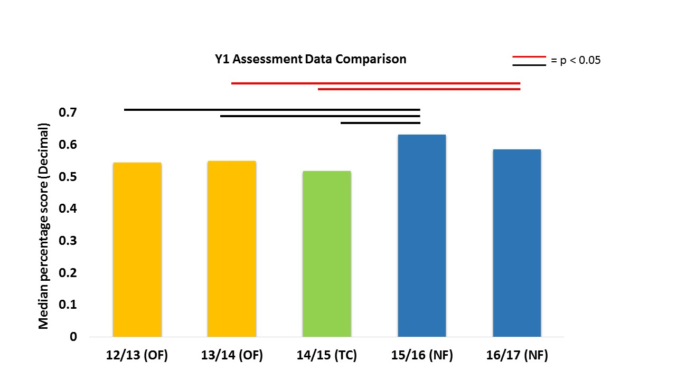
Figure 1: Comparison of median year 1 histology-specific assessment scores 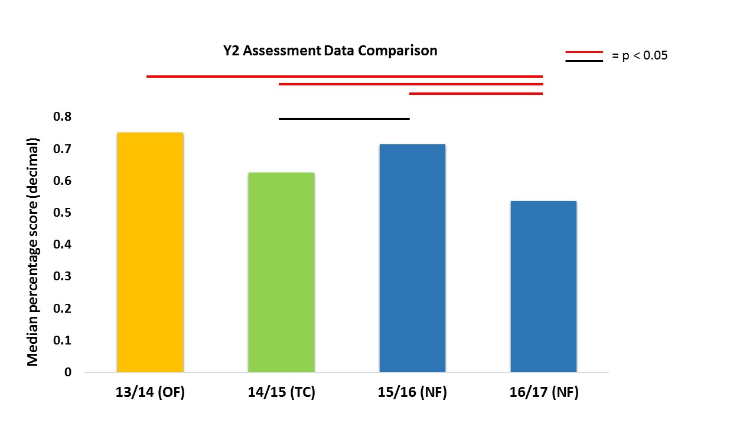

Comparison of year 2 data was inconclusive, as depicted in Figure 2. The median scores for year 2 of 16/17 cohort may be anomalous and explained by a higher proportion of moderate/difficult questions included in the assessment.

Figure 2: Comparison of median year 2 histology-specific assessment scores

Analysis of questionnaire data reflecting the 2016/17 (NF) cohort perceptions revealed that, when compared to data from a previous questionnaire completed by the TC pertaining to their first year (OF), the only parameter showing a significant difference was student appreciation of the relevance of histology, which had improved. Curiously, when this data from the 16/17 cohort was compared to data from the TC pertaining to their second year (also NF), analysis revealed that the recent cohort rated histology as significantly worse across most parameters. 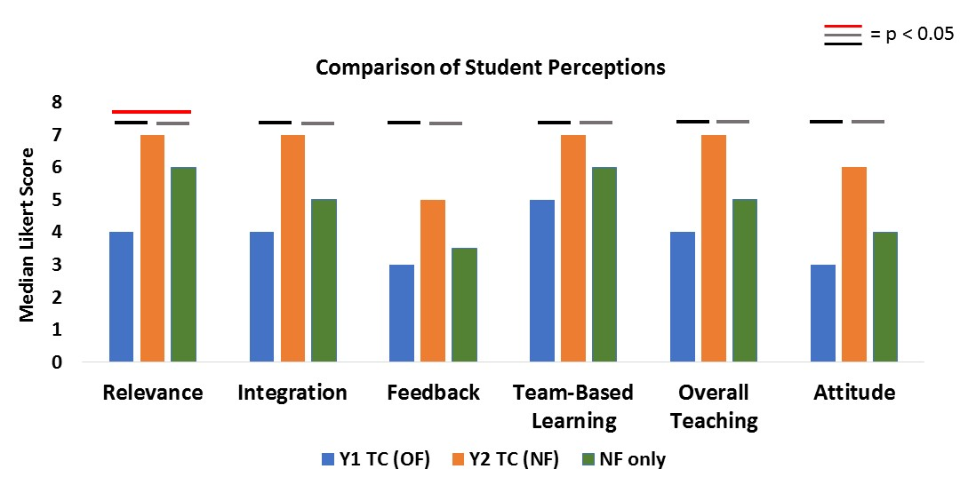
Figure 3: Comparison of Questionnaire data

These results suggest that when students can compare the NF to the OF, they prefer the NF, however, when they are unable to make such a comparison due to not having experienced both formats, preconceptions and stereotypes about histology may be influencing the drop to baseline levels in student perceptions - except for their opinions on its relevance.
Module evaluation data related to histology teaching for year 1 modules for the TC and the 16/17 cohort revealed that the evaluations for both first year modules by the 16/17 cohort were rated significantly higher than for the TC. This contradiction with the questionnaires may be explained by the fact that questionnaires were completed immediately after the assessment whereas module evaluations are completed weeks later.
These results are encouraging, and show that the NF is certainly having some benefit in improving student exam scores and improving their understanding of the relevance of histology. However, further refinement is required to maximise the potential of this novel approach to teaching histology.

Student Learning:
This was my first foray into qualitative research and it facilitated learning a wealth of new skills. Developing questionnaires and retention tests in exam format enabled me to improve my attention to detail and ability to consider multiple ways a participant may interpret and answer questions, thus allowing the production of clear and concise material.
Recruiting participants for Focus Groups was another novel experience that required patience and persistence alongside multiple recruitment strategies including social media, posters and emails. Developing these provided a valuable insight into the rigorous ethical and quality assurances that must be met when recruiting for a study. Conducting the Focus Groups independently taught me to develop a sound framework and stick effectively to a time limit, whilst simultaneously gathering the required information.
Performing statistical analyses using software unfamiliar to me presented the opportunity to improve my problem-solving skills, as I worked towards selecting appropriate tests as well as using the software in the proper fashion.
Finally, working with the Anatomy Department offered an enlightening introduction to the world of medical education, particularly to the effort and scrutiny that goes into the development and implementation of every teaching strategy and every exam question. It also gave me the opportunity to interact and learn from specialists in the field, one that I consider myself privileged to have experienced.
These are all experiences that have vastly broadened my horizons, and left me better prepared for my future endeavours into research.

Please state which Society Winter or Summer Meeting the student is intending to present his/her poster at:

Summer Meeting 2019 IFAA

Proposed Poster Submission Details (within 12 months of the completion of the project) for an AS Winter/ Summer Meeting – (no more than 300 words)
Background:
Histology is commonly viewed by medical students as uninteresting and lacking in relevance for their future careers. Student feedback at the University of Southampton highlighted this, and revealed that traditional teaching methods were not sufficiently engaging. This sparked a revamp in teaching style to a new format (NF) that integrated histology with gross anatomy whilst offering a more interactive and student friendly learning experience via the use of online resources such as ePracticals and team-based histology workshops. The effect of this NF has not been fully evaluated.

Aims:
To evaluate the effect of the NF on student assessment results.
To evaluate the effect of the NF on student perceptions of histology.

Methods:
Assessment data of multiple cohorts who studied using solely the old format (OF) of teaching was gathered, histology questions and scores isolated and compared to that of cohorts who experienced the NF using Kruskal Wallis analysis on SigmaPlot.
Data from questionnaires offered to a recent cohort who studied on the NF was used to evaluate the effect of the NF on student perceptions of histology. Module evaluations and focus groups provided further data to assess student perceptions.

Results:
Analysis of assessment data revealed that Year 1 NF scores were significantly higher than the OF. Comparison of Y2 data was inconclusive. Questionnaire data revealed that student opinions of histology remain poor – with the exception of their appreciation of its relevance, which was rated significantly higher than with the OF. This is contrasted by module evaluation data, which shows that students on the NF rated histology better than those on the OF.

Conclusion:
Current results with the NF are encouraging, showing that assessment scores and student appreciation of the relevance of histology have improved. Refinement is needed to fully harness the potential of this novel approach to histology teaching.

Brief Resume of your Project’s outcomes: (no more than 200-250 words).
The title of your project and a brief 200-250 word description of the proposed/completed project. The description should include sufficient detail to be of general interest to a broad readership including scientists and non-specialists. Please also try to include 1-2 graphical images (minimum 75dpi). NB: Authors should NOT include sensitive material or data that they do not want disclosed at this time.

Modernising Histology Teaching in Medical Education: A Study to Support Blended and Integrated Approaches

Maclyn Augustine, Stuart Morton, Scott Border
This project focussed on evaluating the effect of a new format (NF) of histology teaching on student perceptions and assessment results. Poor student feedback provided the rationale for the introduction of a NF that integrates histology with gross anatomy, whilst offering a more interactive and student friendly learning experience via the use of ePracticals and team-based histology workshops.

Histology assessment scores of students who experienced the NF were compared against those of students who experienced the old format (OF). Questionnaire data between OF and NF students was compared in a similar fashion.

Our results show that the NF appears to have had a positive effect on assessment scores, with multiple NF cohorts performing significantly better than those on the OF, as displayed in the graph below. The questionnaire data shows that whilst opinions of histology improved drastically amongst students who went through a transition (TC) and experienced both formats of teaching, a few years later, those who have only experienced the NF seem to once again have a low opinion of histology as a subject – although the improvement in student appreciation of the relevance of histology seems to be maintained.

Figure 1: Comparison of median year 1 histology-specific assessment scores

These are encouraging signs, suggesting that an integrated and blended approach may be beneficial to student learning, however refinement to the format is required to optimise both assessment scores and perceptions of histology.

Other comments: (no more than 300 words)
Detailed numerical data from all analyses have not been included nor have all results of the study (Focus group analysis, retention test data, full module evaluation data analysis) due to sizing restraints, but will be at the time of presentation.
I would like to sincerely thank the Anatomical Society for this opportunity and for funding the project – it would have been impossible to complete without this support.
I would also like to express my gratitude to the Centre for Learning Anatomical Sciences for offering me the space and equipment required to complete this project.

Signature of student: Maclyn Augustine Date: 19/10/18
Signature of supervisor: Stuart Morton Date 19/10/18

END OF FORM
----------------------------------------------------------------------------------------------------------------------------------------
File: USVRS-AwardandBursaryTemplateLetter 2018-v2FINAL-220218

File: USVRS 201718 Morton and Augustine – Report no signature website uploaded 261018

