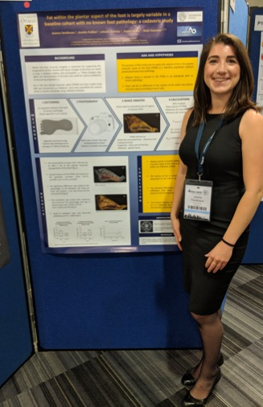

Image 2: Joanna Tomlinson at the IFAA conference presenting her poster on, ‘Fat within the plantar aspect of the foot is largely variable in a baseline cohort with no known foot pathology: a cadaveric study’

File: Tomlinson Image 2

