PROJECT: ‘The role of calcium dependent neurotransmission in axon path finding and axon maintenance of specified cortical neuron populations’
START DATE: 1.10.14
SUPERVISOR: Professor Zoltan Molnár, Oxford University
CO-SUPERVISOR: Dr Anna Hoerder-Suabedissen, Oxford University
PROJECT RESUME
Neurons in the brain – be it human, mouse, frog or fly – communicate with each other by the release of neurotransmitters (small molecules) from one cell onto another. Neurotransmitters are packaged into small vesicles in the pre-synaptic cell and are released into the space between the two neurons when the membrane of the vesicle fuses with the cell membrane of the pre-synaptic cell. This fusion event is tightly regulated, and requires a number of essential proteins, collectively referred to as the SNARE complex. In the past, several laboratories around the world have produced knock-out mice of many of the individual protein components of the SNARE complex – but this is almost invariably lethal at birth because the newborn mice are unable to breathe. We will be using a new mouse model in which the SNARE complex protein Snap25 will only be knocked-out in specific subsets of neurons in the mouse cerebral cortex, so their breathing and other essential physiological functions are normal. We will be investigating whether the “silenced” neurons in the Snap25-flox mice can integrate normally into the emerging brain circuitry. We will compare “silenced” and “normal” neurons in the same brain, to measure whether they have the same cell shape and whether their long-distance processes are established with the same precision. This may give us useful insights into the pathomechanisms of diseases like schizophrenia, as there are poorly functioning variants of the Snap25 gene that are strongly associated with an increased risk of schizophrenia.

2 images from previous studies leading up to the actual studentship, but they are related.

1. Thalamocortical projections in a E18 Snap25 KO cortex.This is from: Normal development of embryonic thalamocortical connectivity in the absence of evoked synaptic activity.
Molnár Z, López-Bendito G, Small J, Partridge LD, Blakemore C, Wilson MC.
J Neurosci. 2002 Dec 1;22(23):10313-23.

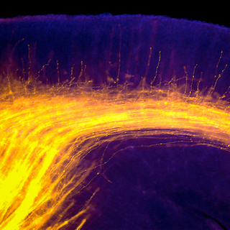

2. The second one depicts hetergeneous populations of subplate neurons from Molecular diversity of early-born subplate neurons.
Cereb Cortex. 2013 Jun;23(6):1473-83. Hoerder-Suabedissen A, Molnár Z.

