Human origins and the Ecomorphology of Tree Climbing

Supervisors: Dr Susannah Thorpe* and Professor Bill Sellers$

*School of Biosciences, University of Birmingham, Edgbaston, Birmingham, B15 2TT
$School of Earth and Environmental Sciences, Michael Smith Building, University of Manchester, Manchester , M13 9PT

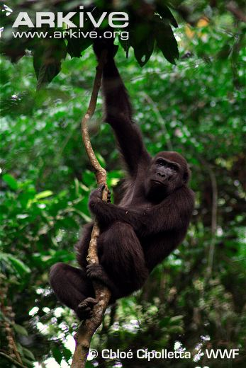 | 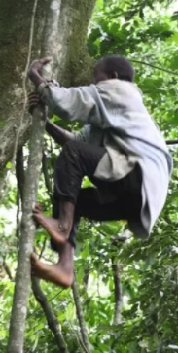
Western lowland gorilla hanging from a tree (Chloe Cipolletta, WWF, from ARKive) | a Twa man climbing a larger vine generates forces via cupped hands and flat feet postures (Courtesy of George Perry) | Virtual robotic chimpanzee demonstrating the energetic cost of maintaining a stable gait (from Sellers et al, R. Soc. Open Sci 5: 17-1836)

Bipedalism and the extraordinary manipulative abilities of the human hand, that are central to tool use and technology, are widely considered to be two of the major hallmarks of humanity. Many researchers have concluded that early humans (hominins) must have completely lost their ability to climb around the forest canopy when they became bipedal and began making tools (e.g. Latimer, 1991). However, new evidence suggests that significant arboreality was achieved by multiple species with short hands and bipedal adaptations from before the common ancestor of chimpanzees and humans to well into the genus Homo. Moreover recent studies have shown that the muscles of living apes are highly 'plastic'. This means that they can exhibit demanding locomotor behaviours without these necessarily being reflected in the skeleton. A good example are habitual human climbers who have significantly longer fibres in their calf muscles than neighbouring farming populations, without any skeletal evidence of their climbing ability. We suggest that we have substantially underestimated the muscle plasticity of fossil hominins, which has led to reconstructions of hominin locomotor repertoires that have been far too narrow and stereotyped.

This studentship will study the arboreal locomotion and ecology of human tree climbers and gorillas in Gabon and the biomechanics of these movements on zoo-housed gorillas and human volunteers. They will then create musculoskeletal models of human and gorilla climbing in a range of environments, and morph the mechanics of human/ gorilla locomotion to extinct species and habitats. This approach will reveal the extent to which early humans could exploit forest canopy despite their increasingly modern anatomy to develop a new paradigm for humans’ evolutionary history.

