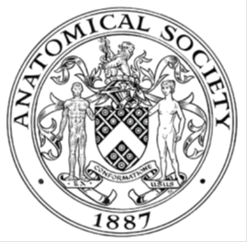
_______________________________________________________________________________________
AWARDEE REPORT FORM
_______________________________________________________________________________________

NAME |  | Matthew Myers
UNIVERSITY |  | University of Southampton
NAME OF AWARD |  | Leonard Thomas Travel bursary
PURPOSE OF AWARD conference attended (full name) with city and dates
to participate in the Anatomical Society Winter Meeting, Dundee, 18th to 20th December, 2017.

REPORT: What were your anticipated benefits?
Present my research on the use of feedback with a modern anatomy curriculum and investigating the differences in neuroanatomy knowledge in staff vs students. Also, to expand my knowledge of current anatomy practices.

COMMENTS: Describe your experience at the conference / lab visit / course / seminar.
The conference was well organised and enjoyable. The oral presentations were to a high standard of relevant and interesting research in anatomy. It was a great opportunity for me to present research to experts in the field. The keynote talk from Prof Dame Sue Black was an exceptional insight into the world of forensic identification. The gala dinner was well organised and enjoyable.

REPORT: In relation to skills, what were the most important things you gained? (does not apply to equipment grant)
I was able to develop my oral presentation skills which are essential also for teaching and as a medical student. Similarly, it was useful to have a discussion with others after the oral presentation and during the poster session where ideas can be shared.

REPORT: How do you think you will put this learning experience into practice in the future?
I picked up on a number of teaching techniques from oral presentations which I plan to apply to my teaching of junior medical students. I will also apply the feedback from my oral presentation to any future talks I deliver.

SIGNATURE | Matthew Myers |  | DATE | 04/01/2018
If submitted electronically, a type-written name is acceptable in place of a hand-written signature

File: AS-Award-Report-Form-BLANKCO-SEAL-date110216



