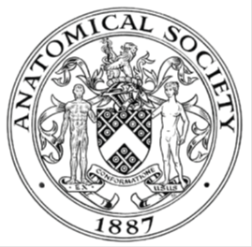
_______________________________________________________________________________________
AWARDEE REPORT FORM
_______________________________________________________________________________________

NAME |  | Pritishkumar Tidke
UNIVERSITY |  | National University of Ireland, Galway, Ireland
NAME OF AWARD |  | Symington Bequest Funding, Anatomical Society, UK
PURPOSE OF AWARD conference/event attended/organised (full name) with city and dates.
Travel grant for attending the Microscience Microscopy Congress 2019 from 1st -4th July which was organised by the Royal Microscopical Society, in Manchester, UK.

REPORT: What were your anticipated benefits?
Conferences are an essential part of academia and as a second year PhD student at the National University of Ireland Galway, I was looking forward to the experience of attending this big microscopy conference and having the opportunity to listen to some of the brightest scientists sharing their work. I anticipated that one of the biggest benefits of attending this conference is getting to know other people in the field of microsocpy. I expect to see researchers presenting the very latest findings, some of which are yet to be published and I expect these ideas could be a great inspiration for my own research. I will also get a chance to attend social functions as part of the conference and have an opportunity to meet other academics with similar interests to me.

I have been looking for such a conference since starting my PhD. As a PhD student it was a great opportunity to present my research work in the poster form, entitled ‘Development of a quantitative model for the ordered process of chromatin rearrangements at DNA double strand breaks’. Hence I could share my research with a multi-disciplinary audience. When working in research the skills of presentation and communication are particularly important. Fortunately, this conference will give me the chance to practice these skills, and it will help me to build my confidence.

By attending presentations, I will learn from others and improve my own skills and knowledge about microscopy. Listening to and participating in lively discussions at conferences can give me new ideas, help refine my existing knowledge, and maybe even change my mind about some key issues in microscopy. Presenting a poster gave me a chance to take an active part in communicating with other academics and can showcase my work to potential employers or grant-awarding bodies in the field of microscopy. Finally, I expected that attending this conference in the beautiful historic city of Manchester would be good fun and allow me to experience a different culture!

COMMENTS: Describe your experience at the conference / lab visit / course / seminar/ event.
It was my first time visiting the United Kingdom and I was very excited to see this country. I must mention that I feel very fortunate to see the historical city of Manchester and the exciting science presented at this conference. The venue for the conference was also very nice which included a big exhibition hall and different lecture rooms dedicated to the parallel conference sessions. As a first-timer to a big international congress it was a bit overwhelming to choose between so many talks, workshops and exhibitions happening at the same time, but definitely a very positive experience once I decided what to attend to. I was mesmerised by the quality of research from world renown labs. I really enjoyed lunch time scientific /non-scientific discussions with other delegates. One of the most positive aspects of this conference was the level of interaction between researchers as every session was very interactive and involved everyone in the discussion. The poster presentation sessions were impressive with more than 100 posters presented on a wide range of microscopy-related topics. Everyone was very approachable and I have made some useful contacts which will be very helpful to the progression of my scientific career.
REPORT: In relation to skills, what were the most important things you gained? (does not apply to equipment grant. For public engagement/outreach awards what did your audience gain and how did you evaluate success?
There were a number of conference talks that I would pick out as highlights which have expanded my knowledge of microscopy as a tool to further our understand of biology. I especially liked the seminar by Prof. Gabriel Popescu from University of Illinois, USA who described use of quantitative phase imaging in the study of dynamics of cellular systems and Prof. Ulrike Endesfelder, MPI Marburg, Germany who talked on cellular study at molecular level by live cell and quanitative localisation microscopy. The lecture presented by Prof. Daniel Davis, University of Manchester, UK which focussed on the visualisation of immune cell killing using super resolution microscopy was a fantastic experience. Several other lectures about super resolution microscopy inspired me as to the usefulness of this technique in my own future research work. On the last day of the conference, the lectures I attended were mainly based on the role of imaging in diseases. I enjoyed the talk by Professor David Entenberg which demonstrated how single cell imaging can be used to understand tumor cell dissemination and metastasis and this certainly improved my knowledge of cancer biology.

It was fascinating to hear the plenary delivered by Prof. Keith Riles, University of Michigan, USA entitled ‘Entering the Era of Gravitational wave Astronomy via Attometry’ which gave me insight into the recent developments in the field of gravitational waves. In addition to the symposiums and poster sessions I enjoyed interacting with the exhibitors and did this in the gaps between attending talks. This gave me knowledge about the latest technologies and instruments available in the field of microscopy. It was a fabulous experience to talk with the exhibitors from different companies and nice to receive some free scientific gifts which they were offering. Last but not least, Manchester is a beautiful city to roam around and I enjoyed visiting the football museum and I also captured some beautiful moments with historical buildings and monuments of the city.

REPORT: How do you think you will put this learning experience into practice in the future? For public engagement/outreach awards how with the materials/knowledge generated by this activity be used in the future?
All the lectures that I attended were very informative and since I plan to pursue a career in academia this knowledge will be very useful for me in future. This was also an excellent opportunity for networking, and I made several new connections. I was fortunate to meet and understand how scientists perceive a specific question. Finally, I have learned a great deal and was inspired by the work of other labs, so would like to thank the Anatomical Society for awarding me this Symington Bequest Funding and supporting me to attend this conference.

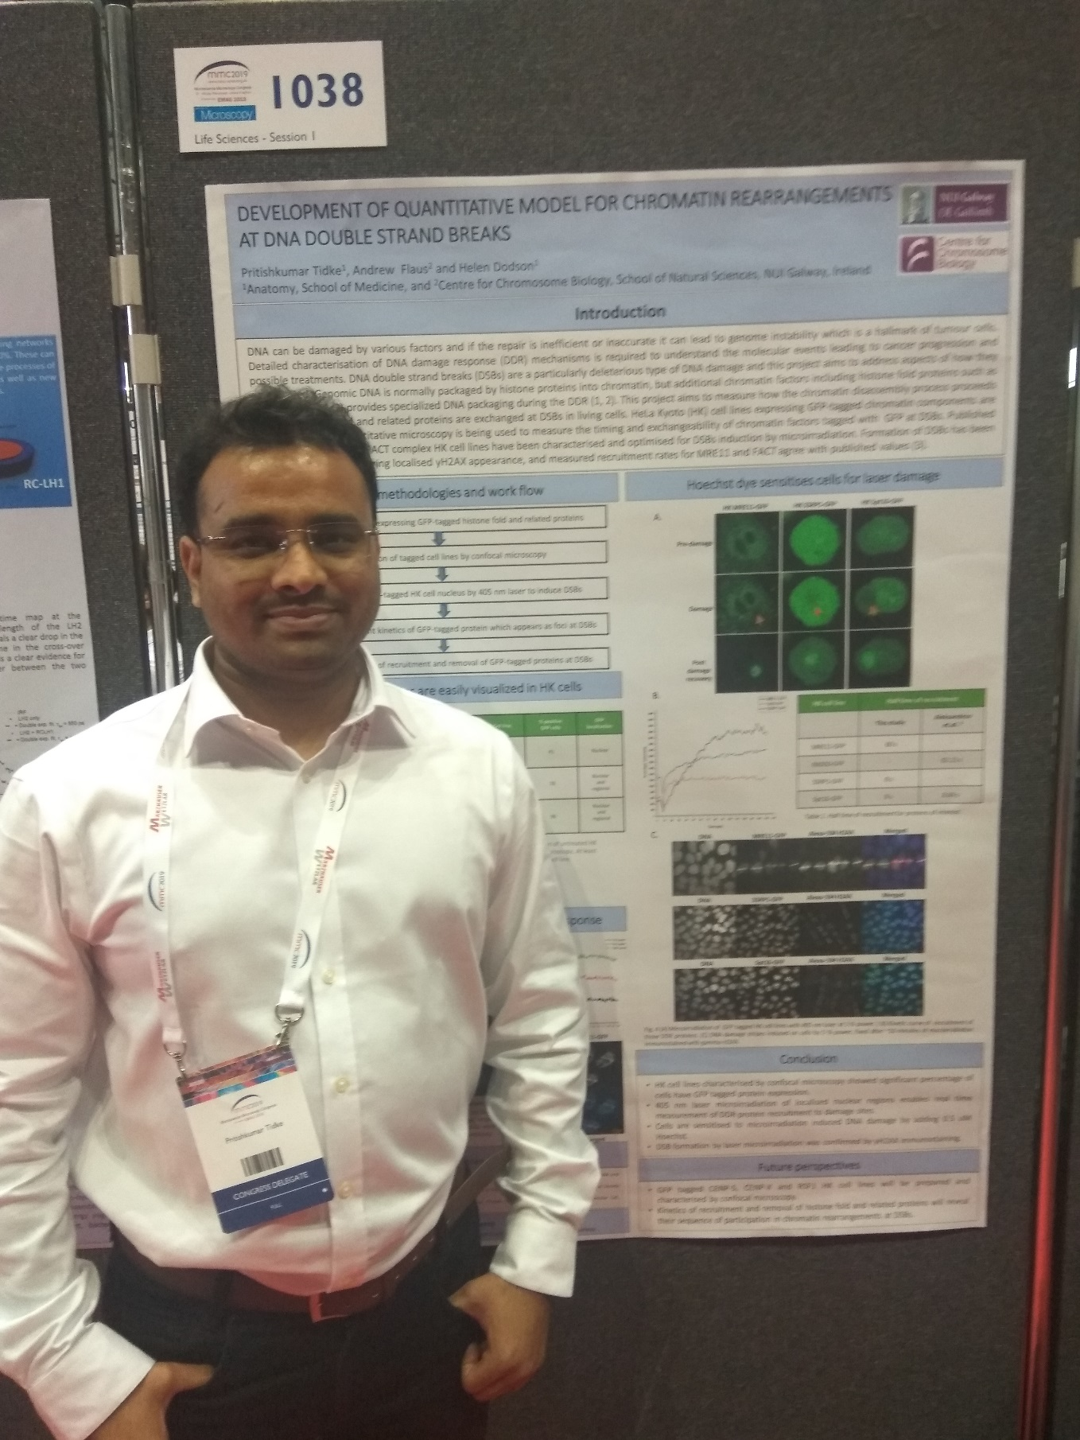

Data Protection/GDPR: I consent to the data included in this submission being collected, processed and stored by the Anatomical Society.
YES
Graphical Images: If you include graphical images you must obtain consent from people appearing in any photos and confirm that you have consent. A consent statement from you must accompany each report if relevant. A short narrative should accompany the image.
YES

Copyright: If you submit images you must either own the copyright to the image or have gained the explicit permission of the copyright holder for the image to be submitted as part of the report for upload to the Society’s website, Newsletter, social media and so forth. A copyright statement must accompany each report if relevant.
YES
SIGNATURE |  |  | DATE
If submitted electronically, a type-written name is acceptable in place of a hand-written signature

File: AS-Award-Report-Form-BLANKCO-SEAL-date110216-Amended AT-070818

