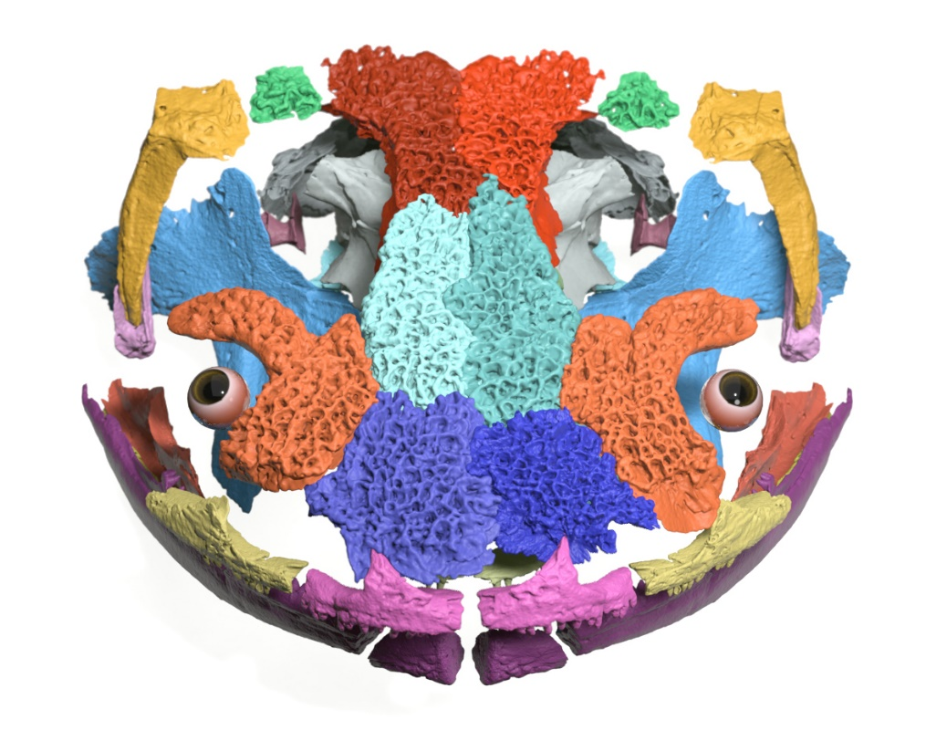

File: Marc Jones Fossil salamander face on – v1 - 251122

