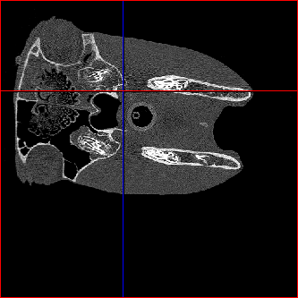

Ethmoid labyrinth

Left Mandible

Left guttural pouch

Right guttural pouch

Right Mandible

Larynx

After Cropping

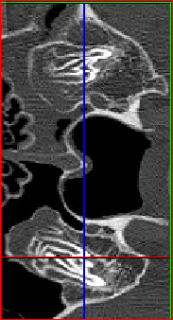

Rectus capitis ventralis

Stylohyoid

Right guttural pouch

Left guttural pouch