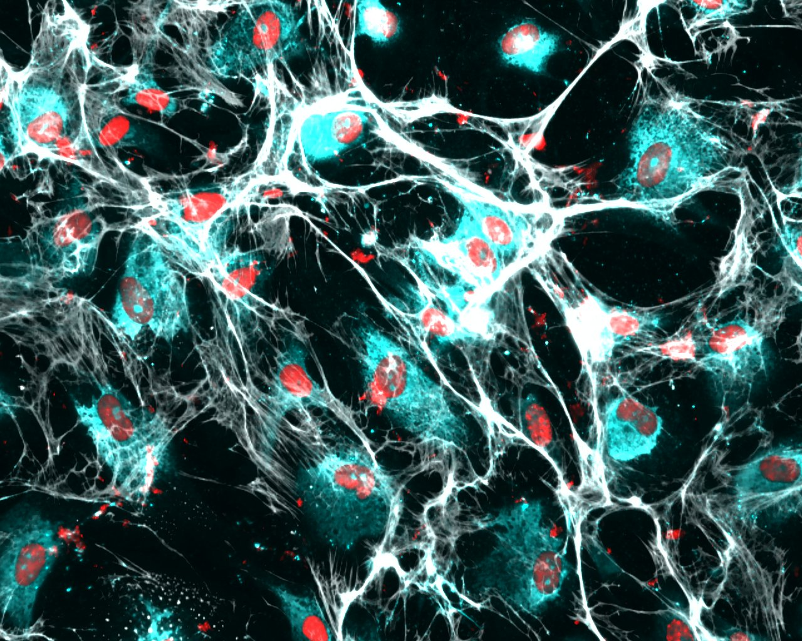

File: Joint Runner-Up Best Image Award – Martyna Stasiewicz – v1 - 170722

