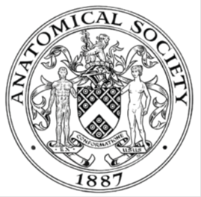
_______________________________________________________________________________________
AWARDEE REPORT FORM
_______________________________________________________________________________________

NAME |  | Ingrid Gotaas
UNIVERSITY |  | University of Cambridge
NAME OF AWARD |  | Barclay-Smith Travelling Awards
PURPOSE OF AWARD conference attended (full name) with city and dates
Anatomical Society Winter meeting, Dundee, 18th-20th of December 2017

REPORT: What were your anticipated benefits?
To get updated on the latest news in the broad field of Anatomy, to meet fellow Anatomists and to see what technologies are being used to both research and teach in the UK/Ireland but also the rest of the world (e.g. Japan).
COMMENTS: Describe your experience at the conference / lab visit / course / seminar.
The Winter Meeting was a very interesting experience to me. Having gone on to do my PhD in molecular biology after receiving an undergraduate summer bursary from the Anatomical Society, I didn’t expect to be so enthused by the many great talks put on during this meeting. However, I enjoyed all of them, and I especially enjoyed the Prize Lecture by Prof. Dame Sue Black, who is an absolutely amazing inspiration and a great speaker. I learned a lot, and getting to see what is happening in the field and how it is expanding was probably my favorite part.

REPORT: In relation to skills, what were the most important things you gained? (does not apply to equipment grant)
Presenting a poster for the first time is definitely one of the most important things I gained from the meeting. I was initially very nervous to present, but everyone I talked to during the session were just interested in what we had researched and I genuinely enjoyed discussing it with them. Presenting your work is such an important part of science, and to be allowed to do that for the first time in what feels like a safe environment was very rewarding.

REPORT: How do you think you will put this learning experience into practice in the future?
As a scientist beginning my postgraduate career, getting practice in presenting your work is one of the best things you can do. This will absolutely come in handy when I go to my first year symposium back at my University, and even when I do my first year report and examiners interview me – just being able to talk about your research in a confident way, and respond to questions calmly and without getting flustered. The Anatomical Society meeting was a great venue for increasing my presentational skills, and for that I am grateful.

SIGNATURE | Ingrid Lager Gotaas |  | DATE | 22/12/17
If submitted electronically, a type-written name is acceptable in place of a hand-written signature

File: AS-Award-Report-Form-BLANKCO-SEAL-date110216

