UNDERGRADUATE SUMMER VACATION SCHOLARSHIP AWARDS – FINAL SUMMARY REPORT FORM 2017/18
NB: This whole report will be posted on the Society’s website therefore authors should NOT include sensitive material or data that they do not want disclosed at this time.

Name of student:
Daniel Oluboyede
Name of supervisor(s):
Dr Cecilia Brassett, Dr Tom Turmezei, Mr Jai Chitnavis
Project Title: (no more than 220 characters)
Micro-computed tomography of the proximal tibia for virtual biopsy of entheseal bone
Project aims: (no more than 700 words)
AIMS AND OBJECTIVES

The role that entheseal bone structure plays in the Segond injury has not been previously investigated. This project aims to develop a protocol for sectioning, preparation, and microCT scanning of the proximal tibia for comparison of the anterolateral entheseal bone with other key entheseal sites such as the anterior cruciate ligament (ACL), posterior cruciate ligament, medial collateral ligament, popliteus insertion, and proximal tibiofibular syndesmotic entheses using virtual bone biopsy analysis. Challenges will include developing an appropriate bone dissection strategy, minimisation of imaging artefact from marrow gas penetration, and reliable anatomical localisation of virtual bone biopsy sites. Preliminary comparison of results across the different entheses of the proximal tibia will also lay the platform for generation of a hypothesis as to why the anterolateral capsular structures are a part of the ACL injury pattern from a microstructural perspective for future study, and what surgical reinforcement may offer in terms of prophylactic or treatment benefit.

METHODS
The proximal tibia will be selected from cadaveric donors without macroscopic evidence of previous knee trauma, surgery, or degenerative joint disease who have provided consent prior to decease for the use and imaging of their tissue for anatomical research. It was originally envisaged that after removal of overlying soft tissues, the proximal tibia will be cut into several sections, comprising the medial, central, and lateral tibial plateau, patellar entheseal, medial and lateral posterior metaphyseal, diametaphyseal and diaphyseal regions. Each specimen will then be scanned individually in the microCT scanner at the Department of Zoology, University of Cambridge, at c.80μm pixel spacing.

DICOM imaging output will be transferred to the Bone Research Group at the Department of Medicine, University of Cambridge, where virtual bone biopsy will be performed with MicroView 3D Image Viewer and Analysis Tool, supported by Dr Ken Poole, Reader in Metabolic Bone Disease. The difference in morphometric parameters between entheseal and non-entheseal bone at different sites around the proximal tibia will be examined, comparing cortical thickness, bone volume over tissue volume (BV/TV), and bone mineral content.

Project Outcomes and Experience Gained by the Student (no more than 700 words)
PROJECT OUTCOMES AND EXPERIENCE GAINED

- Development of a protocol for preparation of proximal tibia
I learnt to perform dissection of cadaveric legs which included disarticulation at the knee and removal of the soft tissue to leave only the bony insertions of ligaments and tendons onto the proximal tibia. I prepared 5 cadaveric proximal tibial specimens in the same way for scanning.

- Understanding the principles of the microCT scanner and preparing the specimens for scanning
Dr Keturah Smithson at the Department of Zoology, University of Cambridge, took my supervisor and I through the principles and procedure of microCT scanning using the Nikon XTH225 ST microCT scanner. I prepared a document outlining the protocol which was then used by my supervisor for scanning, as it was not permitted for undergraduates to be trained in using the scanner independently in view of the cost of the equipment. However, I learned the process and prepared the specimens for scanning. I also used an imaging phantom (with the density of cortical bone), water and air as controls.

- Learning how to use Microview software
Dr Linda Skingle at the Bone Research Group of the Department of Medicine, University of Cambridge, introduced me to the MicroView 3D Image Viewer and Analysis Tool software and taught me the standard operating procedure of bone analysis. MicroView enabled me to take a virtual biopsy of the 5 specimens through 3D reconstruction of the microCT scans. Using the software, I was able to determine regional morphometric bone parameters including bone mineral density, bone volume over tissue volume (BV/TV), trabecular thickness, trabecular spacing and trabecular number in the specimens. In view of time, the BV/TV was measured in regions of non-entheseal trabecular bone, and entheseal bone including the patellar tendon, lateral collateral ligament, anterior and posterior cruciate ligaments, and iliotibial tract. The region of the Segond injury was also investigated. I prepared a document outlining the protocol for virtual biopsy of proximal tibiae.

In conclusion, throughout the 8 week period, I have become more adept in the process of undertaking an anatomical research project. I have become more knowledgeable of the anatomy of the knee, microarchitecture of bone and bone physiology. I have learnt a number of transferrable technical skills including dissection, microCT scanning procedure and virtual biopsy of bone in 3D. I have become more aware of important factors to consider in scientific research including ethical responsibility, collaboration, and the suitability of methodology and data analysis with respect to project validity and integrity. Importantly, I have a new perspective and appreciation of the scientific process and a motivation to add to scientific anatomical knowledge throughout my career.

Please state which Society Winter or Summer Meeting the student is intending to present his/her poster at:
Winter

Proposed Poster Submission Details (within 12 months of the completion of the project) for an AS Winter/ Summer Meeting – (no more than 300 words)
The poster will contain a brief introduction to the current research regarding bone microarchitecture in the proximal tibia with regard to certain injuries and/or fractures. This will be followed by a description of the materials and methods used in this project, which comprises microCT scanning of 5 cadaveric tibiae with 3D reconstruction of the images obtained. A virtual bone biopsy technique was developed to compare a number of parameters between different sites of entheseal and non-entheseal bone. In view of time constraints, one of these parameters, the bone volume fraction, at these sites was measured within each tibia. In addition, the regional pattern of bone volume fraction was compared between the tibiae. Finally, there will be a discussion of the results obtained and suggestions for future research.

Brief Resume of your Project’s outcomes: (no more than 200-250 words).
The title of your project and a brief 200-250 word description of the proposed/completed project. The description should include sufficient detail to be of general interest to a broad readership including scientists and non-specialists. Please also try to include 1-2 graphical images (minimum 75dpi). NB: Authors should NOT include sensitive material or data that they do not want disclosed at this time.

Micro-computed tomography of the proximal tibia for virtual biopsy of entheseal bone

This project aims to determine the difference in morphometric parameters between entheseal and non-entheseal bone at different sites on the proximal tibia. This was performed in three main stages of which protocols were produced as guidelines for future work: dissection and disarticulation of cadaveric legs, microCT scanning of the proximal tibiae, and virtual biopsy on the 3D reconstructed images.

Dissection included removal of soft tissues and disarticulation at the knee joint so that only the tendinous and ligamentous insertions remained on the proximal tibial specimens. The Nikon XTH225 ST microCT scanner housed in the Department of Zoology, University of Cambridge, was then used to produce <80µm resolution scans of 5 specimens. The MicroView 3D Image Viewer and Analysis Tool software was used to reconstruct the scans for virtual biopsy (Figure 1). Bone volume over tissue volume (BV/TV) at different sites including both non-entheseal trabecular bone, and entheseal bone at the insertions of the patellar tendon, lateral collateral ligament, anterior and posterior cruciate ligaments, and iliotibial tract.

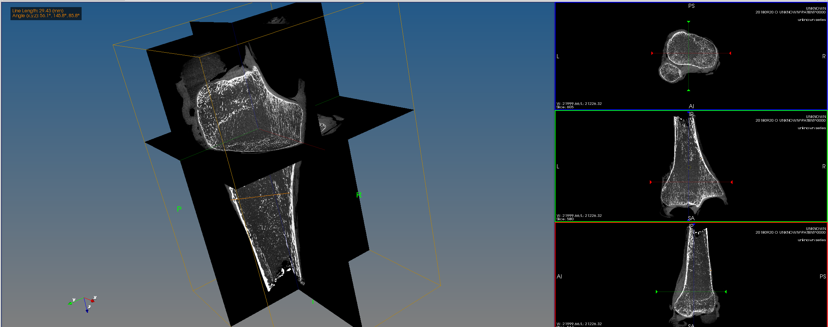
Figure 1 – 3D virtual biopsy of proximal tibiae

In addition, the region of the Segond fracture (Segond, 1879) was also investigated. This avulsion fracture at the anterolateral aspect of the proximal tibia presents with concomitant anterior cruciate ligament (ACL) injury in 75-100% of cases (Goldman et al., 1988; Felenda and Dittel, 1992). It is hoped that the data collected in this project may be used to provide more insight into the pathogenesis of Segond fracture and inform management of ACL injury.

Other comments: (no more than 300 words)
It is envisaged that this project will be continued by increasing the sample size later in this academic year. I will be doing this together with a Year 4 clinical student on more cadaveric specimens using the protocols developed.

Signature of student..........Ms Daniel Oluboyede...........Date…1/11/18...

Signature of supervisor……………Dr Cecilia Brassett....... Date…1/11/18…

END OF FORM
----------------------------------------------------------------------------------------------------------------------------------------
File: USVRS-AwardandBursaryTemplateLetter 2018-v3FINALGDPR-210518 – Dr Cecilia Brassett

File: Brassett Oluboyede Report USVRS website unsigned

