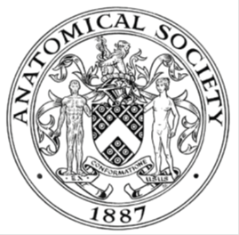
_______________________________________________________________________________________
AWARDEE REPORT FORM
_______________________________________________________________________________________

NAME |  | Ellen Kelly
UNIVERSITY |  | University of Edinburgh (when USVRS research undertaken, class of 2021)
NAME OF AWARD |  | Barclay-Smith Travelling Fund
PURPOSE OF AWARD conference/event attended/organised (full name) with city and dates.
Provided financial support for my attendance at the Winter 2021 Anatomical Society Meeting in Dublin, 4th-6th July 2022.
REPORT: What were your anticipated benefits?
The Barclay-Smith Travelling Fund enabled me to attend this meeting by contributing to the costs incurred by this attendance (meeting registration, travel and accommodation), which may not have been possible without this financial support.
The primary anticipated benefit of attending this meeting was the opportunity to present a poster to delegates at the meeting. This poster was based on the research project I undertook with the support of the Anatomical Society’s Undergraduate Summer Vacation Research Scholarship in Summer 2021. Additionally, this is the first meeting I have attended, and therefore was an invaluable experience, enabling me to network with others in the field of anatomical sciences, find out about current research and develop a range of skills.

COMMENTS: Describe your experience at the conference / lab visit / course / seminar/ event.
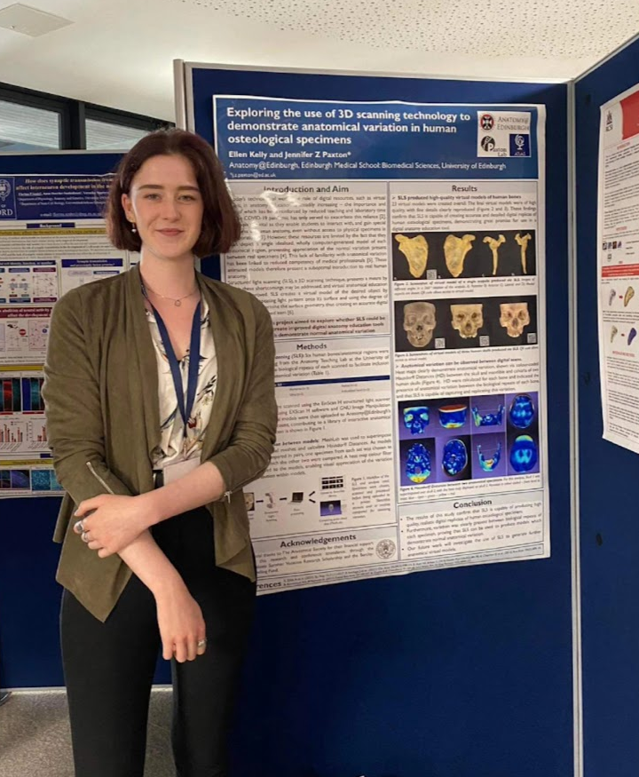
I thoroughly enjoyed attending my first Anatomical Society meeting and found the environment and people (particularly conference organisers) to be very friendly and welcoming. Presenting my poster on the first day provided the first opportunity to present my research and talk to others interested in the same research area, whilst gaining confidence in my ability to engage those less familiar with the topic. I also met other USVRS students and enjoyed the opportunity to share experiences and navigate our first meeting together.

I took advantage of the chance to attend a variety of interesting talks and learn more about current research in the field of anatomical sciences, particularly enjoying those based on anatomy education and technology. This experience solidified my interest in anatomical science research, and my intention to pursue a career in a related field.

REPORT: In relation to skills, what were the most important things you gained? (does not apply to equipment grant. For public engagement/outreach awards what did your audience gain and how did you evaluate success?
Preparing and presenting my poster enabled me to develop a wide range of skills, including oral and written communication and presentation skills. The experience also developed my ability to clearly and succinctly communicate the methods, findings and importance of my work to those who are unfamiliar with the research area. Through attending other presentations and talks, I was also able to identify areas in which I could improve and deliver a more engaging presentation. Additionally, attending my first conference and meeting academics and researchers within the Society provided the opportunity to develop my networking skills.

These are vital transferrable skills, which will benefit me in many areas of my future career, regardless of what I choose to pursue.

REPORT: How do you think you will put this learning experience into practice in the future? For public engagement/outreach awards how with the materials/knowledge generated by this activity be used in the future?
This learning experience enabled me to develop numerous vital transferrable skills, including presentation, oral/written communication and networking, which I will definitely use in the future in both my personal and professional life. This experience also strengthened my passion for anatomical research and highlighted the importance of my area of research interest – the skills developed at this meeting would be particularly valuable if I were to pursue a career in this area.
Data Protection/GDPR: I consent to the data included in this submission being collected, processed and stored by the Anatomical Society. Answer YES or NO in the Box below
YES
Graphical Images: If you include graphical images you must obtain consent from people appearing in any photos and confirm that you have consent. A consent statement from you must accompany each report if relevant. A short narrative should accompany the image. Answer N/A not applicable, YES or NO in the box below
YES
Copyright: If you submit images you must either own the copyright to the image or have gained the explicit permission of the copyright holder for the image to be submitted as part of the report for upload to the Society’s website, Newsletter, social media and so forth. A copyright statement must accompany each report if relevant. Answer N/A not applicable, YES or NO in the box below
YES
SIGNATURE | Ellen Kelly |  | DATE | 24/07/22
If submitted electronically, a type-written name is acceptable in place of a hand-written signature

File: AS-Award-Report-Form-190919

