_______________________________________________________________________________________
AWARDEE REPORT FORM
_______________________________________________________________________________________

NAME |  | Dr Zubeyde Bayram-Weston
TWITTER HANDLE* optional |  | @ZBW23
UNIVERSITY |  | Swansea University
NAME OF AWARD |  | Departmental Seminar Award 2022/23 - Round 4
PURPOSE OF AWARD conference/event attended/organised (full name) with city and dates.
Prof Dr Philippa Francis-West, King's College London was invited to present her research at our departmental seminar in the Faculty of Medicine, Health and Life Science at Swansea. The Seminar she gave on the 14th of September 2023 on entirely dedicated to her talk on “Making and Shaping Bones”. The seminar was in person at Singleton campus – room Glydwr D, Glyndwr Building, Swansea. Zoom link was also available who those who could not attend in person. (Hybrid Seminar in person and streamed live Zoom).

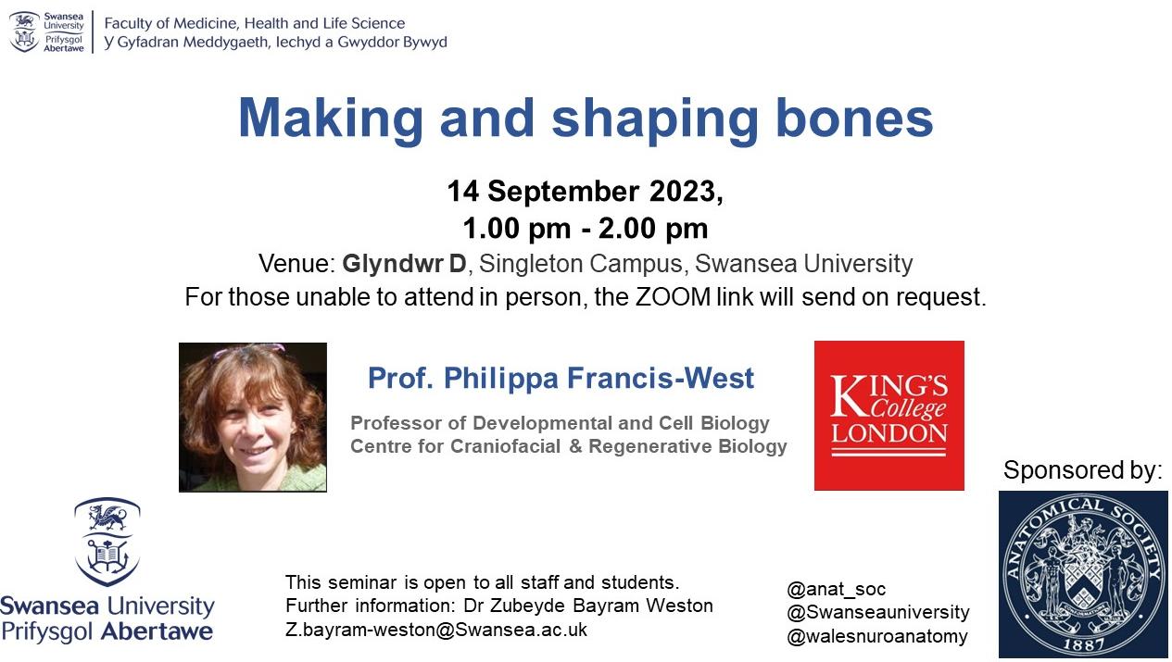

REPORT: What were your anticipated benefits?
Prof. Francis-West is a distinguished figure in the field of Developmental Biology, particularly renowned for her exceptional contributions to cranial development. I met Prof. Francis-West through my prior involvement in a research group at Cardiff University and our paths continued to intersect over the years within the realm of tissue engineering prior to my Ph.D. This connection afforded me insight into her pioneering work in craniofacial development, encompassing both bone formation anatomy and genetics, and the remarkable proficiency with which she conducts her research.
Naturally, I anticipated an intellectually stimulating seminar that aligned not only with my own research pursuits but also resonated with a diverse audience that expected to attend. Prof. Francis-West was invited to present her talk at a departmental meeting within the Faculty of Medicine, Health and Life Sciences, a hub encompassing a spectrum of research and teaching programmes, including medicine, paramedicine, Nursing, osteopathy and healthcare science.
Consequently, the audience comprised principal investigators, postgraduate students, researchers and undergraduate students, as well as faculty members, engaged in the intricacies of bone formation. A significant portion of the attendees held a vested interest in bone tissue research, often entwined with direct clinical interactions. Extending an invitation to Prof. Dr. Francis-West to our faculty and dedicating the session exclusively to her presentation presented a great opportunity for Swansea University’s academic community and students to forge connections with an outstanding scientist leading the charge in cutting-edge research.
In turn, it provided Prof Dr. Francis-West with a platform for a rich scientific exchange among an audience who shared her dedication for research in the content of developmental anatomy. I am pleased to report that the seminar not only met but exceeded all my expectations, leaving me thoroughly gratified with the experience.
COMMENTS: Describe your experience at the conference / lab visit / course / seminar/ event.
Prof. Dr. Francis-West delivered an outstanding seminar that resonated precisely with the diverse audience outlined earlier with over 69 attendees (over 25 in person, 44 over the Zoom). The culmination of her presentation sparked an engaging and thought-provoking discussion at the end of her talk. Attendees had ample opportunities to actively engage with Prof Francis-West, fostering not only formal discourse during the talk but also informal interactions.

Furthermore, this visit provided Prof Dr Francis-West with the invaluable opportunity to acquaint herself with our research facilities in Swansea. Here, she engaged in constructive scientific discussions and explored potential areas of convergence for future collaborative research endeavours.
REPORT: In relation to skills, what were the most important things you gained? (does not apply to equipment grant. For public engagement/outreach awards what did your audience gain and how did you evaluate success?
Personally, I significantly expanded my understanding of an area where my knowledge was limited. In addition, this seminar yielded significant benefits for the audience, as they had the privilege of listening to an esteemed international expert passionately discuss her research field. I have received very positive unsolicited feedback from students and staff (verbally and via email). This seminar also facilitated the establishment of potential collaboration for future research.

REPORT: How do you think you will put this learning experience into practice in the future? For public engagement/outreach awards how with the materials/knowledge generated by this activity be used in the future?
I trust this scientific visit will mark the initial stride towards forging a scientific collaboration.
Data Protection/GDPR: I consent to the data included in this submission being collected, processed and stored by the Anatomical Society. Answer YES or NO in the Box below
Yes
Graphical Images: If you include graphical images you must obtain consent from people appearing in any photos and confirm that you have consent. A consent statement from you must accompany each report if relevant. A short narrative should accompany the image. Answer N/A not applicable, YES or NO in the box below
YES

I can confirm that I have obtained consent from Prof. Dr. Francis-West for photographs via email.
This image below is used in the X (former Twitter) feed at the beginning of the seminar.

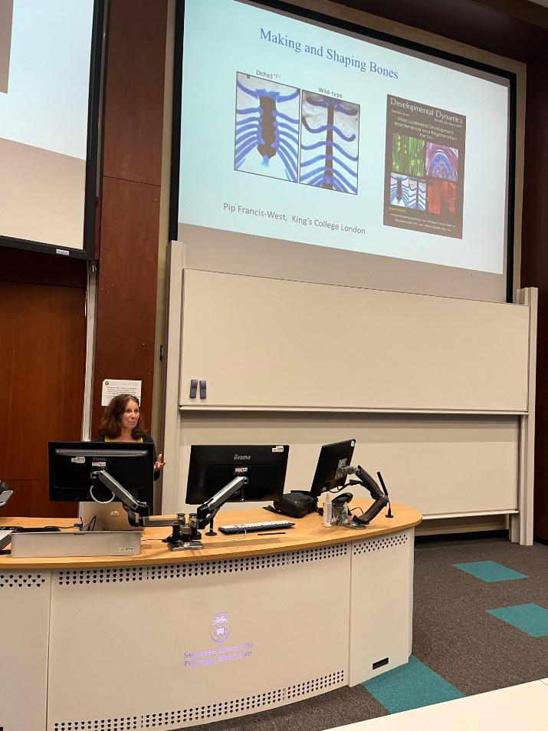

Copyright: If you submit images you must either own the copyright to the image or have gained the explicit permission of the copyright holder for the image to be submitted as part of the report for upload to the Society’s website, Newsletter, social media and so forth. A copyright statement must accompany each report if relevant. Answer N/A not applicable, YES or NO in the box below
Yes.

SIGNATURE | Zubeyde Bayram-Weston |  | DATE | 26/09/2023
If submitted electronically, a type-written name is acceptable in place of a hand-written signature

File: AS-Award-Report-Form-220922

