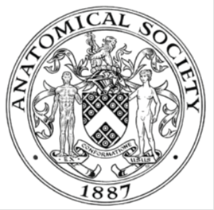
_______________________________________________________________________________________
AWARDEE REPORT FORM
_______________________________________________________________________________________

NAME |  | Matthew Lok Harvey
UNIVERSITY |  | King’s College London
NAME OF AWARD |  | Barclay Smith Travelling Fund
PURPOSE OF AWARD conference attended (full name) with city and dates
Attending the Anatomical Society’s Summer Meeting at the University of Oxford from 23rd to 25th July
2018

REPORT: What were your anticipated benefits?
The opportunity to present research, I carried out during an undergraduate summer vacation research scholarship funded by the anatomical society, on the development of the submandibular and sublingual salivary gland main excretory ducts.
A chance to meet researchers from other universities and in other fields, as well as expand my knowledge of current anatomical research.
COMMENTS: Describe your experience at the conference / lab visit / course / seminar.
Having not attended an academic conference before, I did not know what to expect, thankfully the meeting was very well organised, and I was able find my way around quite happily.
While the seminars I attended discussed subjects quite different to my own research, I found them quite interesting and was able to learn a good bit about neuroanatomy and other topics about which I previously knew little. The chance to try the Hololens mixed reality display was an unexpected bonus of attending the meeting, and it left me thinking of plenty of ways such apparatus could be useful in communicating my work to others.
Being able to present my research was a valuable opportunity, as a dental student I have had few opportunities to attend lab meetings or present my work to others, so I was glad to be able to get experience of doing so. The questions people asked about my work helped me to understand what figures and annotations I might want to include in the research article I plan to write.
Seeing other people’s posters and talks helped me to better understand what makes a good poster/talk.

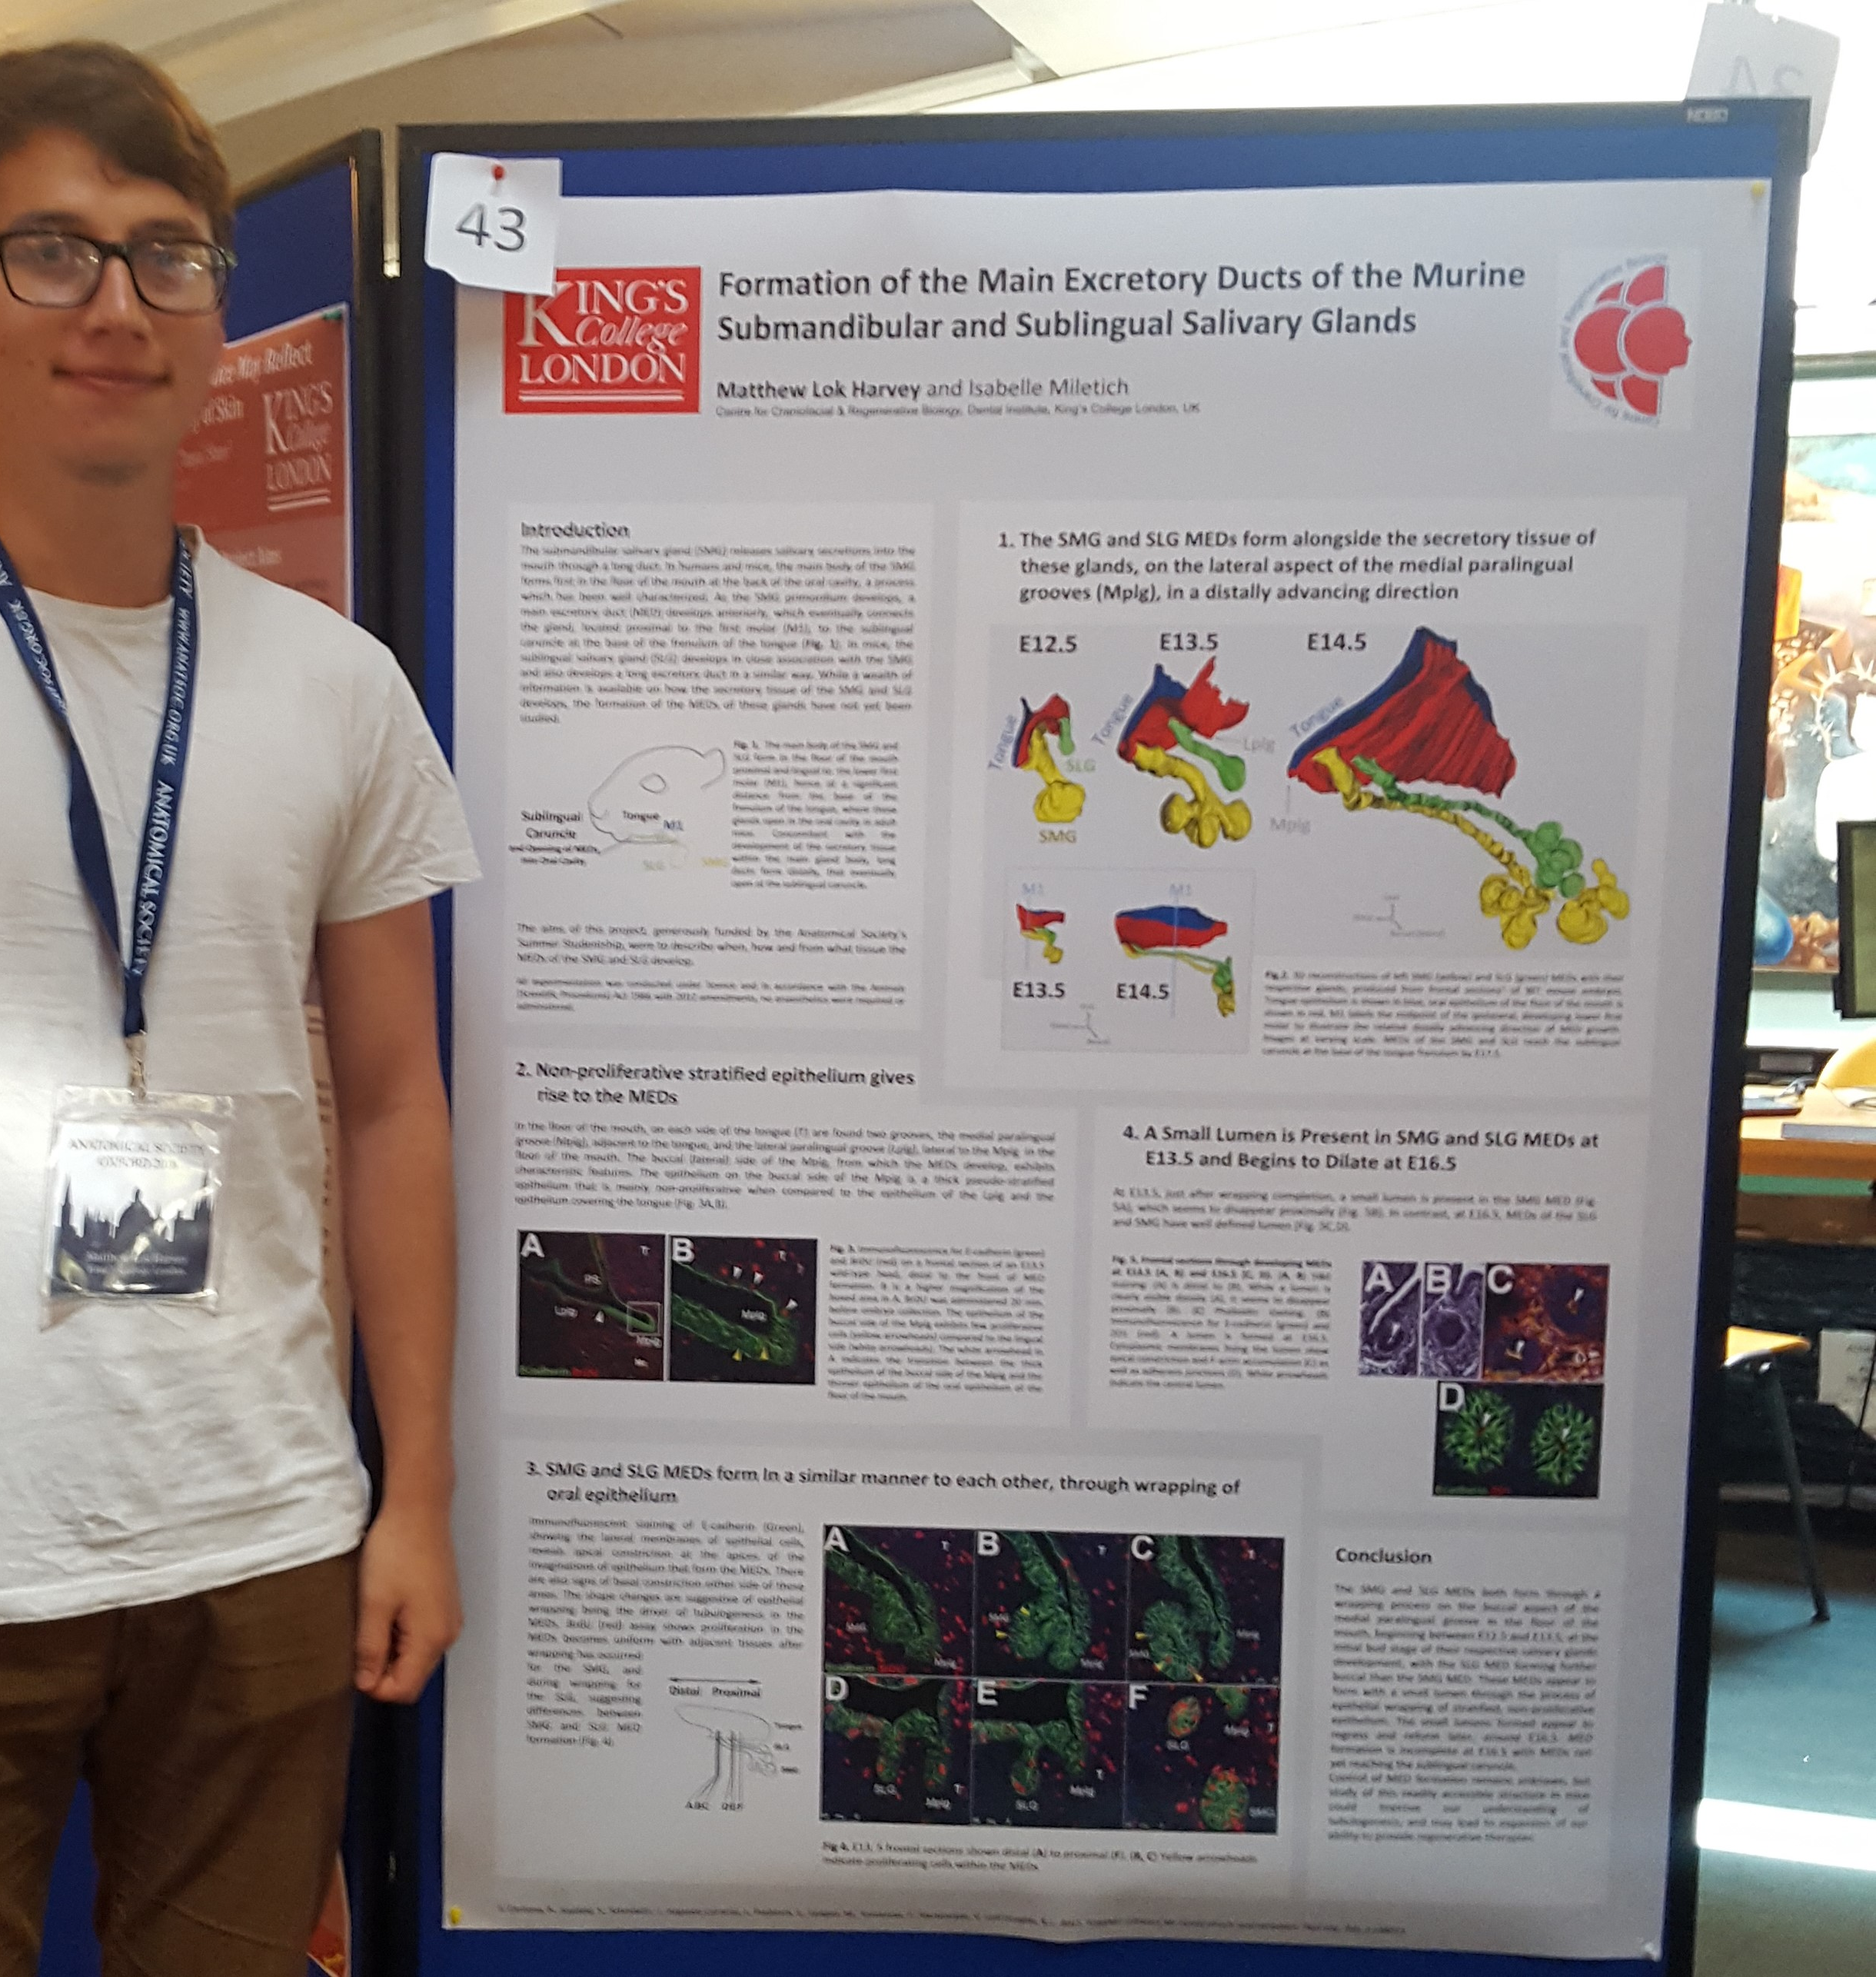
Me and the poster I presented at the conference

REPORT: In relation to skills, what were the most important things you gained? (does not apply to equipment grant)
I learnt about what happens at an academic conference and the experience has left me understanding the value of attending such conferences.
I was able to enhance my presentation and communication skills.

REPORT: How do you think you will put this learning experience into practice in the future?
The practice in presenting my work has left me more confident in my ability to discuss it.
I will be able to learn from others’ presentations, as I know better how to capture an audience’s attention and communicate information without overwhelming.
I am more aware of what questions to expect in future about my research, so will be able to improve on my presentation of it by addressing these questions.

SIGNATURE | Matthew Lok Harvey |  | DATE | 03/08/18
If submitted electronically, a type-written name is acceptable in place of a hand-written signature

File: AS-Award-Report-Form-BLANKCO-SEAL-date110216

